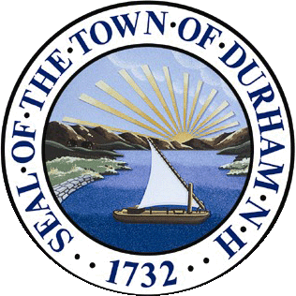 | TOWN OF DURHAM  8 Newmarket Road  Durham, NH 03824-2898  603.868.8064  www.ci.durham.nh.us
Durham Trustees of Trust Funds
8:30 AM, Friday, October 28th, 2022
Council Chambers, Town Hall
8 Newmarket Road, Durham, NH

AGENDA
I. Call to order.

II. Public Input (Town Council rules – speakers limited to 5 minutes).

III. Approval of Agenda (draft on web page).

IV. Approval of Minutes: August 28 and September 23rd, 2022 (drafts on web page).

V. Old Business:
- Update on Doe Farm/Land Stewardship Sub-Committee (LSSC). The LSSC met on 13 October for the first time since June. The agenda was distributed to the Trustees by e-mail. Tom Brightman, Tom Bebbington and Mike Everngam plan to walk parts of Doe Farm with Tracy and Arianna from RCCD on 11 October to survey invasive species eradication needs.
- Update on Cemetery Committee. Cemetery Committee Chair and Trustee Chair meet with Council on 19 October to present annual reports.

VI. New Business:
- Expenditure Requests: TBD.
- Monthly MS-9 Spreadsheet.
- Investment Advisor’s 3Q22 Report.
- Reports or issues brought forward by Trustees.

VII. Adjourn.

Next Regular Meeting: 08:30 AM on November 28th at Town Hall.

