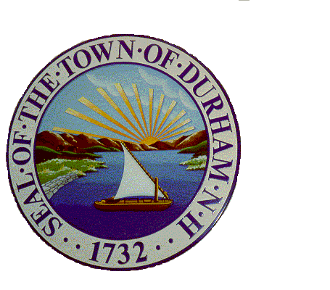
TOWN OF DURHAM
8 NEWMARKET RD
DURHAM, NH 03824-2898
PHONE: 603/868-8064
www.ci.durham.nh.us

LOT MERGER APPLICATION

The applicant must file two duplicate originals. Please type or print legibly in black ink.

As provided for in NH RSA 674:39(a), the undersigned applicant(s) request(s) that the Town of Durham, New Hampshire, hereby merge the following lots of land for the purposes of being assessed and regulated as a single lot of land. Approval by the Durham Town Planner, below, is subject to confirmation that the lot merger is not inconsistent with local and state law. Once this merger is approved the lots may not be conveyed separately without new Planning Board subdivision approval.

Name(s) of record owner(s). The name(s) must be identical for all lots to be consolidated:

_______________________________________________________________________________

_______________________________________________________________________________

Mailing address(es) of owner(s):

_______________________________________________________________________________

_______________________________________________________________________________

The following existing lots are to be consolidated into a single lot:

Map & Lot # Property Address

_________________ _______________________________________________________

_________________ _______________________________________________________

_________________ _______________________________________________________

This approval must be recorded at the Strafford County Registry of Deeds by the applicant. It is a condition of this lot merger that none of the lots proposed for a merger are subject to any lien or mortgage OR if there is any lien or mortgage the applicant must obtain approval in writing from each lien or mortgage holder. That lien or mortgage approval must be submitted to the Planning Department and recorded with this lot merger approval. This lot merger will not be approved if there are any overdue taxes due to the Town of Durham.

(over)

By signing below, the applicant(s) acknowledge(s) and agree(s) to the terms of this lot merger above.

_____________________________________ __________________________________
Owner’s Signature Owner’s Signature

____________________________________ __________________________________
Printed Name of Owner Printed Name of Owner

___________________________________ __________________________________
Date Date

____________________________________________________________________________

(For Municipal Use Below)

This application for a lot merger is hereby approved.

_________________________________________________ ______________________
Durham Town Planner Signature Date

_________________________________________________
Printed Name of Town Planner

One original to be retained in Tax Assessor’s files. One original shall be forwarded to the Strafford County Registry of Deeds by the applicant for recording upon approval. Recorded copy to be returned to the Town of Durham Planning Department.

