Town of Durham
ARCHITECTURAL DESIGN STANDARDS
Appendix to the Durham Site Plan Regulations
Part III – Development Standards, Article 2 - Architectural Design Standards
(Most recently revised May 13, 2026)

These regulations are applicable to the Core Commercial Zoning Districts –
Central Business, Church Hill, Coe’s Corner, Courthouse, and Professional Office Districts

CONTENTS
Overview…………………………………………………………………………………… …… 2
A) Findings……………………………………………………………………………… …… 2
B) Purpose……………………………………………………………………………………. 2
C) Authority………………………………………………………………………………….. 3
D) Applicability………………………………………………………………………………. 3
E) Process…………………………………………………………………………………….. 4
F) Using These Regulations………………………………………………………………….. 5

Design Standards………………………………………………………………………………. 6
G) Overview of Zoning Districts…………………………………………………………….. 6
H) General Principles………………………………………………………………………... 11
I) Siting of Buildings……………………………………………………………………….. 12
J) Scale and Massing……………………………………………………………………….. 13
K) Proportion………………………………………………………………………………... 15
L) Height…………………………………………………………………………………….. 17
M) The Roof…………………………………………………………………………….. …… 19
N) Windows…………………………………………………………………………………. 21
O) Entrance………………………………………………………………………….………. 23
P) Building Facades………………………………………………………………………… 24
Q) Materials…………………………………………………………………………………. 25
R) Color……………………………………………………………………………………... 28
S) Lighting of Buildings……………………………………………………………………. 28
T) Storefronts……………………………………………………………………………….. 28
U) Specific Building Types and Building Elements……………………………………….... 30

Definitions…………………………………………………………………………………….. 31

OVERVIEW

A) Findings. The Town of Durham finds that:

- Much of Durham reflects 18th, 19th, and 20th century architectural styles as it has evolved over time from a small village. The town contains a handsome, historic core that embodies a fine architectural tradition, a colorful history, and much visual appeal.

- Preserving and enhancing this area is essential to maintaining the character and identity of our community.

- Building designs which: a) are indifferent to the defining features of our town and to surrounding context; b) do not consider the quality of the pedestrian environment; c) introduce design elements which are incompatible with our traditional character; d) aggressively seek the attention of passing motorists; or, e) are erected at very low cost without due concern for aesthetics, harm our community, depress property values, and degrade our quality of life.

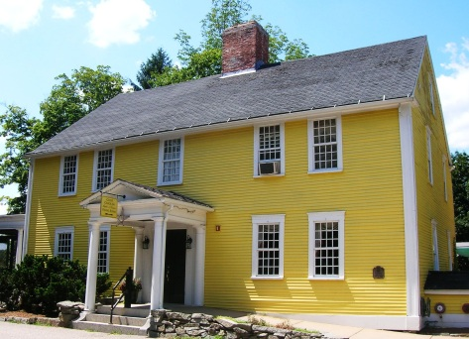
- While subjectivity and judgment are invariably part of reviewing architectural designs, generally accepted principles of good design among design professionals schooled in traditional architecture provide guidance.

- Well-crafted architectural standards promote building design that is functional, economical, attractive, and harmonious. Quality design and sustainable economic development are not mutually exclusive; rather, they are interdependent.
The Three Chimneys Inn (1)

B) Purpose. It is the intent of these regulations (or “standards”) to inspire architects, designers, developers, and builders to produce beautiful structures, respectful of place, context, and tradition. Adherence to these regulations should not be burdensome and they are by no means intended to stifle creativity or variety. On the contrary, it is hoped that they will encourage applicants to produce more thoughtful designs. There is much flexibility embodied in these regulations and many ways of meeting the objectives. The purpose of these Architectural Design Regulations is to accomplish the following:

- Provide for high-quality, human-scale architecture that conforms with generally accepted traditional design principles and is sensitive to neighboring buildings, streetscapes, the broader setting, and our natural and cultural resources;

- Encourage design which is compatible with the architectural heritage of Durham, New Hampshire, and New England;

- Enhance property values and foster civic pride;

- Strengthen commercial vitality and promote the downtown as a welcoming, pedestrian and bicyclist-oriented destination, while maintaining the feel of a small town that is important to Durham residents.

- Minimize potential conflicts between residential and nonresidential uses and between single family and multifamily uses; and

- Create a sense of order, substance, and visual clarity in the built environment.

C) Authority. This section is adopted pursuant to the Town of Durham 2000 Master Plan, 2009 Commercial Core Strategic Plan, and 2011 Architectural Visual Preference Survey, and to the New Hampshire Revised Statutes Annotated section 674:44 - Site Plan Review Regulations.

D) Applicability. Architectural Design Review, under these regulations, is required as part of Site Plan Review as follows:

1) Applicability. Review is required for buildings containing - or intended to contain, in the case of vacant units - any nonresidential use or multifamily use (as defined in Subsection 1.01 Authority of these Site Plan Review Regulations to mean any building containing more than two dwelling units).

2) Exterior architectural appearance. Review is required for any activity which would affect the exterior architectural appearance in any significant manner - including new construction, additions, alterations, demolitions, and relocation - of any building situated in one of the five zoning districts which constitute the Core Commercial area.

3) Core Commercial. The Core Commercial area comprises the Central Business, Church Hill, Coe’s Corner, Courthouse, and Professional Office Districts.

4) Historic District not included. These regulations do not cover any areas within the Core Commercial area which are part of the Durham Historic District, as defined in Article XVII – Durham Historic Overlay District of the Durham Zoning Ordinance and on the Durham Zoning Map. (A companion set of regulations is in place or being developed for the Historic District.) Note that the entirety of the Coe’s Corner and Professional Office Districts are located outside of the Historic District, most of the Central Business and Courthouse Districts are located outside of the Historic District, and only a very small part of the Church Hill District (three landlocked lots without street frontage) is located outside of the Historic District.

5) Exemptions. Review is not conducted for:

a) any activity, including general maintenance, that would have no effect on the exterior architectural appearance in any significant manner, as reasonably determined by the Planning Board;

b) repainting where substantially the same color(s) is(are) used as presently on the building; and

c) repair or replacement of materials where substantially the same material is used.

6) Zoning Ordinance. In the case of any conflict with the Zoning Ordinance, the provisions of the Zoning Ordinance shall prevail.

7) Signage not subject to review. These regulations do not apply to signage, whether freestanding or placed on a building, nor to lighting for signage (See Article XXIII. Signs and Utility Structures in the Zoning Ordinance).

E) Process

1) Materials. As appropriate, applicants shall submit the following:

a) Precise elevation drawings drawn to scale of each impacted façade visible under the provisions of D) 5), above;

b) A color board containing actual color samples of exterior finishes, keyed to the elevations;

c) A material sample, if requested, such as the type of brick proposed;

d) Any other items which the Planning Board determines are necessary in order to conduct its review such as detail drawings, photographs, and product brochures; and

e) Any proposed exterior building illumination (except for signage).

f) Perspectives of the project from all views from public ways, as requested by the Planning Board.

g) Accurate, to scale dimensions/heights of each building within the project area and also of the immediately adjacent structures, or of other structures when the board deems appropriate.

2) Architect. A licensed architect shall design the building(s) and prepare the architectural drawings.

3) Conformance with standards. All applicable design elements shall be in conformance with these regulations as reasonably interpreted and applied by the Planning Board. An application is considered to meet these regulations if the Planning Board, in its reasonable judgment, determines that the application overall demonstrates conformity with these regulations.

4) Waiver requests. Waivers shall be reviewed in accordance with the criteria stated in RSA 674:44 III.(e), as may be amended in the future. The basis for any waiver granted by the planning board shall be recorded in the minutes of the board. The planning board may only grant a waiver if the board finds, by majority vote that:

(a) Specific circumstances relative to the site or conditions of the land, indicate that the waiver will properly carry out the purpose and intent of the regulations; or

(b) Strict conformity would pose an unnecessary hardship to the applicant and the waiver would not be contrary to the spirit and intent of the regulations. For the purposes of this provision, "unnecessary hardship'' means that, owing to special conditions of the property that distinguish it from other properties in the area:
(i) No fair and substantial relationship exists between the general public purposes of the provision and the specific application of that provision to the property; and
(ii) The proposed use is a reasonable one.

F) Using these regulations

1) Readers are encouraged to become familiar with the architectural features of each Zoning District within the Commercial Core area as described in the section titled “Overview of Zoning Districts.” Specific principles outlined in the remainder of this document may then be better understood in context.

2) Definitions. A Definitions section is included at the end of these regulations. Applicants and Planning Board members are encouraged to consult this section to facilitate discussion.

3) Other terms herein. The following additional terms shall also apply:

a) “Shall” means the element or action is required.

b) “Shall not” means the element or action is prohibited.

c) “Appropriate” means the element or action is permitted and desirable.

d) “Inappropriate” means the element or action is not permitted.

e) “Encouraged,” means the particular action or item is desirable, but not required

3) Applicability across sections. Principles discussed in one section apply to other sections, as appropriate. For example, awnings are discussed under Storefronts because most awnings are used as part of a commercial storefront. However, where awnings might be used on a multifamily structure, the same principles will generally apply.

4) Illustrations. Photographs or drawings depicting specific appropriate features and inappropriate features are included in most sections. For any given building, including “signature buildings,” the illustration will invariably show both appropriate and inappropriate features, but the pertinent features are generally highlighted. To clarify, for a building shown under “APPROPRIATE” it shall not be inferred that all aspects of that building, or even the building overall, are(is) appropriate; likewise, inclusion of a building under “INAPPROPRIATE” does not necessarily mean that all aspects of the building, or even the building overall, are(is) inappropriate. (Note. No buildings highlighted under “INAPPROPRIATE”, or used as examples of what not to do, are located in Durham. All photographs were taken by Michael Behrendt, except where otherwise noted.)

DESIGN STANDARDS

G) Overview of zoning districts.

1) Central Business Zoning District.

a) General character. The Central Business District embodies the most urban and formal character. However, the district is underdeveloped, and there is a need for substantial infill and redevelopment, especially on Pettee Brook Lane. Main Street is the primary street in the district and the most pedestrian oriented, and is thus the most sensitive thoroughfare.

b) Signature buildings. These signature buildings help to define the Central Business District:
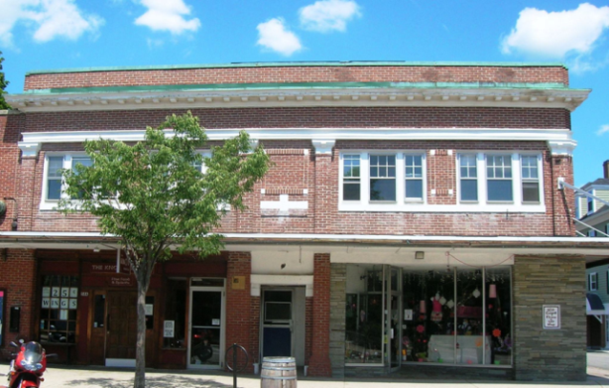
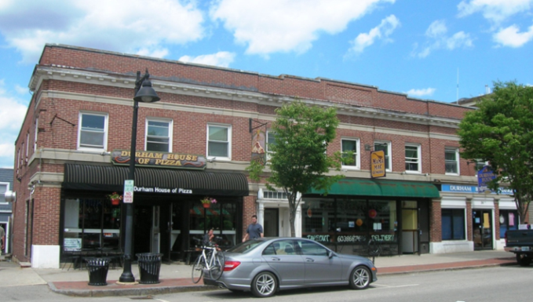

60 Main Street (3)
40 Main Street (2)

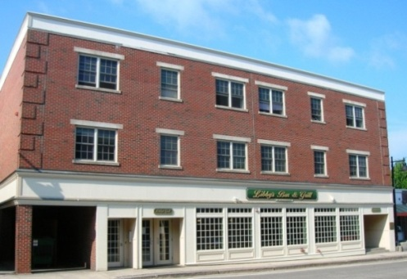
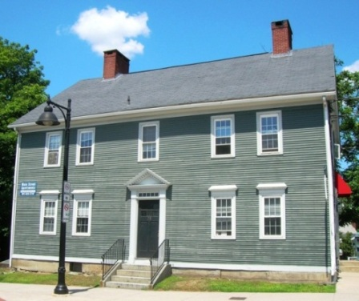
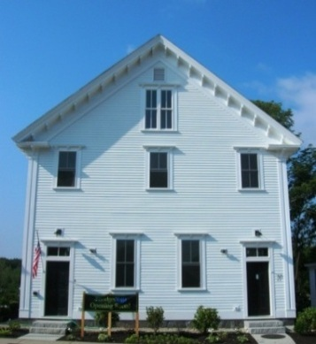

Joshua Ballard House (6)
Libby’s Building (4)
The Grange – Italianate style (5)

c) Prototypes – old buildings. The ideal prototype for the Central Business District is a three story brick building like these three below. Note the simplicity of form, the regular pattern of fenestration, the single (not double) windows, the verticality of the windows, the high quality of the materials, and the fine proportions.

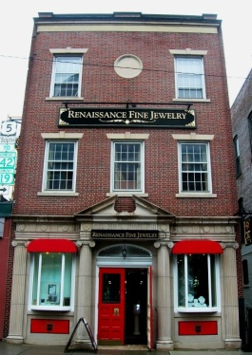
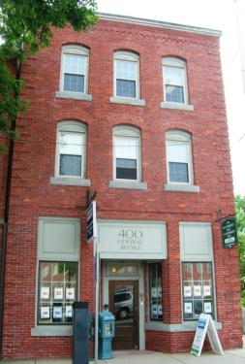
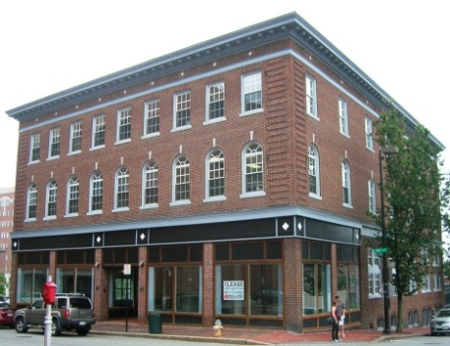

Brattleboro, VT (9)
Dover (7)
Portland, ME (8)

d) Good examples – new buildings. Here are examples of relatively new buildings that can also, generally, serve as models for new construction:
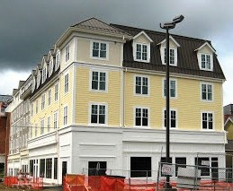
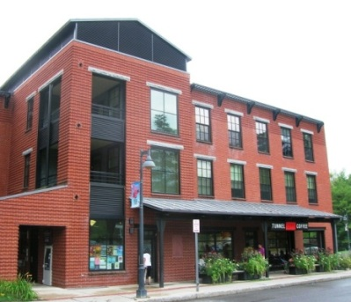
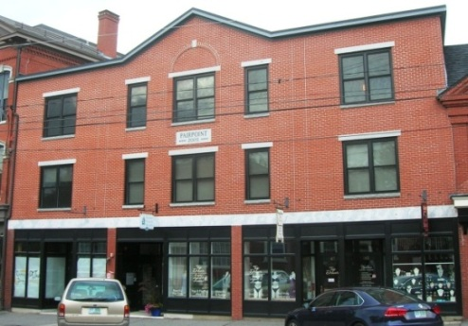

Williamstown, MA (10)
Storrs, CT (11)
(photographer unknown)
Exeter (12)

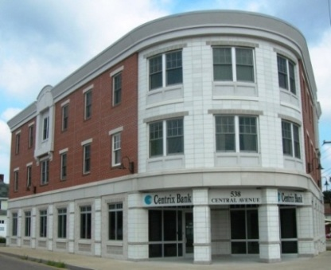
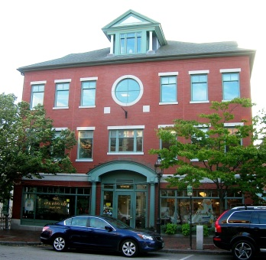
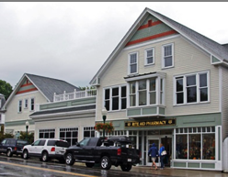

Portsmouth (14)
Camden, ME (15)
(photographer unknown)

Dover (13)

e) Streetscape. Newmarket’s Main Street, below, is highly varied, presenting an inconsistent, though interesting (if not “funky”) streetscape. Brattleboro, VT’s, on the other hand, is highly regular, creating a strong street wall, though one that would likely be too urban and intensive for Durham.
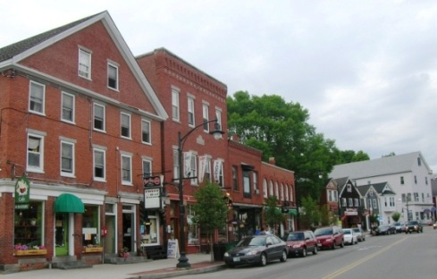
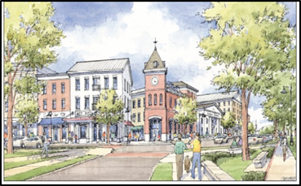
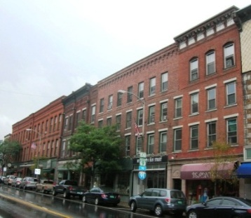

Durham Charrette (B. Dennis Design) (17)
Newmarket (16)
Brattleboro, VT (18)

Using the three-story, flat roofed, brick structure (like the three examples under Prototypes – Old Buildings, above) as the basic building block, Durham’s Central Business District ideally would present a harmonious and integrated, but richly varied, street wall composed of:

- two and a half, three, three and a half, and (where and if permitted under the Zoning Ordinance, and deemed appropriate) four and five story buildings;
- flat roofs and pitched roofs;
- front-facing gables and side-facing gables;
- gables with and without dormers;
- brick and clapboard-sided structures;
- three-bay, four-bay, five-bay, and wider structures; and
- carefully-placed iconic elements like the tower in the rendering, immediately above.

2) Church Hill Zoning District.

a) General character. Among the five zones in the Core Commercial area, Church Hill has the most distinct character and is thus most sensitive to inappropriate development. The district is composed primarily of relatively large Georgian/Colonial Revival style residential structures sided in wood clapboard, some dating from the early periods of Durham’s settlement. The rural past is evident in the number of barns and outbuildings that survive.

Two prominent churches –one resembling a traditional New England meeting house and one a contemporary stone structure - are situated diagonally across from each other at the top of the hill. Most houses are set back 10 to 15 feet from the sidewalk. The landscaped lawns and shade trees are an important feature of this district.

The residential structures are generally 2-1/2 stories high with the gable roofs turned perpendicular to the street. Most have highly regular fenestration and are symmetrical with five bays (often with outer windows placed closer together) and a center entrance, along with a porch or portico.

Although the Grange building is situated in the Central Business District, its recent renovation provides a model for redevelopment in Church Hill. The historic building was restored and a well-designed, though sizable new structure, largely screened from the street, was added at the rear.

New development shall be designed to resemble a single-family house, as generally described above, rather than an apartment block. The conversion of a residential structure for a non-residential use shall not alter the essential residential character of the building.

b) Signature buildings. Here are some signature buildings that help to define the character of Church Hill:
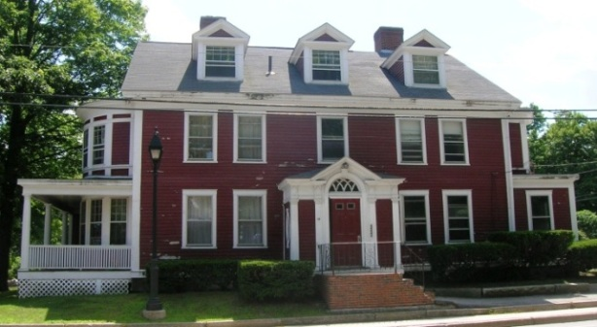
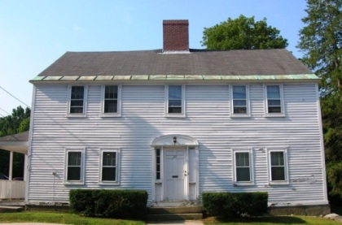
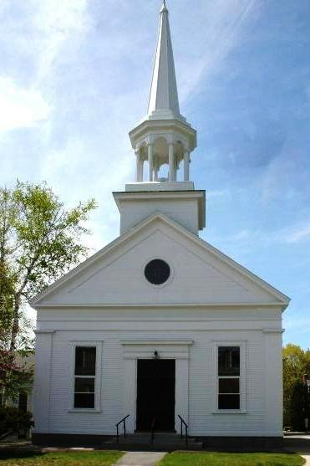

Georgian Style (20)
The Red Tower – Colonial Revival style (21)
Durham Community Church
Greek Revival style
(Photograph by Roger Hawk) (19)

3) Coe’s Corner Zoning District.

a) General character. Coe’s Corner is the least intensively developed and most rural part of the Core Commercial area. It is generally heavily wooded with deeper setbacks so many houses are minimally visible from the road, making the area less sensitive than some other districts. Most buildings are wood frame and simple in form with gable roofs, with the exception of the Italianate-style Pines Bed and Breakfast (below), with its picturesque style and complex massing. Informal layouts of buildings and styles, including barn-type buildings, are appropriate in this district.

b) Signature buildings. Here are some signature buildings that help to define the character of Coe’s Corner.
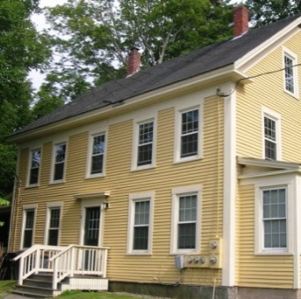
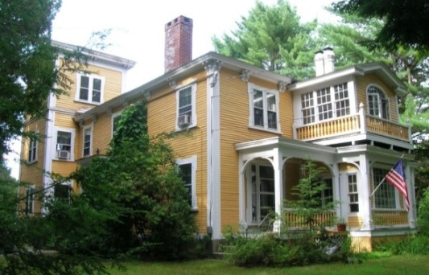

Dover Road (23)
The Pines Bed and Breakfast (22)

4) Courthouse District

a) General character. With the exception of a few sites, the Courthouse District is largely geared toward automobile traffic, and indeed has sometimes been referred to as “Gasoline Alley.” It is the only section in the Core Commercial area where highway-oriented uses are appropriate, and this is reflected in the Zoning Ordinance. Nonetheless, within this rubric, strong design standards are still important.

Buildings shall be placed as close to the street as practical (in accordance with the Zoning Ordinance) and there shall be no parking situated directly in front of buildings. Parking shall be situated behind the building if practical. If not practical it may be placed on the side of the building provided the parking area is no closer to the street than the main wall of the building.

b) Signature buildings. Here are some signature buildings that help to define the character of the Courthouse District. It is noted, however, these buildings are not located in the automobile-oriented section of the district, along Route 108 heading toward Dover.

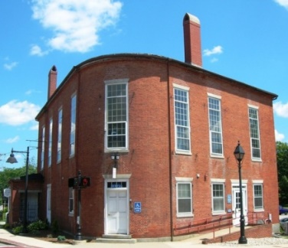
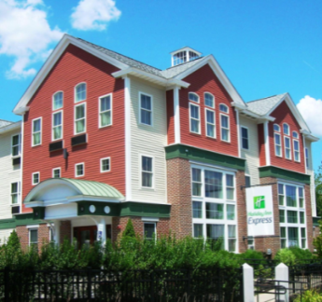

Holiday Inn Express (24)
Old Courthouse – Federal Style (25)

c) Good examples – new buildings. Here are some examples of high-quality, new automobile-oriented designs:
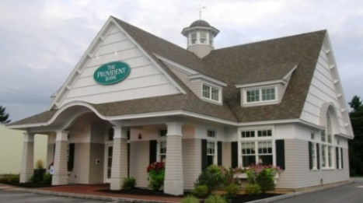
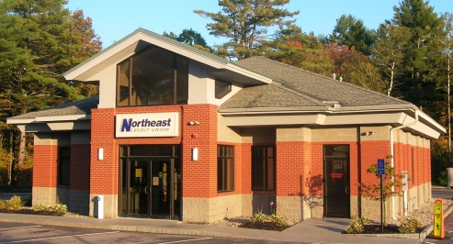
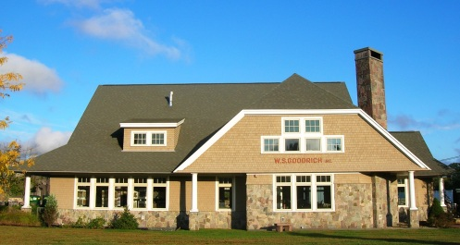

Lee (28)
Epping (26)
Exeter (27)

5) Professional Office District

a) General character. Buildings in this district are highly eclectic - in age, size, building material, use, and architectural style. Nonetheless, there are a number of good models from the late 19th and early 20th centuries in New Englander, Dutch Colonial, Foursquare, and brick Georgian Revival styles all along Madbury Road. Front porches also serve as a unifying theme in this district. Because of the deeper setbacks, greater amount of tree cover, and eclectic styles of architecture, the Professional Office District is not as sensitive as the Central Business and Church Hill Districts.

b) Signature buildings. Here are some signature buildings that help to define the character of the Professional Office District.

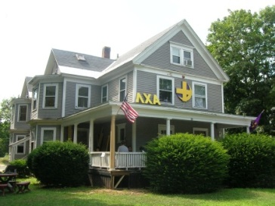
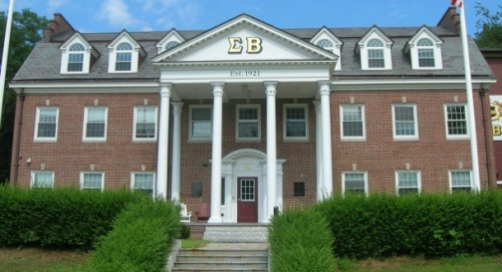
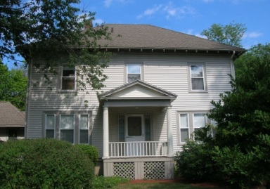

New Englander (29)
Georgian Revival (30)
Foursquare (31)

H) General Principles

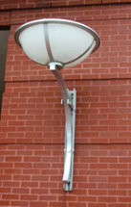
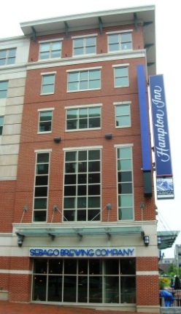
1) Core Commercial zones. Many principles in these regulations apply throughout the Core Commercial area, but each of the five pertinent zoning districts has its own individual character which shall be recognized and reinforced, as discussed above.

2) Traditional idiom. No particular architectural style is stipulated but buildings shall be harmonious with traditional Durham, New Hampshire and/or New England architecture. Thus, the general approach should express traditional or neo-traditional design. However, innovative design is not discouraged provided it is respectful of context and these principles, thus allowing for some deviation from traditional/
Portland, ME 32)
neo-traditional design . Incorporation of distinctive details,
materials, and finishes that mark a building as contemporary, within an otherwise traditional design, is appropriate. For example, see both the lantern and the canopy and
Portland, ME (33)
eaves on these two recently-built Portland, Maine buildings, to the right.

3) Traditional building styles. Typical traditional building styles used over the years in Durham generally include the “formal” or “rational” styles - Georgian, Federal, Greek Revival, Colonial Revival, and Neoclassical, as well as Victorian styles, notably Italianate. (Examples are highlighted throughout.)

4) Details. Designers may use the traditional architectural vocabulary (e.g. gables, porticos, beltcourses) in an original manner that reads as contemporary.

5) Harmony. Designs shall be harmonious with the prevailing character of the zoning district, the surrounding streetscape, and neighboring buildings – in terms of all of the elements discussed in this Design Standards section - recognizing that this objective can be complicated when components of the prevailing character do not conform with the goals of these regulations.

6) Modifications. Modifications and additions to existing buildings shall be harmonious with the character of the existing building, recognizing that this objective can be complicated when components of the existing building do not conform with the goals of these regulations.

7) Features of the site. Building design shall blend with other features of the site - signage, landscaping, lighting, fencing, outbuildings, natural features, and other elements - to the extent practical.

8) Variety within unity. The Town strives to achieve “variety within unity,” wherein a mix of forms is encouraged, but where these various forms are harmonious with one another. Overall uniformity can be monotonous. Well-executed exceptions to general approaches can contribute to, rather than detract from, the standard approach by providing visual interest that conveys liveliness. One excellent strategy to achieve variety within unity, for example, is for neighboring buildings of different but harmonious styles to share the same level for window sills on upper stories.

9) Preservation. Applicants are encouraged (but not required) to preserve existing structures and features that have special architectural, historical, cultural, or contextual value.

10) Visibility. The less visible or prominent a structure or façade, the more flexibility in applying the standards. For example, less strict review is in order for a building located a good distance from the road or for one that is partly obscured by another structure.

11) Chain designs. Many national and regional chain businesses seek to build a standard design across the country or region without regard to local conditions. However, all proposed chain business designs shall be evaluated for conformance with these Architectural Standards. It shall be the responsibility of the applicant to develop designs that are compatible with Durham’s character; the Planning Board need not accommodate such template designs.

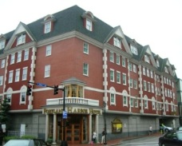
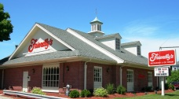
12) Integrity. Buildings shall possess an overall integrity of character, form and detail and convey a sense of seriousness and dignity. All building elements shall be integrated into a coherent, unified design; kitsch, as
exemplified in the two buildings to the right,
Rochester (35)
onto which colonialesque features
Portland, Maine (34)
have been appended, shall be avoided.

I) Siting of buildings

1) Parallel or perpendicular. Buildings shall be placed parallel or perpendicular to the street in order to create a sense of order. For buildings further from the Town center, including Coe’s Corner, when there are strong topographic constraints or buildings are well buffered from the street, there is more flexibility with this principle.

2) Front Setbacks. Buildings shall generally be set back from the public right of way consistent with, but no further back than, buildings on neighboring properties (subject to zoning requirements). The purpose is to create a sense of enclosure of the street, enhancing its pedestrian-oriented character. This is less important in the Courthouse and Coe’s Corner Districts. In the Central Business District buildings shall generally be positioned at the back edge of the sidewalk. Deeper setbacks that create a forecourt shall be reserved for important civic buildings, such as government buildings and churches, or for special designs, such as a restaurant that creates seating in a front plaza.

3) Side setbacks. Side setbacks shall be harmonious with those of neighboring structures - recognizing that some variation in spacing is appropriate based upon the scale, mass, and form of the ensemble of buildings – to create a pleasing, balanced rhythm.. In the Central Business District, there shall be no or minimal side setbacks to enhance a strong sense of enclosure.

4) Creating courtyards. To the extent practical, for open areas (parks or parking lots), whether fronting on a street or situated away from the street, buildings shall be configured to create rectilinear spaces in order to enhance the sense of meaningful, usable space.

Inappropriatee
Appropriatee

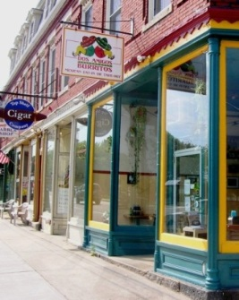
The Newmarket Post Office is set back from
the street by a parking lot in front, disrupting
the downtown streetscape. (39)
This commercial block in downtown Dover is placed right up to the sidewalk. (36)

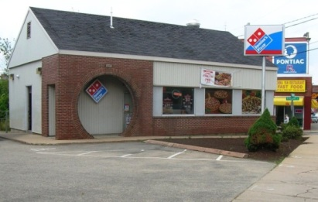
This building is turned at an odd angle to the street, disrupting the downtown street wall. (40)
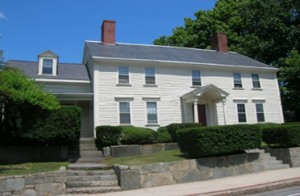
The Valentine Smith house on Church Hill is set back consistent with neighboring properties. The
elevated natural setting is also respected. (37)

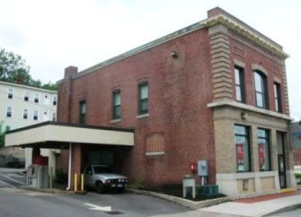
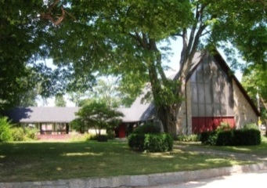
The drive-through on the side of this building disrupts the downtown streetscape. Proposed drive-throughs shall be reviewed in the context of zoning provisions. (41)
A deep front setback, plaza, or courtyard is appropriate for a distinctive civic building like St. George’s Church. (38)

J) Scale and Massing

1) Human scale. Buildings shall above all possess a human scale, both in terms of their overall size and in their details and materials, in order to promote a sense of pedestrian friendliness.

2) Unbroken elements. Blank walls, uninterrupted windows, and blocky, unbroken elements add to the sense of an oversized, non-human scale, and are thus inappropriate.

3) Simplicity of form. A building shall generally have one main block which is discernible as such. It shall have a simple form with subordinate geometric masses appended to it, such as the roof, a porch, a side ell, and/or a projecting front pavilion. The Red Tower (under Appropriate examples, below) exemplifies this principle. However, a well-designed building with a very simple form, good materials, and good proportions, with no subordinate masses, is often the most beautiful of all structures (see the Joshua Ballard house under Signature Buildings in the Central Business District, above).

4) Smaller masses. Especially large structures shall be broken into smaller masses, or even made to appear to be separate buildings, in order to provide human scale, variation, and depth. These smaller masses shall have a strong relationship to one another and each smaller mass shall have integrity of form (see the Portsmouth building under Appropriate, immediately below).

5) Prominent locations. Where it is workable, iconic buildings and building elements, such as towers (see the examples under G) 1) e) in the “Durham Charrette” illustration and under L) 2) in the “An iconic structure – Dover” photograph), shall be incorporated at prominent locations and to terminate vistas.

Inappropriatee
Appropriatee

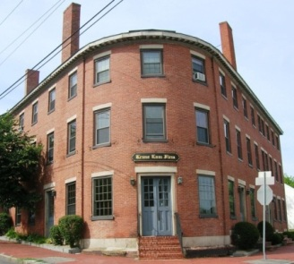
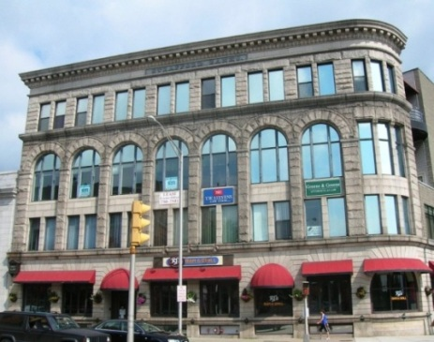
The curving front on this Dover building anchors the corner nicely. (42)

This magnificent building in the heart of downtown Dover would simply be too large for Durham. Its imposing scale is amplified by the use of large blocks of rough-faced granite. (47)
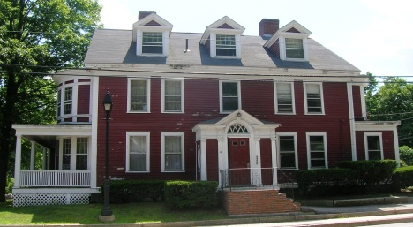

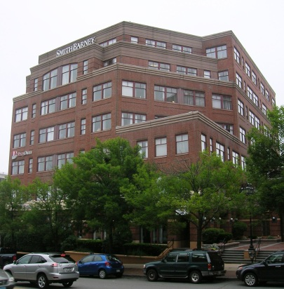

While the materials, upper story setbacks, and landscaping mitigate the mass of this Portland, Maine building, the scale is still much too large for Durham (48)
The main block, clearly discernible on the Red Tower is broken up by regularly spaced windows and various appended forms. (43)

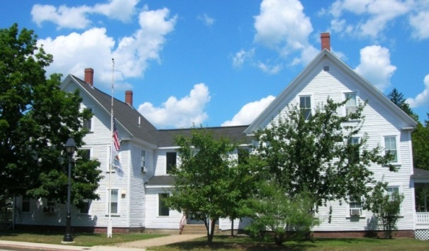

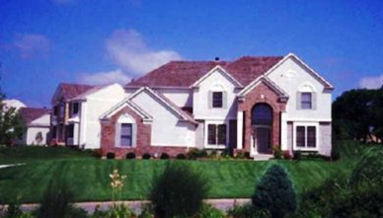
The multitude of gables here creates confusion and disharmony. (Photographer unknown) (49)

Durham Town Hall reads as two separate buildings (which it actually was) connected by a passageway. (44)

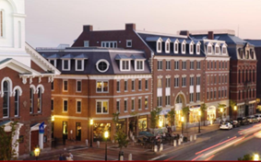
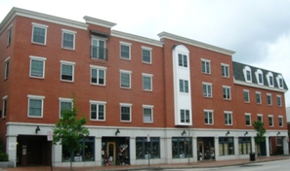

These new buildings in Portsmouth are actually one structure dressed up to look like three.
(photographer unknown) (45)
In this new structure in Exeter, also evoking three buildings, the three sections are poorly integrated. The building pales in comparison to the Portsmouth example (left). (50)

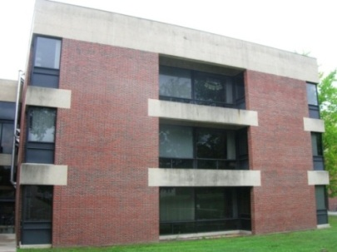
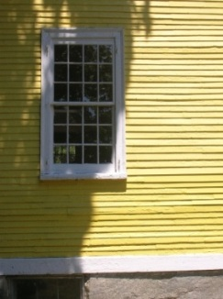

The mammoth concrete headers over the openings convey an outsized (non-human) scale to this Williams College (Massachusetts) building. (51)
The narrow clapboards brings an intimate scale to the main structure of the Three Chimney’s Inn (46)

K) Proportion

1) Definition. Proportion is the relationship of one dimension to another, such as:
- height of a window compared to its width,
- height of a building compared to its width,
- width of windows compared to the wall space between them,
- area of windows on a building façade compared to the area of wall space,
- height of a column compared to its width, or
- height of columns compared to the spacing between them.
- size of building appendages (such as dormers or a porch) compared to the overall size of the main structure

2) Ratios. Proportion is expressed as a ratio, such as 1:3, or as a fraction, such as 1/3. For example, a window that is one foot wide and five feet high (1:5 or 1/5) has elongated proportions. When one speaks of a building as having “good proportions” this means that the various individual ratios embodied in the building are harmonious with one another.

3) Proper Proportion. Use of proper proportions conveys a sense of order, balance, and calm, and enhances beauty, while use of poor proportions is unsatisfying and even unsettling.

Buildings shall be designed to convey a sense of proper proportion. Generally, taller proportions are more satisfying in a townscape, as vertical proportions evoke the human body. Vertical proportions shall prevail especially in the highly pedestrian-oriented Central Business District. Horizontal proportions are compatible with pastoral landscapes but they also evoke the automobile, and thus predominantly horizontal proportions are appropriate only in the Courthouse District. Many houses in the Church Hill District are horizontal in overall shape and in the foundation, cornice, and ridgeline. That horizontality is balanced by the verticality of the entry door, porch columns, windows, dormers, and corner treatments.

4) Golden Section. The golden section, which is the ratio of approximately 3:5 or 5:8 is a good guide to proper proportion. Many windows and building facades in traditional buildings approximate the golden section. For example, numerous golden sections are expressed in various components of the Parthenon.

Appropriatee
Inappropriatee

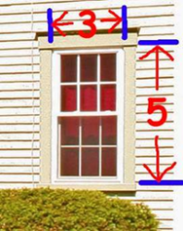
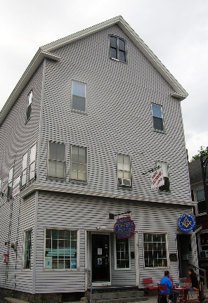
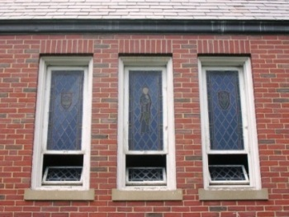

This window demonstrates the golden section.
(Photo by Roger Hawk) (52)
These windows in St. Thomas More Church are narrower than 3:5 but are elegant. (53)

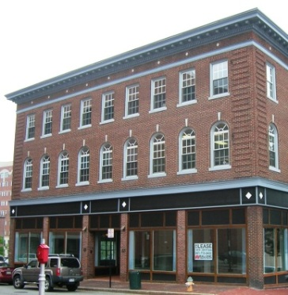

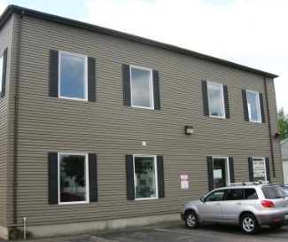

It is doubtful that these two façades were laid out with much consideration or knowledge of proportion. (56&57)

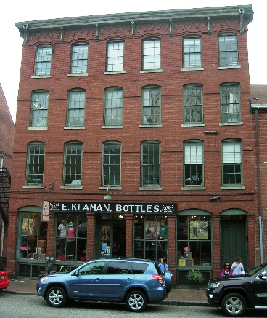

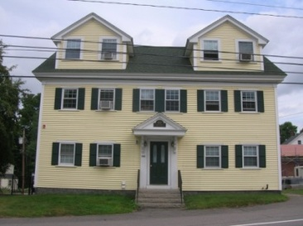

The excellent proportions of these two Portland, Maine buildings are innately satisfying. (54&55)
The dormers are out of proportion relative to the rest of the house resulting in an ungainly, top-heavy appearance. (58)

L) Height. Note that height limits and related principles, including treatment of “story” are specified in the Zoning Ordinance. This section provides standards to be met within those parameters.

1) Minimum height. Buildings shall contain at least two stories (and preferably at least 2-1/2 stories), in order to reinforce the streetscape. The only district where this is not essential is the Courthouse District, though it is still preferred. Where a single story is used (and often, also when there are only two stories), such as in part of the Courthouse District, devices - such as a high parapet (as shown on these two buildings below), a tall story, a corner tower, or a steep roof - shall be incorporated to add stature to the building.
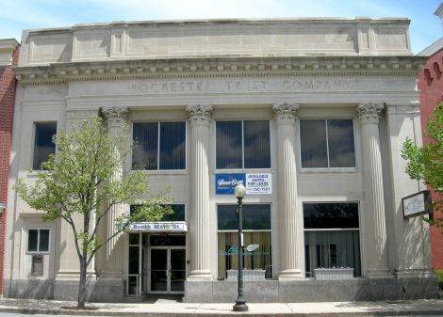

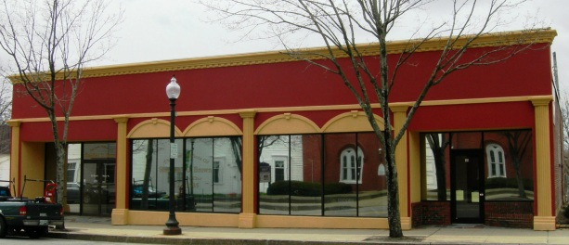

Rochester – new façade (59) Rochester (60)

2) Maximum height and criteria for taller buildings. On the other hand, buildings shall not be so tall as to create a canyon effect and be out of scale with the human form and surrounding buildings. With the tallest buildings, it may be desirable to employ techniques to reduce the sense of height.

Within the Central Business District, buildings taller than three stories may be erected only: a) if and as permitted in the Zoning Ordinance; and b) if the Planning Board determines that a building taller than three stories is appropriate based upon the criteria (a – k) given below. The Planning Board shall also consider the following criteria in determining whether an especially tall structure is appropriate in any of the five districts, especially when unusually tall stories are involved (A typical building story is 11 or 12 feet +/- with lower stories often taller than upper stories).
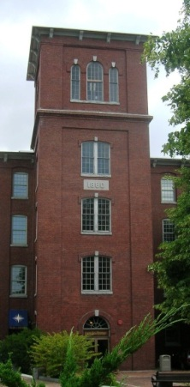
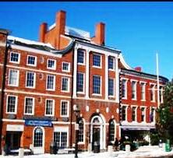
a) Its location, whether midblock or at a prominent corner (greater height is generally appropriate at the corner except where adjoining a street or area of lower scale)

b) The width of the building (greater height is generally appropriate with narrower buildings)
There are numerous variables
to consider – Portsmouth
(photographer unknown) (61)

c) The number of stories and height of each
An iconic structure -
Dover (62)

(greater height is generally more appropriate with taller stories)

d) The type of roof used and whether a cornice line is established at a lower story
(establishing the cornice line at a lower level can reduce the apparent height)

e) The placement and character of the upper stories, whether they are set back or otherwise made less apparent (if set back or less apparent then greater height is generally appropriate)

f) The use and nature of the building and whether it is an iconic structure (an iconic structure may merit greater height)

g) The balance of vertical and horizontal elements (a good balance can mitigate height)

h) The scale and quality of materials and details (quality in overall design can mitigate height)

i) The height of the adjacent buildings (great height is more appropriate next to taller buildings)

j) The width of the street (a wider street can better accommodate greater height). See next subsection.

k) Topography of the location and solar access, whether for the building itself or for its neighbors

3) Height-width ratio of street. The relationship/ratio between: a) the average height of buildings on both sides of the street, and b) the average width measured across the street between those facing buildings on opposite sides of the street, impacts the feel of a street. If the ratio is too low, such as 1:4, then there will fail to be a sense of enclosure created by the low facing street walls. If the ratio is too high, such as 2:1, then a canyon effect will result. (These two examples are given for illustrative purposes only.)

4) Mitigating height. Additional height/stories can be mitigated by techniques such as setting back the top story(ies); using a pitched roof; making the top floor visually lighter or less intrusive in some manner; or incorporating more horizontal elements into the design. Incorporating a gable as part of the roof allows for an additional story (or partial story) with less impact than adding an entire floor with a flat roof. These four buildings illustrate methods for mitigating the impact of an additional story (though these buildings are not necessarily appropriate for Durham).
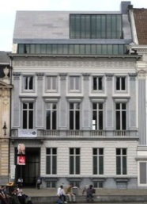
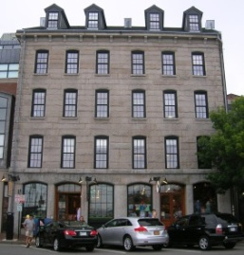
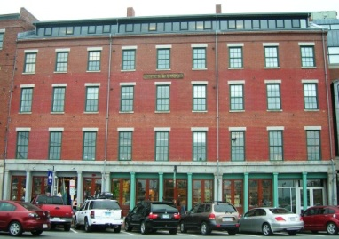
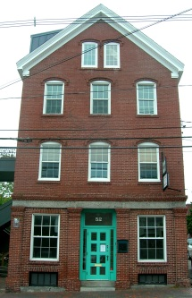

Portland, ME (63) Portland, ME (64) Portland, ME (65) Ghent, Belgium (66)

5) Gables. Most existing gable structures in the Core Commercial area are 2-1/2 stories, although a few are 3-1/2 stories. Gable structures over 2-1/2 stories shall be carefully executed in order to not appear ungainly or out of scale.

6) Variation in heights. Some variation in building height within a block is desirable to help break up the mass of the block and to create variety and interest; generally, however, there shall not be more than a one- or 1-1/2 story difference in height between adjacent buildings in order to maintain continuity along the streetscape. This limitation does not apply when the adjacent building is one story.

- First floor. The first floor shall be at grade or preferably raised slightly above grade. It shall be prominent and readily discernible as the first story. If there is a lower level or basement floor it shall be situated entirely or mostly below grade in order that it read clearly as a basement level and cause no confusion as to which is the first story.

- Fifth Story Setbacks. When a building contains five stories, the fifth story shall be set back from the first floor of the building as follows:

a) On lots that abut Main Street the 5th story shall be set back by at least 20 feet. This requirement applies to any side of the building that forms an angle of 45 degrees or less with Main Street.

b) By at least 10 feet where the building faces any other public street and the lot abuts that street (This setback applies specifically to whichever elevation faces the public street – front, side, or rear).

M) The Roof
1) Special treatment required. As a design element the roof - serving as a hat, of sorts - has a significant effect on the character of a building. The lack of a roof – or some special treatment of the cornice - can promote a feeling of a boxiness, which can read as clumsy or graceless. The roof shall be treated in a special manner, with a gable, a cornice, a frieze band, dentils/brackets, a parapet, or some combination of these. The taller the building, however, the less necessary is a pitched roof.

2) Extensive roof areas. Extensive areas of visible roof shall be broken up with dormers, cross gables, cupolas, chimneys, parapets, balustrades, towers, and/or other such elements.

3) Gable roofs. Front-facing gable roofs shall generally not be used on wide buildings as the gable would be either too shallow to span the width or excessively large and high. Generally, 2-1/2 stories is the ideal height for gable-roof buildings. Front-facing gables shall have a minimum roof pitch of 4/12. The pitch of the gable shall be compatible with the architectural style. For example, a lower pitch is used on Greek Revival buildings than on Italianate buildings.
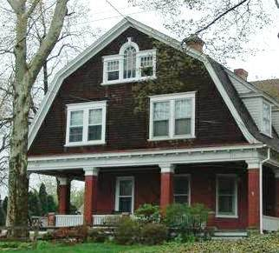
4) Roof styles. Roof styles in the Core Commercial area shall be limited to flat roofs, gable roofs, hip roofs, and shed roofs (the latter on dormers or appendages only. However, gambrel roofs are also appropriate in the Coe’s Corner district, but not in other districts as they are evocative of a rural setting. Eccentric roofs shapes and combinations of different roof styles/shapes shall not be used.
Gambrel roof (67)

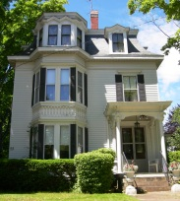
5) Mansard roofs. Mansard roofs (as shown on the right) shall not be used.
They are strongly associated with one specific architectural style – the 19th century Second Empire Style – and generally project a sense of kitsch when used on new buildings.

6) Eaves. Eaves shall have a minimum depth of six inches to create a shadow and be discernible.
Mansard roof (68)

7) Pitched roofs. All buildings in the Church Hill, Coe’s Corner, and Professional
Office Districts shall have a pitched roof.

8) Green roofs. Use of “green” or vegetated roofs and incorporation of solar panel arrays is encouraged (though not required under these architectural standards) and it is understood that accommodations may be needed in the design to provide for these elements, as well as structures serving roof top agriculture.
Appropriatee
Inappropriatee

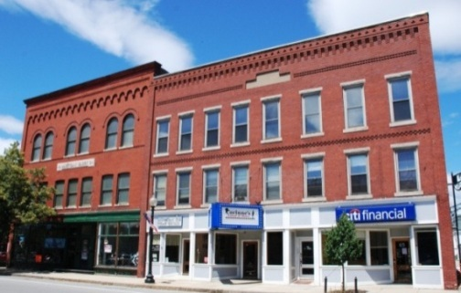
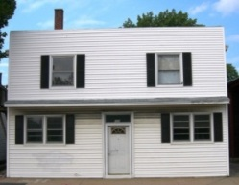
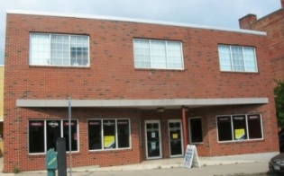

The lack of attention given to the roofs of these two buildings adds to their lack of appeal. (75)

Notice the elaborate brickwork at the cornices on these two Rochester buildings. (69)

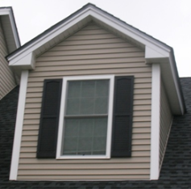
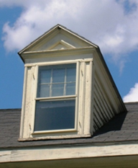
The improper use of siding material around this dormer adds to the sense of it being unduly large. (76)

Dormers shall not include siding but rather be a solid casing from the window to the corner of the dormer wall. (70)

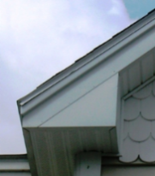
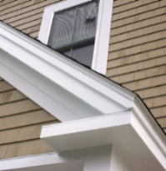
Where an eave return is used, it shall be horizontal and underlay the raking cornice as shown on the Grange. (71)
Porkchop eaves are clunky and inappropriate. (77)

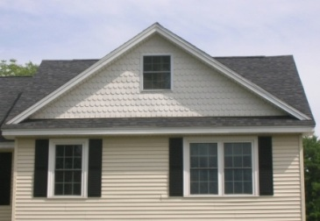
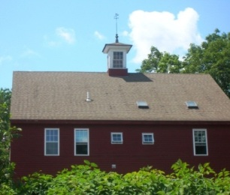
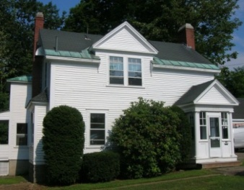

Cross gables shall rise straight from the wall below, with no extension of the roof across the bottom of the triangle. (78)

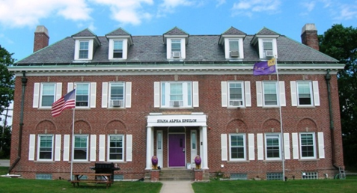
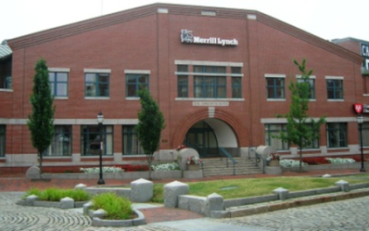
Gable roofs shall not be used on the broad side of buildings, nor shall eccentric roof forms be used. (79)

Cupolas, cross gables, and dormers shall be used to break up the expanse of roof, as shown on these three Durham properties. (71, 72 & 73)

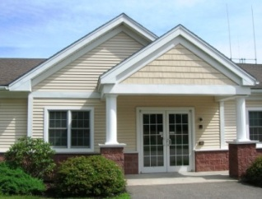
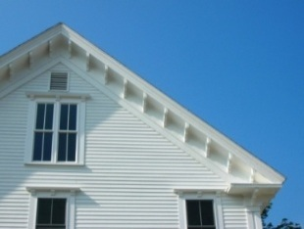
The deeply-projecting eaves, with closely-spaced brackets, on the Grange. (74)
Nesting gables bring unnecessary clutter. (80)

N) Windows

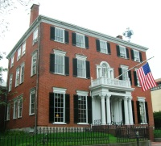
1) Regular pattern. Windows are an integral part of a building and shall be richly incorporated on front facades, and to a lesser extent, on side facades. The windows along the front facade, and to a lesser extent, on the side façade, along with the door and other decorative elements shall align horizontally and vertically in order to establish a coherent, orderly pattern and rhythm. Some departure from a perfect grid is desirable in order to create variety in rhythm as demonstrated in
this Federal-style structure (the window height decreases with each story and the space between the outer windows is narrower than the
Portland, ME (81)
space adjacent to the middle windows).

2) Vertical form. Primary windows and window panes shall be vertical in form, with horizontal-to-vertical proportions generally measuring 3:5. In cases where horizontal “ribbon” windows may be acceptable, such as in the Courthouse District, there shall be a series of contiguous vertical windows with prominent fixed mullions in between, arranged in a horizontal band. (This is also required for storefronts. See that section below.)

3) Window style. The primary window style – with the exception of storefronts and buildings located in the Courthouse District – shall be double hung (whether operable or not). A limited number of fixed windows (i.e. those which have one window sash/frame and do not open) may be used where deemed appropriate to the overall design.

4) Shutters. If shutters are used they must be fully functional or appear to be fully functional. They shall be sized properly for the window opening – i.e. each shutter should be the full height of the window and approximately one half the width of the opening. Fake shutters screwed in flat to the wall shall not be used.

5) Window molding. Windows in wood frame buildings shall have a wide (generally four inches) molding/trim on all sides. Windows in brick buildings shall have a distinct lintel above and sill below, though treatment of the side jams is encouraged also.

6) Window to wall proportions. The proportion of window area to wall area on facades shall be carefully considered. Too little window area creates an unwelcoming presence, while the use of too much glass can be jarring in the context of a traditional downtown.

- Muntins/mullions. Windows - other than storefront windows and small, appropriately-designed fixed windows - shall be divided into multiple panes of glass. This approach helps the window “hold” the surface of the façade, rather than appearing like a hole in the wall (the effect produced by a large single sheet of glass).
Appropriatee
Inappropriatee

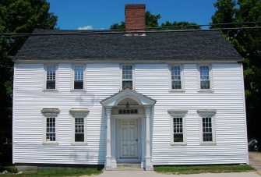
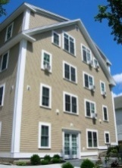
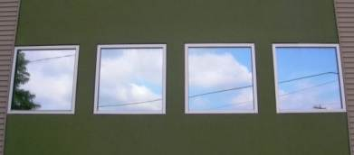
The Grange addition and Ebenezer Smith House (81&82)

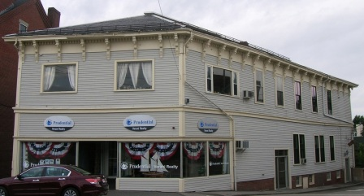
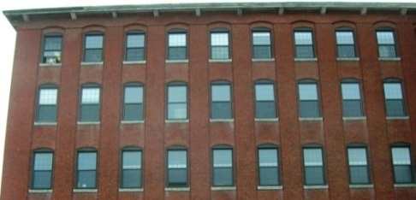

The regular pattern of windows in these three properties provides a pleasing rhythm. Such regularity is surprisingly not monotonous and serves to break up the scale of a large building, even a New England mill. (83)
Square windows, especially when unbroken by muntins, are inherently unsatisfying. This is evident in comparing the original and inappropriate picture windows on this Exeter building. (91&92)

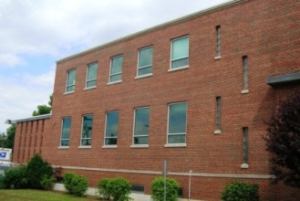
Creative variation in the window pattern, can add interest
as in the Durham
Post Office. (84)
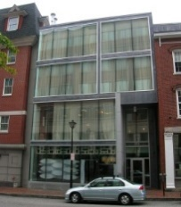


The ratio of glass to wall space on these two Portland, Maine buildings is way too high. (92&93)

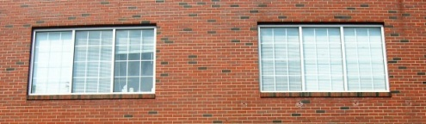
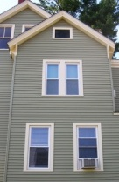
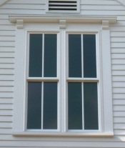
These double windows on Durham buildings are properly separated by strong, wide mullions. (85)

Double and triple windows shall be separated by a strong vertical mullion, so that each window reads as a completely separate window. (94)

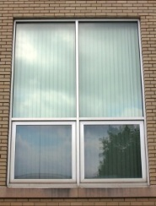
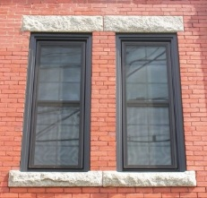
All windows in masonry buildings shall have a distinct lintel over the windows, providing structural, or at least convincing visual, support to the window opening. (86)
There is no lintel, or special treatment, over this window, so it appears that the brick above would simply collapse. (95)

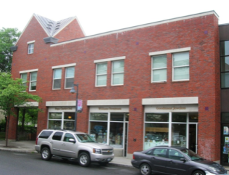
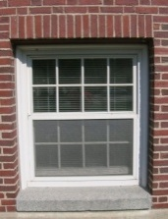
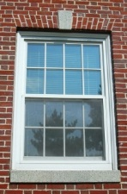
The heavy lintel over the store windows does not even overhang the brick jams on the side and is visually, if not functionally, precarious. (96)

In these two windows in Hetzel Hall, the splayed arch over the window on the left, is functional, whereas the bricks over the window on the right would collapse without some invisible support underneath. Nonetheless, the window on the right is acceptable, though not preferable. (87)

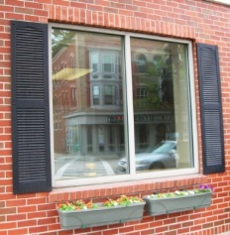
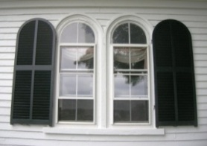
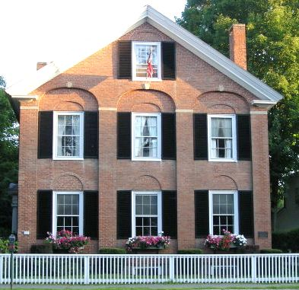
These shutters are screwed flat to the wall. (97)

If shutters are to be used they shall be fully functional. (88)

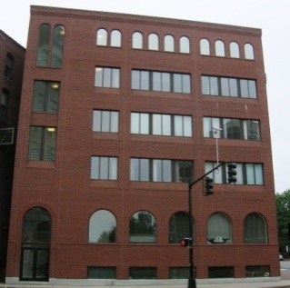
Woodstock, VT
(photograph by Todd Selig) (89)
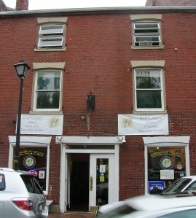

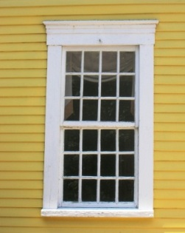
A better approach is to simply design a handsome window and accent it with a rich trim rendered in a contrasting color, as shown here at the Three Chimney’s Inn. (90)

Slider windows (above left on middle floors), awning windows (above right on top floor), casement windows (which swing out and are hinged on the vertical side) and large, fixed windows with no muntins (above left on first and top floors) are not appropriate. (98&99)

O) Entrance. The entrance is an important element in defining a building, and shall be articulated through use of special design features, such as a portico, an entry porch, a canopy, an awning, an arcade, a colonnade, sidelights, transom window, trim surround, or a combination of these. The entrance shall be located on the front façade, preferably in the center, and shall be prominent and readily recognizable. (See section on Storefronts, below.) Here are some good examples:
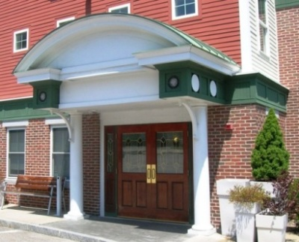
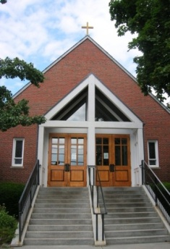
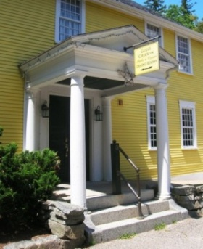
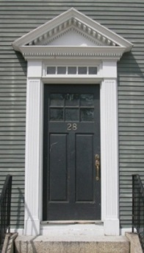
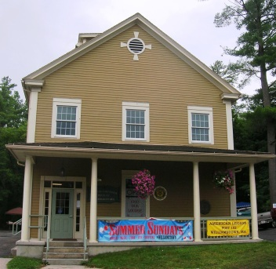

Door surround Portico/Entry Porch Full-width porch on new building St. Thomas More Holiday Inn Express (104)
Ballard House (100) Three Chimney’s Inn (101) in Williamstown, MA (102) Church (103)

P) Building façades

1) Cohesiveness. Overall, there shall be a cohesive, if not regular pattern in the façade.

2) Tripartite structure. Buildings shall generally have three distinct parts: a base, a midsection, and a top. This evokes the classical column (with its base, shaft, and capital), and the human form (with our feet, body, and head).

3) Depth. Some depth shall be created on the front façade. Shallow depth is created through use of trim/details projecting forward from the façade. Greater depth is accomplished through use of porches, projecting or recessed sections, bay windows, or arcades. Inclusion of a usable front porch (generally measuring eight feet in depth, with no screens) on residential buildings is strongly encouraged.

4) Embellishment. Traditionally, the parts of a facade that may be embellished/articulated in some fashion include the following. A number of these elements shall be incorporated for every building.

a) The horizontal base where the building meets the ground (such as a special treatment for the foundation or a water table).

b) The horizontal top where the building meets the sky (such as a projecting cornice with brackets)

c) A horizontal section in between (such as a belt course between stories)

d) The vertical corners on the left and right sides (such as corner boards or quoins)

e) Vertical articulation in the middle (such as pilasters)

f) The area around the door/entry (such as a portico)

g) The areas around the windows (such as window surrounds)

h) Embellishment of the walls such as with decorative brickwork, inset tiles, terra cotta panels.
Appropriatee
Inappropriatee

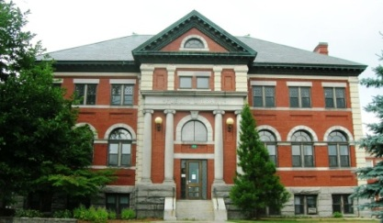
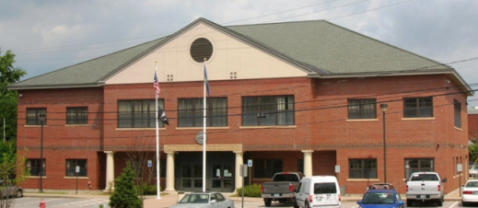

The new courthouse in downtown Dover suffers a fatal flaw in emphasizing horizontality over verticality. (111)
The Dover Public Library has a distinct bottom, middle, and top. The pavilion, dentilled cornice and pediment, arches, engaged columns, corner quoins, and profusion
of colors and materials give it a rare exuberance. (105)

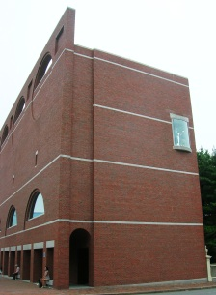
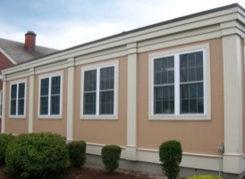
Pilasters are used to articulate the nicely-proportioned façade of this Dover building. (106)
Blank walls stifle pedestrian vitality by creating visually dead space - Portland Art Museum (112)

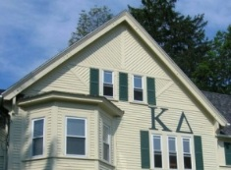
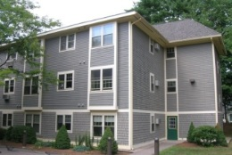

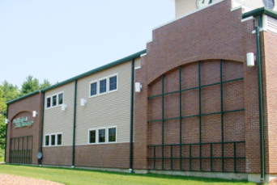

The ornamentation on this big box seems to be quite random.
(photographer unknown) (113)
These two buildings in the Professional Office District use decorative wood trim and cross banding to great effect. (107&108)

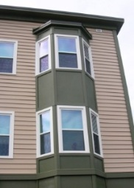
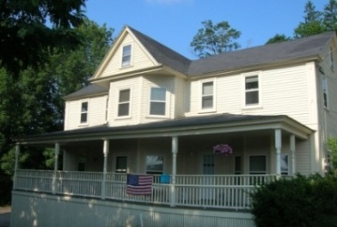
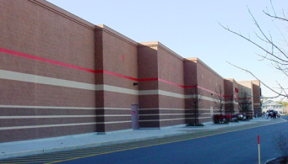
A series of stepped back facades is often used in a misguided attempt to add interest to building. (photographer unknown) (114)

Bay windows Porches enliven the street. (110)
add vibrancy. (109)

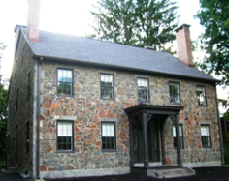
Q) Materials

1) Appropriate materials. Buildings in the Core Commercial area were traditionally constructed of brick or sheathed in wood clapboard. These are the preferred materials for new construction.

Materials shall be high quality, durable, and substantial in appearance. Natural materials, or materials that effectively
This iconic house on Newmarket Road is a rare example built with shale. (115)
mimic natural materials shall be used. Because vinyl siding
conveys an insubstantial plastic feel it is not appropriate in the denser, more public, higher value core commercial areas.

Appropriate materials for the main walls of the structure include:
- deep-red brick,
- painted or stained wood clapboard,
- fiber reinforced cement clapboards (products from companies such as James Hardie and Smartboard), which effectively mimic wood clapboards,
- cellular PVC (from companies such as Azek and Versatek) for trim boards, which effectively mimic wood trim,
- natural stone,
- painted or stained wood shingles/shakes in the Professional Office and Coe’s Corner Districts only. Shingles/shakes convey a rustic feeling and are thus not appropriate in the Central Business, Church Hill, nor Courthouse Districts
- high quality simulated brick

2) Inappropriate materials. Vinyl siding, aluminum siding, plastic, sheet fiberglass, T-111 plywood, flaky shingles, salvage-style brick with multiple colors, prefabricated metal wall panels, undressed concrete, and cinder block shall not be used (except on facades that are not visible, or substantially not visible, from the street).

3) Foundations. Foundations shall be composed of, or clad with, concrete, textured block, brick, or stone.

4) Mixing materials. Except for the trim and details, mixing wall surface materials shall generally be avoided except for mixing materials between storefronts and upper stories, and when employing a architectural style which historically mixed materials.

5) Clapboard width. Clapboards shall show about four inches to the weather. Wider clapboards shall generally not be used, unless the Planning Board determines that wider boards better fit the character of the building.
Appropriatee
Inappropriatee

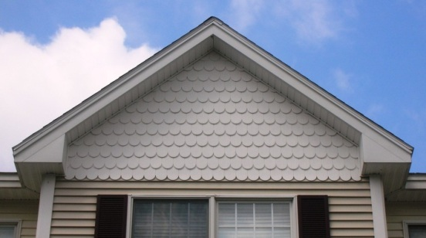
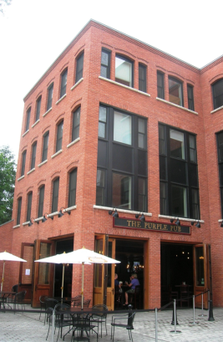

A high-quality red brick is used on this new Williamstown, MA building. (116)

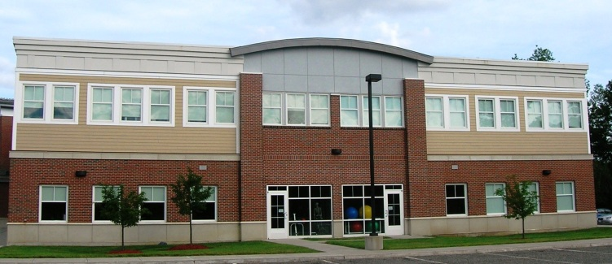

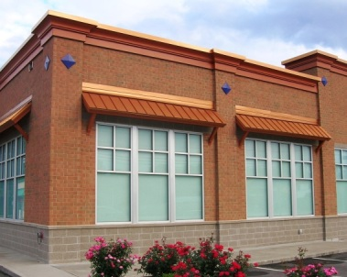
Handsome, durable masonry and metal are used on this Rite Aid in Exeter. (117)

It is now vogue to mix clapboard and shingles, usually in vinyl (top), and other materials (above). Use of more than one primary material on the façade often presents a lack of clarity or focus in design. (120&121)

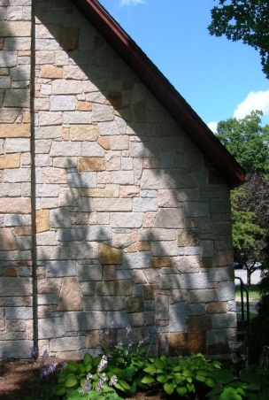
Only natural stone shall be used, as in St. George’s Church. Stone shall be laid in roughly horizontal patterns or it will have an artificial wallpaper quality. (118)
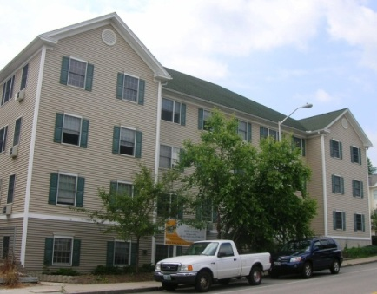
There is an overriding plastic feel about this building clad in vinyl. (122)

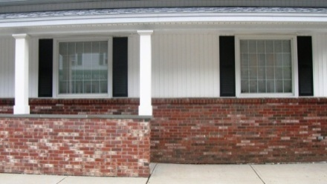
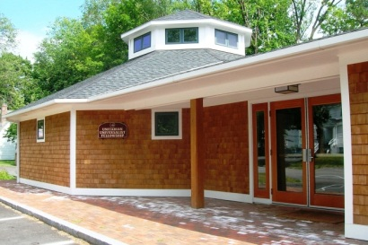
Multicolor, salvage-style brick is not appropriate. (123)

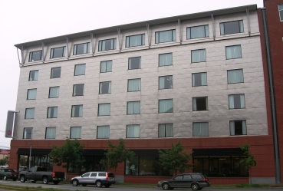
Cellular PVC is used for trim on the Unitarian Church function hall. (119)
Insubstantial or eccentric materials, like this thin metal siding, shall not be used. (124)

R) Color
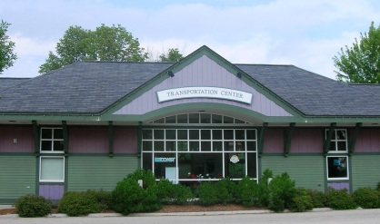
1) Colors shall generally blend with nature, i.e. be earth tone, neutral, or pastel in character. Primary, high intensity, bold, metallic, or fluorescent colors shall not be used. Bright colors are generally inappropriate, but, if used at all, shall be limited to accent areas. It is recognized that some discernment is required to distinguish between bright colors which are garish
Deep, rich colors on the Dover
train station (125)
and those which are playful or decorative.

2) Colors with no tradition in this region, such as Mediterranean
types of colors used in Florida, are not appropriate.

3) Subtle colors are appropriate on larger, plain buildings whereas smaller buildings with more detailing can more effectively incorporate stronger colors.

4) Multiple colors. Generally, it is preferable to use two or three colors on one building. If more than one color is used, then one color shall dominate and the other(s) be used for trim or accent. Multiple colors shall be harmonious with one another. Example: An effective color scheme on wood frame residential property is to use a medium dark color for the body, a light color in the same family of colors for trim, and a bolder color, such as red, for the front door.

5) Brick. Brick shall be a deep red or reddish brown.

6) These types of colors are not appropriate. The three colors on the left are unduly bold and the color on the right is not appropriate for this region.
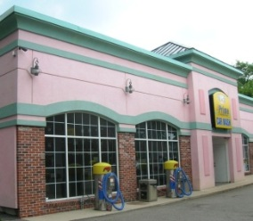
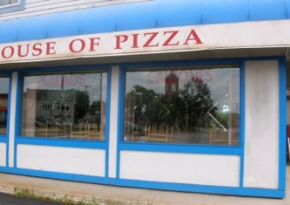
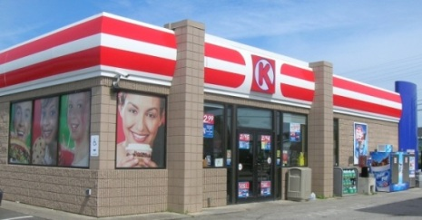
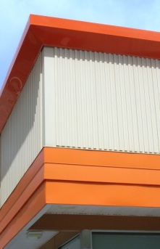

(126 – 129)
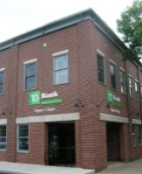

S) Lighting of buildings. Only low key, low intensity wall pack, gooseneck (as shown on the building to the right), or spot type lighting of building exteriors is appropriate. Use of lighting to highlight the building in a prominent manner, such as with brightly illuminated roof fins or neon tube lighting is not appropriate. (See also Article XXIII. Signs and Utility Structures in the
Dover 130)
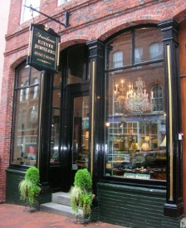
Zoning Ordinance.)

T) Storefronts

1) Compatibility with rest of building. The design of the storefront shall be compatible with the character of the rest of the building, to the extent possible, recognizing that the storefront is a separate design element.
Portland, Maine (131)
2) Three sections. Storefronts shall have three distinct parts: a base or “bulkhead”, tall and open glass display windows, and a wide lintel, band or crown over the windows to visually separate the storefromt from the upper floors.

3) Windows. Use of large plate glass type windows is appropriate provided each window is vertical in orientation. Large panes shall be separated from one another along wide glass openings with substantial fixed wood or metal mullions. Fake grilles and grids shall not be used. Glass shall be untinted, except for the use of stained glass, which is encouraged.

4) Awnings. Use of awnings is encouraged. Awnings shall be made of canvas and be a minimum of three feet deep. In the Central Business District awnings shall be five feet deep (A greater depth is called for in that district since awnings there are likely to shield pedestrians). Awnings shall be positioned above the storefront window but below the lintel/sign band.
Appropriatee
Inappropriatee

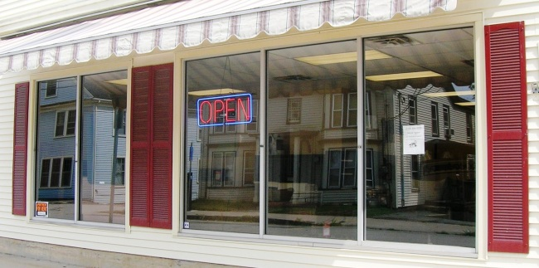
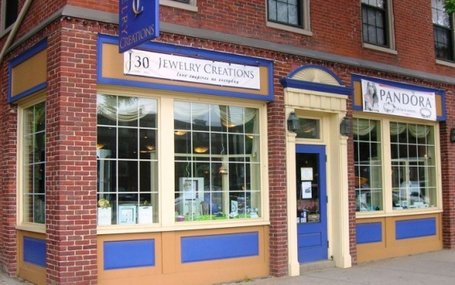

The base/bulkhead is too low and the expanse of large glass panes is too extensive. (136)
This storefront in Dover has three distinct and attractive vertical sections. (132)

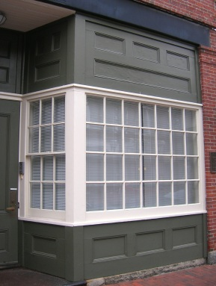
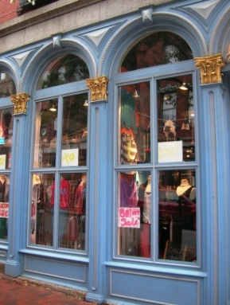
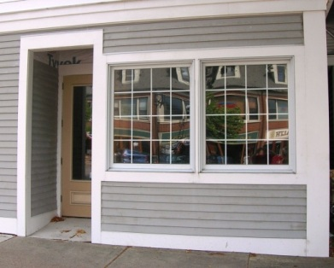
The windows are squat/square and the fake grille impedes visibility. Clapboards are generally too rustic in character to use on a storefront. (137)

If a grille is to be used it shall be composed of real through-muntins and separate panes of glass. (133)

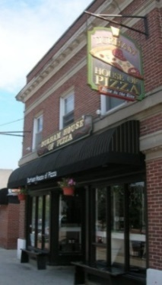
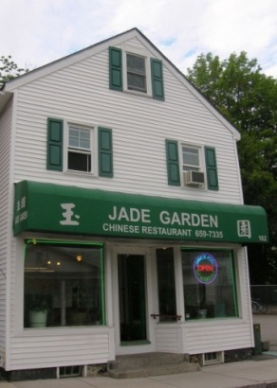

The canvas awning at the Durham House of Pizza is inviting to patrons. (134)
Vinyl awnings pulled tight over the frame convey a plastic feeling. (138)

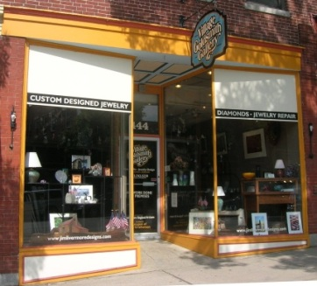
The storefront in Dover is open and clear and the recessed entry draws in customers (although it would be preferable to break up the size of the glass with a few mullions. (135)

U) Specific Building Types And Building Elements

1) Utility Elements. All utility elements, such as dumpsters, utility meters, and ground mounted air conditioning units, shall be screened and located such that they are not visible from a public way. Rooftop utilities shall be screened with raised parapets or other devices.

2) Garages. Garages (private and public) and garage doors shall be unobtrusive. Doors shall be placed on side facades not facing the street, doors shall be fully screened from view by landscaping or other structures, and/or garages shall be set back substantially from the street.

Appropriatee
Inappropriatee

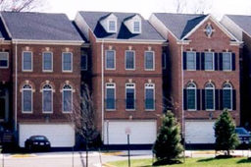
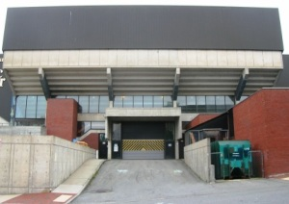
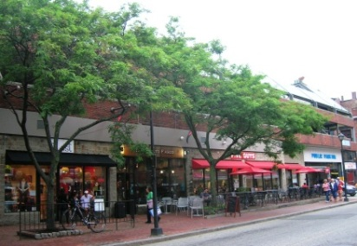
This parking garage in Portland, ME is screened by “liner businesses” and street trees. (139)

Garage doors shall not face the street. (140&141)

3) Gasoline Stations. Canopies shall incorporate features to avoid the sense of a gigantic, hovering mass. A pitched or hipped roof shall be used. The fascia of the canopy shall be short in height and the columns shall be articulated in some manner. All vertical surfaces shall be nonreflective and colors shall be muted.
Appropriatee
Inappropriatee

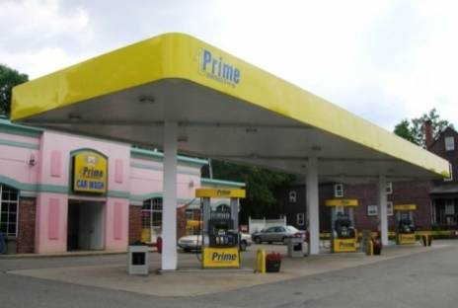
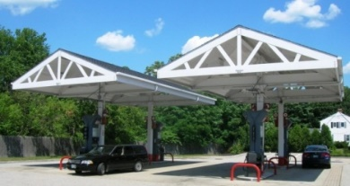
(145)
Durham (142)

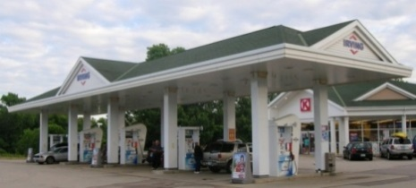
Northwood (143)

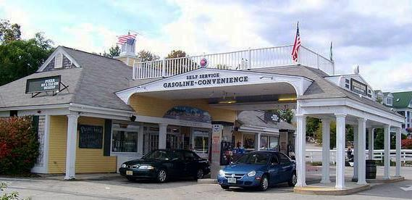

Meredith (photo by Roger Hawk) (144)

DEFINITIONS
Note. Definitions are provided for many words that are not included in the text of these regulations for the purpose of enhancing discussions about architectural design among applicants, designers, staff, and the Planning Board.

Arcade: A series of arches supported by columns, sometimes forming a covered walkway.

Arch: A curved form spanning an opening, which may take various rounded forms including a pointed shape.

Axis: A line established by two points in space and about which forms and spaces can be arranged.

Axonometric drawing: A drawing showing a building in three dimensions.

Awning window: A single sash window that opens outward from the top.

Baluster: The upright part of a railing, often vase-shaped, which supports the top rail.

Balustrade: A series of balusters with a rail.

Bay: Vertical division of a building façade, delineated by some regular recurring feature such as windows or columns.

Bay window: A window element projecting outward from a building facade.

Bond: The pattern formed by bricks in a wall using one or more sides or positions (oblong or upright) of the brick.

Box: Generally refers either to "big box" or "small box"; a very simple building with minimal adornment or complexity in its form, usually a rectangular footprint with a flat roof, and few if any windows.
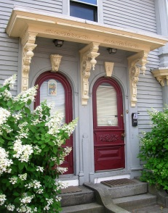
Bracket: A structural (or visually structural) element projecting from a wall which supports a roof overhang or other overhang, generally in the form of an "L" or a triangle (see photo).

Build to line: The opposite of the conventional minimum front setback requirements, i.e. a maximum setback to which buildings must be placed.

Bulkhead: The base section of a storefront, located underneath the windows.
Brackets (147)

Cantilever: A horizontal element projecting from a wall without external support.

Capital: The top portion of a column or pilaster crowning the shaft.

Casement: A single sash window that opens outward from the side.

Clapboard: Narrow, horizontal, overlapping wooded boards, typically in wood, that form the outer skin of an exterior building wall.

Colonial: The style of architecture in the American colonies in the 17th and 18th centuries (prior to the American Revolution), derived mainly from English traditions.

Colonnade: A row of columns supporting a roof, arches, or an entablature.

Column: A freestanding upright support element usually round in cross section. In classical architecture consists of a base, shaft, and capital.

Column, engaged: A column, which is attached to a wall (round in cross section).

Corner board: A decorative vertical board placed at the corner of a wood frame building.

Cornice: Horizontal projecting top portion of an entablature or any linear element placed along the top of a building’s facade or atop a section of the facade to divide the facade into sections.
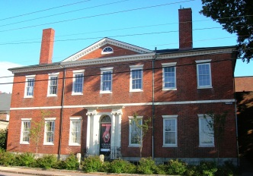
Course: A horizontal decorative band extending across a façade (as shown here).

Course, belt: A wide course.

Course, string: A narrow course.
Course - Old Portsmouth Library (147)

Cupola: Small enclosed or partially enclosed structure crowning a roof or tower.

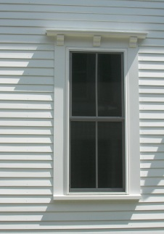
Dentils: Small, rectangular blocks arranged in a tooth-like series under an overhang.

Dormer: Window rising vertically atop a roof.

Double hung window: A window with two vertical sliding sashes, each closing half of the window opening (as shown here).

Eave: The horizontal or downward projecting overhang at the lower edge of a roof.

Eave, porkchop: An eave return which is boxed in, in the shape of a triangle.
Double-hung window (148)

Eave, return: A short section of the eave which wraps around onto the gable
side of the building.

Elevation: A head-on drawing of a building facade, without any allowance for
perspective; one exterior face or side of a building (comparable to a facade).

Ell: A wing of a building that lies perpendicular to the length of the main portion.

Entablature: The horizontal top part of an order of classical architecture. It is supported by columns and consists of three levels - architrave, frieze, and cornice.

Exterior architectural appearance: The architectural character, general composition, and general arrangement of the exterior of the building, including the kind, color, texture of the building material and type and character of all windows, doors, light fixtures, and appurtenant elements integral to, or affixed to, the building.

Facade: The front or principal exterior face of a building; may refer to other prominent exterior faces as well.

Fascia: A flat vertical board that forms the face along the edge of a flat roof or along the horizontal (or eave) side of a pitched roof. Also, the front vertical face of an awning.

Fenestration: Arrangement of windows on a façade including number, size, proportion, spacing, and composition.

Finial: Small vertical ornament at the top of a roof.

Flaky shingles: Irregular wood shingles, frequently untreated or stained rather than painted, with various curves and splits that give an appearance of peeling off an exterior surface (such as one might see at a "Fish Shack Restaurant").
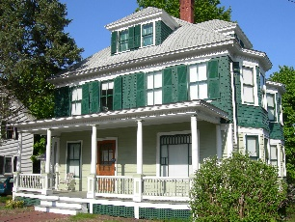
Foursquare: A style of house built in the first few decades of the 20th century. The Foursquare is typically square or close to square in plan and somewhat cubic in volume, with a hipped roof with a dormer in the center of the front, and sometimes, on the side roof slopes.

Frieze: A decorative, horizontal band set just below the cornice.
Four Square (149)

Frontispiece: An ornamental portal around the entrance

Gable: A simple pitched roof form with two opposite sloping sides; the triangular part of a wall formed by a gable roof.

Gable, cross: A gable form attached to and placed perpendicular to a larger gable roof

Gambrel: A roof form with a double sloped profile - a steep lower plane and a less steep upper plane (A gambrel differs from a mansard in that a gambrel is two sided while a mansard is four sided, and the pitch of the two planes on a mansard is closer to 90 degrees.

Golden section: Mathematicians have studied the Parthenon in Athens, Greece, and found a complex series of golden sections in the façade. The golden section is a proportion that human beings seem to find innately satisfying. It is the ratio of 1 to 1.618… (an irrational mathematical constant, like pi), which is roughly equivalent to 5:8 or 3:5. The golden section is the ratio of x:y as derived from the width and length of a rectangle – with a width of x and a length of y – where x/y = y/x+y. There are numerous other standards of proportion, such as those developed by Leonardo Da Vinci, based on the human body.

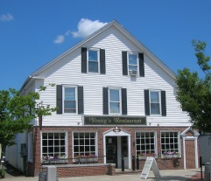
Half story: The top floor of a building covered by a gable or hip roof (see photo), which therefore has less usable square footage than the full stories below.

Hierarchy: The articulation of the importance of a form by its size, shape, or
placement relative to the other related forms.

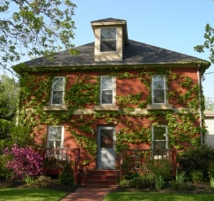
Hipped (or hip) roof: A roof which slopes upward from all four sides of a building and end in a ridge or end a point (see photo).
Young’s Restaurant –
a 2-1/2 story building (150)

Lintel: A horizontal structural member that bridges an opening.

Lozenge: A diamond shaped ornament applied to a wall.
Hipped roof (151)
Lunette: A semicircular or half-moon window or other element on a facade.

Mansard: A steep, story-high roof with two planes on all four sides, the first plane almost vertical and the second plane above, nearly flat; named for Francois Mansart, 17th century French architect.

Masonry: Heavy materials including stone, brick, concrete, concrete block, and stucco.

Massing (or mass): The shapes, sizes, and arrangement of the three dimensional forms that compose a building.

Medallion: An ornamental plaque applied to a wall.

Molding: Decorative detailing applied around a window or door or to the surface of a wall.

Mullion: Vertical or horizontal element separating windows or doors set in a pair or series. A mullion differs from a muntins in that the former is permanent, more substantial, and connected to the walls (See “Muntin”).

Muntin: Dividers between panes of glass within an individual window (See “Mullion”).

Neoclassical: A formal style of design evoking ancient Greek or Roman architectural forms.

Oriel window: A bay window projecting from a building's upper floor.

Panel: A decorative rectangle raised or recessed on a wall.

Parapet: A low wall or railing extending above and in the front of a roof.

Pavilion: A full height projecting section in the middle of the front façade (in terms of Classical architecture, as opposed to a freestanding structure).

Pediment: Triangular front end of a roof, comparable to a gable except that a pediment always has an articulated horizontal side.

Pergola: An unenclosed structure with an open wood framed roof, often latticed.

Piazza: An open space oriented to pedestrians, usually rectangular in shape, defined by a building or buildings on two or more sides.

Pier: A freestanding upright support element, usually rectangular in cross section, and wider and more squat than a column.

Pilaster: A column or pier affixed to a wall surface (rectangular in cross section).

Plan: The layout of a building drawn in the horizontal plane.

Porthole window: A circular window (also called a bull's eye window).

Portico: A covered space usually supported by columns surrounding an entrance and forming the centerpiece of the facade.

Proportion: The relation of one dimension to another, such as the height of a window compared to its width. Scale is the proportion of the size of a building or building element to that of a different entity, usually a typical human being.
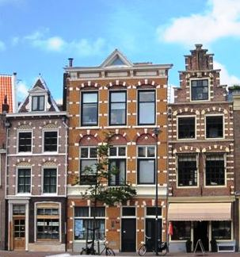
Quoins: Corner stones or other materials made to resemble stones, set at the corners of a building, window, or door.

Rational Architectural Styles: Formal styles derived from ancient Greek forms including Georgian, Greek Revival, Federal, Rennaisance-Revival, and Neoclassical. These styles generally embody simplicity, symmetry, balance, and regularity more than the free-form romantic or picturesque styles which are generally asymmetrical with irregular and complex masses and details.
Quoins (152)
Rhythm: The use of recurring patterns to organize a series of like forms or spaces.

Ridge: The linear intersection of two sloping roof planes.

Sash: A single window within its frame that opens in some manner.

Scale: The perception of the size of a building or building element relative to the human body or other buildings or objects in the vicinity. “Human scale” means the size of a building or building element is oriented toward the size of a typical human being or such that a human being, whether stationary or in motion, adjacent to or passing by, will perceive the size to be comfortable.

Sense of enclosure: An outdoor area where the height and continuity of adjacent or surrounding buildings or other structures loosely establishes the feeling of a three dimensional space.

Shed roof: A roof composed simply of one sloping plane.

Sill: The horizontal bottom element of a window or door frame.

Skin: The outer clothing or membrane of a building - clapboard, brick, steel, etc.

Soffit: The underside of any building part, such as under an eave, arch, or lintel.

Story (also called “floor”): The complete horizontal division of a building, situated at or above ground level, comprising the usable space or room(s) on one level. Each such division is considered one full story, except for the top level when it is under a sloped roof, which is considered a half story. (See “Half story.”)

Street wall: A street wall is the part of a building that faces the street, but it generally refers to how and where several buildings line up to define a proper walking environment.

Surround: An ornamental device used to enframe a window or door.

Symmetry: The balanced distribution of equivalent forms and spaces about a common line (axis) or point.

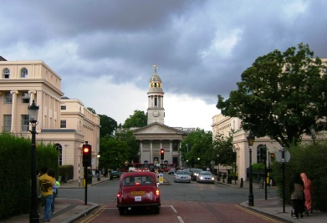
Termination of a vista: Strategic placement of a building, tower, or
iconic element at the end of a street, in the center of view, perpendicular to the buildings on both sides, intended to provide a focal point in front of the viewer (See photo to the right).

Texture: The quality of finish on a wall or roof surface.

Tower: A distinctly vertical structure, which may be freestanding or attached to another structure.
Terminating a vista (153)

Traditional: Sensitive to, evocative of, or harmonious with any
particular style of architecture established prior to1950 except for Modernism.

Turret: A small, slender tower usually located at the corner of a building.

Victorian: Term used to cover all of the various styles of architecture during the reign of Queen Victoria - 1837 to 1901, including Second Empire, Italianate, Gothic Revival, Colonial Revival, Queen Anne, Renaissance Revival, and others. (Georgian, Federal, and Greek Revival styles predate the Victorian era.)

Water table: A masonry feature that consists of a projecting course that deflects water running down the face of a building away from lower courses or the foundation.

