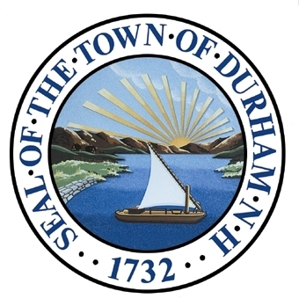

Vision and Community Character
Developing an overall vision statement and community character chapter for the Town of Durham provides the inspiration needed to make necessary strategic planning decisions and achieve future success. This chapter paints a portrait of Durham’s future, looking to the years 2025 and beyond, by illustrating the variety of long-term desires and interests of the community.

Adopted by the Durham Planning Board on November 18th, 2015.
Master Plan Vision

In 2025 and beyond, Durham is a balanced community that has successfully maintained traditional neighborhoods, natural resources, rural character, and time-honored heritage, while fostering a vibrant downtown, achieving energy sustainability, and managing necessary change. Durham has effectively balanced economic growth, which has been essential in supporting our schools, resources, and town services, and stabilized property taxes. Durham has encouraged mixed residential and commercial development in and near the downtown including retail establishments, offices, services, eateries, and other businesses that serve local needs and interests while attracting visitors from neighboring vicinities. In designated areas beyond downtown, balanced development was accomplished by prudently integrating our community’s range of values. Through forward-thinking engagement on the part of our citizens and town government, in tandem with continued pursuit of a productive partnership with UNH, our vision for Durham was realized.
Outreach and Visioning Process

In order to gain a better understanding of how residents visualize Durham’s future, the Master Plan Steering Committee, with help from UNH Cooperative Extension, held a visioning forum in January of 2011. The forum gave residents the opportunity to suggest ideas for addressing various challenges facing the community, in the areas of housing, natural and cultural resources, recreation, land use, zoning, business and industry, and community facilities and infrastructure. Information obtained from the forum was also helpful in developing questions for the master plan survey that was sent out to residents in April of 2011. The survey results helped the town identify the following: the qualities and attributes of Durham that are of value and in need of preservation; the qualities and attributes that are perceived to be at risk or in need of change; and the priorities and attributes deemed necessary for Durham’s future over the next 10 to 20 years.
Master Plan Advisory Committee (MPAC)
The MPAC is made up of 14 members, some of whom represent Town boards and committees, and is charged with assisting the Durham Planning Board with the Master Plan update process.
The Master Plan Advisory Committee used the data from the forum and the survey to develop the vision statement for the Master Plan. Later, the summarized data was provided to the Strafford Regional Planning Commission (SRPC) as the basis of this Vision and Community Character chapter. In an effort to strengthen the authenticity of the vision statement, as well as to identify inconsistencies, the Master Plan Advisory Committee and SRPC examined principal statements in the vision statement and cross referenced them directly with results from both the visioning forum and survey. Descriptions and reoccurring themes from the executive summary of the 2000 Master Plan were also compared to the 2011 outreach results to determine if there were community values in the 2000 plan still relevant today, and therefore should be integrated into the Vision and Community Character chapter. As part of this analysis, the Master Plan Advisory Committee and SRPC did a community cornerstones brainstorming exercise to develop a list of existing places, historical events, and points of interest that symbolized Durham. This list was sent out in the Friday Updates to get feedback from the community.
What You Said: Source: 2011 Visioning Forum
“I want a vibrant, walkable downtown with a multitude of recreational activities for citizens of all ages, preferences, and races”.

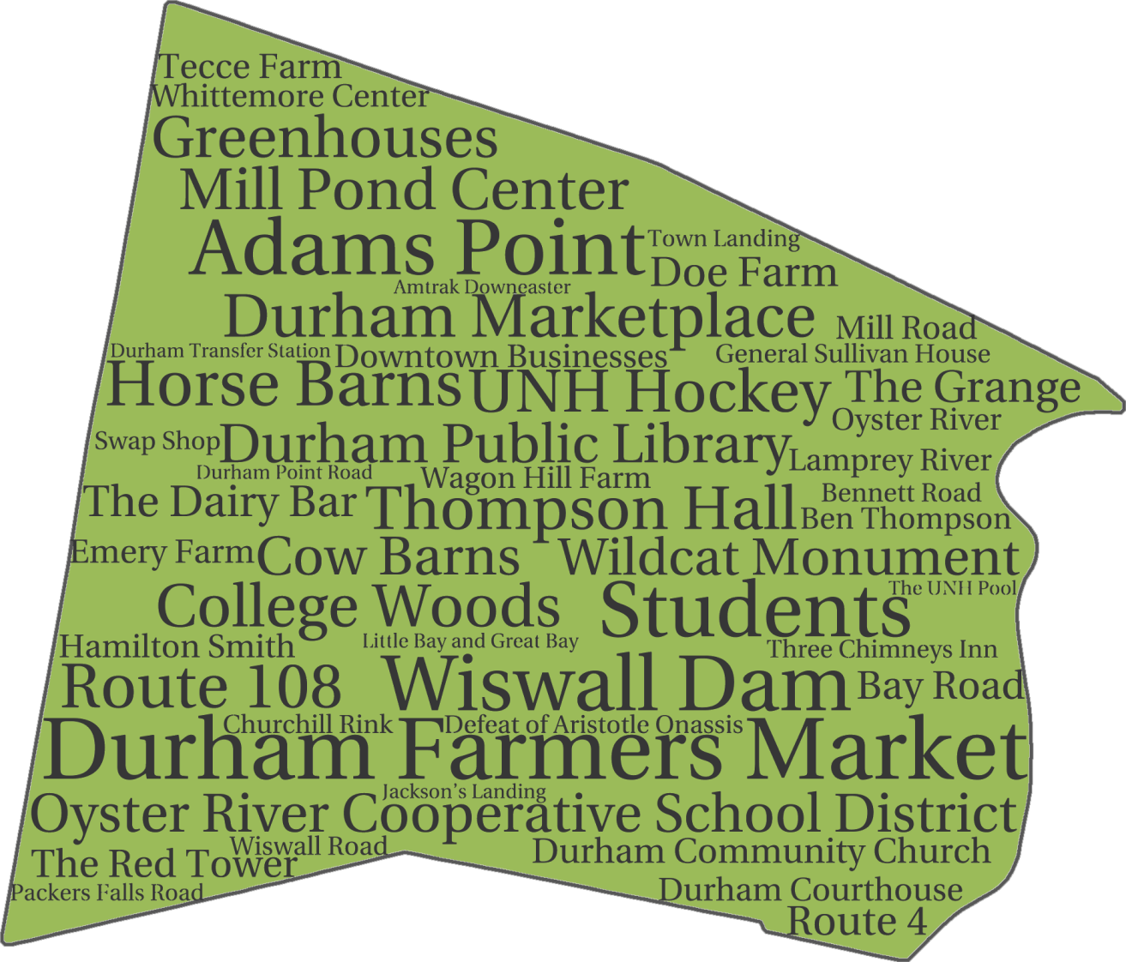
The analyses determined that the Master Plan Vision statement was very much in line with what the majority of residents were looking for, and also indicated that many of the community values referenced in the 2000 Master Plan are still viewed by residents as essential, so should not be lost. Another result stemming from this process was it allowed the Master Plan Advisory Committee to better gauge the perceptions and desires of Durham residents about the Town’s future.
Note: The Community Cornerstones identified in Figure 1 were not ranked in any way. They were placed and sized at random using a web service that allows the creation of word clouds (tagul.com).
Source: SRPC and the Durham Master Plan Advisory Committee
Figure 1: Community Cornerstones – April 2014
Strafford Regional Planning Commission recommended that shared community values expressed by residents during the visioning forum and survey be used as a guide to write this chapter. The Master Plan Advisory Committee provided important guidance to SRPC and recommended that the Vision and Community Character Chapter include the following objectives: capture Durham’s unique small town characteristics; reframe certain messages to better describe what Durham is and what Durham wants to be; initiate a renewed focus on the qualities that make Durham such an attractive place to live; and embrace the cultural, educational, and business opportunities associated with the University.
Introduction
Quick Facts: Over 460 individuals responded to the master plan survey with 90 citizens attending the visioning forum.
Definition: Community Cornerstones
A community cornerstone is an entity that is generally considered by the members of a community to be an important or defining element. It may be a building, structure, place, neighborhood, park, natural feature, institution, historical event, program, or even a person (alive or deceased). This can be used as a tool to track shifts in community perceptions over time.

Durham has a rich cultural history as a small New England town located on Great Bay, with a past that includes shipbuilding and early industrial mill enterprises as well as the establishment of the University of New Hampshire. The town also has deep agricultural roots and a tradition of natural resource protection.
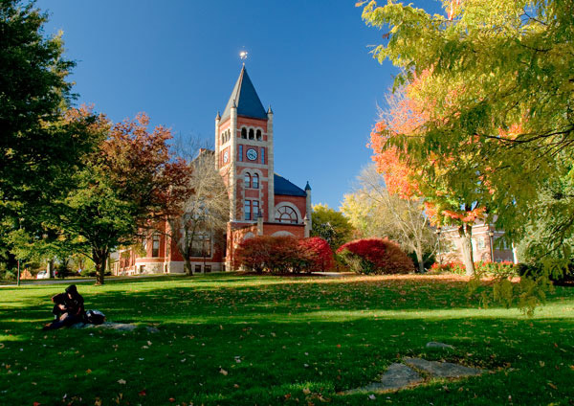
Today, Durham still has many small town characteristics, and residents benefit from a town that has strong community bonds, excellent schools, an accessible downtown, and a wide variety of cultural, environmental, and recreational opportunities. Durham citizens recognize that while the community has small town characteristics, it is also home to the region’s largest employer – the University of New Hampshire (UNH). The University is the entity that makes Durham unique and sets it apart from other communities in the Seacoast and other small NH towns. The University offers benefits and resources that other communities strive for and contributes significantly to Durham’s economy and character. Yet despite all of the benefits, Durham understands that a large institution of this type poses unique challenges to the town.
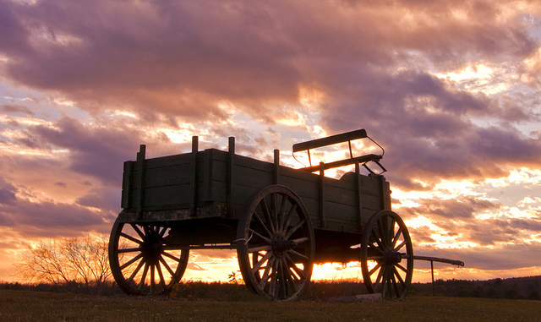
Durham has been going through a significant transformation over the past several years. The town has sought development in order to breathe new life into the downtown, for residents as well as UNH students, and has also looked to development to increase the tax base in order to stabilize property taxes. Both of these development goals are in part related to having to share the town with the University of New Hampshire.
Photo 1: Thompson Hall (Source: Mark Space)
As Durham prepares to move from the past to the future, the community must take time to view itself through the lens in which it currently appears. This chapter builds upon the core community values and principles set forth in the original 1989 Durham Master Plan and in subsequent updates in 1995 and 2000. Essential for continued progress is the need for the community to take a balanced approach and work together to protect important natural resources, strengthen existing recreational opportunities, preserve cultural and agricultural heritage, and achieve full economic potential by promoting economic growth in the downtown and other appropriate locations, balance fiscal responsibility, and integrate resources coming from the University.
Photo 2: Wagon Hill (Source: Jiva Bludeau)

Durham’s Community Character: Past, Present, and a Vision for the Future

Past
Durham is fortunate to be located next to the Great Bay Estuary, a distinctive ecological and cultural resource in the Seacoast area that has been celebrated by Durham residents over time for its scenic beauty, and has been a key element in shaping the town’s history. Great Bay was and continues to be extremely important to the regional economy, and is an invaluable resource for the town. Durham’s position along the Oyster River, which drains into Great Bay, allowed the town to establish a noteworthy shipbuilding industry, which in turn enhanced the shipbuilding trade in the Seacoast area. While this trade is long gone, the gundalows that transported lumber from Durham sawmills down the Oyster River to support a rapidly expanding coastal population are still embodied on the town seal.
During its settlement period, Durham had a thriving economy and was an early transportation hub. It was the first community located on the 1796 New Hampshire Turnpike from Portsmouth to Concord. However, due to destruction of the turnpike bridge over Little Bay in 1855 and the establishment of the railroad network throughout the U.S., Durham became less of a gateway trade center, and the town’s industry shifted to small-scale local milling and agricultural activities.
Present
What You Said: Source: 2011 Visioning Forum
“Small-scale agriculture should not be burdened by zoning.”

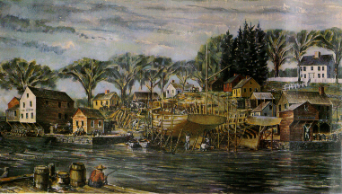
Current interest and activity in local agriculture and locally grown food is stronger than ever, even though less than 1% of Durham residents categorize farming as their primary employment. The importance of agriculture to the town was strongly endorsed by residents in the 2011 Master Plan Survey. Reflecting that support, the Town Council established an Agriculture Commission that same year and devoted a new chapter in the present Master Plan to agriculture. The UNH College of Life Sciences and Agriculture is recognized regionally and nationally for its research and training programs in traditional, organic, and sustainable agriculture and maintains several farms on campus. In recent years, UNH has added undergraduate and graduate degree programs in sustainable agriculture. Other agricultural resources include the UNH Horticultural Farm, the Fairchild Dairy Teaching and Research Center, the Agricultural Experiment Station, the Macfarlane Research Greenhouses, and the Smith Equine Center.
Quick Fact: NH College of Agriculture and the Mechanic Arts was founded in 1866 as a land grant college in Hanover and moved to Durham in 1893, where it became the University of NH in 1923.
Photo 3: Oyster River (Source: John Hatch circa 1822)

Table 1: Largest Employers of the Region
Employer | Number of Employees
University of New Hampshire | 4,077
Liberty Mutual | 3,500
City of Rochester School System | 1,155
City of Dover Municipal Services | 1,139
Wentworth-Douglass Hospital | 1,100
Source: NH Employment Security Economic and Labor Market Information Bureau Community Profiles - 2013
Today, Durham is defined largely by the fact that it is the home of the University of New Hampshire, which is the largest employer in the region, with over 4,000 employees. A significant portion of the town is developed around the University and in many places, including Main Street and the downtown, it abuts the campus. The University provides opportunities for Durham residents to mingle with people from different cultures, take classes, and attend athletic events, and to explore entrepreneurial business opportunities. Durham also benefits from alternative transportation options the University has provided in the town over the last several years.
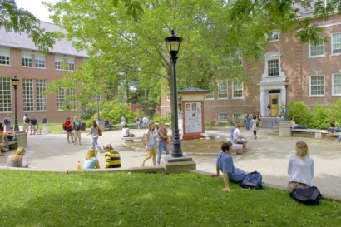
Despite the many benefits the University offers Durham, the presence of this large entity in the middle of the town presents challenges. Perennial issues have been competition between town and campus commercial businesses, the non-taxation of UNH property (negotiated payments in lieu of taxes), and disruptive student behavior downtown and in nearby neighborhoods. Over the past few years, there have also been some dramatic changes in downtown Durham as well as beyond the downtown because of a significant amount of private student housing developments. The number of new buildings and the size of some of them have impacted the perception of Durham as a small town community, and residents have expressed concern about the large number of students living in these buildings.
Photo 4: UNH Campus (Source: Navitas at UNH)
The tax burden has remained a concern for Durham residents. Taxes are high because of the cost of financing the school district, and the cost of police/fire, and other municipal services, as well as the limitations for economic growth. These constraints on growth are stressed by the limited land available for development due to Durham’s natural landscape, existing developed land, local conservation efforts, University owned land, as well as land in current use and restrictive land use regulations that make it challenging for developers. There remains a need to stabilize this problem using a balanced approach of smart economic development, reasonable fiscal policies, and collaboration with UNH on public/private ventures to allow a broader diversity of residents to afford to live in Durham.
Vision for the Future
While most residents recognize that Durham is no longer the small town it once was, they would like it to retain the aspects of small town life, including an engaged community, a friendly, vibrant downtown for people of all ages, and a natural environment that isn’t overshadowed by the built environment.
By using resident input gathered during the public engagement process, this chapter attempts to paint a picture of Durham’s renewed vision of itself, where residents can find optimism as well as compromise. Here, Durham’s core values and principles are retained while also creating a more sustainable and prosperous future.
Durham’s Vision Core Values and Principles

Quality of Life

The recurring themes and values expressed by residents will serve as the backbone for describing the quality of life in Durham. Six quality of life factors are listed here; they are based on what residents said during the visioning forum and the community survey.
- Natural Beauty – Durham is home to beautiful forests, open spaces, and waterfront shorelines, wetlands, and other natural communities thanks in large part to a long tradition of preserving its natural resources. Residents noted scenic views along the Oyster and Lamprey Rivers, College Woods, Mill Pond, Adams Point, Wagon Hill and more.

- Recreation – Many residents agree that a broad range of outdoor and indoor recreational activities can be found throughout the town, and they play an essential role in making Durham a vibrant community. The town has made a conscious effort to increase residents’ sense of belonging by encouraging them to participate in a variety of healthy, fun activities. The Durham Parks and Recreation Department recommends outdoor activities including: bird watching, boating, cross country skiing and snowshoeing, fishing, horseback riding, ice skating, pond hockey, and hiking. Durham has an extensive network of public trails, which showcase the community’s commitment to natural resource protection and diverse wildlife habitats. There are also a number of events including the Memorial Day Parade and the lighting of the town tree that help to strengthen community bonds.
Quick Fact: ORCSD was one of the first cooperative school districts established in New Hampshire. (1954)

What You Said:
“Would like to see groomed cross-country ski trails.”
Source: 2011 Visioning Forum

- Strong School System – Durham has a solid reputation as a community that provides quality educational opportunities for students. The Oyster River Cooperative School District (ORCSD) serves the communities of Durham, Lee, and Madbury and offers a high standard for education and infuses young learners with the importance of a good education. The ORCSD has a history of embracing progressive educational philosophy. This was affirmed by their strategic planning process in 2013, during which a vision and guiding principles were adopted. According to the vision ORCSD: “…is a place where students, parents, staff and community members work together to foster a life-long passion for learning and engage all students in developing the skills and knowledge they need to further their education; participate as citizens, succeed in the work-place; live healthy lives; and thrive in the 21st century.” The planning process also identified broad goals: caring about every student; implementing individualized learning; fostering inclusion and heterogeneous groupings; offering small student-to-teacher ratios; developing a dynamic and stimulating faculty; including visionary school leaders; and encouraging genuine parent involvement.
What You Said:
“Exceptional school – listening to community voices.”
Source: 2011 Visioning Forum

- Cultural, Agricultural, and Historic Resources – The construction of the new Town of Durham Public Library is a good example of how strongly the community advocates for the preservation of its cultural resources. The library is far more than a building that houses books and newspapers, as it has become a community gathering place where residents engage in a variety of activities: book discussions, poetry readings, arts and crafts, family movies, CPR courses, cooking demonstrations, and more. Durham residents have continually supported the protection of farmland and forest land, indicating the high value placed on the land and their heritage. Durham residents have access to the community gardens at Wagon Hill, a 139-acre property acquired by Durham in 1989. Citizens also have access to local food, farm stands, and a Farmers’ Market. Durham is rich with history, exemplified by the many historic sites, structures, events, and people. Currently, the New Hampshire Division of Historical Resources has four Durham properties listed on the National Register: the General Sullivan House, Wiswall Falls Mills Site, Thompson Hall, and the Durham Historic District.
What You Said: Source: 2011 Visioning Forum
“Availability of fresh, local foods through ‘small agriculture’ and expanded farmers markets.”

- Engaged Citizenry – There are rarely instances when a decision is made in Durham without the active involvement of the public, whether the issue is the Route 108 bike shoulder project or the architectural design of the new Durham Town Hall. Durham residents actively participate in public discussions, on boards and committees, and through the public hearing process. One of the Town Council’s 2014-2015 overarching goals is to “Embrace openness in the conduct of public business”. This reflects, among other things, the commitment of the Town to residents who would like to share their concerns and ideas about Durham’s future.

- University Town – There are a lot of qualities that go into making a great university town. In Durham, the juxtaposition between the downtown center and the University of New Hampshire creates an ongoing and continuous mix of students and full-time residents. During a semester, the downtown area is often filled with people from all walks of life. From students to longtime residents, and everyone in between, the interactions between Durham and the University population are forever linked due to the close proximity of the campus. Durham enjoys the many intellectual and cultural benefits of being a college town, while recognizing the challenges associated with its relationship with the University.
Quick Fact: The Ambursen style dam, built in 1913 at the Mill Pond, is the only intact one left in New Hampshire.

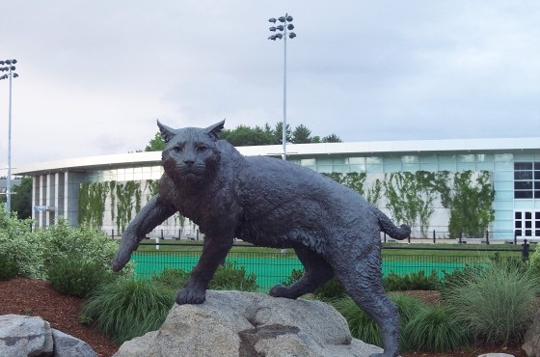
Photo 5: Wildcat monument (Source: UNH)
Diversity
Photo 7: (left to right) UNH Hockey Game (White out the Whitt), Whittemore Center, and the Wildcat Monument

Durham has a wide diversity of strongly held views that contribute to the town’s character. But it is not an ethnically or economically diverse community, unless the student population is considered. The town recognizes that striving to achieve a greater level of diversity is an aspirational goal.
In order to make progress, Durham may wish to consider exploring the following ways to address challenges the town is currently experiencing: attracting a wider variety of people through alternative housing choices, strengthening its partnership with UNH by promoting their state of the art facilities and institutions that appeal to younger generations, maintaining a strong and active senior population, and reversing the trend in the number of declining young professionals and families (25-44 years old).
- In order to attract a broader range of people to live in Durham, the Town needs to create more diversity in housing choices.
  - The Seacoast area is one of the least affordable regions in the State of New Hampshire. Many residents cannot afford to live in the communities in which they work causing economic, social, and environmental impacts. In Durham, a majority of the workforce employed at the University comes from elsewhere in the region, while many Durham residents commute to other towns. Currently, there are a limited number of residents who both live and work in town. One option to address this issue could be to revisit local housing policies to allow more workforce housing options. Workforce housing is an affordable housing option that would allow the middle class more of an opportunity to live and work in Durham. Affordable housing includes single-family homes, condominiums, and apartments.
Quick Fact: According to the 2010 Census, NH saw a 4.9% to 7.7% rise in minority populations over the past decade

  - Encouraging higher density multi-family housing that is not student targeted is another tool that could be utilized strategically to allow more medium income individuals the option of living in Durham.
  - Durham may need to consider providing education and outreach to its residents to improve community support as well as technical assistance to decision-makers and private developers on the benefits that affordable housing can provide. The town has the unique opportunity to draw UNH alumni back to Durham after graduating. Many of the undergraduates and graduate students that spend a great deal of time in Durham while receiving their education may want to return to the area. Investigating affordable housing options for those seeking to return to their alma mater to begin their professional careers or to start a family may be a long-term viable option to consider.
What You Said:
Source: 2011 Visioning Forum
“Diversity and more affordable housing.”

- In order to appeal to younger generations, Durham needs to promote the University’s cultural, age, and ethnic diversity.
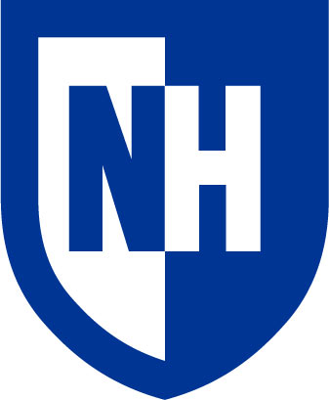
  - Durham has a unique advantage and opportunity through the University, which provides both age and ethnic diversity. Since the adoption of the 2000 Master Plan, the undergraduate student enrollment at UNH has increased by roughly 22%. The influx of nearly 2,300 additional students in 13 years, with an average age of 20 years old (18 for first year students), offers Durham the benefits of youth involvement in community activism and other volunteer programs. Young people in this age bracket bring with them a certain type of enthusiasm, style, and knowledge of the latest trends in technology, social media, fashion, music, art, and pop-culture. On any given day there is a blend of new ideas and different young adult perspectives that can contribute to Durham’s character and provide an atmosphere that attracts new residents. This growing student population is also becoming more ethnically diverse. According to data from the fall 2013 undergraduate profile, there were over 1,000 minority students enrolled at UNH. There were 142 international students, representing 30 different countries (top three are: People’s Republic of China, Canada, and Vietnam), attending UNH this past fall. Some of this increase in the international student population can be attributed to Navitas at UNH, which is part of the International University Transfer Program (IUTP) that offers students an academic and cultural pathway into the University. As UNH has continued to set goals to increase their diversity ethnically, racially, and internationally, Durham will need to strengthen and support the growing diversity at UNH to attract younger residents.
Quick Fact: In June, Forbes ranked Navitas #25 in their 2014 World’s 100 Most Innovative Growth Companies List

Photo 6: UNH Logo (Source: UNH)
- In order to maintain a strong, active senior population, Durham needs to ensure the availability of affordable senior housing.
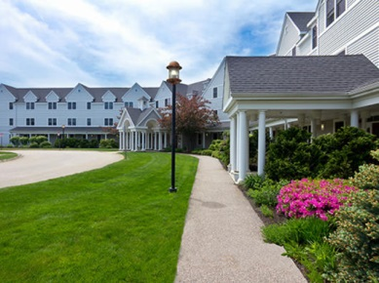
  - The senior population in Durham is an engaged group of citizens who stay actively involved in community activities that are important to them. Durham recognizes their importance and the added benefits these individuals bring to the community including: diversity, energy, perspective, and a high level of volunteerism. The Town could take a balanced approach in determining what the current market is and what the necessary steps are to allow and promote desirable senior housings. This type of private development would also bring in tax revenue that would be fiscally beneficially to the Town.
Photo 7: Emeritus at Spruce Wood (Source: Brookdale.com)

- In order to reverse the current trend of declining numbers of young families, Durham needs to provide more affordable single-family housing and employment opportunities while balancing other non-student generating uses.
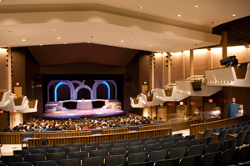
  - During the development of the 2000 Master Plan, recommendations were made to restrain the growth of single family developments with a focus on non-student generating uses in the community including the purchase of conservation land. This was largely due to concerns about the cost burden of the school system. According to a build-out analysis of single-family subdivisions, Durham was projecting an additional 410 Oyster River students by the year 2010. Considering that there were 1,057 Durham students enrolled in 2000, the town was anticipating approximately 1,467 students by 2010. In reality, the Durham school enrollment was only 929 (538 less than what was expected) in 2010. Due to the various growth management techniques to restrain increases in single-family development, the town has seen an increase in the home values of their existing housing stock, which has led to a drop in both younger families and student enrollment in the Oyster River Cooperative School District. The lack of employment opportunities for young professionals may also be contributing to this downward trend. Durham may consider taking a balanced approach by providing affordable single-family housing opportunities to attract young professionals looking to start families.
What You Said:
“Make homes affordable to young families.”
Source: 2011 Visioning Forum

Photo 8: Paul Creative Arts Center (Source: UNH Campus Journal)
Quick Fact: As of 2010, there were 538 fewer students enrolled in the Oyster River Cooperative School District than expected

Recreational and cultural opportunities can be part of the foundation for making Durham a more diverse community.
- Recreational opportunities – Durham boasts a number of recreational opportunities that provide outdoor enthusiasts with plenty of enjoyable activities. The surrounding landscape is perfect for site activities including hiking, fishing, and boating.

- Cultural Opportunities – As mentioned above, it is important to recognize the variety of cultural opportunities available through the University including the Paul Creative Arts Center (PCAC) that offers a 688-seat proscenium theater, a flexible-seating black box theater, two recital rooms, a 4,500 square foot art museum, and art studios. Durham also benefits from being located in the Seacoast with many local art galleries, fine-dining, music, and theater.

Integration with the University

As stated throughout this Master Plan, the University of New Hampshire sets Durham apart from other communities in the area, and it plays an essential role in regard to the character of the town. The University offers resources that other communities strive for, in particular, their leadership in academic research that supports new, and innovative business opportunities.
Table 2: High Research Activity Institutions in New England
Institution | Location
Boston College | Chestnut Hill, MA
Clark University | Worcester, MA
Northeastern University | Boston, MA
University of Maine | Orono, ME
University of Massachusetts – Lowell | Lowell, MA
University of Massachusetts – Boston | Boston, MA
University of New Hampshire | Durham, NH
University of Rhode Island | Kingston, RI
University of Vermont | Burlington, VT
Source: The Carnegie Classification of Institutions of Higher Education, 2010
The University of New Hampshire is nationally recognized as a research university. It’s one of 99 institutions in the country classified as “high research activity,” by the Carnegie Foundation and one of only 9 such institutions in the New England area. Currently, the University is challenged because there is much less federal money for research than in the past and the competition is much greater for a mid-level university like UNH. However, the University receives approximately $110 million in research each year, making it the second largest research and development center in the State. In recent years, UNH has made a stronger push to achieve a greater level of innovation and commercialization from some of its research. It has greatly improved the support and resources available to recruit talent and assist researchers in pursuing patents, copyrights, and agreements that potentially can foster commercialization.
What You Said:
Source: 2011 Visioning Forum
“I want Durham to be the first choice for businesses coming out of the University.”

Durham residents have expressed they would like to see more entrepreneurial opportunities coming from UNH and staying in Durham. Currently, the town is not capturing the trained workforce, including entrepreneurs who graduate from the University. Durham may want to consider taking a larger role in supporting startup incubator and idea accelerators, encouraging partnerships with local businesses, and investing in high-speed broadband internet to help fuel innovative growth. One example of how integration with University has improved is the InterOperability Laboratory (IOL) recently signing a 20-year lease to relocate from the Goss International Building to the new $30 million Madbury Commons development in downtown to be closer to UNH campus. This project will provide an economic growth engine in Durham’s downtown.

Vibrant Downtown

According to both the survey and visioning forum results, Durham residents responded overwhelmingly that the Town needs a vibrant downtown in order to preserve its small New England character, and to maintain a strong sense of community. While many residents feel Durham’s current downtown is attractive and accessible, others think it lacks many of the characteristics that they would like to see there. There are also differing opinions on the physical extent of the downtown. Most residents see it as including Mill Plaza and Main Street, but some make a strong argument that Pettee Brook Lane should also be included. Many residents requested a more pedestrian friendly downtown, bike lane networks, better sidewalks, and other transportation alternatives that address traffic calming issues, parking, and dangerous crossings at merge areas. The majority of Durham residents agree that improving the quality and appearance of the downtown will provide more opportunities for diverse businesses, mixed retail shops and restaurants, professional office space, and a wider range of housing choices.
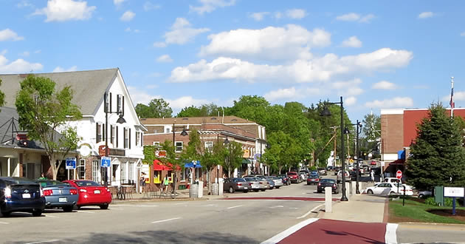
Implementing walkability principles is an approach the Town might choose to consider. The 2012 Livable Walkable Communities Toolkit is an educational and community planning resource to inform and educate communities, planning-related professionals, and policy makers about how they can retrofit the built environment – not only to encourage and implement safe places to walk and bike for children and their families – but also to increase access to healthy foods and additional opportunities for physical activity. The Toolkit includes items such as: 1) a walkable center, whether it’s a main street or a public space; 2) enough people for businesses to flourish and for public transit to run frequently; 3) affordable housing located near businesses; 4) plenty of public parks and places to gather; 5) design for buildings close to the street with parking to the back; 6) close proximity to schools and workplaces so residents can walk from their homes; and 7) complete streets that are designed for bicyclists, pedestrians, and transit.
Photo 9: Main Street (Source: SRPC)
Creating a better quality, vibrant downtown also involves balancing the current business environment so it caters to residents as well as students. Many smart growth principles encourage greater density, mixed-used development, and transit-oriented options that could be applied within the downtown. Allowing a greater mix of retail including stores and restaurants will offer greater choices for families and help attract young professions looking to move to the Seacoast area. The Town would need to address issues with the current building stock and capitalize on the entrepreneurial startup business opportunities coming out of the University. Durham would also need to consider creating more diverse housing options through redevelopment efforts to allow for a greater mix of medium income individuals to be living close to the downtown.
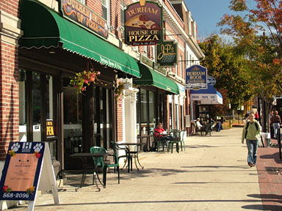
Durham may elect to put a greater emphasis on the philosophy of placemaking. According to a report titled, “Places in the Making: How placemaking builds places and community,” public places play a key role in building community. It’s an innovative approach to urban design and can empower local communities to create a sense of “belonging” through place. Reports such as the one mentioned above examine the interactions between placemaking, community participation, and the expanding ways communities can collaborate to make great public spaces. This type of planning method has become increasing popular and there are a number of similar tools Durham could use to help guide downtown revitalization efforts.
Photo 10: Downtown Durham (Source: Painetworks.com)
Through smart planning combined with their community engagement process, Durham has the opportunity to retain its historic and cultural character, while incorporating modern-day changes to make the downtown an area that is economically vibrant, compact, and sustainable.
Quick Fact: Shaping an environment to enable social interaction will improve a community’s quality of life.

What You Said:
“Create a cohesive downtown – unite Mill Plaza, Main Street, and Pettee Brook Lane.”
Source: 2011 Visioning Forum

Fostering Consensus and Defining Balance

Balance may be the most important core focus area in Durham’s Vision. Many residents feel that current policies and regulations along with large scale changes in Town have led to a variety of challenges. This section will focus on two of these challenges facing Durham. The first is balancing economic development that preserves small town characteristics and environmental stewardship. The second challenge is finding balance in the partnership between Durham and UNH.
- Balancing economic development while preserving small town characteristics and environmental stewardship – While there are varying opinions on the extent to which these may be out of balance, the Town recognizes the importance of finding compromise. Some Durham residents remain concerned about future development pressures and the impacts these pressures will have on the Town’s environment and small town feeling; others believe Durham is sufficiently protected and they support policies that would allow more land to be made available for affordable housing developments and light commercial mixed-use in the downtown and commercial core as well as in identified outlying areas. Balancing sustainable and fiscally responsible economic development with land use control measures and environmental resource protection efforts will continue to be an important issue to address.
  - The natural features of Durham’s landscape have dictated much of the prioritization of conservation land and the town may need to consider which significant lands remain in need of protection in order to ensure that the town is making the best possible investments in land protection.
What You Said:
Source: 2011 Visioning Forum
“More incentives for bringing business to Durham.”

  - In order to help stabilize the tax burden, Durham may want to consider ways to attract commercial growth by allowing more land to be made available for development, collaborating with the University in public/private enterprises, and revisiting existing zoning and land use regulations that may be a deterrent to developers.
What You Said: Source: 2011 Visioning Forum
“Development in appropriate areas, especially downtown to broaden tax base.”

  - Durham will need to acknowledge that each of these perspectives is important, while also recognizing that the town has a significantly higher percentage of constrained land (roughly 65%) than other nearby communities. This percentage represents conserved land, Town-owned land, UNH property, and other developed land in Durham. It does not consider constraints resulting from local land use regulations or land that is constrained because of wetlands, very poorly drained soils, floodplains, and steep slopes. These additional constraints are examined more closely in the Existing Land Use Chapter. It should be noted that some existing developed land in Durham could be redeveloped.

- Finding balance in the partnership between Durham and UNH – Durham would like to see more University research and expertise evolve into innovative local businesses, and would also like to work with UNH to develop public/private ventures on University-owned land. The town would also like to improve the relationship between UNH students and Durham’s full-time residents.
  - UNH is the second largest research and development center in the state and has made great strides in recruiting talent and assisting researchers in pursuing patents, copyrights, and agreements that potentially foster commercialization. This provides an opportunity for Durham to capture some of the well trained workforce and emerging economy that is coming out of the University. According to a 2011 report by the Kauffman Foundation and the Young Invincibles, which conducted a nationwide cellphone and landline survey of 872 young Americans, the Millennial generation (18-34 years old) is enthusiastic about entrepreneurship, and sees it as a path to success. Many young people are delayed in starting a business due to the inability to get a loan or credit, risk in the economy, and/or lack of the skills and knowledge necessary to start and run a small business. In Durham, this last barrier is less burdensome for young people due to the Peter T. Paul College of Business and Economics at UNH, which is an Association to Advance Collegiate Schools of Business (AACSB) accredited school that offers advanced business, management knowledge, and entrepreneurial studies to its students. Durham has an advantage in having such a resource and may want to consider motivations to help this kind of innovative development.
Quick Fact: According to the Young Invincibles Policy Brief, more than 54% of young people either want to start a business or have already started one.

  - The other key factor in finding balance between the Town and University is the need to strengthen the relationship between residents and UNH students. According to the Master Plan survey results, a majority of Durham residents care about the students and genuinely want them to feel welcome. Yet, there are some residents who feel Durham is a divided community. There are a number of challenges for the Town associated with the students, but it is the disruptive behavior of a small percentage of students that fuels the perception that there is a conflict between students and full-time residents. Durham understands that the best way to work on this issue is to improve University relations.
What You Said: Source: 2011 Visioning Forum
“Conflict between residents and students.”

Smart Growth Principles

Durham’s Commitment to Smart Growth Principles

It is Durham’s overarching policy to adhere to smart growth principles, when applicable, in the development of all Master Plan chapters.
The American Planning Association (APA), as articulated in its Policy Guide on Smart Growth, supports the development of mixed use, livable communities where people choose to work, live, and play because they are attractive and economical options, not forced decisions. Smart growth supports efficient and sustainable land development; incorporates redevelopment patterns that optimize existing infrastructure; and consumes less land for sustained agriculture, open space, natural systems, and rural lifestyles. Smart growth is about tailoring choices for individual settings, retrofitting communities to offer diverse choices in terms of housing types and prices, and providing transportation options. This approach to growth and planning can deliver dynamic, attractive communities with greater choices for consumers and can be a powerful tool for farmland, open space, and habitat preservation.
Smart growth provides choices — in housing, in transportation, in jobs, and in amenities (including cultural, social services, recreational, educational, among others) — and uses comprehensive planning to guide, design, develop, manage, revitalize, and build inclusive communities and regions to:
Definition: Smart Growth
“Smart growth is not a single tool, but a set of cohesive urban and regional planning principles that can be blended together and melded with unique local and regional conditions to achieve a better development pattern. Smart Growth is an approach to achieving communities that are socially, economically, and environmentally sustainable.”
Source: American Planning Association

- have a unique sense of community and place;
- preserve and enhance valuable natural and cultural resources
- equitably distribute the costs and benefits of land development, considering both participants and the short- and long-term time scale;
- create and/or enhance economic value; expand the range of transportation, employment, and housing choices in a fiscally responsible manner;
- balance long-range, regional considerations of sustainability with short-term incremental geographically isolated actions;
- promote public health and healthy communities;
- apply up-to-date local and regional performance measures of successful urban and regional growth;
- encourage compact, transit-accessible (where available), pedestrian-oriented, mixed-use development patterns and land reuse; and
- increase collaboration and partnerships to advance place-based and regional goals and objectives, while respecting local land-use preferences and priorities.
Core Principles of Smart Growth
Ten Years of Smart Growth
Over the past decade, Durham has demonstrated its commitment to smart growth in its policies, including:
- adoption of a conservation subdivision ordinance
- numerous land protection efforts
- encouraging commercial zoning in areas located in the downtown core and outlying areas
- substantial investments in improving the downtown
- a number of traffic calming measures
- pedestrian and bicycle enhancements
- a transparent and open public engagement process
- multi-family zoning in the downtown
- strong support for preservation of natural and historic resources
- designation of four scenic roads
- promotion of downtown redevelopment
For more information, on how these policies and activities are reflected in the Town Council goals, please visit: 2014-2015 Council Goals.

- Efficient use of land and infrastructure
- Creation and/or enhancement of economic value
- A greater mix of uses and housing choices
- Neighborhoods and communities focused around human-scale, mixed-use centers
- A balanced, multi-modal transportation system providing increased transportation choice
- Conservation and enhancement of environmental and cultural resources
- Preservation or creation of a sense of place
- Increased citizen participation in all aspects of the planning process and at every level of government
- Vibrant center city life
- Vital small towns and rural areas
- A multi-disciplinary and inclusionary process to accomplish smart growth
- Planning processes and regulations at multiple levels that promote diversity and equity
- Regional view of community, economy, and ecological sustainability
- Recognition that institutions, governments, businesses, and individuals require a concept of cooperation to support smart growth
- Local, state, and federal policies and programs that support urban investment, compact development, and land conservation
Quick Fact: NH RSA 9-B sets policy that New Hampshire and state agencies act in ways that encourage smart growth

What You Said:
“Review zoning to make it more updated with strategies like smart growth.”
Source: 2011 Visioning Forum

- Well defined community edges, such as agricultural greenbelts, wildlife corridors or greenways permanently preserved as farmland or open space

Policy Outcomes
- Economic benefits
- Planning structure and process
- Transportation and land use
- Fiscal responsibility
- Social equity and community building
- Farmland protection and land conservation
- Public health

The Master Plan Steering Committee was made up of 16 community members and was instrumental in organizing both the citizen survey and public visioning forum in 2010-2011. Many members went on to join the MPAC.
Belknap, Jeremy. The History of New Hampshire, volume III. Boston: Belknap & Young, 1792.
Durham Historic Resources. Durham’s Master Plan, 2014.
To address this concern Durham has amended their zoning to allow student housing as a conditional use only, setting the bar higher for developers and allowing for key redevelopment projects to leverage student housing in core areas.
Workforce Housing Coalition of the Greater Seacoast, 2014.
Minority refers to students that identify themselves as either Hispanic/Latino, Asian/Pacific Islander, Black/Non-Hispanic, Native Hawaiian/other Pacific Islander, American Indian/Alaskan Native, or two or more races.
Navitas Ltd. is a global education provider that offers a wide range of educational services through three major Divisions to students and professionals, including university programs, creative media education, professional education, English language training and settlement services.
The Carnegie Classification of Institutions of Higher Education (2010) determines their research classifications based on a measure of research activity for doctorate-granting institutions
Dollar amount represents fiscal year 2014.
A 27,000 square-foot facility to support ground tests for up to 60 companies that offers third-party neutral testing services for data communications, networking, and storage industries. It employs students from around the state, allowing them to get hands-on experience with companies around the world, such as Apple and Intel.
The 2012 Livable Walkable Communities Toolkit was prepared by the Southern New Hampshire Planning Commission and funded by a grant from the HNH Foundation.
Silberberg, Susan. “Place in the Making: How placemaking builds places and community”. MIT Department of Urban Studies and Planning. 2013.
Young Invincibles partnered with Lake Research Partners and Bellwether Research, with funding from the Ewing Marion Kauffman Foundation to conduct a nationwide survey of young Americans on their thoughts about the economy and entrepreneurship.
The American Planning Association comprises 47 chapters representing states and regions, 19 divisions covering special interest areas and populations, students in collegiate schools of planning, and its professional development arm, the American Institute of Certified Planners (AICP).
American Planning Association. Policy Guide on Smart Growth. April 14, 2012.

