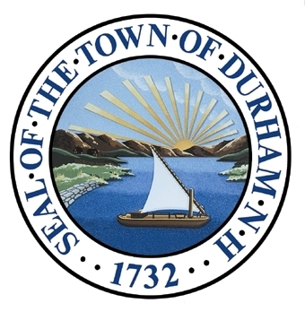

Recreation
The Recreation Chapter of the Master Plan presents a vision and steps to guide the Town’s efforts for the next ten years and beyond. This chapter includes a summary of the Town’s recreational resources and opportunities, the growing roles and responsibilities of the Durham’s Parks and Recreation Department, and offers a series of goals and recommendations for achieving the overall vision of a community that provides and supports recreational resources, facilities, and programs.

Adopted by the Durham Planning Board on November 18th, 2015.

Our Vision
In 2025 and beyond, Durham celebrates exceptional water and land-based natural resources used for recreation. The community boasts a wide-range of outdoor and indoor recreational activities that enhance a healthy lifestyle and quality of life, including first-class public parks and recreational facilities available for its residents. Improvements to existing infrastructure have led to Durham being recognized as one of NH’s most walkable and bikeable towns. Residents enjoy a busy, interconnected town-wide trail system that links residents and visitors of all ages to Durham’s neighborhoods, the downtown, improved playing fields, along with conservation lands and open spaces. The community also benefits from a variety of recreational opportunities associated with the University, including multi-purpose athletic facilities and managed natural areas.
Along the shoreline at the mouth of the Oyster River, Wagon Hill Farm is one of the brightest jewels in this interconnected system. Its historic and scenic beauty is actively shared with the community in each of our four seasons.
Closer to town, Jackson’s Landing is the second largest community park and a busy center for summer camps. An improved ice rink is used for organized sports and family skating, as well as hosts a schedule of year round events. Residents have access to a children’s playground, rowing shells, kayaks, canoes, and storage space that are available to rent at Town Landing.

Foundation
Throughout successive Master Plans, Durham’s citizens have consistently voiced support for the protection of water resources for recreational use, access to outdoor recreation activities, and the importance of pedestrian and bicycle friendliness. Suggestions from the Parks and Recreation’s survey in 2007 underscored what has long been a challenge for the program – the need to increase awareness among residents of the recreational opportunities and facilities.
What Do We Look Like?
What Do We Look Like?
Terrific place for outdoor recreation
Open spaces
Good water access
Multi-use opportunities
Limited bike trail
Lacking sports fields
Recreation website needs improvement
Lack of collaboration
What Will We Look Like?
Better sports facilities
Improved walkability
Better coordination and partnerships with other ORCSD communities
More UNH volunteers for recreation
Developing Wagon Hill Farm as a recreational destination
How Important are the Following Attributes to you?
 | Overall Positive Response Rate |  |  | Strongly Agree |  | Somewhat Agree
Protection of water resources for recreational use | 90% |  |  | 58% |  | 32%
Access to outdoor recreation activities | 83% |  |  | 46% |  | 37%
Importance of pedestrian and bicycle friendliness | 82% |  |  | 52% |  | 30%
Importance of improving better bike lanes downtown | 74% |  |  | 41% |  | 33%
A performing arts center in or around downtown | 72% |  |  | 35% |  | 37%
A community recreational center for people of all ages | 69% |  |  | 33% |  | 36%
Expansion of parking at Wagon Hill Farm | 68% |  |  | 21% |  | 47%
Promotion of more outdoor events for the community | 67% |  |  | 27% |  | 40%
More community events and festivals | 51% |  |  | 15% |  | 36%
 | Overall Positive Response Rate |  |  | Excellent |  | Good
Rate existing athletic and playing fields | 33% |  |  | 7% |  | 26%
Rate indoor recreation facilities | 12% |  |  | 2% |  | 10%
TOTAL NUMBER OF PARTICIPANTS | 467 citizens
The following is a summary of comments and input received during the 2011 Visioning Forum and 2011 Master Plan Survey completed by the Town of Durham. Results of these two engagement opportunities form the foundation of this Recreation chapter while providing a lens of public perception and interest surrounding Durham’s recreation resources.
2011 Master Plan Survey Results: Recreation
2011 Visioning Forum: Recreation

Introduction

This is an exciting time for public recreation in Durham. It is no secret that our town has so much to offer residents – from woodsy paths and waters for boating to a lively assortment of recreational classes and annual events that bring the community together. An article published by the Boston Globe in March 2014, titled Durham, N.H., is a great place for the young at heart, highlights Wagon Hill Farm, Town Landing, Adams Point Wildlife Management Area among other places for exploring and outdoor recreation. An increasing number of residents are discovering the diverse offerings of Town-owner lands, including the iconic Wagon Hill Farm. Here, gardeners tend their plots near the barn, dog owners walk the trails in the early morning, kayakers embark from the shore for lessons, school children and families play and explore, and residents come together for live music while the summer sun sets.
On Main Street, residents gather by the hundreds to cheer our Memorial Day Parade. In winter, they warm themselves by the fire on the chilly night Santa Claus visits to light the town tree. And year round, at the Parks and Recreation room in our historic Courthouse, residents dance, balance, and stretch themselves into shape in an array of classes – Zumba, Yoga, and Tai Chi, to name a few. Today, residents have more bike lanes and crosswalks to navigate as Durham’s downtown grows and redevelops.
The purpose of this chapter is to guide planning and programming decisions driven by the Master Plan – focused on improved accessibility, enhanced partnerships, and increased awareness of local recreational opportunities – enabling Durham to better address these challenges. This chapter reflects the findings of surveys and the consensus of Parks and Recreation Committee members and volunteers who devote countless hours organizing events and listening to fellow residents.
Photo 1: A local father reads a story during the Annual Feather Fest Event at Wagon Hill Farm (Photo Credit: Durham Parks and Recreation Department)
Parks and Recreation Committee Mission Statement:
“Durham Parks and Recreation, its Director and Committee, strive to offer a wide range of quality programs, parks, and facilities that encourage all community members to participate in healthy, fun, and enriching activities. Together, they celebrate the essential role public recreation plays in fostering a cohesive and vibrant community.”

History of Durham’s Parks and Recreation Department

Both the 1994 and 2000 Master Plans prioritized hiring a recreation director to address maintenance of trails, lack of centralized and readily available information about recreational resources, and gaps in programming offered by the Oyster River Youth Association (ORYA) and UNH. Though a Recreation Advocate was hired in 1995, the position was not retained.
Oyster River Youth Association (ORYA)
The Oyster River Youth Association provides inclusive, fair, diverse and developmentally appropriate recreational programs to the youth of Durham, Lee and Madbury, NH. ORYA meets the changing needs of the children and families in our community for sports and recreational activities by acquiring and maintaining facilities, promoting volunteerism and seeking collaborative and strategic partnerships.
In 2001, the Town Council created the current administrative structure for municipal recreation in Durham and established a volunteer committee to directly support programs, advocate for and make decisions about recreational needs, liaise with other departments and organizations, and advise Town employees to act on priorities.
In 2007, the Parks and Recreation Committee surveyed the community to gather input on the need for a full-time recreation director and comprehensive public parks and recreational program in Durham. [Readers are encouraged to turn to this chapter’s Appendix for a detailed summary of the results of the survey.]
In 2009, the Town Council officially adopted the title of Parks and Recreation Department, the first part-time Recreation Director was hired, and the Department relocated to its current home, the historic brick Courthouse at the corner of Main Street and Newmarket Road.
From 2009 to 2010, management of facilities and other resources was enhanced and the number of recreational programs offered increased. Since 2009, the Director’s position has undergone several changes, and three people have served as Director. The position’s hours increased from 20 to 30 hours per week in 2011, and then full time in 2013. Management and programming has improved as the Director’s hours have increased over time. During this transition, the purpose of the Parks and Recreation Committee has undergone a significant shift. Before a full-time Director was hired, the Committee was actively involved in planning and implementing community events. More recently, the Committee’s focus is on setting policy, in coordination with the Director, and providing advice on recreational improvements needed in order to meet future demands as the town grows.
Views of Recreational Resources Today and Vision for the Future
In acknowledging the importance of recreation in its many forms to our residents, and in recognition of the good work of volunteers over many years in establishing a strong program, the Town Council established a full-time Parks and Recreation department director’s position. With this critical investment, the department is poised to pursue a vision for the steady improvement and promotion of our recreational resources, facilities, and programs. The new director strengthened bridges between Durham and the University of New Hampshire (UNH), by providing significant recreational assets for residents young and old. Many new volunteers are improving the logistics of our annual celebrations and programs.
Quick Fact: In 2013, Durham established a full-time Parks and Recreation Department director’s position

The valuable partnership between Town staff, community volunteers and departments at the University of New Hampshire continues to grow – affording Durham residents young and old a variety of recreational opportunities geared toward their interests. A fully integrated marketing plan would take advantage of all forms of media to report to the public about Durham’s recreational offerings. That programming would be informed by a systematic assessment of the community’s recreation needs and preferences. With the help of a creative business model covering a portion of operating expenses through grants, business sponsorships, and dedicated revenues from events and program fees, the Parks & Recreation program would aim to have its programs open to lower income residents. However, the Department’s capital needs and general staffing require the continued financial commitment and support of Town government. Interns and work-study students provide invaluable support to the director, but the successful program envisioned here for Durham’s future will eventually require an assistant Parks & Recreation director.
Five-Year Statewide Comprehensive Outdoor Recreation Plan (2013-2018)
Every five years, the State is required to produce a plan that complies with National Park Service requirements in order to remain eligible to receive federal Land and Water Conservation Fund grant funding. In January 2013, the New Hampshire Division of Parks and Recreation in cooperation with the Office of Energy and Planning released the 2013-2018 Statewide Comprehensive Outdoor Recreation Plan. The Plan provides the outdoor recreation community with a proactive framework based on a strategic vision, current data, and public input, and offers recommended priorities, goals, and actions.
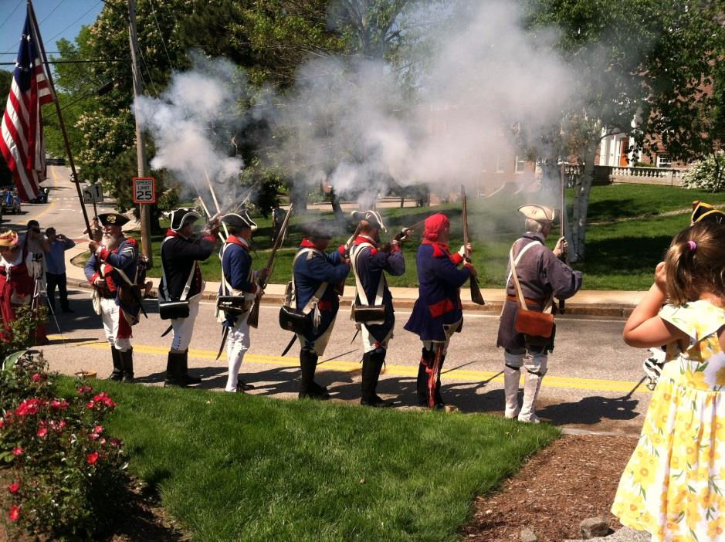
The Durham Parks and Recreation Committee reviewed this plan to assist in the development of this chapter and to make sure the its goals and recommendations mirrored those in the statewide plan. Activities referenced in the statewide plan that Durham may wish to pursue include:
Photo 2: Newmarket Militia during the Annual Memorial Day Parade (Photo Credit: Durham Parks and Recreation Department.
- Active transportation programs, policy and funding (i.e., bike/walking paths, connectivity of trails, etc.)
- Community emphasis on trails, parks and playgrounds to attract new home buyers
- Engaging youth in the outdoors during school time hours
- Creating physically active programming for seniors
Durham should continue to use the statewide plan as a resource and guide to develop projects that will provide accessed and safe physical connection for outdoor recreation opportunities within the community.

Recreational Trends
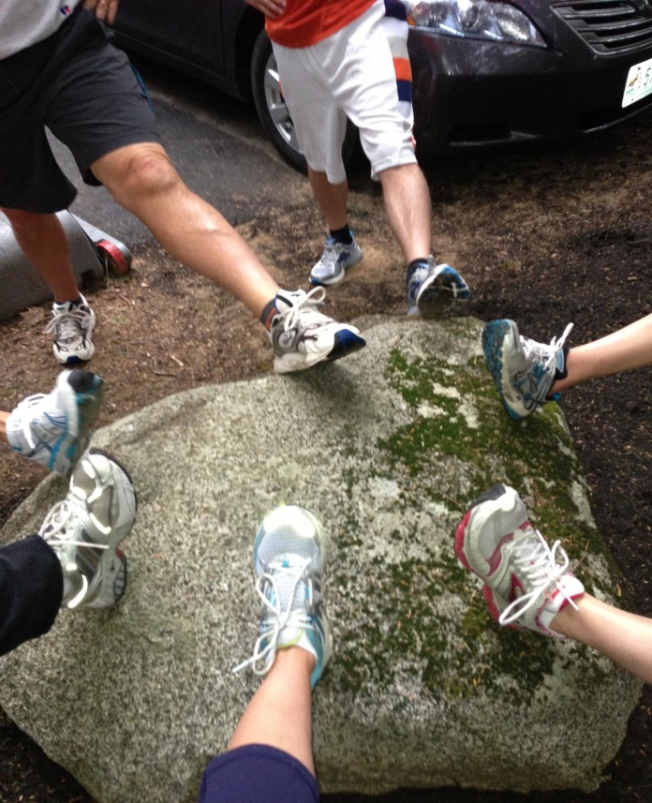
During their review of the statewide planning process, the Durham Parks and Recreation Committee identified a variety of national recreational trends. These trends provide context on how outdoor recreation opportunities help to build stronger economies and improve the health and well-being of residents and visitors. Important trends for Durham to consider include, but are not limited to:
Photo 3: “Couch-to-5K” participants stretching before a group run (Photo Credit: Durham Parks and Recreation Department)
- Return to Nature: Nearly 50 percent of Americans ages six and older participated in outdoor recreation in 2011, a slight increase from 2010, equating to a total of 141.1 million Americans.
- First Time Participants: Activities with the highest percentage of first time participants in 2011 included stand up paddling, triathlons, freshwater fishing, and adventure racing.
- Fitness and Health Benefits: Outdoor participants rate their fitness level at 6.4 on a 10-point scale. In terms of health, outdoor participants rate their health level at 7.6 on a 10-point scale.
- Youth: Among ages 6 to17, bicycling is the most popular outdoor activity.
- Preservation of Land: The majority of Americans agree that preserving undeveloped land for outdoor recreation is important. A large percentage of outdoor participants believe that developing local parks and hiking and walking trails is important and that there should be more outdoor education and activities during the school day.
What You Said:
“Improved coordination and partnership with local groups”
Source: 2011 Master Plan Visioning Forum

New Hampshire offers an ideal setting for residents and visitors from all walks of life to participate in an array of four season outdoor recreation opportunities. Durham should remain cognizant of larger recreational trends in order to successfully plan for recreation improvements at the local level.
Existing Recreational Opportunities in Durham

Town residents of all ages, abilities, and interests need not look beyond our borders to experience a broad range of outdoor and indoor recreational activities that enhance a healthy lifestyle and build a sense of community. Residents can count on seasonal celebrations that bring our community together and provide shared time in our cherished parks. Boating has long been a popular recreational activity in Durham and across New Hampshire. The growth in popularity of self-powered boating (canoe, kayak, paddle boarding, etc.) has been significant in the past five years. Durham boasts numerous access points for self-powered boaters, that can help meet the boating needs of the community. Creating connected trail systems, parks, and recreational facilities will help meet the recreational needs of the region and our community.
Land Based Activities
Durham’s open space lands and existing conservation easements are among the town’s most important recreational resources. The Existing Land Use chapter states that Durham has conserved nearly 30% of its entire land area. These conservation projects translated into the permanent protection of unique ecosystems and wildlife on properties that provide residents with a variety of recreational opportunities. The Parks and Recreation Department has identified and prepared an inventory of Town-owned, State-owned, and University-owned outdoor recreation sites available for public use.
What You Said:
“Better access and improved communication about resources”
Source: 2011 Master Plan Visioning Forum

Town-Owned Lands and Buildings
Father Lawless Park (Woodridge Recreation Area): Located on Fogg Drive, off Mill Road, the park is home to the Father Lawless Baseball Field, other baseball diamonds, basketball courts, tennis courts, swing sets, and a soccer field.
The Courthouse: This former Town Courthouse and Town Hall is now home to both the Durham Historic Association Museum and the Durham Parks and Recreation Department. The Museum offers an ever-growing collection of the town’s history, as well as archives of local and genealogical interest. The Parks and Recreation Department provides residents a wide range of quality programs that encourage community members to participate in healthy, fun, and enriching activities, such as Yoga, Tai Chi, Pilates, Zumba, and Bootcamp.

Longmarsh Preserve Area: The preserve consists of three contiguous parcels: the Langmaid Farm, Colby Marsh, and Horsehide Creek. It is bisected by the class VI portion of Longmarsh Road. Parking for a few cars is available at the end of the class V portion of the road. Beyond an iron gate the road continues as a class VI woods road/pedestrian trail. The central trail is accessible to mountain bikes, and horses, as well as hikers.
What You Said:
“Develop knowledge of and access to recreation trails”
Source: 2011 Master Plan Visioning Forum

Town-Owned Facilities and Areas
- historic buildings, structures, dams, and museums;
- parks and playgrounds;
- tennis courts;
- playing fields;
- an open-sided ice rink;
- an old reservoir/freshwater pond;
- waterfront access;
- farms;
- fields and wooded areas;
- fresh water and tidal wetlands; and
- wildlife and nature preserves, and conservation areas

Mill Pond Park: Located at the Mill Pond Dam along the Oyster River, the park is a local landmark. Year round there are pleasant views of the freshwater pond and marsh. Visitors can sit at tables and observe a variety of local wildlife including great blue herons, snapping turtles, ducks, and the adored swans. In winter, families can be seen playing pond hockey or ice-skating.

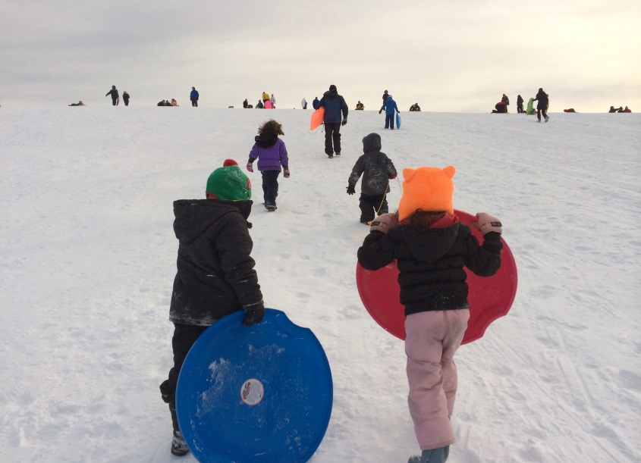
State Owned Lands
Photo 4: Sledders heading back up the hill for another run at Wagon Hill Farm (Photo Credit: Parks and Recreation Department)

Adams Point Wildlife Management Area: Operated by the New Hampshire Fish & Game Reserve, the 80-acre tract at the mouth of Great Bay is the site of UNH Jackson Estuarine Lab. Hiking trails offer visitors pristine shoreline views of tidal estuaries, marshes, open meadows, and woods – whether for walking or cross-country skiing.

University Owned Lands & Facilities
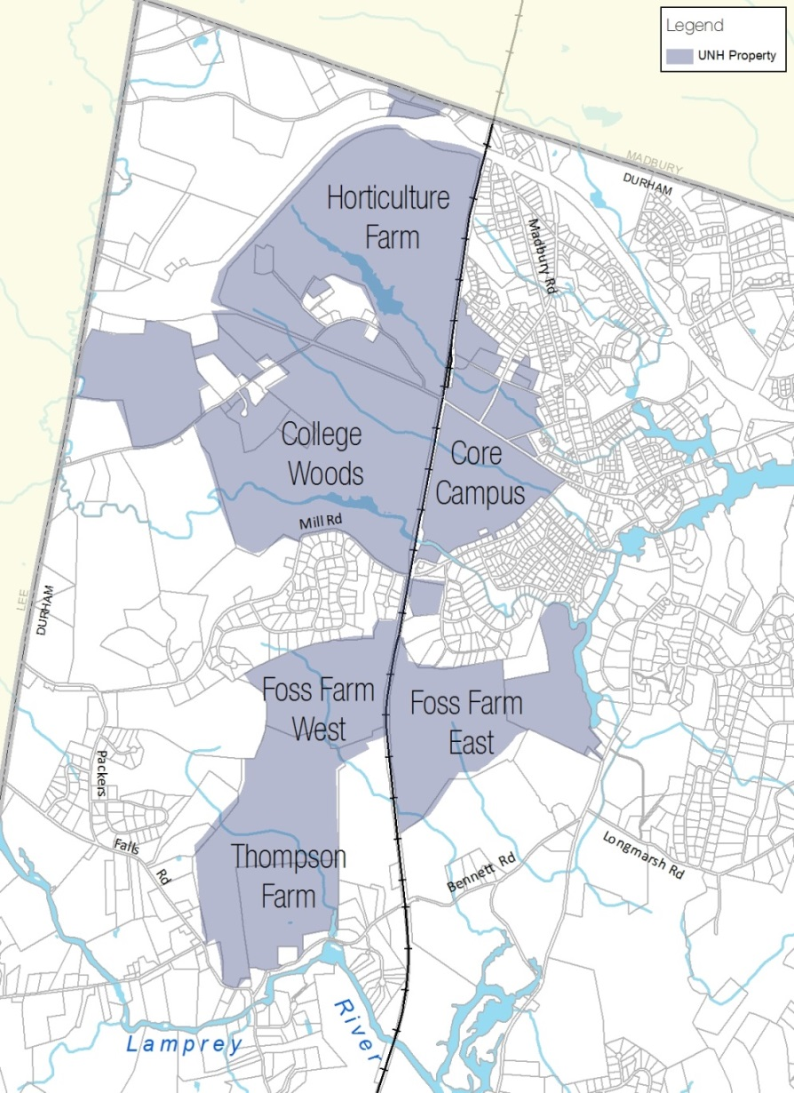
College Woods: Managed by the University of New Hampshire Office of Woodlands and Natural Areas, the 64-acre tract is used for research, instructional, and recreational activities. Recreational activities include hiking, walking, skiing, jogging, bird watching, cross-country skiing, and general relaxation. Biking is allowed outside of the Natural Area.
Map 1: UNH Owned Properties (Source: SRPC)

East Foss Farm: Managed by the University of New Hampshire Office of Woodlands and Natural Areas, the 164-acre tract is used extensively for teaching and research, wood production, and provides a variety of wildlife habitats. Classes regularly practice timber harvest activities and prescribed burning. East Foss Farm is also used for recreational purposes, such as walking, running, hunting, mountain biking, and cross-country skiing.

Thompson Farm: Managed by the University of New Hampshire Office of Woodlands and Natural Areas, the 204-acre property consists of agricultural fields, streams, and wet areas. There is a small working farm area and an extensive trail system, which connects with the trail system at West Foss Farm. The primary recreational uses are biking, cross-country skiing, hunting, and running.

West Foss Farm: Managed by the University of New Hampshire Office of Woodlands and Natural Areas, the 92-acre property is open to the public for recreation. The property is used for mountain biking, walking, running, live role-playing combat club activities, Boy Scout activities, and cross-country skiing.
Quick Fact: The UNH outdoor pool was originally a 2.6 acre University Pond, created prior to 1924.
UNH Outdoor Pool: Managed by the University of New Hampshire Campus Recreation Department, the 1938 WPA-era-built outdoor pool had a long history of providing recreational opportunities for Durham residents. For many Durham residents, the pool represented an important and historical landmark in town. While the original pool was closed in 2014, a new pool will be built on site that incorporates substantial redesign and system upgrades as part of the Hamel Recreation Center expansion project. Final design developments and pre-construction site preparation is underway; the pool will be operational for the 2016 season.
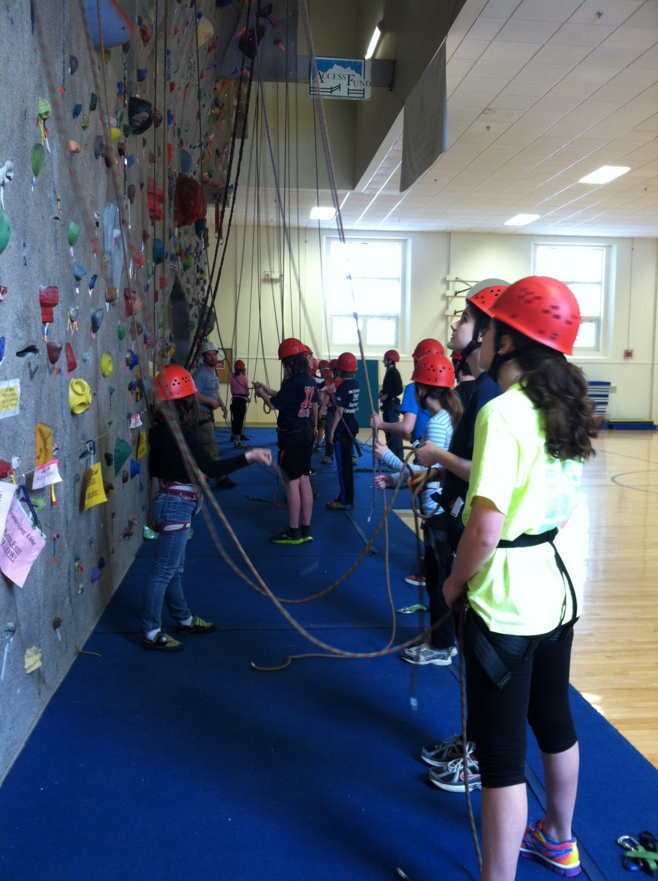
Cowell Stadium – Home to the UNH Wildcats football team for more than 75 years, the 6,500-seat multi-purpose stadium offers residents an opportunity to watch collegiate level sporting events each year. Surrounding the playing surface is a 400-metre track that is used by UNH track and field teams, as well as residents and students for leisure activities and has been the site of annual Special Olympics events and Fourth of July celebrations.
Photo 5: Durham Climbing Club participants learn belaying techniques (Photo Credit: Durham Parks and Recreation Department)
Field House – A multi-purpose athletic facility on UNH’s campus, the Field House offers a number of recreational uses, including:
- Lundholm Gym is a 3,500-seat multi-purpose arena that is home to the UNH Wildcats basketball, volleyball, and gymnastics teams.
- Swazey Pool is a 25-yard pool with six lanes for competitive use.
- Jerry Azumah Performance Center is a state of the art strength and conditioning center
Whittemore Center – Home to the nationally ranked UNH Wildcats ice hockey program, this multi-purpose arena hosts sporting events, family shows, tradeshows, concerts and community events. A versatile venue, the Whittemore Center can accommodate 6,500 for a hockey game and up to 7,500 for a concert or show.
New Hampshire Hall – Home to the UNH outdoor artificial climbing wall, the facility is open for use to UNH students and the community.
Paul Creative Arts Center – This 1960 facility, a center for study and enjoyment of the arts, houses three academic departments—Art and Art History, Music, and Theatre and Dance—plus the Museum of Art and the University’s Celebrity Series. The aging center includes a 688-seat proscenium theater, a flexible-seating black box theater, two recital rooms, a 4,500 square foot art museum, practice rooms, art studios, and faculty and program offices.
Trails System in Town

Durham is home to an extensive trail network that serves a variety of groups within the town including young children, parents, students at the University, and long-term residents. As part of their effort to improve public awareness, as well as identify potential areas for improved access and additional facilities, the Parks and Recreation Department is developing a series of brochures and maps of town trails to provide residents with more information and key aspects of each site.
Doe Farm: Owned by the Town, the 80-acre parcel offers visitors beautiful woodland trails that lead down to the Lamprey River and its backwaters. Walking, with and without dogs, and cross-country skiing are popular trail uses. Scouts help maintain some of the trails and bridges. Moat Island, separated from the mainland during high water, is left as a natural area with no formal trails.
Jackson’s Landing: Donated to the Town of Durham by resident Herb Jackson, the property provides limited boat ramp access (tide-dependent for motorized boats), tables and benches for picnicking, and a few trails that lead visitors to the tidal portion of the Oyster River. Durham and UNH rowing teams share a boat shed and dock. A playground for small children and a covered ice-skating rink, open from mid-October through mid-March, provide other recreational opportunities.
Oyster River Forest: Acquired by the Town in 2013, this 171-acre property offers the public low-impact recreational uses, such as birdwatching, fishing, hiking, and cross-country skiing. Durham’s only permanently conserved Town-owned property affords significant opportunity for trails on the property itself and as part of a network of trails on nearby properties, including the adjacent UNH College Woods.
Packers Falls: Owned by the Town of Durham, the area offers trails that lead visitors through the woods and down to the Lamprey River where they can swim or fish. While there is no boat ramp, outdoor enthusiasts can launch canoes, kayaks, or rowboats downstream of the falls (which can be considered Class II or III, depending on the water level).
Sweet Trail: Owned and managed by the Town of Durham, the Nature Conservancy (TNC), New Hampshire Fish & Game (NHFG), the Society for the Protection of New Hampshire Forests (SPNHF), and private landowners, the Sweet Trail is a four-mile trail from Longmarsh Road in Durham to the Great Bay Estuary in Newmarket. Along the way, hikers experience a remarkable array of upland forests, freshwater wetlands, and tidal salt marsh.
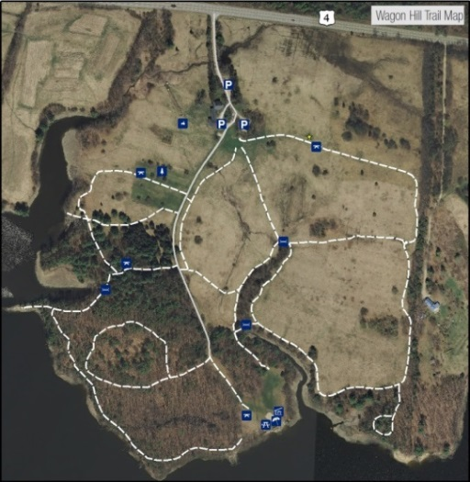
Wagon Hill Farm: Owned by the Town of Durham, the 139-acre tract is widely known for the historic wagon at the top of the hill. Recognized as a local landmark by seacoast residents, UNH students, and tourists alike, the property was acquired in 1989 “to preserve its scenic vistas, provide for future municipal purposes and preserve open space in order to provide for a healthful and attractive outdoor environment for work and recreation, and to conserve land, water, forest, and wildlife resources. Popular activities include walking, kayaking, dog-walking, and sledding and snowshoeing in the winter. Summer concerts, the annual Durham Day festival, weddings and picnics are all held at this special town site.
Map 2: Wagon Hill Farm Trail System (Source: SRPC)
Quick Fact: The Sweet Trail crosses property that, if not for a well-organized group of local citizens, would have been developed in the 1970’s by Aristotle Onassis as an oil refinery.

Wiswall Dam: Once the business center of the community, this Town-owned property is listed as a National Register Historic District. It offers a variety of recreational opportunities for residents including hiking, fishing, kayaking, and swimming. Equipped with ample parking, an educational kiosk, and picnic tables, the area is a popular destination site. Each spring New Hampshire Fish & Game stocks the area below the dam with rainbow, brown, and brook trout, making the site an attractive fishing location for local anglers. The Wiswall Dam, which is also listed on the National Register of Historic Places, was upgraded in 2012 with a redesigned fish ladder providing anadromous fish passage to 43 miles of riverine habitat upstream of the dam.
Water Based Activities
Oyster River
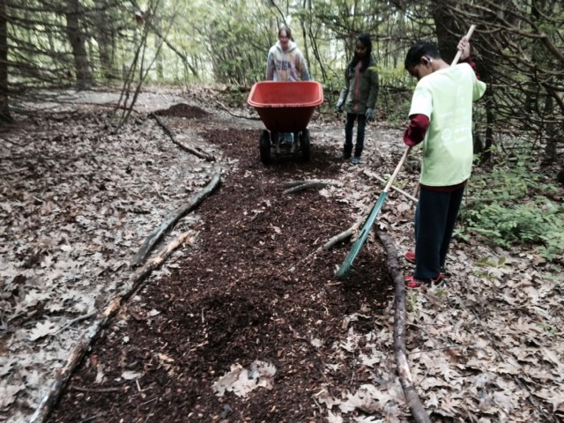
The Oyster River is a tributary of the Piscataqua River and part of the Great Bay Estuary in coastal New Hampshire. The river has a long tradition of providing residents and visitors with numerous recreational opportunities including fishing and boating. The upper part of the river, upstream of the Route 155A crossing, is a great spot for wild and stocked brook trout. The tidal portion of the river is a winter smelt fishery, and with adequate river herring runs, this part of the river also has the potential to be a popular location for striped bass. Boaters can access the Oyster River downstream of the Mill Pond Dam at either Old Landing or Jackson’s Landing. There is no ramp at Old Landing and boat launching is limited to canoes, kayaks, and rowboats. A dock provides access to moored boats. Depending on the tide, Jackson’s Landing is accessible for all boat types, including motorized boats. The boat shed and dock are shared by the Town of Durham and UNH. Boating at Mill Pond is limited to canoes, kayaks, and rowboats. Other recreational opportunities at these sites include bird watching, hiking, swimming, and ice-skating.
Photo 6: Oyster River Middle School students doing trail work at Wagon Hill Farm during Servicepalooza (Photo Credit: Durham Parks and Recreation Department)
Lamprey River
The Lamprey River is one of the longest and flattest rivers in the Piscataqua River watershed. It is nationally recognized for its outstanding environmental characteristics and is one of two rivers in New Hampshire to be federally designated as a Wild and Scenic River (the other being Wildcat River in Jackson). In the summer months, residents can canoe, kayak, and swim. Local anglers benefit from the State fish stocking program, which supplies brown, brook, and rainbow trout and maintains shad and herring restoration programs. In winter, visitors can enjoy cross-country skiing, snowshoeing, skating, and snowmobiling once the river freezes.
Quick Fact: The Lamprey River is one of two rivers in New Hampshire to be federally designated as “Wild and Scenic”
What You Said: Source: 2011 Master Plan Visioning Forum
“I want more opportunities for sailing classes and pond hockey.”

Great Bay
Great Bay is New Hampshire’s largest estuarine system (saltwater and freshwater) and is the drainage confluence of three major rivers, the Lamprey, Squamscott, and Winnicut. In recent years, recreational opportunities and tourism-related activities have become a much larger contributor to the region’s local economy. Depending on the tides, Great Bay boat access points include Adams Point, Chapman’s Landing, and Depot Road at the Great Bay Discovery Center. Once on the water, anglers can expect to catch striped bass, bluefish, eels, tomcod, shad, smelt, river herring, and flounder. Other recreational opportunities include hiking, swimming, and birdwatching. Great Bay encompasses nearly 25,000 acres of tidal waters and offers numerous viewing platforms for wildlife and birdwatching opportunities. Wildlife photographers and visitors may catch a glimpse of muskrat, whitetail deer, chipmunk, mink, otter, red fox or cottontail rabbit. Adams Point is one of the best birdwatching locations and is ideal for viewing bald eagles. Trails lead visitors around the point and offer excellent views of the Bay. Hunting is another popular activity, especially for waterfowl. All of the lands managed by the Great Bay National Estuarine Research Center are open to hunting unless otherwise posted.
Town-Owned and Private Facilities
Churchill Rink at Jackson’s Landing
Owned by the Town of Durham, Churchill Rink has a long tradition of outdoor ice-skating for residents and visitors. The facility has a roof with open sides, bathrooms, a snack bar, and locker rooms. The ice is primarily used by organized youth, high school and adult groups. There are public skate options, open stick and puck, and family pond hockey. The Rink offers learn-to-skate programs through the Oyster River Youth Association, as well as birthday party packages and private ice parties.
Community Playgrounds
- Oyster River Cooperative School District Complex (High School and Middle School) provides outdoor playgrounds for children with easy access to sports fields, tennis courts, and other recreation opportunities. The schools in the surrounding towns (Moharimet in Madbury and Mast Way in Lee) provide additional recreational space and activities.
- Father Lawless Fields (Woodridge Park) is a neighborhood park that provides a variety of recreational opportunities for young children, including: baseball and soccer fields, four tennis courts and two basketball half courts, a skateboard park, and a playground area.
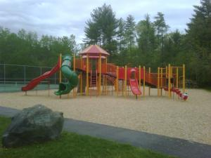
Photo 7: Woodridge Park Playground (Photo Credit: Parks and Recreation Department)

Private Facilities

- Durham is home to a broad range of outdoor and indoor recreational activities provided by local businesses, including yoga and Pilates, strengthen and conditioning, and other health and wellness classes. Cultural and crafting opportunities can also be found in the downtown core and on UNH’s campus.
- Adjacent to Moharimet Elementary School, Tibbett’s Field in Madbury offers two over-sized soccer fields for public use. The area offers a fitness trail and ample parking for residents and visitors.
Municipal Recreation Programs and Events
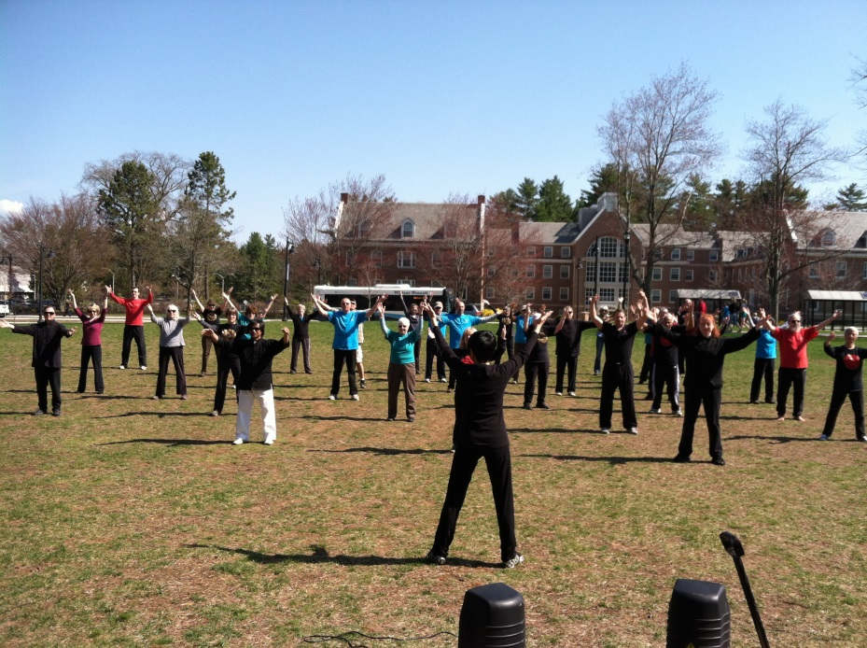
Durham allocates funding for the Parks and Recreation Department to provide a variety of programs and to organize community events for residents of all ages. This section provides information on the diversity of recreation opportunities within the community associated with the Parks and Recreation Department, as well as collaboration with other partners.
Photo 8: Durham Parks & Recreation Instructor Leads a Group of Students and Residents through a Routine during the Annual Tai Chi Day (Photo Credit: Parks and Recreation Department)
Recreation Education and Adventure Close to Home (R.E.A.C.H.)
R.E.A.C.H. is collaboration between Oyster River Cooperative School District, Durham Parks & Recreation Department, and the UNH InterOperability Laboratory to provide exceptional opportunities for our ORCSD students. Camp R.E.A.C.H. is a community-based summer camp experience for local youth. Camps include: math skills, woodworking, computer science concepts, cooking classes, miniature tree house design and construction, and pewter casting.
In addition to the morning and afternoon camps, R.E.A.C.H. also offers young children outdoor trips and sport programs. These include: bow and arrow skills, hiking adventures, theater performances, art design challenges, rope courses, kayaking tours, and trips to popular NH destinations like Water Country, Attitash Mountain, Pawtuckaway State Park, and Wagon Hill Farm.
Oyster River Youth Association
The Oyster River Youth Association (ORYA) provides sports and recreational programs to the youth of Durham, Lee, and Madbury through acquiring and maintaining facilities, promoting volunteerism, and seeking collaboration and strategic partnerships. ORYA offers children a variety of sporting activities including: baseball, basketball, football, hockey, soccer, rugby, tennis, and track. The Durham Parks and Recreation Department provides additional extracurricular programming for this age group (grades kindergarten through eight).
Recreation Program
The Durham Parks and Recreation Department has made significant progress in improving recreation programs in the community. Table 1 highlights some of Durham’s recreation programs. [Readers are encouraged to turn to this chapter’s Appendix or visit the Parks and Recreation website for a complete list of programs.]
Special Events
Table 1: Durham’s Recreation Programs
Coyote’s Inkwell | Michael Lang, storyteller and owner of The Coyote’s Inkwell, at Jackson’s Landing; sharing folktales, fables, and his own original stories around a bonfire
Durham’s Climbing Club | Youth Rock Climbing Club. Participants will have personalized instruction, and learn: belaying; knots; commands; problem solving skills; gear knowledge; confidence!
Yoga at Wagon Hill Farm | Free Summer Yoga at Wagon Hill Farm.
Tai Chi | Focused on increasing strength and balance for everyday movements.
Speed Camp | Improve: speed; acceleration; core strength; coordination; reaction time; conditioning.
Pilates | Core and flexibility training wrapped into one hour. You will improve your flexibility, gain core strength, and overall body tone. Recommended by physicians and physical therapists as an excellent class for individuals with lower back, neck, or hip issues
Couch to 5K | Learn to run, or work your way up to running a 5k. Program concludes with Bobcat Bolt.
Snowshoeing | Guided snowshoeing tours of local parks.
HoopFIT | Hooping is a fun cardio activity that burns up to 600 calories per hour. Add in the music and the social aspect of hooping and you have a great workout that feels like a party.
Source: Durham Parks and Recreation Department (2015)
A partial list of activities is provided in this section. [Readers are encouraged to turn to this chapter’s Appendix or visit the Parks and Recreation website for a complete list of events, times, and locations.]
Spring Festival/Egg Hunt at Town Landing (Late March or Early April) – Durham’s youth hunt for “hidden” eggs, play games, listen to music, and snack on treats.
Memorial Day Parade (May) – Each Memorial Day weekend, Durham hosts the town parade involving various community groups and committees.
Summer Concerts at Wagon Hill Farm (June – August) – A free summer concert series at Wagon Hill Farm.
Durham Day at Wagon Hill Farm (September) – Each Fall, this is a celebration of the Durham, complete with live music, games, BBQ, vendors, etc.
A Spooktacular Day in Durham at Jackson’s Landing (October) – To celebrate the spirit of Halloween, Durham residents are invited to participate in pumpkin decorating, games, prizes, treats, ice skating, and face-painting.
Photo 9: Kids watch the Annual Tree Lighting Celebration (Photo Credit: Parks and Recreation Department)
Feather Fest at Wagon Hill Farm (Thanksgiving Day) – To celebrate
Tree Lighting Celebration on Main Street (December) – As Christmas approach, Durham’s tree lighting downtown is filled with games, vendors, crafts, live music, and an appearance from Santa.
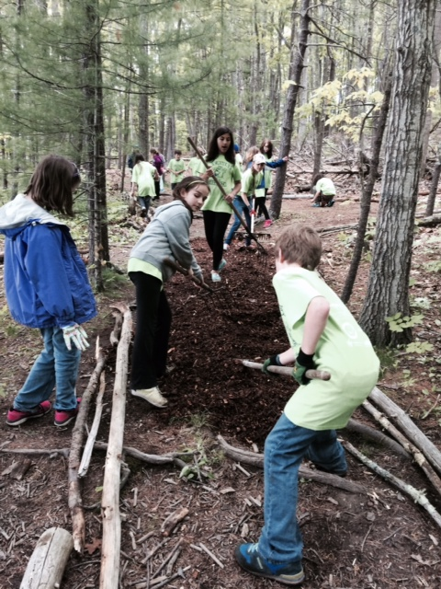
Key Conclusions
Photo 10: Oyster River Middle School students doing trail work at Wagon Hill Farm during the Servicepalooza (Photo Credit: Parks and Recreation Department)
- Greater emphasis on the administration of the town’s recreational resources, facilities, and programs will be required to reach both the goals set forth by the Town Council and the long-term vision of the Parks and Recreation Committee.
- As the community demand for increased recreation services rises, a greater number of local resources will be required to successfully manage current and expanding recreational needs.
- Durham’s recreation resources are underutilized due to a lack of awareness.
- There is a certain level of uncertainty of how the existing and future trail system in town will function in the long-term.
- Durham’s trail system is not well known, poorly marked in many areas, and often inadequately maintained.
- Bicycling around town, particularly navigating the downtown core and accessing outlying properties, can be dangerous and unpleasant.
- Most water access points contain some limitations on boating and are underutilized, likely as a result of the lack of community awareness, poor signage, and inadequate facilities.
- The 1995 Wagon Hill Farm Master & Management Plan is in need of an update, in coordination with the Land Stewardship Plans for Town-owned properties.

Goals and Recommendations

This section outlines the goals and recommendations associated with the key conclusions of the chapter and are intended to strategically guide the town’s recreation efforts over the coming decade. It’s important to note that the goals and recommendations below are not prioritized. Below each goal are related key conclusions from the previous section of this chapter that form the respective goal’s foundation.
Land Use Recommendation

Issue: Durham has made great strides in the management and administration of its recreational resources, facilities, and programs in the last decade, but much more work remains to realize the visions of the Parks and Recreation Committee and Durham Town Council.
Goal: Continue to support improvements in the management and administration of the town’s recreation resources, facilities, and programs
Key Conclusions References: #1
Recommendations
Partnerships, Collaboration, and Resource Sharing
- Acknowledge the importance of and continue to work with UNH, private, and other nonprofit owners of recreational facilities in Durham to ensure their continued availability and maintenance.
- Continue to work with the Oyster River Youth Association and the towns of Lee and Madbury to provide a full spectrum of recreational programs, minimize conflicts, and enhance marketing and public awareness.
- Work with new partners on opportunities that arise in the future to improve and/or expand program offerings and access to recreational facilities and areas.

Staffing
- Hire an assistant recreation director, as demand requires, enabling the director to maximize time on planning, organization, and management.
- Utilize intern and practicum students to focus on special projects. Hire an assistant Recreation Director, enabling the Director to manage and enhance programs, events, grants, marketing, budget, and community surveys
Planning
- Develop maintenance plans and schedules for all recreational resources and facilities and set goals for every two-year period.
- Use sustainable landscaping techniques to reduce ongoing maintenance costs.

Funding
Explore ways that the Town’s recreational resources, facilities, and programs can work to mutually support other attractions and businesses. For example, programming and events can draw residents to the farmer’s market in the summer and also to downtown businesses – as with the Tree Lighting event.

Issue: Durham will require additional facilities and funding to handle current and future recreational needs.
Goal: Assess the need to develop new outdoor and indoor recreational facilities; and pursue funding necessary to support management and operations that will meet the future needs of the community.
Key Conclusions References: #2
Recommendations
Partnerships, Collaboration, and Resource Sharing
- Continue to work with ORYA to develop a cooperative system to manage sports fields.
- Work with the Oyster River Cooperative School District and the high school to explore improving/ widening the use and management of district sports fields.

Planning
- Assess the recreational needs of different user groups in the community, especially seniors, and how they are being met. If there are unmet needs, prepare a strategic plan to guide the addition and/or improvement of recreational facilities, programs, and related administration.
- Prepare a needs assessment and maintenance schedule for all Town-owned recreational sports fields that are open to the public. Address issues such as ball fields that are compromised by seasonally wet conditions (e.g., Woodridge field), managing weeds, chemically treating and aerating fields, and the need for additional fields.
- Repair and upgrade the ice rink and plan for off-season use. Study the demand for and financial considerations associated with enclosing the rink, improving lockers and restrooms, and hosting tournaments.
- Develop a centrally located community recreational center and enhance existing facilities to provide space for intramural, adult, senior, and tot programs as well as ORYA activities. Examine the possibility of private sector development, ORYA participation, and potential funding sources.

Funding
- Explore opportunities (in addition to Town funds) to support recreation and facility maintenance, including user fees based on generally accepted standards in the region, potential grant sources, community fundraising, and, possibly, a revolving fund from program and special user fees (i.e., for weddings, etc.).
- Encourage support for Town-owned recreational facilities and reduce maintenance costs through the adoption of a business sponsor program for specific facilities, athletic equipment, and/or other activities.

Regulations
Collaborate with the Planning Department to require that new developments and subdivisions are more pedestrian and bicycle friendly and provide small parks, gardens, playground, and/or recreational facilities at the time of construction. Consider imposing fees that would be used for recreational purposes, including the construction, repair, replacement, or maintenance of Town-owned recreational facilities.

Issue: Durham’s recreational resources are underutilized due to lack of awareness as evidenced by the 2007 and 2001 surveys
Goal: Create sustainable methods of promoting the town’s existing unstructured recreational resources
Key Conclusions References: #3
Recommendations
Education and Outreach
- Improve the provision of information about recreational assets, such as trail and water access, facilities, parking, and programs – in brochures, online, and at strategic facilities (inventory notebooks) in places such as: Durham Town Hall, the library, local real estate brokers, local schools, recreation buildings, and at kiosks located at various parks.
- Expand online resources that can be accessed via computer; make these resources mobile-friendly.

Issue: Though the Town of Durham has formalized ownership for several trail systems in the last decade, there remains limited assurance that access to the rest of Durham’s extensive trail system will be available to the public in the long-term.
Goal: Prepare a strategy to protect and enhance the existing trail network in areas susceptible to development and/or transportation projects throughout the town
Key Conclusions References: #4
Recommendations
Partnerships, Collaboration, and Resource Sharing
- Work with the Conservation Commission and the Agricultural Commission via the Land Stewardship Committee to implement the multi-year proposal to inventory, prepare notebooks and management plans for each of the approximately 75 Town-owned properties and conservation easements to identify existing and ongoing maintenance needs as well as to guide multiple interests in use of the properties. Keep binders for each Town-owned property at the Durham Town Hall as a resource for employees, committees, and the public. Make the inventory available online. See Appendix for more complete description of the inventory and stewardship plans.
- Work with the Land Stewardship Committee to designate appropriate multiple public uses and benefits and establish ongoing maintenance plans for Town-owned properties.
- Actively work with UNH on long-term protection of trails in Durham that are owned by UNH or other public and private entities.

Advocacy
Support the Planning Board and Conservation Commission’s efforts to preserve existing recreational trails and water access points, particularly in the downtown area, and create new ones as part of its review of development or transportation projects, to maintain and/or provide connections between natural areas, neighborhoods, downtown, work places, and other significant locations to continue to create a pedestrian-friendly sense of community.
Issue: Durham’s trail system is in need of promoting with improved trail marking and maintenance schedules.
Goal: Prepare a strategy to regularly mark, add signage, and maintain the trails network
Key Conclusions References: #5

Recommendations
Partnerships, Collaboration, and Resource Sharing
- Work with the Conservation Commission to prioritize the trails in terms of amount of usage and need for maintenance and to perform regular maintenance.
- Work with the Conservation Commission, Agriculture Commission, and Land Stewardship Committee to create and include maps in the binders for each Town owned property that include existing and proposed trails and other common interests.
- Establish a stewardship program in coordination with the Conservation Commission and other interested groups and continue to seek volunteers to participate in trail cleanup events.

Education and Outreach
Continue to improve the public’s awareness of trails on Town-owned land with improved trail and parking signage, maps, and mobile-friendly interactive features.

Planning
- Establish a reporting system for trail and park maintenance issues.
- Create a log of signage needs and to document changes and maintenance efforts.
Issue: A majority of the downtown is not bikeable and needs improvement in order to provide safer navigation throughout town, as well as encourage walking and biking as an alternative transportation option.
Goal: Collaborate with Town of Durham staff, and, if existing, a local bicyclist advocacy group to develop a safe commuter and recreational bicycling network in Durham
Key Conclusions References: #6
Recommendations
Planning
- Create a bicycle subcommittee to prepare a comprehensive bicycle plan to increase Durham’s bikeability. As part of this effort, examine what other towns in the region are planning and doing to increase their bikeability. Designate bicycle routes in Durham with signage, pavement markings, and other techniques to improve bicycle safety.
- Continue to work to link the regional and local trail network to Wagon Hill Farm and other important recreational and community locations in Durham.

Advocacy
Endorse and continue to support development of the Seacoast Region Bikeway, as it may be updated periodically, and in particular, the portion of the Bikeway that is located in Durham to link improvements in Durham’s bicycle system to the regional trail network.

Education and Outreach
Post information about progress in developing the bicycle comprehensive plan, bicycle routes, signage, and the Seacoast Region Bikeway to the Town of Durham website and prepare other promotional materials to increase the visibility of bicycle transportation options.

Partnerships, Collaboration, and Resource Sharing
Work with the Energy Committee to draft language for the Planning Board to consider in regard to their site plan review. Model language should stress that developers of new development and redevelopment projects be responsible for incorporating recreational infrastructure and improvements to the existing lot and surrounding areas.
Issue: Most water access points contain some limitations on boating and are underutilized, likely as a result of the lack of community awareness, poor signage, and inadequate facilities.
Goal: Prepare a strategy to improve water access with appropriate signage, maintenance, and improvements.
Key Conclusions References: #7
Recommendations
Advocacy
Continue to encourage the State to include Durham’s water access points on its list of future coastal dredging needs. Seek input and support from other stakeholders and examine other options if dredging is not feasible.

Planning
Improve facilities at the Jackson and Town Landings, including boat storage, programs, restrooms, aesthetics, and parking.

Issue: The 1995 Wagon Hill Farm Master & Management Plan is in need of an update to guide the town in improving the site as an active recreational site and community gathering place.
Goal: Work to formulate and implement a cost-efficient plan to improve infrastructure at Wagon Hill Farm that welcomes greater recreational use, while protecting its land, water, forest, and wildlife resources
Key Conclusions References: #8
Recommendations
Partnerships, Collaboration, and Resource Sharing
- Continue to collaborate with the Conservation Commission, Agricultural Commission and other interested parties via the Land Stewardship Committee to develop an updated plan for Wagon Hill Farm that reflects the community’s interests in recreation, conservation, and agriculture on the property.
- Support the establishment of a volunteer stewards group to welcome visitors to the property, provide information and coordinate with staff on maintenance and programming needs.

Outreach and Education
Encourage individual visitors and community, school, and summer camp gatherings for recreation and environmental education.

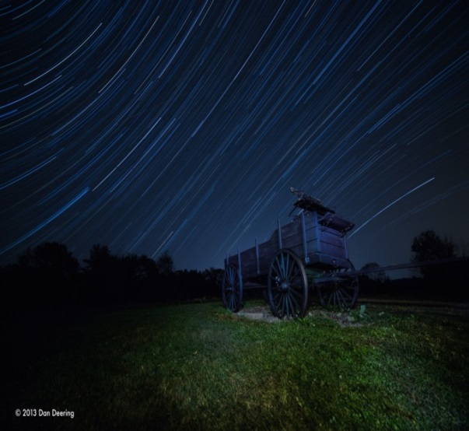
Planning
Photo 11: Wagon Hill Farm Astrophotography (Photo Credit: Dan Deering)
- Evaluate proposed improvements to the house and barn that could lead to the establishment of a modest visitors’ center and indoor space for community activities.
- Expand public transportation to the site.
- Improve access for bikers to the site.
- Evaluate and update rules and regulations and permitted and unpermitted uses of the property.

Staffing
Establish an on-site caretaker position.

Funding
Implement a non-resident parking fee to assist with on-site improvement projects and maintenance.
Connections to Other Chapters
Recreation issues intersect and align with many aspects of the community’s plans for the future. As a result, they help inform other chapters of the Master Plan. Considerations raised in this chapter echo throughout this document and are especially linked to the following components of other chapters.

Vision and Community Character
Durham is a town with a lot to offer residents - from woodsy paths and waters for boating to a lively assortment of recreational classes and annual events that bring the community together.
Agriculture
Wagon Hill Farm is widely recognized as a local trademark by residents. Here, gardeners tend their plots near the barn, dog owners walk the trails in the early mornings, kayakers embark from the shore for lessons, school children and families play and explore, and residents come together for live music while the summer sun sets.

Demographics and Housing
According to national recreational trends, more and more younger children are participating in outdoor activities. Youth - among ages 6 to 17 viewed bicycling as the most popular outdoor activity.
Downtown and Commercial Core

Residents have more bike lanes and crosswalks to navigate as Durham's downtown grows and develops. Town-owned and private facilities within walking distance of the downtown are Churchill Rink, community playgrounds at the Oyster River High School and Middle School, and a broad range of outdoor and indoor recreational activities by local businesses including yoga and Pilates, strengthen and conditioning, and other health and wellness classes.
Economic Development
With the help of a creative business model covering a portion of operating expenses through grants, business sponsorships, and dedicated revenues from events and program fees, the Parks and Recreation program would aim to have its programs open to lower income residents. However, the Department's capital needs and general staffing require the continued financial commitment and support of the town.
Energy

Durham wishes to pursue recommendations released in the 2013-2018 Statewide Comprehensive Outdoor Recreation Plan. Recommendations include active transportation programs (bike/walking paths), emphasis on community trails, parks and playgrounds, and engaging youth in the outdoors during school hours; all of which encourage non-motorized activities.
Existing Land Use
The Parks and Recreation Department has identified and prepared an inventory of Town-owned, State-owned, and University-owned lands with outdoor recreation sites available for public use.
Historic Resources
Durham has a number of historic buildings, structures, dams, and museums. For example, the former Town Courthouse is now home to both the Durham Historic Association Museum and the Durham Parks and Recreation Department. The Museum offers an ever-growing collection of the town's history, as well as archives of local genealogical interest. The Parks and Recreation Department provides residents a wide variety of quality programs that encourage community members to participate in healthy, fun, and enriching activities.
Natural Resources

Durham's open space lands and existing conservation easements are among the town's most important recreational resources. These conservation projects translated into the permanent protection of unique ecosystems and wildlife on properties that provide residents with a variety of recreational opportunities.
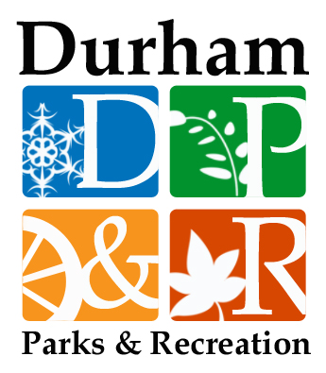
Qualifications
This chapter is intended to provide a brief summary of national trends related to the economic and health benefits of outdoor recreation, statewide activities and goals, and existing recreation opportunities within the community. Comparative analyses between the Town of Durham, Strafford Regional Planning Commission planning region, and State of New Hampshire are provided as a contextual tool for informing readers. While this chapter does provide a snapshot view, it is not a comprehensive study.
Findings are based largely on data derived by using the NH Land Use Mapping Standard, Master Plan Visioning Forum, Master Plan Survey, and the Five-Year Statewide Comprehensive Outdoor Recreation Plan (2013-2018).
Additional datasets that were referenced during the development of this chapter include those from the Durham Parks and Recreation website, the UNH’s Department of Natural Resources & the Environment, and input from the Parks and Recreation Committee. Goals and recommendations were developed by the Durham Parks and Recreation Committee.
This chapter is intended to provide Durham decision makers with the best available information.

This calculation does not consider open water.
The Town Council has placed a priority on Recreation, calling for efforts in its 2013 goals to: “Strengthen the community by supporting an array of recreational, artistic, and educational opportunities, and by celebrating and sustaining Durham’s history and natural setting and initiatives that promote public transportation options, including safe walking and biking.”

