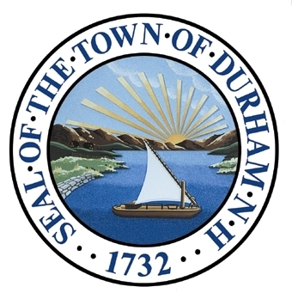
Natural Resources
The Natural Resources Chapter of the Master Plan presents a vision and steps to guide the Town’s efforts for the next ten years and beyond. This chapter includes a summary of the town’s diverse natural resources, areas of critical concern, and conservation and protection measures. It offers a series of goals and recommendations for achieving the overall vision of a municipality that fosters a sustainable and resilient community by maintaining the integrity of its natural resources, while also allowing for growth.

Adopted by the Durham Planning Board on November 18th, 2015.

Our Vision
In 2025 and beyond, Durham’s abundant natural resources continue to characterize and enhance quality of life in this seacoast community. Durham’s abundant natural resources — including beautiful forests, coastal streams and waterbodies, attractive waterfronts, open space, agricultural land, and drinking water resources — are well protected. Through protecting these resources, Durham maintains its rural character. Both public and private natural resources provide the foundation of what makes Durham an attractive place to live, work, and play, as well as support its role as a family oriented community and a center of education and employment in the region. The town’s conservation measures reflect recognition of Durham’s valuable and diverse resources. Durham continues to assess and, as necessary, amend its practices and regulations to foster a more sustainable and resilient community while balancing development and conservation.

Foundation
2011 Master Plan Survey: Natural Resources
Responses from 467 citizens who participated in the survey

0BDurham residents agree with the following statements:
 | 1BOverall Positive Response Rate | 2BStrongly Agree | 3BSomewhat Agree
4BProtecting the sources of our drinking water is important to me | 5B96% | 6B81% | 7B15%
8BDurham should protect its coastal streams and water bodies that lead to Great Bay | 9B96% | 10B71% | 11B25%
12BProtecting aquatic habitats is important to me | 13B91% | 14B63% | 15B28%
16BProtecting water resources for recreational use is important to me | 17B90% | 18B58% | 19B32%
20BDurham should play a role in encouraging less consumption, leading to less waste | 21B77% | 22B51% | 23B26%
24BDurham should concentrate commercial development in existing developed areas to preserve outlying, high-quality natural areas | 25B73% | 26B44% | 27B29%
28BDurham residents find the following attributes important or attractive
29BNumber of Responses
30B(participants chose top 3 attributes)
Rural character | 31B119
Natural areas, settings, and resources | 32B40
Lamprey and Oyster Rivers | 33B25
Green, scenic, and open spaces | 34B16
Wagon Hill | 35B16
Access to the seacoast | 36B14
Great Bay | 37B11
Land conservation | 38B8
Parks | 39B7
40BTOTAL NUMBER OF PARTICIPANTS | 41B467 citizens
Throughout successive Master Plans, Durham’s citizens have consistently voiced support for protecting the town’s natural amenities and water resources. Residents identify rural character, land conservation, scenic quality, and access to the community’s natural areas and resources — such as the Lamprey and Oyster Rivers, College Woods, Adams Point, Foss Farm, Mill Pond, and Great Bay — as important or attractive attributes of Durham. Proximity to the Seacoast is also important.
Balancing the protection of key natural areas with development, growth, access to, and use of these resources is an often contentious issue in Durham, as in many other communities. Striking a sustainable balance between conservation and development is a goal that has shaped Durham’s history for decades.
The following tables summarize relevant comments and input submitted during the 2011 Visioning Forum and 2011 Master Plan Survey, which were completed by the Town of Durham. Results of these engagement opportunities provide a lens of public perception and interest surrounding these topics and form the foundation of this Natural Resources chapter.
2011 Visioning Forum: Natural Resources
Responses from 90 citizens who participated in the forum

42BWhat do we look like today? | 43BWhat will we look like in the future?
Access to conserved lands is lacking | Connected natural resources, including rivers and open spaces
Trails overlap with recreation | Core vision of protecting natural resources
Mill Pond Dam is in danger (controversial) | Protect and restore rivers
Rural gateways need more attention | Celebrate Great Bay
Community gardens and Wagon Hill | Better accessibility to open space and resources
Endangered green areas associated with desire to develop tax base | Sustainable drinking water
Pollution and over use of salt threaten water quality in small streams | Land protection of water resource areas
Oyster River has pretty good water quality | Protection from corporate raiding of water sources
Diminished natural resources, pollution, over use of salt, water quality, small streams  are threatened | Cooperation between schools, library, recreation department, with regard to  resources and increased opportunities
Water treatment plant needs to be updated to keep up with growing population
Invasive species are a problem
TOTAL NUMBER OF PARTICIPANTS: 90 citizens

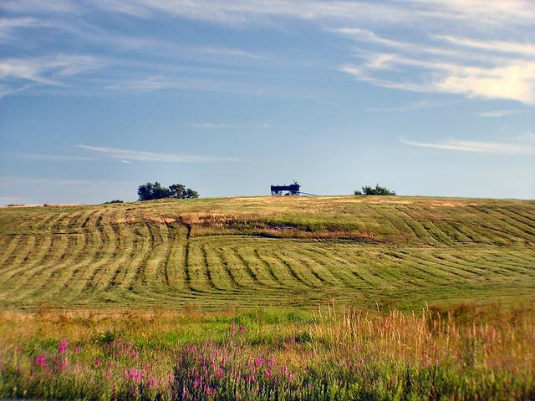
Photo 1: Wagon Hill Farm (Source: WunderPhotos)

Durham’s Natural Resources
Photo 1: Wagon Hill (Source: Durham Chiropractic)
An Introduction to the Town’s Natural Resources
Durham’s location on the Great Bay estuary, its proximity to the seacoast, and its diverse natural resources are defining features of the community. With an array of beautiful forests and open space, coastal river and estuarine systems, and marshes and wetlands, the town’s resources are ecologically significant at a local and regional scale.
These resources provide a number of ecosystem services, or benefits to society. These services include clean air and drinking water supplies; floodwater storage; stormwater management; productive agricultural soils; recreational opportunities; increased property values; and aesthetic value. Maintaining ecosystem services is critical to a high quality of life in Durham. Replacing these services would require significant capital investment, should they be degraded.
Durham Town Council’s 2014-2015 Goals Related to Environmental Sustainability and Resilience
The Durham Town Council identified a number of strategies for environmental sustainability and resilience within its goals. These strategies reflect the Town’s commitment to maintaining the quality of natural resources in the region.
- Pursue long-term economic and environmental sustainability and resiliency, anticipating the community’s and the region’s future needs through a framework that formally integrates the consideration of multiple elements including society, ecology, economics, transportation, agriculture, recreation, food and drinking water, climate, and energy resources.
- Continue to explore collaborative efforts with UNH to enhance mutual intellectual, cultural, environmental, and economic benefits, as well as community-building opportunities.
- Revitalize Durham’s commercial core to expand the tax base and enhance the sense of community while maintaining our small town character and cultural history and by weaving natural processes into the built environment for their environmental, social, and aesthetic benefits. Emphasis should be placed on “Smart Growth”, increasing commercial opportunities and consumer choices, and enhancing the town’s taxable base through economic development projects that fit with the character and goals of the community.

For many years, Durham residents have expressed strong support for environmental protection and conservation. Many of the town’s treasured public and private open spaces are already conserved, although two major properties, Wagon Hill and College Woods, are not. As a result of residents’ desire to protect natural resources, many of the town’s natural systems remain intact and a significant percentage of land is permanently protected, in spite of the fact that southeast New Hampshire is the fastest growing region in the state.
A Vision for the Future
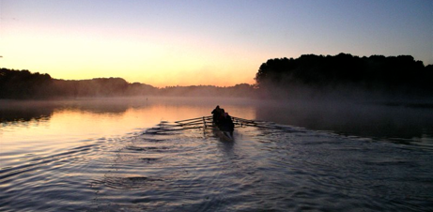
In order to maintain healthy ecological systems, Durham will continue to protect water resources that support natural habitats for aquatic organisms, as well as for other functions that include drinking water, flood control, and recreation. The Town will prepare and implement stewardship plans for Town-owned property. Durham will discourage deforestation or fragmentation of large undeveloped areas and preserve or restore connections between natural areas to maintain wildlife and wildlife habitat. Through open space preservation, the Town will provide greater access to natural resources and waterways.
Photo 2: Great Bay (Source: Great Bay Rowing)
Because natural systems are not constrained by political boundaries, partnerships and regional collaboration will continue to play an integral role in natural resource management. Durham has a long history of collaboration and stewardship and will continue to partner with neighboring towns, state and federal agencies, the University of New Hampshire, and organizations that share an interest in or impact Durham’s natural resources.
Natural resource stewardship, or the protection and wise management of natural resources, and the development of a sense of environmental responsibility, foster sustainability within the town. In support of this, the Town and Conservation Commission will ensure that residents, businesses, and municipal staff are educated about the importance of protecting natural resources and well informed of the tools, resources, and strategies available for natural resource protection.

Durham will encourage organizations, such as the schools, library, and recreation department, to use conservation lands to attract residents to the outdoors.
The Town will periodically review and evaluate its local land use regulations to ensure natural resources are adequately protected. Through the use of the best science available, state guidance and model ordinances, best management practices, and by exploring new and creative practices and policies that enhance greenspace and support climate adaptation and mitigation, Durham will continue to demonstrate leadership in environmental sustainability.

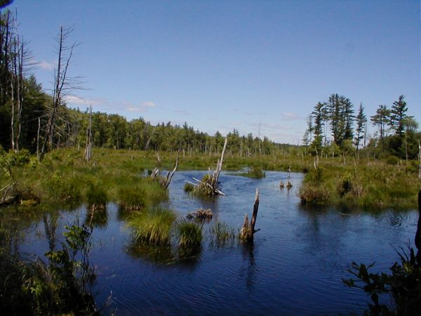
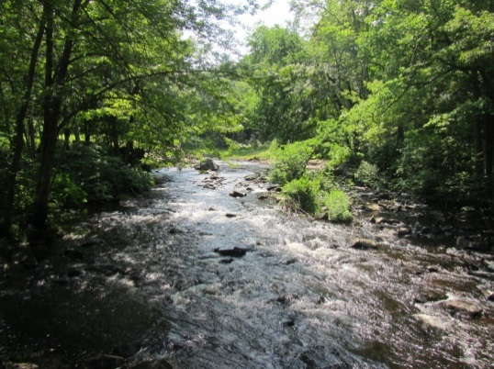
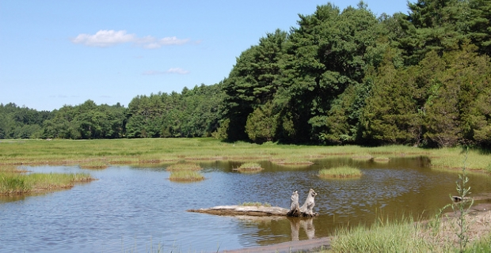
Six Areas of Critical Concerns
Photo 5: Oyster River (Source: Scott Finley)
Photo 3: Lamprey River (Source: BostonKayaker)
Photo 4: Little Bay (Source: UNH Marine Science and Ocean Engineering)
Drinking Water Supplies
Long-term protection of ground and surface water resources is essential for high quality drinking water. The health and water quality of the Oyster and Lamprey Rivers and the Spruce Hole Aquifer, which are all important drinking water sources for the Town of Durham, is paramount to ensuring a long-term supply of drinking water for Durham and the University of New Hampshire.
A regional approach to groundwater management is essential as activity in the towns of Durham, Lee, Madbury, and Newmarket affects drinking water resources each community draws from. Durham’s drinking water aquifers require ongoing protection from activities such as road widening; reconstruction; new road or sidewalk construction; residential and commercial development; gravel wetland construction; and potential contamination that flows within bedrock aquifers. Over the last several years, the acquisition of conservation easements on tracts of land along the Oyster River has increased the protection of this valuable resource.
Surface Water and Estuarine Resources
Surface water, stormwater, and wastewater within the Great Bay watershed flow into the bay and thus directly impact the water quality of the estuary and its tributaries. Over the last decades, the increase in impervious surfaces due to development has contributed to water quality degradation in Great Bay. Both public and private actions are needed to reduce pollution entering the bay and to support the health of valuable aquatic and shoreland wildlife habitat. Actions may include land acquisition and other conservation measures; wetland, aquifer, and shoreland protection ordinances; and public education to raise awareness about stormwater management and the sensitivity of the Great Bay ecosystem.
Wetland Protection
Durham has a significant number of wetlands, including salt marshes, which are one of the most productive types of wetlands. Wetlands provide a multitude of services to the community and to natural systems. These benefits include flood control, wildlife and fish habitat, water purification, groundwater protection, shoreline stabilization and erosion control, recreation, and protection from storm surge. Two potential primary threats to wetlands include development within wetlands and within wetland buffers and invasive species, such as phragmites and purple loosestrife. To maintain viable wetland systems, impacts to wetlands should be considered and, where feasible, minimized when new development or road improvements are designed.
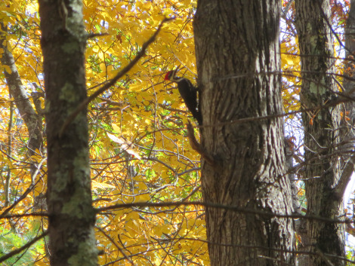
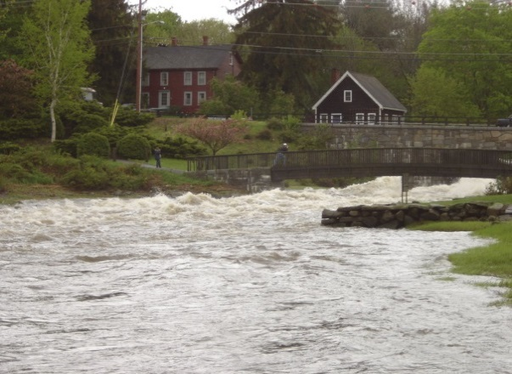
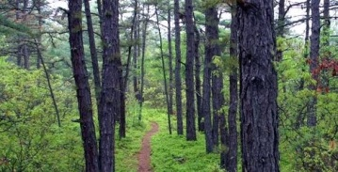
Forest Land and Open Space
Photo 6: Doe Farm (Source: NewHampshire.com)
Photo 7: Pileated Woodpecker (Source: Wordpress, The Park Explorer)
Photo 8: Oyster River (Source: DurhamNHFlood.Blogspot)
Durham’s forests, trees, and open spaces also provide many benefits, services, and products to the community. Protection and management of these resources is key to a high quality of life in town. Nearly sixty percent of the town consists of various types of forest cover. Urban forests and the trees and vegetation that compose the natural landscape provide beautification in neighborhoods and the downtown, while providing valuable habitat for wildlife, increasing stormwater management, shading buildings in summer, and enhancing property values.
Wildlife and Wildlife Habitat
Durham’s large areas of undeveloped land are ideal for providing and protecting habitat for many species of wildlife. The town lies within three watersheds and has many streams, ponds, marshes, and wetlands scattered throughout its boundaries. Tidal estuaries, freshwater streams, and salt and freshwater wetlands serve as critical habitats and greenways. Wildlife corridors and greenways provide travel ways and migratory routes between habitat areas and also support many recreational opportunities throughout the community. However, the town lacks an interconnected greenway network permitting wildlife habitat connectivity. Expansion of these areas will further connect residents with the environment.
Conservation practices and public awareness help to ensure adequate habitat and habitat connectivity for wildlife. Restoration efforts, such as the program implemented by Durham’s Conservation Commission and USDA Natural Resource Conservation Service for the New England Cottontail rabbit, a threatened species of particular concern, also help maintain habitat.
Impacts of Climate Change and Sea Level Rise
Climate change is already having impacts on natural resources and systems. Due to several factors, including proximity to the seacoast, location along a tidal river, and the numerous streams and rivers within the community, many areas of Durham are at risk of flooding associated with storm surge and increased precipitation rates. In addition to impacting public and private infrastructure and buildings, the projected increase in temperature and precipitation will affect sensitive habitats and species. For example, warmer temperatures have permitted harmful, cold intolerant insects like the hemlock woolly adelgid to move northward into New Hampshire. Measures to increase resiliency and reduce risks include discouraging development in floodplains; designing drainage and highway projects to reflect future precipitation and temperature change projections; and increasing public awareness of the risks associated with sea level rise and climate change.

Durham’s Natural Resources
Topography
Durham’s topography is characterized by gently rolling hills with elevations ranging from sea level along tidal areas to greater than 290 feet on Beech Hill along the town’s northern border. There are a total of approximately 48 acres of steep slopes with greater than 25% grade within Durham. These areas are located primarily along streams and rivers within Durham.
Bedrock Geology
Three types of bedrock are present in Durham. Exeter Diorite (Early Devonian), which is part of the New Hampshire Plutonic Suite (an igneous formation), composes approximately 71% of bedrock in Durham. Kittery Formation, which runs along the Town’s western boundary, and Eliot Formation, which runs along the eastern boundary, account for approximately 17% and 13%, respectively. These formations are both metasedimentary and metavolcanic rocks of the Merrimack Rough.
Aquifers
Retreating glaciers deposited sand and gravel as great as 80 feet deep in a northwesterly-southeasterly direction in Durham. These deposits make up a large stratified drift formation, known as the Spruce Hole Aquifer, located in the western part of Durham. The eastern portions of town have bedrock aquifers with water deposits located in fissures and cracks in the strata of the rock formation. Approximately 738 acres of stratified draft aquifer underlie Durham. Roughly 55% of the acreage suitable for high-yield wells (>75 gallons/minute) and 23% of the acreage suitable for very-high yield wells (>150 gallons/ minute) in Durham are protected.0F The transmissivity (or rate at which water travels horizontally through the aquifer) of the stratified drift aquifer in Durham ranges from 0 to over 3,000 square feet per day (Map 1).
New Hampshire’s Groundwater Protection Act (RSA 485-C) was enacted in 1991 to protect and preserve valuable groundwater resources. The act authorizes municipalities and public water suppliers to develop local groundwater protection programs. Durham reclassified a portion of its stratified drift aquifer as GA1 Groundwater of high value for present or future drinking water, which enables greater local and state protection.
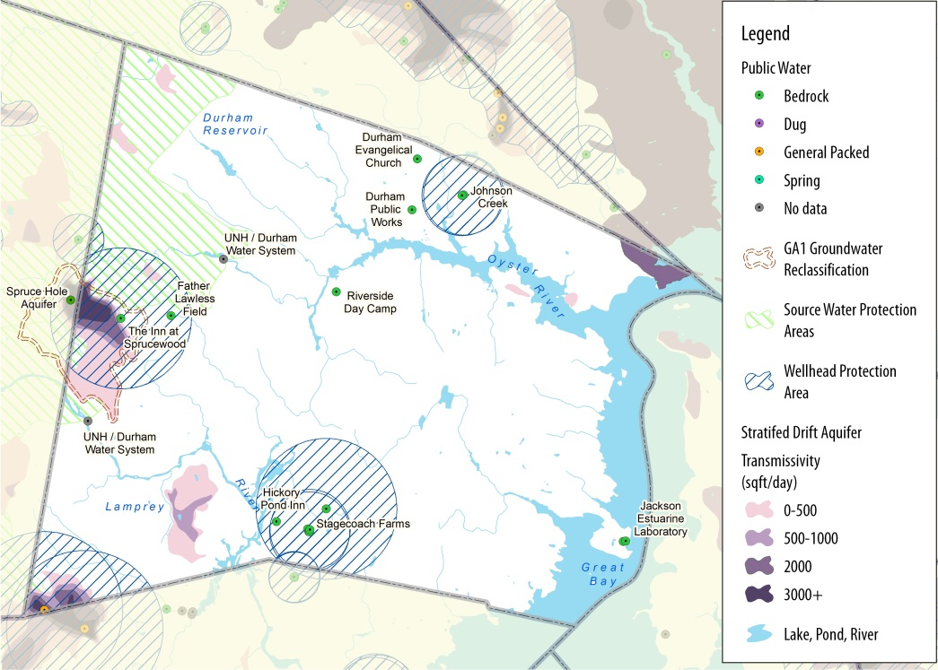
Durham recently developed a new groundwater supply well within the Spruce Hole Aquifer. This well can yield up to 1.04 million gallons per day and will be used to meet future water supply growth demands and peak summer and fall water demands, and may reduce surface water treatment costs. The Spruce Hole well will also serve as a redundant water supply source.1F
Map 1: Source water and public water system (Source: SRPC)

Watersheds
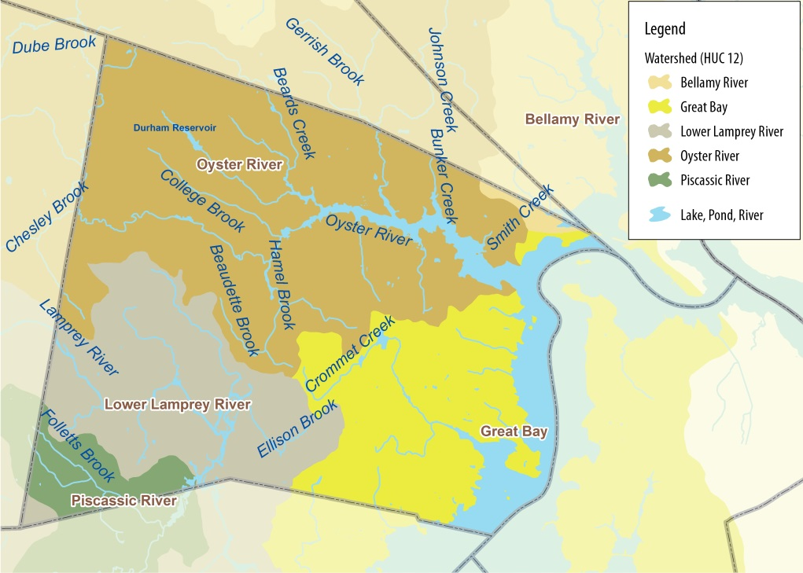
Durham lies primarily within the three coastal watersheds in the Salmon Falls-Piscataqua River Watershed: the Oyster River, Great Bay, and Lower Lamprey River watersheds (Map 2). Nearly half of the town falls within the roughly 20,000 acre Oyster River watershed, which extends east from Barrington to Great Bay. The southwest corner of Durham lies within the Piscassic River watershed and a small portion of northeast Durham lies within the Bellamy River watershed. Management of the land and water within these watershed influences the health of both Great and Little Bays.
Map 2: Watersheds and surface water (Source: SRPC)
Surface Water
Durham has both fresh and estuarine water resources. Surface water accounts for nearly 10%, or 2.4 square miles, of the total area of Durham. The town’s major surface water bodies include the Great Bay and Little Bay estuaries and the Oyster and Lamprey Rivers. Along with their numerous perennial and intermittent streams and rivers, these systems support diverse aquatic habitats and wildlife corridors, drinking water systems, and recreational opportunities. Mill Pond, located near the NH Route 108 crossing, is a one acre pond that also provides ample habitat and recreational opportunities. The Mill Pond Dam separates the saltwater from the freshwater portion of the Oyster River, which was designated into the New Hampshire Rivers Management and Protection Program in 2011.
Did you know?
- Great Bay is one of EPA’s 28 National Estuary Program Sites in the country
- Lamprey and Oyster Rivers are designated under NH River Management and Protection Program
- The Lamprey River is one of only two National Wild and Scenic Rivers in New Hampshire

Surface water from the Oyster and Lamprey Rivers provides drinking water for approximately 12,600 residents served by the UNH / Durham Water System.2F Durham Reservoir, which is fed primarily by the Oyster River, Chesley Brook, and Dube Brook, is also an important surface water resource in Durham. With an estimated storage volume ranging from nine to 14.7 million gallons, the reservoir is an alternative source of drinking water for the Town. F

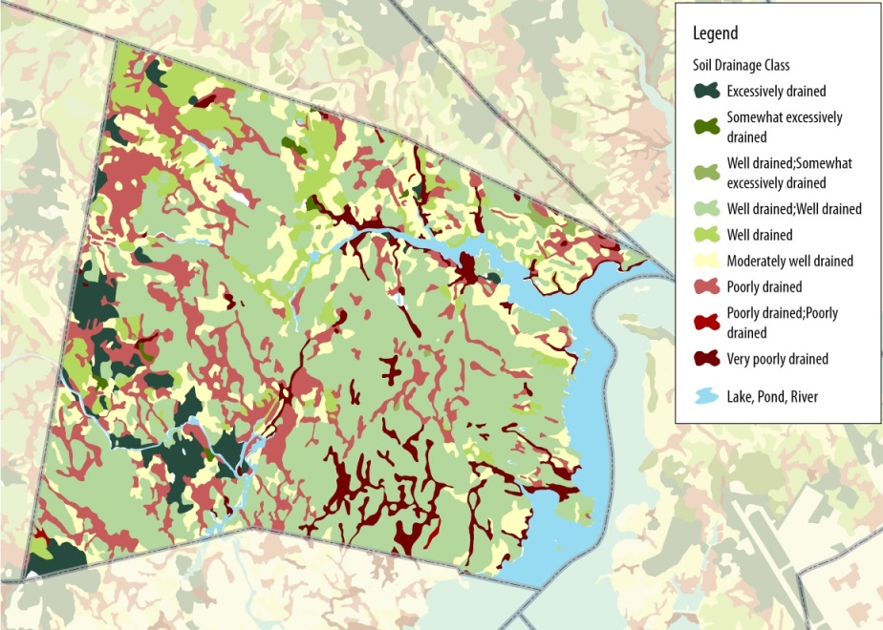
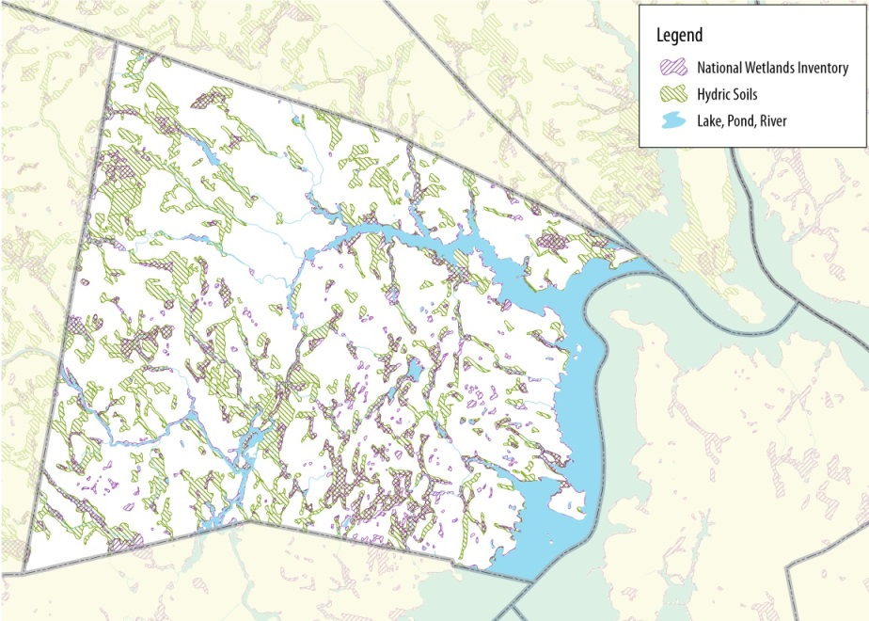
Soils
Map 3: Soil drainage (Source: SRPC)
Map 4: Wetlands (Source: SRPC)
Durham lies within an ecoregion characterized by mostly sandy and coarse textured soils. Silt and fine particle clay soils of marine origin occur in lower parts of the landscape. Over 50% of soils in Durham are well drained, somewhat excessively drained, or excessively drained (Map 3). Poorly drained and very poorly drained soils account for approximately 16% and 5%, respectively, in Durham. Drainage is one of five characteristics used in High Intensity Soil Surveys. Approximately 47% of soils are classified as prime farmland or farmland of local or statewide importance. Soils that are best suited for agriculture are located in the northwest, southwest, and northeast quadrants of the Town.
The four most prevalent soil types in Durham account for approximately 68% of all soil types. These include:
- Hollis-Charlton very rocky fine sandy loams (8-15% slopes and 3-8% slopes)
- Buxton silt loam (3-8% slopes)
- Scantic silt loam (0-3% slopes)
- Hollis-Charlton extremely rocky fine sandy loams (8-25% slopes).4F
Wetlands
Wetlands systems associated with the Lamprey River, Oyster River, Ellison Brook, LaRoche Brook, Hamel Brook, Crommet Creek, Johnson Creek, Bunker Creek, and Horsehide Brook are identified as significant due to their size, interconnected nature, and wildlife habitat that they provide.
Best Management Practice: Wetlands control flooding. Bisecting wetlands with roads or increasing the height of roads without mitigating measures should be avoided to prevent increases in the frequency and magnitude of flooding events.

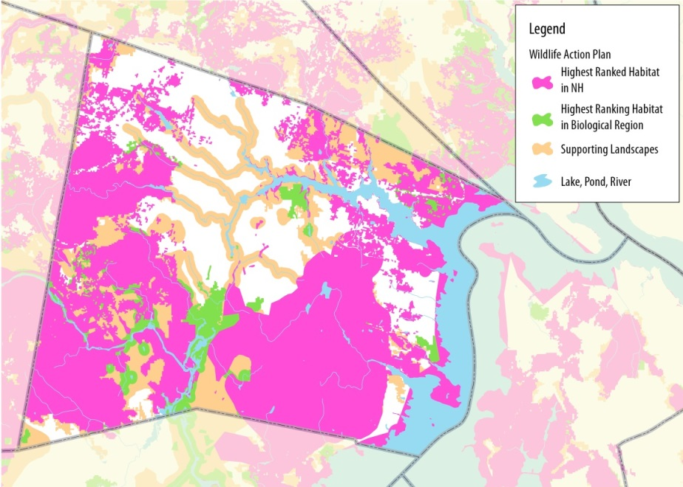
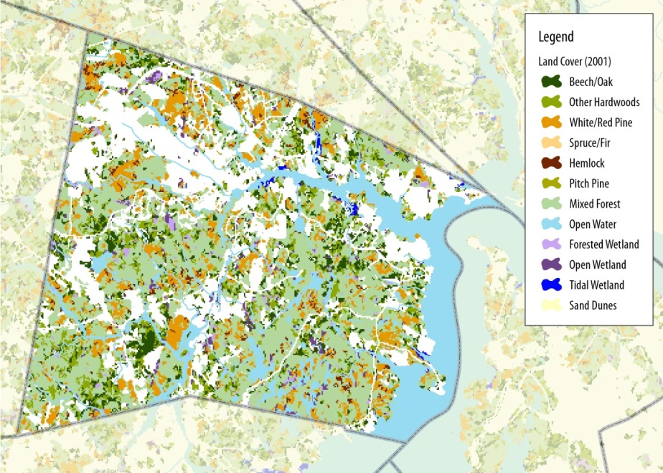
Forests and Open Space
Map 5: Land cover (Source: SRPC)
Map 6: Wildlife Action Plan habitat (Source: SRPC)
Durham’s land cover is dominated by diverse, hardwood, coniferous, and mixed forest types, open water, and wetlands. With the exception of land in the town core and areas along Route 4, Durham’s land cover consists predominantly of forest and managed agricultural cover. Forests account for nearly 60% (or 8,418 acres) of the land area within the Town.
Table 1: Forest Land Cover
Type | Acres
Mixed Forest | 5,212
White/Red Pine | 1,467
Other Hardwoods | 1,076
Beech/Oak | 999
Hemlock | 183
Pitch Pine | 11
Spruce/Fir | 2
Source: NH GRANIT 2001 Land Cover Assessment
The Town owns five lands with significant conservation value: Doe Farm, Wagon Hill Farm, Oyster River Forest, Longmarsh Preserve, and Wiswall Dam Properties (discussed in following section). College Woods, a 250 acre area of woods, streams, and small fields located in the northwestern portion of town, is another key natural area in Durham.

Significant Habitat and Wildlife
Table 2: Wildlife Habitat Type
Floodplain Forests | Appalachian Oak-Pine Forests
Grasslands | Hemlock Hardwood Pine Forests
Coastal Islands | Headwater Streams
Salt Marshes | Shrublands
Peatland | Vernal Pools
Marsh and Shrub Wetland
UNH students and professors have identified a wealth of diverse and significant wildlife habitats and species through numerous wildlife research projects. Significant wildlife habitats in Durham are included in the table below.
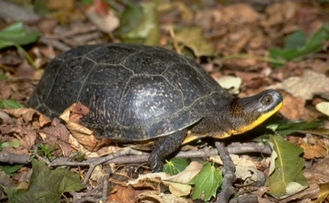
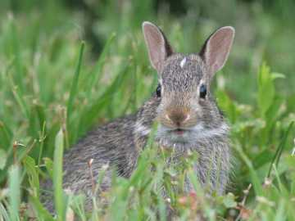
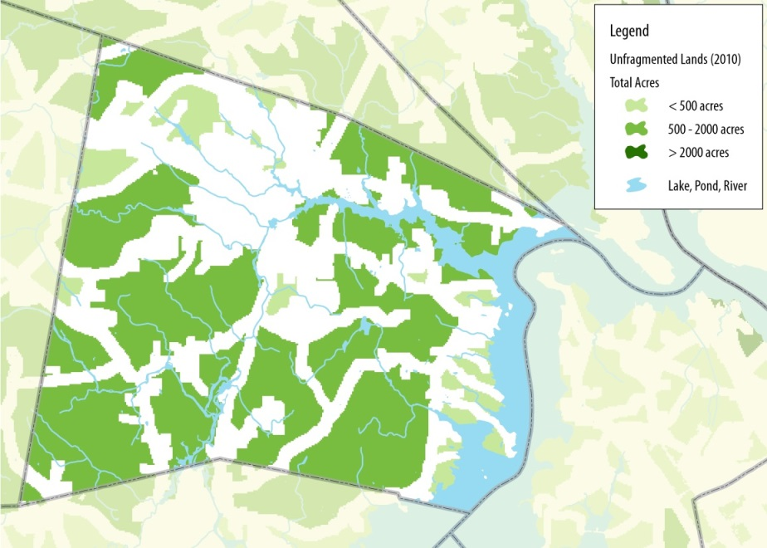
There are 12 known state listed endangered species found in Durham and an additional 20 known state listed threatened species. Currently there are no known occurrences of federally listed endangered or threatened species in Durham. Species proposed for listing including river herring and the New England cottontail. See supplementary material for a list Species of Special Concern, or rare species and exemplary natural communities, in Durham.5F
Map 7: Unfragmented lands (Source: SRPC)
Photo 10: Blandings Turtle (Source: VernalPool.org
Photo 10: Cottontail (Source: Gary Kessler)
According to New Hampshire Fish and Game’s Wildlife Action Plan, much of Durham’s landscape is designated as part of the highest ranked wildlife habitat by ecological condition in the state or biological region. Major river corridors within the town are designated as valuable supporting landscape.
Did you know?
The Great Bay estuary was formed by melting glaciers over 14,000 years ago. There are five unique water habitats within the bay: eelgrass meadows, mudflat, salt marsh, channel bottom, and rocky intertidal. (Source: GBNERR)

Conserving wildlife corridors in both urban and rural areas is essential to providing habitat for many species. Wildlife corridors and greenways (corridors of protected open space managed for conservation and recreation purposes, support wildlife and plants) serve as valuable buffers along streams and rivers, and provide recreational opportunities for residents. Greenways often follow land or water features and provide important linkages between open spaces.
Photo 10: Cottontail (Source: Gary Kessler)
Photo 9: Blandings Turtle (Source: VernalPool.org)

Land Conservation and Protection
Land Protection
Land conservation and protection is a key aspect of maintaining habitat, recreational areas, and water quality. The Town conserves and protects natural resources through the acquisition of conservation land, easements, and maintaining open space, in addition to its local regulations.
There are a range of options available to communities and landowners who seek to protect land. The appropriate method for protecting land depends on the natural resources present on a particular property and the goals of the landowner. The length of the term of protection and the restrictions on the use of the land vary depending on the method of land protection.
Two commonly used perpetual land preservation mechanisms are conservation easements and fee simple acquisitions. A landowner who wishes to permanently conserve property while retaining ownership may opt to protect land through a conservation easement. Other land protection methods, such as a deed restriction, limit a landowner’s use of the land but do not necessarily run with the land or protect the property in perpetuity. Deed restrictions, or restrictive covenants, can be used to set aside common open space areas of development, such as in a conservation subdivision. The diversity of protection strategies offers greater flexibility to the Town and landowners.
Since 2003, when voters approved a $2.5 million Conservation Bond, Durham has leveraged grant funds and its Conservation Fund6F to preserve 735 acres through ten conservation easements. In 2004, Durham adopted a Conservation Subdivision Ordinance. To date, two conservation subdivision projects have been approved, resulting in the conservation of a total of 43.6 acres. As of 2015, nearly 30% of land (accounting for over 120 parcels) in Durham has been permanently protected.7F Refer to the Existing Land Use Chapter for more information about conservation land in Durham.
Durham’s Conservation Commission
The Durham Conservation Commission (DCC) has a state legislative mandate to inventory, manage, and protect the natural resources of the town, and to make recommendations to the state on all applications to the New Hampshire Wetlands Bureau. The DCC acts as an advocate for natural resource protection in town and regional affairs, and is a source of information for Durham residents. The Commission works with other Town boards and committees (such as Parks & Recreation) and with the Department of Public Works to manage the Town-owned conservation lands. It also works with the Planning Board on land use planning and regulations.
Fee Simple Acquisition: An acquisition in fee simple includes all land ownership rights with no encumbrances. A land trust can conserve land through an outright purchase or donation, in which the landowner sells or grants all rights, title and interest in the property to the land trust. The land trust owns this land, maintaining perpetual stewardship and management responsibility. (Source: Triangle Land Conservancy)
Conservation Easement: A restriction placed on a piece of property to protect its associated resources that is either voluntarily donated or sold by the landowner and constitutes a legally binding agreement that limits certain types of uses or prevents development from taking place on the land in perpetuity while the land remains in private hands. (Source: The Nature Conservancy)

Table 3: Easements Funded in part by Durham Residents
Amber Acres | Fogg Farm
Emery Farm | Merrimack Easement
Langley Farm | Roselawn Farm
Mill Pond Center | Beaudette Farm & Woodlot
Source: Town of Durham

Table 4: Town-Owned Lands
Doe Farm | An 87 acre conservation area with beautiful woodland trails that lead down to the Lamprey River. Doe Farm is dominated by upland forest with a mix of red oak, white pine, and red pine and Norway spruce plantations.
Wagon Hill Farm | A 139 acre property with a variety of trails and scenic views that features an historic wooden wagon at the top of a hill overlooking Route 4. Wagon Hill has a small manmade sandy beach, many acres of grassland habitats, mowed trails, oak forest, old apple orchards, and over 60 community garden plots.
Oyster River Forest (aka Sprucewood Forest)* | A 172 acre property consisting of woods and fields that abuts College Woods and sits over 55 acres of the Spruce Hole Aquifer.
Longmarsh Preserve | A 73 acre preserve with marshes, open water, rocky outcrops, mature oak and pine forest, and abundant wildlife. The four-mile Sweet Trail starts at Longmarsh Preserve and ends at Great Bay in Newmarket.
Spruce Hole Conservation Area* | A 35.6 acre permanently protected conservation area that sits atop the Spruce Hole Aquifer, a public water supply. Unique species including black spruce trees, pitcher plants, sundew, and orchids are found in the peat bog.
Wiswall Dam Properties | A forested property with trails along the Lamprey River that is listed as a National Register Historic District and offers a variety of recreational opportunities. Wiswall Dam is also listed on the National Register of Historic Places. The dam has a fish ladder that provides anadromous fish passage to 43 miles of riverine habitat upstream of the dam.
*Permanently protected
Source: Town of Durham

Town-Owned Lands
The Town of Durham owns and manages diverse natural areas, conservation lands, and culturally significant properties. Table 4 provides a brief summary of Town-owned lands. These lands provide habitat for wildlife and a range of ecosystem services, such as drinking water protection and opportunities for recreation. They are also an important component of regional ecological systems and recreational networks. The four-mile long Sweet Trail, for example, runs from the Longmarsh Preserve to Great Bay.
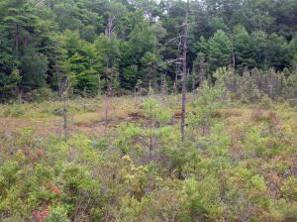
Did You Know? The Spruce Hole bog and Spruce Hole Conservation Area provide over 35 acres of protection for the Spruce Hole Aquifer, which is an important water supply for Durham and UNH.
The Spruce Hole bog is a unique geological feature called a kettle hole. A kettle hole is a depression formed by blocks of ice that are lodged in a deposit of till or drift and separated from the main, retreating glacier. According to the National Park Service, this bog is the last known kettle hole in southern New Hampshire.
Photo 11: Spruce Hole bog (Source: Underwood Engineers)

Table X: Town-owned lands
Table X. Town owned land

Land Use, Future Conservation Lands, and Natural Resources
Since 2000, Durham has experienced a successful period of private and public land conservation. As development pressure continues to increase, however, there is a continuing need to ensure that natural resources are well protected. The Town will need to achieve a sustainable balance between protecting natural resources and allowing for the growth and development necessary generate tax revenue required to fund future anticipated capital needs for public facilities.
There are a number of strategies the Town can take to work towards this goal. These include:
- Minimize the impact of existing and future development on natural resources, such as through integration of practices that reduce the impact of the built environment on the natural environment, into all aspects of planning and development in the community.
- Identify, prioritize, and conserve key ecological lands.
Map 8: Permanently conserved land, developed land, and developable (unconstrained) land (Source: GRANIT, SRPC)
- Review and amend local regulations, as necessary, to ensure regulations are enforceable and effectively protect natural resources.
- Ensure Town commissions and committees collaborate to identify common goals and objectives, creative and innovative solutions to minimize potential conflicts between desired future land uses, and opportunities to engage residents and other stakeholders.
- Enhance partnerships with organizations and neighboring communities that rely on and protect common natural resources.
Sustaining the ecological function and valuable ecosystem services provided by natural resources within the town and region may require that the Town purchase land or easements or adopt more stringent regulations.
Important natural features and resources in Durham include large, unfragmented forest land, intact floodplains and riparian zones, high quality stream networks, irreplaceable coastal and estuarine features, significant fish and wildlife habitats, critical habitat supporting rare species and exemplary natural communities, and connections among important land areas.
The Town will need to be strategic in how it allocates conservation funds but should also seek willing landowners or opportunities to leverage grants and other funding sources that arise. Maintaining a significant reserve in the Conservation Fund will help the Town to leverage dollars with conservation partners and respond to conservation opportunities that protect these ecological assets.
Within Durham, the land itself available for conservation and for other uses is also limited. Over 30% of the town is permentantly protected and an addional 15% is either owned by UNH or has another kind of develoment restriction (Map 8, Table 5).

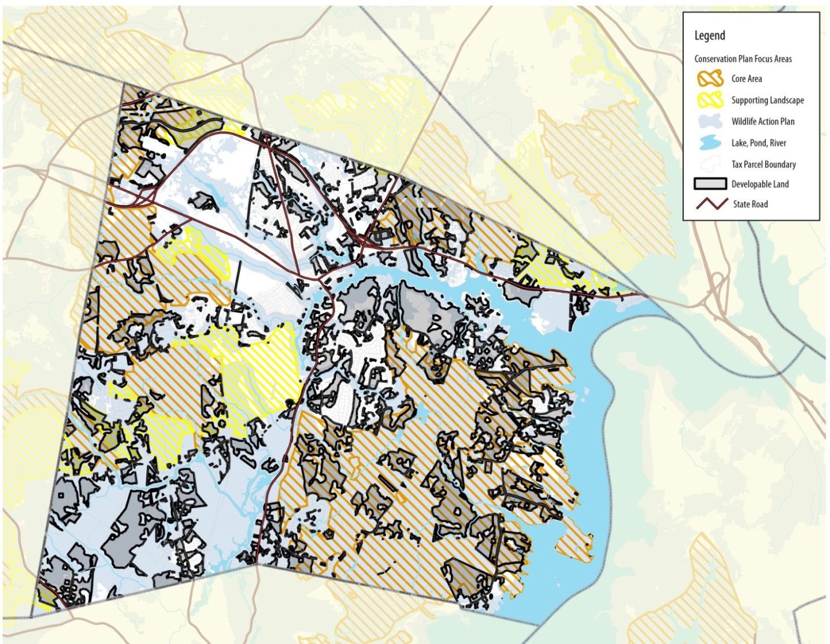
Five areas of town outside downtown core have been identified as potential locations for future development in the Economic Development Chapter of this Master Plan. The Future Land Use Chapter of this plan examines potentially competing land uses in these and other areas of Durham.
Map 9: Potential conservation priority areas and developable (unconstrained) land (Source: SRPC)
Did You Know? Durham has Guidelines for Acquiring Legal Interest in Conservation/Open Space Land to guide the acquisition of conservation/open space land. These guidelines were adopted by Town Council in 2004 and revised in 2008.

Table 5: Conservation Land Constraints
 | Land  (Acres) |  |  | Percent of Durham’s Land Area
Conservation Land | 4,281.3 |  |  | 29.9%
UNH | 1,928.3 |  |  | 13.5%
Town Owned & Other Protected Land |  |  | 192.4 | 1.3%
TOTAL |  | 6,402.1 |  | 44.7%
Source: SRPC
Because of this, identifying the best lands for future conservation is essential. Durham’s Guidelines for Acquiring Legal Interest in Conservation/Open Space Land guide the acquisition of conservation land and open space. The town may wish to establish a set of criteria to help prioritize conservation land prior to evaluating land on a project by project basis. These criteria may include lands identified in the Department of Fish and Game Wildlife Action Plan or Coastal Conservation Plan; the presence of rare habitats or species; drinking water protection; contiguous networks; patches that support wildlife; and lands that support other Town objectives, such as recreation or access to greenspace, in addition to natural resource protection.

Local Regulations

Durham helps protect surface water resources through shoreland, wetland, flood hazard, and aquifer overlay districts, as well as subdivision and site plan regulations (summarized below). Refer to the Town’s Zoning Ordinance, Subdivision Regulations, and Site Plan Review Regulations for more information.
Table 6: Summary of Local Regulations Intended to Protect Natural Resources
Article XIV Shoreland Protection Overlay District | Intended to protect the quality of the town’s surface waters in order to promote public health and safety, maintain wildlife habitat, and conserve and protect shoreline and upland resources.
Article XIII Wetland Conservation Overlay District | Intended to protect the quality and functioning of wetland throughout the town by managing the use of the wetland and the upland buffer adjacent to the wetland in coordination with the state dredge and fill permit system.
Article XV Flood Hazard Overlay District | Regulations that apply to all lands designated as special flood hazard areas by the Federal Emergency Management Agency in its Flood Insurance Study for the County of Strafford, New Hampshire, together with the associated Flood Insurance Maps (FIRM).
Article XVI Aquifer Protection Overlay District | Intended to protect, preserve and maintain existing and potential groundwater supplies and related groundwater recharge areas within the town.
Article XIX Conservation Subdivisions | Requires that the key natural, historical, archeological, and cultural features on conservation subdivision sites be identified for protection and the development planned to protect these resources
Subdivision Regulations 9.06 Stormwater Drainage | Requirements for subdivision proposals with lands identified as Special Flood Hazard Areas in the “Flood Insurance Study for the Town of Durham, N.H.” with the associated Flood Insurance Rate Maps and Flood boundary and Floodway maps of the Town of Durham
Subdivision Regulations 9.07 Special Flood Hazard Areas | Requirements for subdivision proposals with lands identified as Special Flood Hazard Areas in the “Flood Insurance Study for the Town of Durham, N.H.” with the associated Flood Insurance Rate Maps and Flood boundary and Floodway maps of the Town of Durham
Source: Town of Durham

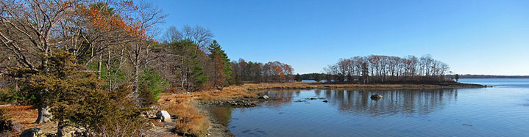
Photo 12: Great Bay (Source: Conservation Law Foundation)
Table X

Water Resource Management
Durham and UNH adopted an Integrated Watershed Planning and Permit approach in an effort to develop effective, collaborative, and sustainable solutions to reduce nitrogen loading within the watershed. This allows the Town and UNH to address water quality objectives for their shared wastewater treatment facility and adjacent regulated municipal stormwater systems that discharge into the Oyster River estuary.8F
The goals of this project include:
- Collaboration: Expand on existing collaborative efforts between the Town of Durham and UNH to combine resources and more efficiently address wastewater and stormwater permit obligations with a solution oriented integrated watershed approach.
- Cost-Effectiveness: Identify the most cost-effective solutions by balancing the potential capital and operational costs with the anticipated effectiveness of the various wastewater treatment, stormwater management and nonpoint source control measures.
- Sustainability: Identify measures within the regulated urbanized and municipal sewered areas of Durham and throughout the watershed to achieve water quality objectives through a more holistic and watershed-based approach.⁹
For more information about this innovative approach to watershed management planning and implementation, see the Oyster River Integrated Watershed Plan for Nitrogen Load Reductions – Final Technical Report – July 2014.
Ecosystem Services and Quality of Life
Ecosystem services support society and contribute significantly to quality of life. Ecosystem services are benefits people obtain from ecosystems. These include provisioning services such as food and water; regulating services such as flood and disease control; cultural services such as spiritual, recreational, and cultural benefits; and supporting services, such as nutrient cycling, that maintain the conditions for life on earth.
Photo 13: Wagon Hill (Source: Flickr, Brandan O’Neil)
The Natural Services Network map shows lands that provide important ecological services such as drinking water, storage of flood water, high value and productive agricultural soils, and important wildlife habitat, as identified using the New Hampshire Natural Services Network GIS-based tool (Map 10).
Protection and management of forests, trees, and other vegetation will ensure the provision of many benefits, services, and products including:

- Improved wildlife habitat for specific species of concern
- Places for recreational activities
- Improved scenic quality, community character, and property values
- Watershed protection, reduced impact of stormwater, and improved water quality
- Improved air quality.

Did you know? In addition to increasing property value, urban trees can shade buildings and provide energy and cost savings for homeowners.
Although often challenging to quantify, natural resources provide numerous economic benefits. The Trust for Public Land found that every $1 invested in land conservation through state programs returned $11 in natural goods and services to the New Hampshire economy.9F
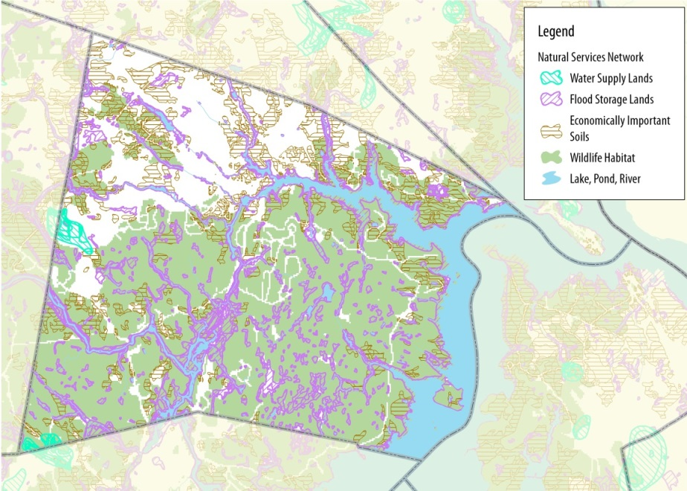
Stewardship, Collaboration, and Partnerships
Map 10: Natural Services Network (Credit: SRPC)
Durham has a strong history of stewardship built on a foundation of volunteers from organizations and associations, groups from UNH, and residents. Stewards play a key role in monitoring water quality, restoring natural areas, and educating residents, businesses, and Town officials and staff.
Continuing to partner with conservation groups to identify, fund, and leverage conservation dollars to the greatest extent possible will enhance the community’s ability to protect its valuable natural resources. It is important that the Town plans carefully for capital investments in its natural resources, seeks alternative sources of financial support, and ensures that its limited resources are effectively invested.
As natural systems cross political boundaries, the Town should continue to identify opportunities to collaborate with communities within the Great Bay watershed when managing ground and surface water. Durham should also seek opportunities to expand and connect greenways and corridors with partners in adjacent communities. Partnering with watershed associations will guide collaborative water resource planning with neighboring communities.
Collaborative Management of Durham’s Resources
The Town must take a comprehensive and collaborative approach when developing and updating stewardship and management plans. These plans provide an opportunity for the Town to evaluate the appropriate balance between maintaining adequate protection while allowing for public use and enjoyment of natural areas for specific, diverse properties. Many factors, including an ecosystem’s sensitivity to human activity or the critical services it provides as well as the land’s public value, must be weighed and considered.
Collaboration among the Agriculture Commission, Parks and Recreation Committee, and Conservation Commission is a fundamental component of developing a vision and plan to preserve the value of important Town-owned lands, including Wagon Hill.

Trends and Future Concerns
Impervious Surface: A material with low permeability that impedes the natural infiltration of moisture into the ground so that the majority of the precipitation that falls on the surface runs off or is not absorbed into the ground. Common impervious surfaces include:
- Roofs
- Concrete or bituminous paving such as sidewalks, patios, driveways, roads, parking spaces or lots, and storage areas
- Compacted gravel including drives and parking areas
- Oiled or compacted earthen materials
- Stone, concrete or composite pavers
(Source: Durham Site Plan Review Regulations)

Population, land use, and development changes impact natural resources, forests, agricultural lands, critical water supply resources, and biodiversity.
Land Cover Change
In its New Hampshire’s Changing Landscape 2010 update, the Society for the Protection of New Hampshire Forests identified the following statewide trends:
- New Hampshire continues to rapidly develop its sources of clean drinking water – almost 20,000 acres of land over aquifers was converted from natural land cover to urban land uses from 2002 to 2010. Only 22% of important aquifers are protected from future development.
- Based on current trends and predictive models, New Hampshire’s forested lands will continue to decline in acreage. Forest loss linked to population growth indicates the conversion of another 225,000 acres by 2030, dropping New Hampshire forest land to 78.5% of total land area.
- New Hampshire continues to lose farmland. Over the last two decades, the state has seen a 23% decline in acres used for cropland and pasture.10F
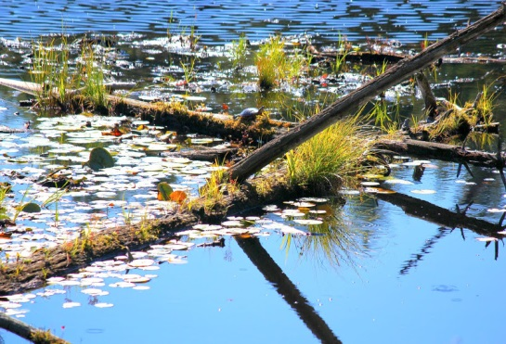
Water Quality in the Great Bay Watershed
Photo 14: Longmarsh Preserve (Source HikeNH.com)
Development, increase in impervious surface cover, agricultural runoff, and lack of septic system maintenance are factors that result in nonpoint source pollution. Nonpoint source pollution, along with point source pollution, impacts water quality in Great Bay. One primary contaminant affecting Great Bay is nitrogen. In the five years between 2005 and 2010, the total nitrogen load into the estuary increased by 42%. This has led to the loss of wildlife habitat, closure of shellfish beds, and decline of water quality in the estuary.11F According to NHDES, the Oyster River watershed contributes the highest amount of nitrogen of any watershed in Great Bay.
As towns in the Seacoast region grow, the water quality of both Durham’s salt and fresh water bodies become increasingly vulnerable to degradation associated with residential septic systems, lawn fertilizers, herbicides, pesticides, wastewater treatment plants, accidental spills, erosion, and stormwater runoff.
The Piscataqua-Salmon Falls watershed in New Hampshire and Maine has been identified as one of the country’s top 15 watersheds most at risk for potential decline in water quality resulting from the conversion of private forest land to housing development.12 Sediment and stormwater runoff associated with land use disturbance has been identified as a significant contributor to water quality decline by the Piscataqua Region Estuaries Partnership (PREP).13 Furthermore, development that encroaches on shorelands reduces the availability of important habitats for wildlife. Over the long term, the cumulative impact of mismanaged stormwater runoff is a substantial threat to the environmental health of the estuarine system.
Climate Change, Sea Level Rise, and Flooding
Climate change will have widespread impacts on natural resources. Projected changes in temperature and precipitation will have a range of direct and indirect impacts on plants, wildlife, and ecosystem processes.14F Ecosystems will face both spatial and temporal changes that may result in lack of suitable habitat for many valuable species. Forest composition is projected to change. By 2100, the optimal growing conditions for northern hardwood forest species is expected to move at least 100 to 300 miles north.15 As temperature warms, many species that currently live within the boundaries of conservation land may shift or migrate northward and out of protected areas.
Climate change will affect water temperature, water quality, streamflow, and aquatic biota. An increase in stormwater runoff associated with higher precipitation will contribute to higher nutrient and contaminant levels in streams, rivers, and Great Bay.15 In addition, climate change will also likely increase the threat of invasive species.
In coastal areas and along rivers and stream, flooding and storm surge may impact species with low tolerance for changes in salinity or inundation. Higher acidity levels associated with climate change will also have a negative impact on species that inhabit coastal waters.
Maintaining natural areas, open space, floodplains, and adequate buffers is an important component of climate adaptation. Considerations for reducing climate change impacts on natural systems include:
- Limiting the impact that human adaptation strategies have on ecosystems
- Maintaining wetlands and floodplains that have the capacity to absorb floodwater and protect both human and human systems
- Enhancing habitat and wildlife corridors that support migration and movement
- Reducing existing stressors, such as pollution and invasive species, on natural systems.

Resources and Studies
The Oyster River Culvert Analysis Project
http://www.antiochne.edu/wp-content/uploads/2014/11/oyster_river_culvert-analysis-2010.pdf

Conservation Economics
https://www.tpl.org/conservation-economics-0

Oyster River Integrated Watershed Plan for Nitrogen Load Reduction
http://www.oysterriveriwp.com/pdf/2014-07-10-ORIWMP-v12-Final%20with%20cover.pdf

New Hampshire’s Changing Landscape
http://www.wholecommunities.org/pdf/learning/NHCLsummary.pdf

Ecosystems and Wildlife Climate Change Adaptation Plan
http://www.wildlife.state.nh.us/Wildlife/Wildlife_Plan/climate_change/Eco_Wildlife_CC_Adapt_Plan.pdf

Division of Forests and Lands Natural Heritage Inventory Data
http://www.nhdfl.org/about-forests-and-lands/bureaus/natural-heritage-bureau/

Land Conservation Plan for NH’s Coastal Watersheds
http://www.epa.gov/owow_keep/estuaries/pivot/habitat/pdf/piscataqua_land_conservation_plan.pdf

Natural Resources Inventories A Guide for New Hampshire Communities and Conservation Groups
http://extension.unh.edu/resources/files/Resource000215_Rep233.pdf

Natural Communities of New Hampshire
https://extension.unh.edu/resources/files/Resource000425_Rep447.pdf

Lamprey River Management Plan
http://www.lampreyriver.org/about-us-2013-management-plan-draft

Oyster River Management Plan
http://www.strafford.org/cmsAdmin/uploads/final_oysterriver_cmp_12172014.pdf

Taking Action for Wildlife Conservation Planning Tools
http://www.wildlife.state.nh.us/Wildlife/Wildlife_Plan/conservation_planning.html

Climate Change in Southern New Hampshire: Past, Present, and Future http://www.climatesolutionsne.org/sites/climatesolutionsne.org/files/2014_southernnh_climate_assessment_unhsi_csne_gsf.pdf

Climate Change in the Piscataqua/Great Bay Region: Past, Present, and Future
https://www.climatesolutionsne.org/sites/climatesolutionsne.org/files/greatbayreport_online.pdf

New Hampshire Stormwater Manual
http://des.nh.gov/organization/divisions/water/stormwater/manual.htm

Key Conclusions
1. Durham relies on the Lamprey and Oyster River for drinking water. While the town has given significant attention to managing these resources and their watersheds, long term conservation measures and assessment of future capacity and demand will be essential for maintaining an adequate drinking water supply.
2. There is a strong need to continue, and to enhance, collaborative efforts that conserve and protect natural resources. The town should collaborate with neighboring communities to regionally manage and protect water resources. When identifying priority conservation land and important habitats, the Town should refer to state and regional level studies of key conservation land.
3. Impacts to wetlands should be considered when new development or road improvements are implemented in order to preserve the services they provide to the community and to natural systems. As wetland and shoreline buffers play an important role in maintaining high quality wetlands and waterbodies, trails and access points within these areas should be carefully designed to minimize human impacts.
4. Forests account for a significant portion of Durham’s land area. Forests provide vital wildlife habitat and recreational areas; regulate climate; store, purify, and release water; and help prevent soil erosion. Developing stewardship plans for Town-owned properties will guide management of these valuable properties, including restoration needs, monitoring, trail maintenance, and recreational use.

5. Climate change will likely have a range of impacts on natural resources and systems. Natural resource management and conservation efforts should take into account both the invaluable role of natural areas in providing flood protection as well as the vulnerability of natural systems and species to stormwater runoff and temperature change.
6. Durham should periodically review and update, as necessary, the town’s regulations that protect water resources, as well as encourage protection through best management practices and voluntary efforts.
7. Corridors and greenways play an important role in supporting habitat and recreational opportunities, and the Town can look for opportunities to continue to expand this network.
8. Establishing land conservation goals for the future will aid in identifying critical lands to protect and in maintaining adequate ecosystem services to support a high quality of life for future populations. The Conservation Commission should collaborate with the Agricultural Commission, Parks and Recreation Committee, neighboring conservation commissions, local watershed associations, and organizations such as the Piscataqua Region Estuaries Partnership and UNH Cooperative Extension when identifying conservation priorities.
9. Education and outreach is a critical component of land conservation and natural resource protection. Master plan visioning and survey results indicate the need for greater public education about the quality and protection of natural resources in Durham.
Goals and Recommendations
This section outlines the goals and recommendations associated with the key conclusions of this chapter that are intended to strategically guide the Town’s natural resource efforts over the coming decade. It’s important to note that the goals and recommendations below are not prioritized. Below each goal you will find related key conclusions from the previous section of this chapter.
Land Use Recommendation

Drinking Water Supplies

Issue: Drinking water protection is currently implemented on a community by community basis. Because water bodies and aquifers cross political boundaries, a regional approach to managing these finite resources is essential. Activity in adjacent communities affects resources that Durham relies on, and the complexities of subsurface water flows within bedrock aquifers can cause contamination in locations that are distant from the source.

Goal: Create a regional drinking water resource protection program that is adopted by all communities that share the resource.
Key Conclusions References: # 1, 8, 9
Recommendations
Research, Monitoring, and Data Collection
Following the implementation of the Instream Flow pilot for the Lamprey and Souhegan Rivers in 2015 and the Legislature’s review of the projects, identify future actions for the Lamprey River and next steps for studying instream flow characteristics for the Oyster River, as identified by NHDES. The Instream Program ensures that rivers continue to flow to support natural systems and human uses, including drinking water.
Collaboration, Partnerships, and Resource Sharing
Collaborate with agencies and organizations such as NHDES, Piscataqua Region Estuaries Partnership (PREP), Strafford Regional Planning Commission, and the Lamprey and Oyster River Watershed Associations to engage Durham and adjacent communities in a discussion about the need for regional collaboration when protecting and regulating ground and surface water resource flow, quantity, and quality.

Management and Restoration
Continue to implement a comprehensive, scientifically based Integrated Watershed Management Plan for the Oyster and Lamprey Rivers to balance competing water uses, nitrogen discharge, and other contaminants in Great Bay tributaries.

Issue: Durham’s drinking water aquifers require ongoing protection.

Goal: Monitor the effectiveness of Durham’s Aquifer Protection Ordinance and recommend changes, as necessary, to protect Durham’s drinking water resources.
Key Conclusions References: #1, 2, 3, 6, 9
Recommendations
Regulation
  - Review and amend the Town’s Aquifer Protection Ordinance, as necessary, to adhere to recommended performance standards identified in NH DES’s Model Groundwater Ordinance and best management practices identified in NH DES’s innovative Land Use Planning Techniques.
  - Consider expanding the Aquifer Protection District to include wellhead protection areas.
Outreach and Education
Provide education and outreach about managing their land to protect drinking water resources to landowners whose properties are located within the Aquifer Protection Overlay District.
Issue: Road widening, reconstruction, and new road or sidewalk construction, residential and commercial development, and construction of gravel wetlands require sand and gravel. Sourcing the sand and gravel required for these projects may compromise drinking water resources.

Goal: Prevent contamination of the Spruce Hole Aquifer.
Key Conclusions References: #1, 2, 6
Recommendations
Management
1. Create an inventory of gravel pits and investigate the need for reclamation and repurposing to prevent contamination of drinking water aquifers.
  - As part of the project to bring the Town’s new drinking water source within the Spruce Hole Aquifer online, continue to monitor the gravel pit and stabilize slopes using best management practices. Consider management strategies such as relocating the trail or installing a fence to prevent erosion.

Surface and Estuarine Resources
Issue: Failing septic systems, leaky sewer lines and private connections, and wastewater treatment plants are known to be potential sources of pollution in Great Bay, Little Bay, and their tributaries.

Goal: Ensure that failing septic systems, leaking sewer lines, private sewer connections, and the Durham wastewater treatment plant are maintained, managed, and operated to minimize adverse effects on water quality of Great Bay and the Great Bay watershed.
Key Conclusions References: #2, 6, 9
Recommendations
Outreach and Education
- Work with landowners to identify strategies to reduce septic system discharge into the estuary. Target areas where septic system failure is evident. Seek funding for preliminary engineering from the state and other sources. Identify funding opportunities to provide education and outreach about septic system maintenance as part of the Town’s permit for Stormwater Discharges from Small Municipal Separate Storm Sewer Systems (MS4) from the EPA for residential areas with greater than 30% of residents served by septic systems.
- Conduct a workshop for real estate agents to help them understand the impact of failing septic systems on the water quality of the Great Bay Estuary and the importance of encouraging clients to test septic systems.

Collaboration, Partnerships, and Resource Sharing
Work with landowners and organizations with water quality interests to develop and implement a strategy to support public and private investments in improving privately owned connections to the municipal sewer system. As part of this effort, develop standards for managing the connection of roof leaders and sump pumps to the public system.

Management and Restoration
- As part of the Town’s renewal of the Wastewater Treatment Plant’s EPA discharge permit, continue to make improvements in the plant’s technology to improve the water quality in the Oyster River and Great/Little Bays. Funding may be available through the State.
- Continue to identify and rehabilitate leaking sewer lines and develop a program to address infiltration of water from private sewer services, roof leaders, and sump pumps that are suspected sources of contamination for the Great Bay estuary. This will require financial commitment from both public and private property owners.
- Develop a protection and restoration action plan for College and Pettee Brooks to restore degraded areas.

Issue: The increase of impervious surfaces associated with development is a major source of nonpoint source pollution and contributor to the deterioration of the overall health and ecological integrity of our water bodies.
Goal: Periodically review the Town’s stormwater management regulations. Review and upgrade stormwater facilities to improve the water quality of the Great Bay estuary.
Key Conclusions References: #2, 3, 6, 8
Recommendations
Regulation
- Periodically review ordinances and regulations to ensure adequate erosion prevention, sediment control, and stormwater management plans for projects. Refer to the Piscataqua Region Environmental Planning Assessment and the Southeast Watershed Alliance’s Model Stormwater Standards for Coastal Watershed Communities for guidance on recommended protective standards.
- Adopt an illicit discharge ordinance to manage the connection of roof leaders and sump pumps on private property to the municipal sewer system.
Management & Restoration
Make targeted improvements to systems to detain stormwater discharge into estuary or into the rivers and streams feeding the estuary. Discharges currently impact the local ecology of the receiving stream and estuary as well as enable growth of invasive species.

Collaboration, Partnerships, and Resource Sharing
- Work with landowners and other interested parties to implement the Integrated Watershed Management plan and encourage the use of innovative solutions and low impact development techniques to manage stormwater.
- Consider the need for regional cooperation to when identifying impervious surface coverage limits for each community in the Oyster and Lamprey River watershed.

Research, Monitoring, and Data Collection
Identify key water resource measures to track and report in the Town’s Annual Report. These may include water quality monitoring data, areas experiencing flooding, drinking water quality and availability, loss of wetlands, and invasive species, etc.
Wetland Protection

Issue: Shoreland and wetland buffers may be inadequate and/or inadequately enforced to protect water quality, provide wildlife habitat, reduce direct human disturbance, and maintain aesthetic qualities and potential recreational value. More public education is needed to raise awareness of the sensitivity of our waters and the importance of careful land management in order to generate support for and adherence to local regulations.

Goal: Continue comprehensive protection of wetlands and shorelands through regulatory, educational, and voluntary efforts.
Key Conclusions References: #3, 6, 9
Recommendations
Outreach and Education
- Continue to raise public awareness about the significance of protecting water bodies in Durham. Encourage existing monitoring groups such as Great Bay Watch, Oyster River Watershed Association, the Lamprey River Watershed Association, and the Lamprey River Advisory Committee to report problems to the Town on a timely basis. Funding for programs such as these may be available through the State or PREP.
- Work with the Zoning Board of Adjustment, Planning Board, and the general public to increase awareness of the cumulative, negative impact of variances, special exceptions, and waivers on the Great Bay Estuary and its tributaries. Include information about measures within these laws and ordinances to protect water resources as part of this educational effort.
- Educate landowners on the potential overuse of fertilizers and the negative impact fertilizers can have on water quality and the Great Bay.
- Utilize existing resources, including the Shoreland Habitat Brochure and Shoreland Protection: The Importance of Riparian Buffers, to encourage and promote voluntary best management practices.
- Conduct a workshop and create a digital brochure for realtors to provide education about regulations and inform new shorefront property owners about setbacks from water bodies, vegetative screening, and natural buffers.
- Prepare and post information on the Conservation Commission’s web site to inform shoreland and wetland property owners about the need to secure a permit when their land will be disturbed, such as through building construction, installation of a septic system or dock, etc. Include information about local and state regulations.

Regulation
- When updating the Town’s ordinances, use the criteria established in the 2009 Native Shoreland/Riparian Buffer Plantings for New Hampshire as a primary reference. Assess whether larger buffers than those recommended by the state may be necessary for sensitive waterbodies identified through studies such as the Method for the Evaluation and Inventory of Vegetated Tidal Marshes in New Hampshire (Coastal Method), including Johnson Creek; Little Bay; Great Bay; Lamprey River; Oyster River; Bunker Creek; and the Wagon Hill/Tirrell marshes.
- For applications to the Zoning Board of Adjustment that involve variances under the Wetland Conservation or Shoreland Protection Overlay Districts, establish a procedure for the Planning, Zoning, and Building Departments to forward those applications to the Conservation Commission to give the commission an opportunity to provide nonbinding comment on the applications.
- Amend Building Construction Codes to require applicants for Site Plan Review, Building, or Conditional Use permits that fall within the Shoreland Protection Overlay District to provide the Code Enforcement Officer with pre-and post-construction photographs of their properties to document existing tree cover and to meet with the tree warden to discuss any removal of trees. This would assist with enforcement of the Shoreland Protection Ordinance.

Issue: Durham has a significant number of wetlands and large wetland systems that provide water quality and wildlife benefits. The primary threats to wetlands and wetland buffers include the effects of development and the encroachment of invasive species such as phragmites and purple loosestrife.

Goal: Protect and, where appropriate, restore salt water and other important wetlands.
Key Conclusions References: #2, 3, 6, 9
Recommendations
Management & Restoration
Undertake salt marsh restoration projects. Use the restoration at Jackson’s Landing as a model of invasive species control. The primary marshes in need of restoration, as identified and delineated in the 1995 Coastal Method study for Durham include Bunker Creek, Deer Meadow, Mathes Cove Farm, Bronson’s Creek (a.k.a. Bransan's Creek), Royall’s Cove, Horsehide Creek, Wagon Hill/Tirrell Marsh, Cedar Point, and Crommet Creek.
Research, Monitoring, and Data Collection
- Assess the success of salt marsh restoration efforts to date and after future restoration efforts. Based on the results, adjust restoration techniques.
- In coordination with NHDES, undertake a prime wetlands study and designate prime wetland areas in Durham in order to provide a higher level of protection, as authorized by RSA 482-A:15 and administrative rules Env-Wt 700.

Forest Land and Open Space
Issue: The shorelines, banks, and buffers of Durham’s many disaggregated surface water resources are vitally important greenways that penetrate neighborhoods and the downtown and support plants, wildlife, and recreation. However, the town lacks an interconnected greenway network.

Goal: Continue the efforts of the Durham Land Protection Working Group and Land Stewardship Committee to identify future conservation projects, enhance coordination among Town commissions and committees, and support ongoing stewardship and maintenance of the town’s open spaces and properties.
Key Conclusions References: #2, 4, 7, 8, 9
Recommendations
Conservation
Pursue acquisition of conservation easements or fee title to land protecting critical water resources shown on the Conservation Focus Areas Map. This map includes potential conservation parcels and greenway linkages throughout the town as well as specific areas such as Johnson Creek and the Oyster, Lamprey, and Horsehide Creek Corridors. The map is intended to provide guidance as to the areas in which conservation efforts should focus based on the presence of valuable natural resources. Note that not all of the land identified as potential conservation areas should or must be protected, nor does it prohibit or restrict development in these areas.
Research, Monitoring, and Data Collection
Enhance the inventory of Town-owned lands, projects that are needed, and responsibilities for use, oversight, management, and maintenance based on stewardship plans that are developed cooperatively with the Conservation Commission, Agricultural Commission, and Parks and Recreation Committee.
  - Create stewardship plans for remaining Town-owned property to designate appropriate public uses and benefits and to establish ongoing maintenance plans.
  - Designate the primary responsibility of Town-owned lands among different committees.
  - Post property records on the Town of Durham’s website.
  - Improve public knowledge of existing Town-owned lands and promote their identity with improved signage, parking, marked boundaries, and maps.
  - Increase public awareness of recent conservation easements on local properties, and public access on those properties.

Issue: Forests, which are a significant component of Durham’s water quality and overall quality of life, continue to be lost to new development.

Goal: Reduce the trend of continued loss of forestland and other natural areas, and increase the quantity and quality of existing forest cover in developed areas.
Key Conclusions References: #2, 4, 6, 7, 9
Recommendations
Regulation
Review regulations to ensure that current best management practices for protecting natural resources during commercial development are in place.

Outreach and Education
- Work with forest landowners in Durham to promote conservation practices that maintain working forests. Collaborate with existing partners, including UNH Cooperative Extension and New Hampshire Department of Resources and Economic Development Division of Forests, to provide public awareness and training in support of this goal.
- Provide training for urban and rural landowners on best management practices for their property.
- Promote a conservation ethic in the planning and establishment of new development by setting a clear expectation for developers to protect natural resources and use low impact development (LID) techniques.

Best Management Practice
- Increase the planting, protection, and maintenance of trees, vegetation, and other natural resources on public properties and rights-of-way in the urban areas of the community. Review the Zoning Ordinance, Site Plan and Subdivision Regulations to identify opportunities to encourage the planting of native shade trees along walking paths and sidewalks in neighborhoods and downtown.
- Use green infrastructure principles in the downtown core to guide reduction of the percent of impervious surfaces, manage stormwater flows, and improve water quality (among other environmental benefits).

Planning
Develop management objectives and a management plan for each significant Town-owned property. Objectives should be determined with broad public input and provide the basis for management recommendations. Some properties may have multiple objectives.

Wildlife and Wildlife Habitat
Issue: Although much land conservation has been accomplished in the past ten years, there are still significant habitat areas that remain unprotected in Durham. Private landowners should be encouraged to manage their land to help wildlife, particularly species of concern, and to consider permanently protecting these areas.

Goal: Minimize the loss of large parcels of unfragmented land in Durham and encourage more property owners, including the Town, to manage their properties for wildlife and their habitats.
Key Conclusions References: #2, 4, 7, 9
Recommendations
Best Management Practice
- When development is proposed in areas identified in the Land Conservation Plan for New Hampshire’s Coastal Watersheds:
  - The Planning Board and other relevant bodies should review and negotiate conditions of approval to reduce the intensity of development.
  - The Conservation Commission should encourage cooperation among existing landowners, neighborhood associations, Town staff, and other relevant parties to more effectively minimize the impacts of proposed development.
- Include consideration of wildlife management when developing management plans for Town-owned properties. Undertake demonstration projects on Town property to promote good wildlife management practices.

Collaboration and Partnership
Participate in the UNH Cooperative Extension and NH Fish and Game’s Taking Action for Wildlife program.

Outreach and Education
Using the Town of Durham website, Friday Updates, newsletters, direct mailing, and other resources, inform landowners about voluntary wildlife habitat conservation programs such as the NH Coverts Project, Wildlife Habitat Incentives Program (WHIP), UNH Cooperative Extension Wildlife Assistance for Private Landowners, and Habitat Stewardship Brochure Series (which provides stewardship recommendations for owners of significant wildlife habitat). Encourage the Conservation Commission to participate in these programs.

Goal: Increase landowner awareness of the potential presence of sensitive species on their property to ensure that development projects are designed in such a way to protect these species.
Key Conclusions References: #9
Recommendations
Regulation
As part of the submission requirements for site plan and subdivision permits, encourage applicants and the Conservation Commission to contact the Natural Heritage Inventory Program to determine if species of special concern are known to be located on the property. If species of concern are present, encourage the property owner to voluntarily work with the Natural Heritage Program to help protect them.
Outreach and Education
Increase landowner awareness of sensitive species and threats from invasive plant and animal species. Encourage landowners to manage their properties in to discourage the expansion of invasive species and increase native species’ resilience to diverse stressors associated with climate change and development.
Issue: The shorelines, banks, and buffers of Durham’s many disaggregated surface water resources support plants, wildlife, and recreation and are vitally important greenways that penetrate neighborhoods and the town core. However, the town lacks an interconnected greenway network.

Goal: Expand and strengthen the Durham greenway system town-wide based on major streams and rivers within the core and opportunities to connect large un-fragmented habitats in the rural areas of Town.
Key Conclusions References: #2, 3, 4, 6, 7, 8
Recommendations
Conservation
- Expand and strengthen the Durham greenway system through the acquisition of conservation easements on important lands through donation, purchase, or partnership with public and private conservation groups.
- Work with willing landowners to conserve important lands through donation or sale in fee title or easement. Where possible, create pedestrian connections between conserved lands for pedestrians.

Regulation
Review current regulations to ensure that permitted trails do not contribute to erosion. Maintain adequate wetland setbacks to protect the resource and provide adequate space for portions of the town’s future interconnected trail system. Reclaim areas where setbacks have been compromised.

Accessibility
- Consider the banks of the tidal portion of the Oyster River as a vital contiguous resource. Working with willing landowners to establish interconnected pathways and walkways along the river that connect the downtown, Durham Business Park, and Wagon Hill Farm.
- Encourage the improvement of foot paths and passive recreational uses to protect fresh and salt water bodies.
- Encourage pedestrian access from downtown to the Mill Pond, Oyster River, the waterfront, and other natural areas with well-maintained footpaths. Install educational signage to highlight the unique physical and cultural resources of these natural areas.

Goal: Expand and strengthen the connections among Durham’s conservation lands in rural areas, connecting lands owned by the Town, University of New Hampshire, and private conservation groups along Horsehide Creek, the Lamprey and Oyster Rivers, and smaller tributaries and streams.
Key Conclusions References: #6
Recommendations
Regulation
Evaluate the Shoreland Protection Ordinance to determine whether increased width for greenways is necessary to provide valuable habitat for wildlife. Seek opportunities to reduce erosion and enhance habitat while providing trail for greater access. Revise standards to reflect best management practices and professional guidance.
Collaboration, Partnerships, and Resource Sharing
Collaborate with UNH to promote greater greenway and trail connection throughout the town. Encourage UNH to create greenways as part of their projects.
Conservation
Pursue fee and easement purchases/donations with willing landowners that create pedestrian and trail linkages in rural areas, where possible.

Goal: Evaluate ecologically beneficial options for the Mill Pond Dam after its useful life.
Key Conclusions References: #7, 8
Recommendations
Research, Monitoring, and Data Collection
Gather the best available scientific information to evaluate options for the management of the river.

Planning
Following research and data collection, develop a management plan for the river and its connection to Great Bay.

Issue: Acquiring funding for land conservation will continue to be a challenge. It is important that the town plan for natural resources investments, seek alternative sources of financial support, and ensure that its limited resources are effectively invested.

Goal: Continue to partner with national, regional, and local agencies and groups to leverage conservation dollars to protect lands with conservation values through a variety of funding mechanisms.
Key Conclusions References: #2, 9
Recommendations
Conservation
- Continue to fund the Conservation Fund with 100% of the Land Use Change Tax.
- Access voter-authorized conservation bond money to fund new conservation projects.
- Continue to partner with conservation groups including the Trust for Public Lands, the Great Bay Resource Protection Partnership, the Nature Conservancy, the Society for the Protection of New Hampshire Forests, NH Fish and Game, the Southeast Land Trust of New Hampshire, NH Audubon, and others to identify outside financial resources.

Climate Change and Sea Level Rise

Issue: Due to its position on the seacoast, Durham has a high potential for flooding associated with the impacts of climate change. There is a need for greater public awareness of the risks associated with sea level rise. The community should continue to discourage development in the floodplains and account for watershed wide flooding when designing drainage and highway projects.

Goal: Improve public awareness of risks associated with sea level rise.
Key Conclusions References: #2, 5, 9, 10
Recommendations
Research, Monitoring, and Data Collection
- Use GIS to map hazard areas, at risk-structures, and associated hazards (flood and storm surge) to assess high risk areas.
- Develop an inventory of public buildings and infrastructure that may be particularly vulnerable to sea level rise, and make that inventory available to the public.

Outreach and Education
- Inform citizens of strategies, technical assistance, and identify funding sources for climate adaptation.
- Educate citizens about safety during flood conditions, including the dangers of driving on flooded roads, paying special attention to those homeowners in high-risk areas.

Goal: Minimize the negative impacts of current and future flooding by maintaining flood storage, continuing to discourage development in floodplains, and designing drainage and highway projects with watershed wide flooding issues in mind.
Key Conclusions References: #4, 5, 7, 8
Recommendations
Regulation
- Discourage development in areas that are susceptible to flooding. Encourage development outside of the 500 year floodplain. Review Flood Hazard Overlay District and consider amending standards for the elevation of the lowest floor to two feet above base flood elevation for new construction within the 100 year floodplain.
- Review land use ordinances to ensure adequate protection of the health, safety, and welfare of residents from climate change impacts.

Best Management Practice
- Use best available scientific data available for projected sea level rise in the Durham area to establish design standards for future drainage, highway, bridge, dam repair and construction projects. Review and adjust construction designs for projects currently in the development phase.
- Retrofit critical facilities to at least 1 foot above the 500-year flood elevation or the predicted sea level rise level, whichever is higher, based on the most recent precipitation data from the Northeast Region Climate Center.
Issue: Climate change will impact the Town’s diverse aquatic habitats.
Goal: Minimize the ecological impacts of climate change.
Research, Monitoring, and Data Collection
- Monitor landward migration of salt marsh. Identify barriers to migration and educate waterfront property owners about the impacts of hardened shorelines on salt marshes.
- Monitor the impacts of invasive species on aquatic communities and collaborate with ORWA, PREP, NHDES, and other organizations and agencies to identify restoration activities that increase the resiliency of native species.

Connections to Other Chapters
Natural resource issues intersect and align with many aspects of the town’s plans for the future. As a result, they help inform other chapters of the Master Plan. Considerations raised in this chapter echo throughout this document and are especially linked to the following components of other chapters.
Vision and Community Character
Natural resources provide the foundation of what makes Durham an attractive place to live, work, and play. Residents identify rural character, land conservation, scenic quality, and access to the community’s natural areas and resources as important or attractive attributes of Durham.
Agricultural Resources
Farms are key conservation areas in Durham that both support and depend on ecosystem services, such as productive soils and water filtration. Approximately 47% of soils are classified as prime farmland or farmland of local or statewide importance. Soils that are best suited for agriculture are located in the northwest, southwest, and northeast quadrants of the Town.
Demographics and Housing
Durham's greenways and trails provide neighborhoods with connections to the town's natural areas. Access to natural areas and open space enables a high quality of life for the town’s residents. Parks that are accessible to all ages will become increasingly important in town.
Downtown Development and Commercial Core
If not properly managed, large areas of impervious surfaces that contribute to stormwater runoff may threaten water quality and aquatic species in the town's streams, brooks, and in Great Bay. Encouraging development and infill in the downtown helps promote preservation of open space in other areas of town.

Economic Development
Access to high quality natural areas is a major asset in the Town of Durham. Ensuring the viability of these resources and supporting the provisioning of ecosystem services, such as clean drinking water, is essential to supporting the town’s current and future residents and businesses.
Energy
Street trees and parks that shade buildings and serve as a windbreak can reduce the heating and cooling needs of buildings, thus reducing energy consumption. Increasingly, solar power is an important source of energy in Durham.
Existing Land Use
Forests and managed agricultural land, rivers, and other natural areas account for a significant portion of the town. Land conservation and protection is a key aspect of maintaining habitat, recreational areas, and water quality and limiting the impacts of development. The Town conserves and protects natural resources through the acquisition of conservation land, easements, and maintaining open space, and through its local regulations.
Historic Resources
Durham's settlement on the Oyster River, an area with abundant and diverse natural resources and water access, indicates the fundamental role these resources playedin shaping the development of the community.
Recreation
Natural resources, including forests, open space, and the Oyster River, provide numerous recreational opportunities in the town, ranging from hiking to sledding to paddling, and more.

Qualifications
This Natural Resources chapter is intended to provide an overview of existing natural resources, areas of critical concern, and current and future trends. This chapter is intended to serve as a snapshot and is not a comprehensive study. Durham’s decision makers may require additional information when identifying appropriate policies or regulations, conservation priorities, or management strategies.
Findings are based largely from data extracted from UNH GRANIT GIS data layers. Additional data was obtained from federal and state sources, including the Forest Service, Environmental Protection Agency, NH Fish and Wildlife, and NH Department of Environmental Services. Studies completed by the Society for the Protection of Forests, Trust for Public Land, University of New Hampshire, and Vanasse Hangen Brustlin, Inc. supplemented these sources. The Durham Conservation Commission developed the goals and recommendations included in this chapter.

Society for the Protection of Forest. “A guide to Identifying Potentially Favorable Areas to Protect Future Municipal Wells in Stratified-Drift Aquifers.” (2010).
Underwood Engineers, Inc. and Emery & Garrett Groundwater, Inc. “Development of a New Public Water Supply Well with Artificial Recharge.
NHDES, 2013
University of New Hampshire/Durham Water System (#20066). Water Use Plan.
GRANIT Soils
Species that are listed as threatened or endangered under the NH Endangered Species Conservation Act or 1979 or under the NH Native Plant Protection Act of 1987.
The Conservation Fund contains revenue allocated from the NH Land Use Change Tax. The Land Use Change Tax is a State imposed tax paid by landowners when they convert their land that was in Current Use from open space into developed land. The Conservation Commission uses this revenue for land protection and other conservation-related projects.
GRANIT Conservation Lands
Vanasse Hangen Brustlin, Inc. “Oyster River Integrated Watershed Plan for Nitrogen Load Reductions.” (2014).
The Trust for Public Land. “New Hampshire’s Return on Investment in Land Conservation.” (2014).
Society for the Protection of Forests. “New Hampshire’s Changing Landscape.” (2010 Update).
UNH Cooperative Extension. “Natural Resources Inventories. A Guide for New Hampshire Communities and Conservation Groups.” (2001).
Stein, Susan M. et al. US Department of Agriculture, Forest Service, Pacific Northwest Research Station. “Private Forests, Public Benefits: Increased Housing Density and Other Pressures on Private Forest Contributions.” (2009).
Wake, Cameron. Climate Change Research Center, EOS, University of New Hampshire. “Indicators of Climate Change in the Northeast over the Past 100 Years.” (2005, Updated).
NH Fish and Game Department. Ecosystems and Wildlife Climate Change Adaptation Plan. 2013.
US EPA. Climate Change Impacts and Adapting to Change (Accessed 2014).

