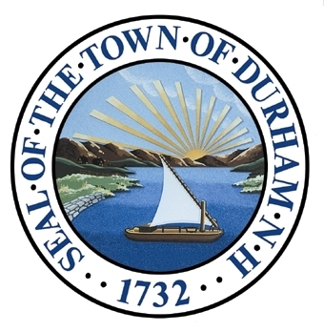

Future Land Use

*The Future Land Use chapter of the Master Plan builds upon ten chapters, adopted in 2015, that examine the existing conditions and offer recommendations in their respective topic areas. This chapter expresses the Master Plan Vision Statement in physical terms by illustrating the proposed locations, extent, and intensity of proposed future land uses through 2025 and beyond.*

Adopted by the Durham Planning Board on January 24, 2018

Introduction

Future development in Main Street West could be on a similar scale to the existing Goss International building (Source: Durham Planning Department)

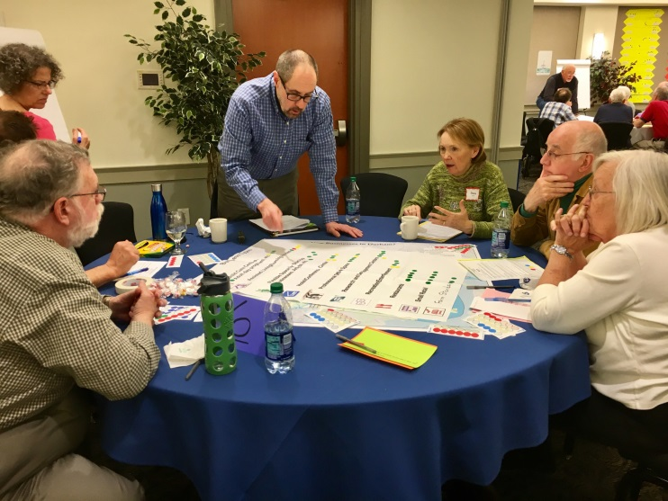

Stakeholders plan for Durham’s future at the “Let’s Talk!” Future Land Use Forum (Source: Todd Selig)

A land use section is one of two sections required for all master plans in New Hampshire. According to RSA 674:2, the land use section of a community’s master plan should “translate the [plan’s] vision statement into physical terms.” The 2018 Future Land Use chapter builds on the ten chapters adopted in 2015, including the Vision & Community Character chapter. The Future Land Use chapter, the culmination of a multi-year planning process, integrates the information from these earlier chapters to show the proposed locations, extent, and intensity of future land uses in Durham.

The Master Plan Vision, as presented in the Vision and Community Character chapter, has four themes. The Future Land Use chapter uses these themes, each consisting of smaller “building blocks,” to summarize public feedback and the implications of the ten adopted chapters for land use in Durham. A future land use map was developed using a variety of GIS mapping techniques and community responses to interview questions. This map is based on a rural-to-urban transect, a planning concept that identifies distinct areas within a community and describes how those areas function on their own and in relation to each other. The Durham Land Use Transect contains six area designations that describe the way each area looks and functions. These designations are not intended to replace Durham’s existing zoning districts, but are useful for informing future zoning decisions. Finally, this chapter recommends ideas, actions, and policies for Durham to consider as the Town implements its vision for future land use. Documentation of the planning process appears at the end of the chapter, and full-sized maps and summaries of outreach activities are available as supplemental materials.

The Durham Community

*Durham’s Master Plan Vision recognizes the importance of forward-thinking engagement when planning for the Durham community. The Land Use Committee worked vigorously to involve all people who have an active interest in Durham’s future, including year-round residents, students, business owners, employees, visitors to the University, and residents of nearby municipalities who are connected to Durham through institutions such as the Oyster River Cooperative School District.*

Master Plan Vision

The Vision and Community Character chapter of the Durham Master Plan, adopted in 2015, committed to the following vision for Durham’s future:

*In 2025 and beyond, Durham is a balanced community that has successfully maintained traditional neighborhoods, natural resources, rural character, and time-honored heritage, while fostering a vibrant downtown, achieving energy sustainability, and managing necessary change. Durham has effectively balanced economic growth, which has been essential in supporting our schools, resources, and town services, and stabilized property taxes. Durham has encouraged mixed residential and commercial development in and near the downtown including retail establishments, offices, services, eateries, and other businesses that serve local needs and interests while attracting visitors from neighboring vicinities. In designated areas beyond downtown, balanced development was accomplished by prudently integrating our community’s range of values. Through forward-thinking engagement on the part of our citizens and town government, in tandem with continued pursuit of a productive partnership with UNH, our vision for Durham was realized.*

Revisiting the Vision and Advancing the Themes

Responses gathered during the 2017 public engagement process were consistent with comments collected during the preparation of the other master plan chapters. This information shared the following themes:

Balance:

*The master plan vision stresses the importance of a balanced approach when integrating community priorities. Many people emphasized sustainability and resilience. Enhancing community character in tandem with economic growth remains a primary goal of the Durham community.*

Quality of Place:

*The Durham community deeply values aesthetics and the character of the landscape. The community treasures the town’s history, rural setting, and cultural, educational, and agricultural resources. Residents emphasize the need for a vibrant and walkable downtown and for businesses that add to the quality of life in Durham. Issues related to quality of place affect the entire town. Urban amenities are most applicable in and around downtown, while rural amenities apply primarily to outlying areas.*

Community:

*The concept of community features prominently in the master plan vision. Community informs the planning process by identifying the full range of people who should be consulted. Diversity is an important component as it reflects aspirations for the future composition of the community. The partnership between the Town and the University of New Hampshire is important in building an inclusive community.*

Connection:

*Connections among people, ideas, and resources are important to Durham. Stakeholders value links to Durham’s history, natural ecosystems, and fresh local food. Connections between the University campus and downtown are essential to support local businesses. Connecting university students and technologies to entrepreneurial opportunities promotes a robust local economy.*

Community

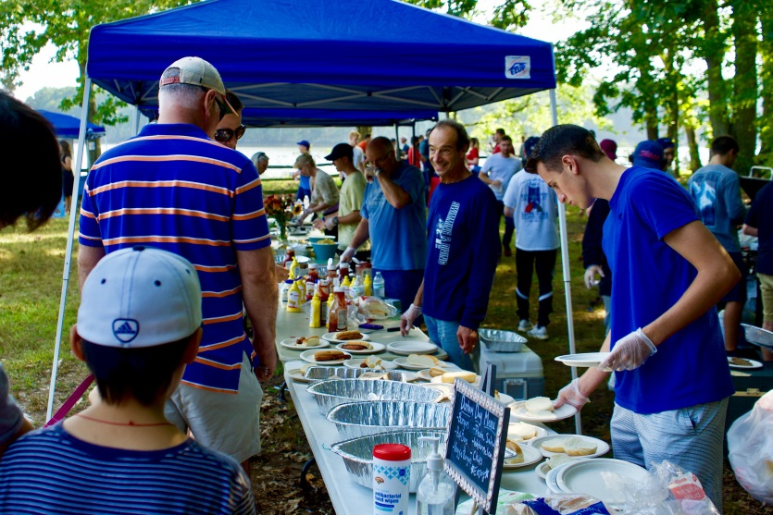

Durham Day, an annual event held at Wagon Hill Farm, is a celebration of the community. (Source: Todd Selig)

Durham is a multifaceted community that values diversity. The presence of the University of New Hampshire flagship campus contributes significantly to the social, ethnic, racial, and economic diversity of the town.

What You Said: *Source: Future Land Use Forum*

*“I love the sense of community – that it comes together in times of need and it works together on important issues.”*

**Diversity and affordability:** The Vision and Community Character chapter recommends offering a wider variety of housing choices in order to foster greater diversity within the community. The provision of affordable purchase and rental options for single-family and multiunit housing is challenged by high demand for student housing in town. Specific strategies for accommodating a range of housing preferences require further discussion.

**University partnership:** The University is a magnet for international students and scholars and largely accounts for the regional concentration of highly-educated young residents. In addition to being a major employer in Durham and the broader Strafford region, the University is a valuable partner in local community and economic development. The University is a source of new technologies and a highly-educated workforce that can support a range of businesses. These resources should be considered in the ongoing dialogue about Durham’s identity and future.

**Life-cycle housing:** The Demographics & Housing chapter and recent community feedback stress the importance of providing housing for residents of all ages. Since Durham is a university town, student housing will continue to be a key component of the local housing stock. But the state’s population is aging, suggesting a need for housing to accommodate a growing senior population. Long-term residents are likely to have different housing preferences based on their stage in life. Current trends indicate that both millennials and baby boomers prefer smaller homes in walkable urban neighborhoods rather than large houses on large lots. This trend places high demand on available properties at the affordable end of the housing spectrum.

Balance

The Vision & Community Character chapter emphasizes the importance of balance in planning for Durham’s future. This concept was particularly prominent in discussions about preserving Durham’s small town and rural character while promoting the economic development needed to keep Durham affordable. Only 35 percent of respondents to the question about property tax rates in the 2011 master plan survey said that tax rates at the time were acceptable. Durham participants were not asked a similar survey question during the development of this chapter, but few participants in any of the Land Use Committee’s outreach activities offered comments related to taxes and tax stabilization. This shift in perception is likely related to larger economic conditions. The 2011 survey was conducted in the immediate aftermath of the economic recession and housing market crash. In contrast, outreach for this chapter occurred following several years of stable property tax rates due to an upswing in the housing market and development in the town. In spite of this stability in recent years, the fiscal forecast in the 2017 Durham Economic Development Report estimates that the Town will need to continue to expand its tax base significantly to meet projected Town spending needs without increasing the tax rate. Durham should pursue a policy of balancing new development with budgetary needs related to capital improvements and other investments in the Town’s future.

What You Said: *Source: Future Land Use Forum*

*“Keep in mind the principles of New Urbanism with a focus on increasing density in the downtown, encouraging walkability and multi-use buildings and community gathering places.”*

**Leverage the commercial core:** The limited availability of land to develop outside of downtown makes infill and redevelopment of the commercial core an essential strategy. The Economic Development chapter notes that Durham has minimal Class A office space. Mixed-use development downtown could provide such space close to the University, where demand is expected to be high.

**New commercial opportunity areas:** The Economic Development chapter identifies five potential areas for commercial and industrial development. Since that chapter was written, the former Durham Business Park on Route 4 has been developed as an assisted-living facility (with room to expand in two future phases). An 11-acre parcel located off Route 108 on Stone Quarry Drive was approved for a continuing care facility in early 2018. This development would extend water and sewer service that could support additional development on the limited available remaining land. The Main Street West area contains water and sewer infrastructure, making it the most reasonable option for future development outside of downtown. However, there are challenges in developing this sector due to the presence of steep slopes and wetlands, and much of the land is owned by the University or held in conservation. These challenges make redevelopment along Technology Drive or on university property near “West Edge” the most likely opportunities for development. The University recently announced its interest in pursuing a research park in this area. A partnership between the University and the Town to develop a shared vision for this area would maximize the effectiveness of future development. More planning needs to be done to clarify this vision and create a framework for development of Main Street West.

What You Said: *Source: Business Focus Group*

*“If you have infrastructure in an area, use it! Out on [Main Street West] there is already water and sewer.”*

**Land conservation:** Directing development to the commercial core balances the need to expand the commercial tax base with the goal of protecting Durham’s natural resources. According to the Natural Resources chapter, nearly 30 percent of Durham’s land area was in permanent conservation as of 2015. While the Town will continue to consider opportunities to conserve important parcels, much of Durham’s ongoing conservation activities are likely to emphasize stewardship of currently conserved lands. This stewardship is essential to maintaining resilient natural ecosystems.

**Agricultural past and present:** The pattern of Durham’s development is influenced by the town’s agricultural past and present. Some of the oldest areas of European settlement in the state are within Durham’s agrarian landscape. The Agricultural Resources chapter emphasizes supporting the town’s working landscapes, which offer cultural and scenic benefits and provide habitat for wildlife. The chapter also discusses farming’s significant contributions to the local and regional economies.

**Historic preservation:** As with natural resources, there need not be a conflict between preservation of historic and cultural resources and economic development. Indeed, the community can leverage these resources to promote tourism, job creation, and general economic development.

**Energy conservation:** Decisions related to building design and development have direct implications for energy consumption. Mixed-use development, especially in the downtown, can reduce automobile use and make more efficient use of utilities. Town codes that encourage energy efficiency and sustainability will reduce the town’s energy footprint.

**Natural resilience and environmental protection:** The Natural Resources chapter provides a comprehensive approach to improving natural ecosystems. Healthy ecosystems provide a variety of benefits, including improved air and water quality and reduced impacts of flooding and other natural hazards.

Connection

Connection is an important theme running through the public input received. Proximity between the campus and downtown reinforces the need for physical access between the two, and into Durham from neighboring municipalities. The Durham community feels a strong connection to its history and landscape, and the social and civic relationships that arise from these connections contribute to the quality of life in Durham.

**Parking and traffic:** The Downtown & Commercial Core chapter notes that parking in downtown Durham in 2015 was adequate for the then-current mix of uses. The downtown and commercial core can function with limited parking if the mix of development creates a “park-once-and-walk” environment. Significant redevelopment or additional density, however, would strain the current parking supply. This may require the Town to consider new infrastructure projects such as a parking garage. A vibrant downtown, as envisioned in the Downtown & Commercial Core chapter, inherently brings shortages of automobile parking and traffic congestion. Improvements to pedestrian and bicycle infrastructure can mitigate these challenges. Durham is served by UNH Wildcat Transit and the Amtrak Downeaster. Continued improvement of these transit assets is important.

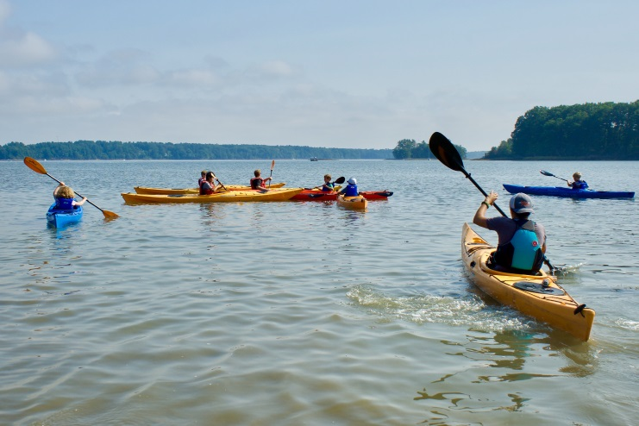

Durham’s public lands, such as Wagon Hill Farm, provide opportunities for people to connect with nature. (Source: Todd Selig)

**Recreation:** The Recreation chapter identifies active transportation, including walking, running, and bicycling, as being increasingly popular, particularly in natural settings. Improving the connectivity of and safe access to trails and pedestrian/bicycle infrastructure, and educating the public about these resources, is important to support the high quality of life in Durham.

**University resources:** The University provides a variety of social, cultural, and intellectual opportunities in the heart of Durham. Many of these opportunities are open to both students and members of the community with shared interests.

What You Said: *Source: Future Land Use Forum*

*“I love the intellectual influence of UNH and its cultural offerings.”*

**Access to local food:** Many residents consider access to locally produced food to be essential. Farm stands, farmers markets, community supported agriculture, and community gardens give residents direct access to fresh food, provide economic support to farmers and other local distributers, and promote opportunities for community engagement.

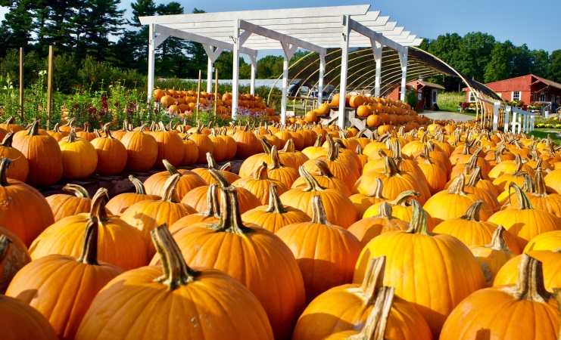

The fall harvest at Emery Farm. (Source: Todd Selig)

**Historic preservation:** Durham has many historic and cultural resources that contribute to its community identity and sense of place. It is important not only to encourage ongoing preservation and reuse of these resources but also to ensure the compatibility of new development with existing resources so future generations will be able to connect with their past.

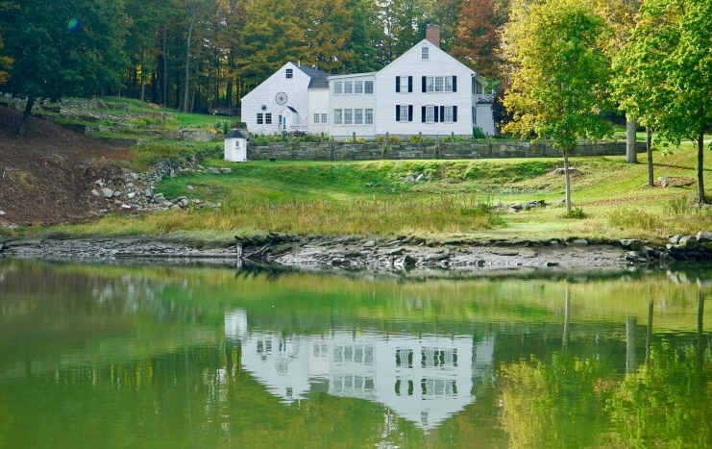

The General Sullivan house as seen from the Oyster River. (Source: Todd Selig)

**Land conservation:** Conservation lands contribute to the natural character of Durham’s rural areas. Access to natural habitat is an important quality of life amenity, and the Natural Resources chapter notes the potential of conserved lands to increase the value of nearby land.

Quality of Place

When asked what they most love about Durham and what they hope for its future, participants overwhelmingly spoke about the town’s character and appearance. Durham’s wealth of natural resources, handsome built environment, and diverse events and activities associated with being a university town set Durham apart. Representations of quality of place in the prior master plan chapters and in stakeholder feedback generally fall into one of three categories: those relating to the town as a whole, those relating to the urban areas of Durham, or those relating to Durham’s rural areas.

**Town-wide resources:** Under the principles of Smart Growth, town and neighborhood centers work well when they include a mix of uses and are built on a human scale. They should be walkable, well-designed spaces that feel comfortable and inviting for pedestrians. In contrast, natural features and resources should be preserved and a lower population density maintained in outlying areas, with development subtly integrated into the environment. In residential areas, thoughtful zoning contributes to maintaining the character of a neighborhood. Appropriate zoning may depend on location and context, including any historic resources in the area. The University of New Hampshire campus is a unique feature of Durham and an important part of the community’s character. According to the Existing Land Use chapter, the University occupies roughly 12 percent of Durham’s total land area. Development on this land ranges in intensity from concentrations of academic and athletic buildings in the campus core to the natural setting of College Woods. The University provides a number of cultural opportunities, such as musical and theatrical performances, that are available to the entire community.

**Urban resources:** While a vibrant downtown is important for supporting a strong commercial tax base, it is also a desirable community feature. Participants in the Future Land Use Forum proposed a variety of commercial uses that they thought would make the downtown a more appealing destination. These suggestions focused mainly on restaurants and small retail development. Providing compatible housing in and near the downtown could bolster businesses as well.

**Rural resources:** Durham is a community with abundant natural resources. Scenic views of Little Bay, the Oyster and Lamprey rivers, and numerous farms, forests, wetlands, and conserved properties contribute to Durham’s special identity. These assets provide opportunities for a variety of outdoor activities and serve to protect habitat and water and air quality. These lands enhance resiliency for the town by storing and filtering stormwater and mitigating the impacts of severe weather.

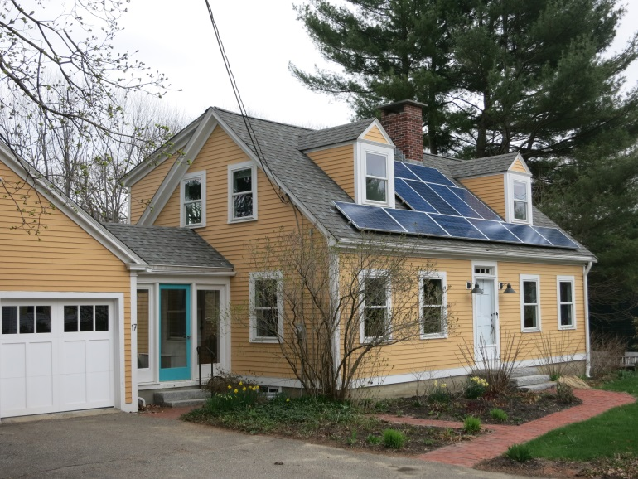Future Land Use Map

A future land use map identifies the proposed locations, extent, and intensity of future land uses in a community. The Land Use Committee selected the rural-to-urban transect as the basis for this map. The transect is a planning tool that illustrates the predominant historical development patterns of various sectors of a community. In its simplest theoretical form, a transect will show a municipality as a series of concentric circles with a gradual transition in character from the most rural setting to the most urban. Design decisions compatible with these designations are then made in each sector. In practice, this is complicated by actual development patterns and natural barriers. Special sectors are used to identify areas that function differently due to a particular unifying feature or institution, such as a hospital.

Source: Center for Applied Transect Studies

Concept: Rural-to-Urban Transect

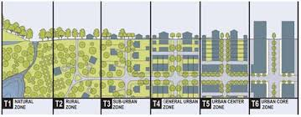

*The rural-to-urban transect is a land use concept popularized by the New Urbanist planning firm Duany Plater-Zyberk. It defines a series of designations that transition from natural features and sparse rural development to a dense urban core. Over the past 40 years, communities have used transects to identify areas with distinct development patterns when considering how neighborhoods or special districts will interact in the future.*

Transect areas are not related to specific zoning districts in this chapter (though they have been used in this manner in other jurisdictions). The transect map may be used to inform future planning and zoning decisions, but it should not be construed as a recommended zoning map. Durham’s transect is based on several factors, including the density of current buildings, location of natural and human-made features, and building constraints such as steep slopes and conservation lands. Six transect areas of Durham have been identified.

Source: SRPC

Source: SRPC

Building Footprint Density

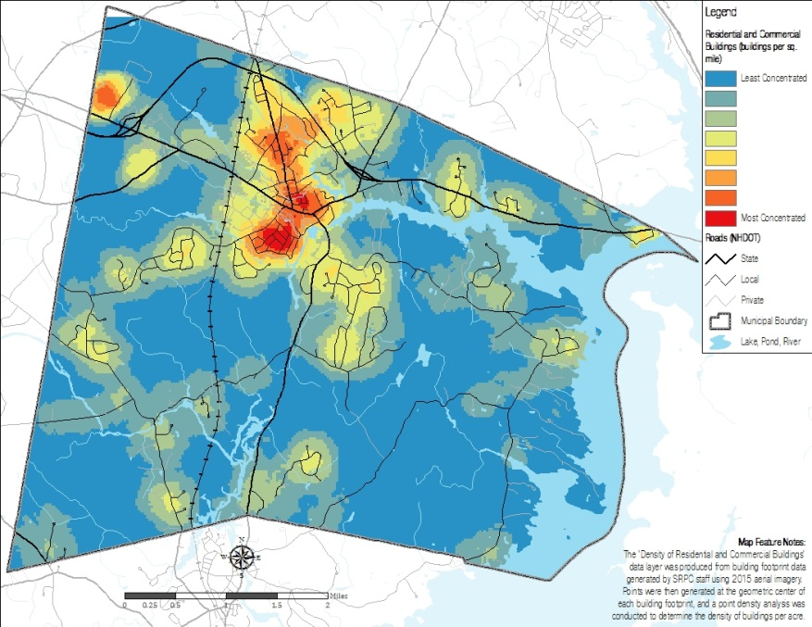

*Each building (townwide) was converted to a single point in order to illustrate a continuum of density in the town. This process has limitations because the individual points do not indicate the size of each building. Nevertheless, it provides a useful approximation of areas that are likely to function differently due to the density of their buildings and uses.*

Building Footprints

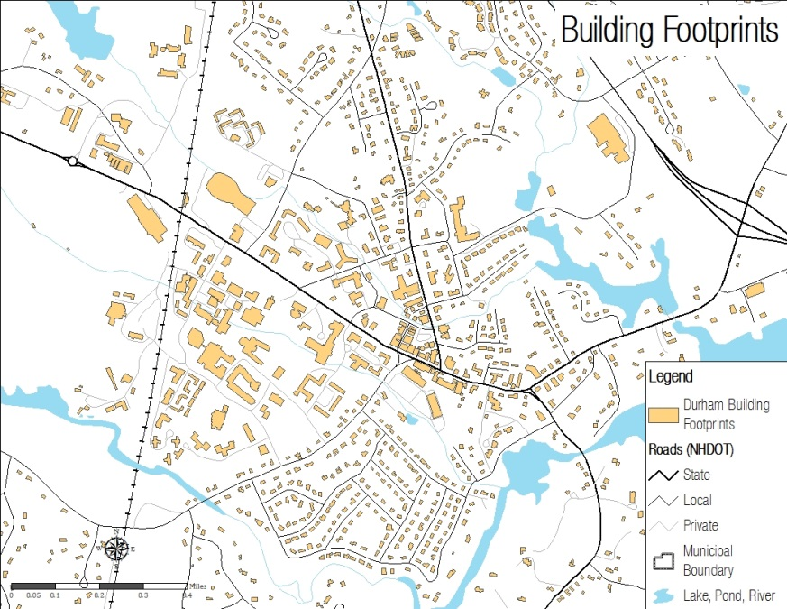

*This map of building footprints, based on 2015 aerial imagery, provides an overview of existing conditions in the core area of Durham. (Full-size copies of all maps are available from the Town.)*

Source: SRPC

Source: SRPC

Forum Feedback – Areas to Avoid

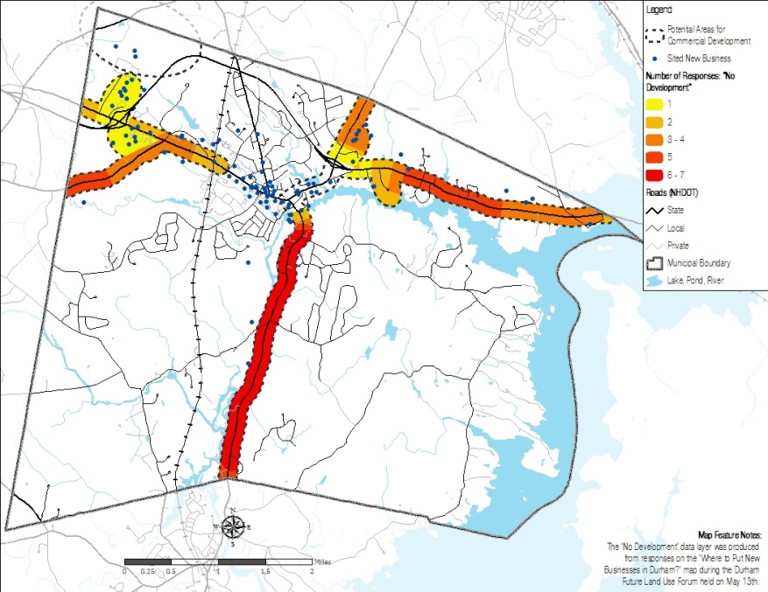

*Participants in the May 2017 Future Land Use Forum were asked to identify areas outside of downtown where they would and would not want to see new commercial development. Areas for discussion included those identified in the Economic Development chapter and land along major transportation corridors. Participants indicated that sections of Route 108 and Route 4 were the least acceptable.*

Forum Feedback – New Businesses

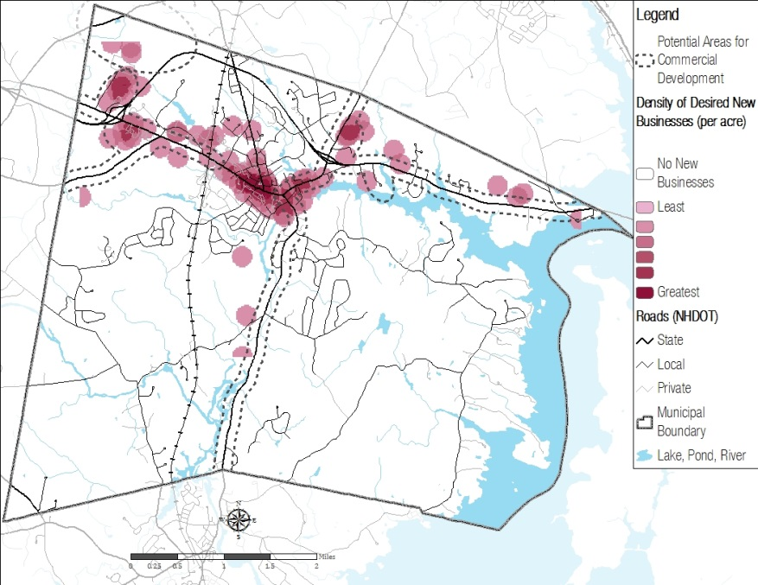

*Forum participants were asked to place stickers in locations that they thought were appropriate for new businesses. These stickers were then mapped as data points to show the density of desirable business locations in Durham. Responses were most concentrated in the downtown, near Technology Drive, and along Route 108 north of downtown.*

Source: SRPC

Source: SRPC

Constrained Lands

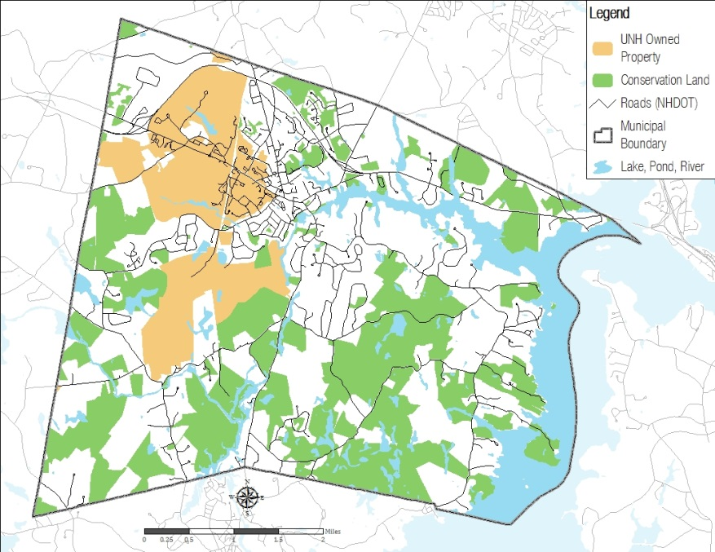

*There are significant constraints to future development throughout Durham due to the amount of land that is owned by UNH, placed into conservation, or limited by various environmental factors.*

Developable Land 2017

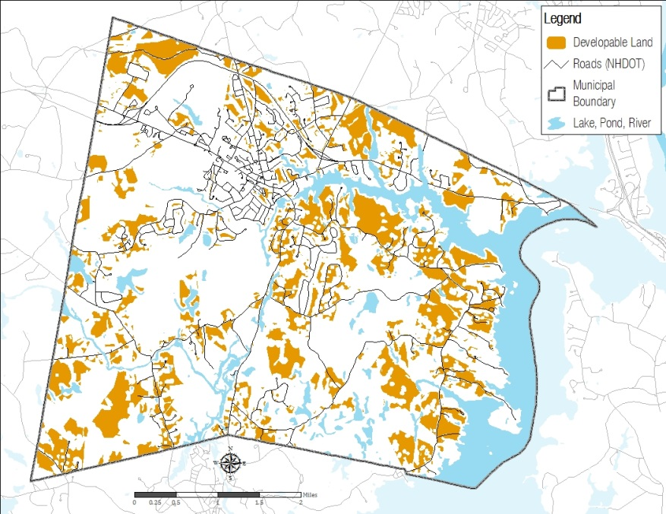

*The Existing Land Use chapter included a “build-out” analysis to determine where new development could occur. This map was updated in 2017 to account for development that has occurred since that chapter was adopted in 2015.*

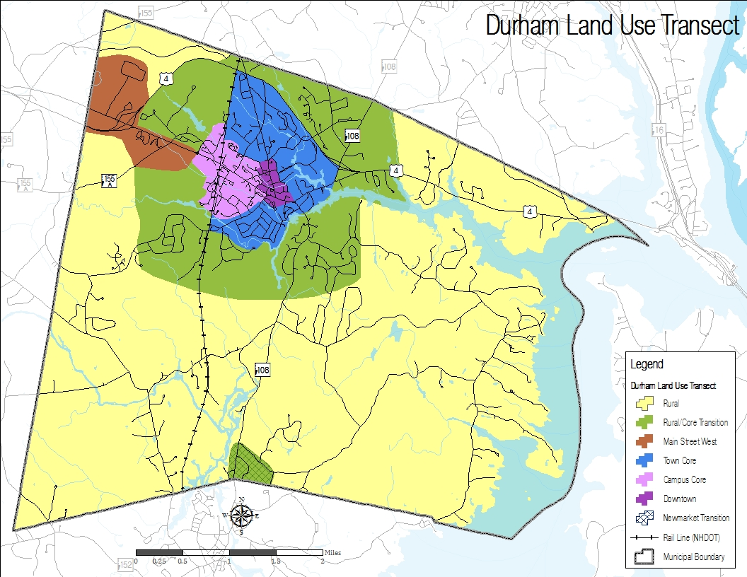

Rural

This designation consists primarily of forested lands, agricultural lands, rivers, wetlands, low-density residential development, and conservation/recreation lands. Limited development is integrated into the natural surroundings. Where possible, development is screened from major roads, with limited access points from major thoroughfares.

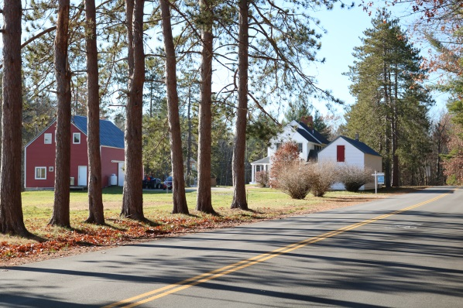

(Source: Nancy O’Connor, SRPC)



Rural/Town Transition

This intermediate designation separates the low-density rural designation from higher density areas. It acts as a visual transition between large- and small-scale buildings and as a buffer between varying levels of activity. Residential development is of intermediate density and, where practical, has pedestrian and bicycle infrastructure connecting to the town core. Commercial and multi-family development is screened from major roads or presents a well-designed façade. Access points are limited along major thoroughfares. Portions of Route 108 approaching Newmarket’s downtown have been identified as part of this sector, due to their proximity to Newmarket’s core and an ongoing project extending sidewalks from Newmarket to this area.

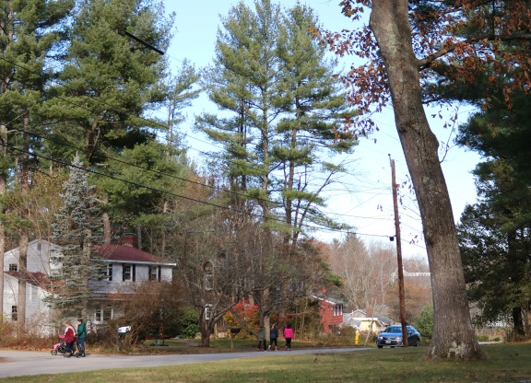

(Source: Nancy O’Connor, SRPC)

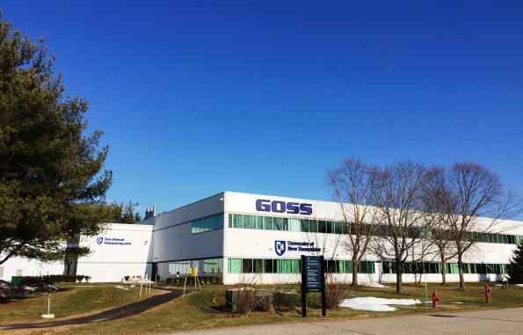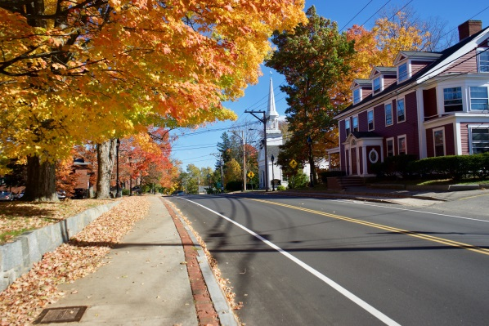

Main Street West

The resources of this area, including sewer/water infrastructure, proximity to Route 4, and connections to University properties, make it suitable for mixed-use development, including larger scale office or research facilities, and potentially suitable for multiunit dwellings. This designation should complement development in the downtown by accommodating office or research uses that are too large to fit in a more urban setting. It is likely to be more auto-dependent than the town core, but its proximity to University athletic facilities, the main campus, and the train station make pedestrian, bicycle, and transit access between this designation and the town core essential. Development of three stories may be suitable in this area, and even whole or partial fourth stories may be acceptable in some contexts if designed appropriately.

The Goss International building is located at the end of Technology Drive (Source: Durham Planning Department)

Town Core

Dense, walkable neighborhoods support commercial and mixed-use development along major thoroughfares. Residential development includes single-family homes at a denser scale than the rural/urban transition. Housing types scale up to include accessory dwelling units, duplexes, and small multiunit development closer to downtown. Commercial development is most likely to be retail, restaurant, or small offices in buildings of two to three stories, particularly as the district scales up toward downtown. Buildings should be designed carefully on all four sides since they may be visible from multiple angles.

The Durham Community Church is in the Church Hill district close to downtown (Source: Todd Selig)

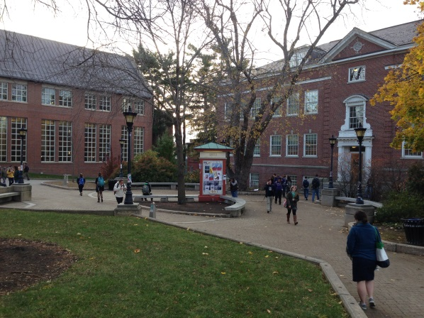

Campus Core

This is the heart of the University of New Hampshire campus as identified by University Campus Planning. This area contains the primary buildings and amenities related to academics, athletics, and student life and is the hub of day-to-day activities and operations. While it is important that the campus core include reasonable accommodations for automobile traffic for commuting students and university employees, it is essential to establish connections within the area for pedestrians, bicyclists, and public transit.

The Dimond Library on the University of New Hampshire campus (Source: Doug Bencks)

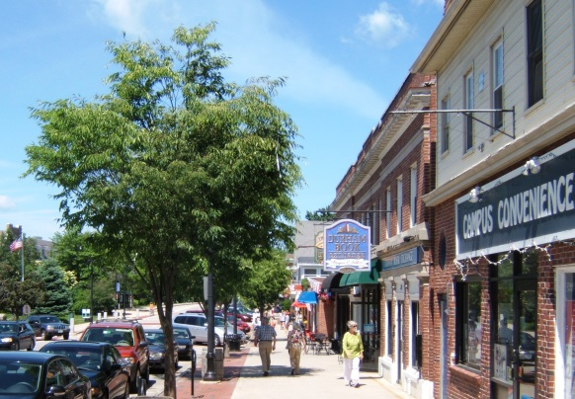

Downtown

This sector is the epicenter of the vibrant downtown that is important to the Durham community. This area prioritizes commercial development on the ground floor (particularly restaurant, retail, and services) with office or multiunit housing development on the upper stories. The basic fabric of the downtown is composed of three-story buildings. A fourth story is allowed under certain circumstances (preferably with some setback from the main façade). Buildings incorporate high quality and pedestrian-oriented design pursuant to the Town’s Architectural Regulations. Transportation infrastructure prioritizes pedestrian, bicycle, and transit access and safety over automobile convenience. Parking is offered with on-street parallel or diagonal spaces, garages, and centralized surface municipal lots that are located on secondary streets and well screened, all of which is designed to encourage park-once-and-walk habits. The market for businesses in downtown Durham comprises residents, business owners, students, UNH employees, visitors to the university, and residents of neighboring communities. Durham will attract this market by encouraging a vibrant mix of retail, restaurants, and other commercial uses.

A sunny day on Main Street in downtown Durham (Source: Durham Planning Department)

Future Land Use Recommendations

Concept: Floor Area Ratio

**

*The floor area ratio expresses the ratio of usable floor area in a building to the area of the parcel it is located on. This zoning tool captures the overall intensity of building development and is intended to be used in conjunction with other standards (such as height limits and setbacks) to provide additional flexibility. A maximum floor area ratio in outlying areas could prevent overdevelopment, while a minimum could encourage density in a downtown.*

Depiction of a 1:1 Floor Area Ratio (Source: City of St. Paul, Minnesota)

The Durham Master Plan includes a table of Land Use Goals and Recommendations that were developed as part of the ten chapters adopted in 2015. The recommended actions proposed in this chapter are intended to supplement, but not replace, those recommendations.

Community Recommendations

**Residential zoning audit**: Public input at the Land Use Forum and other outreach events indicated that residents seek to make Durham more affordable and diverse. The zoning ordinance contains strong restrictions on duplexes and multiunit housing development. The ordinance accommodates single-family houses on large lots or within cluster subdivisions and senior housing in most districts. Durham’s large student population increases demand for affordable housing, leading to more competition for available units. A residential zoning audit would review the ordinance and its table of uses and design parameters to propose innovative zoning tools that promote affordability. These tools may include density bonuses, inclusionary zoning policies, and various forms of multiunit housing, where appropriate. Feedback for this chapter did not reach a clear consensus about policies for diversity and affordable housing in Durham, and it would be beneficial for the community to continue its dialogue about this subject.

Good practice calls for most residential subdivisions in rural areas to be developed as conservation subdivisions (also called cluster subdivisions). Durham requires new subdivisions (with few exceptions) to be laid out in this manner. A review of the ordinance to enhance usability would be beneficial.

Balance Recommendations

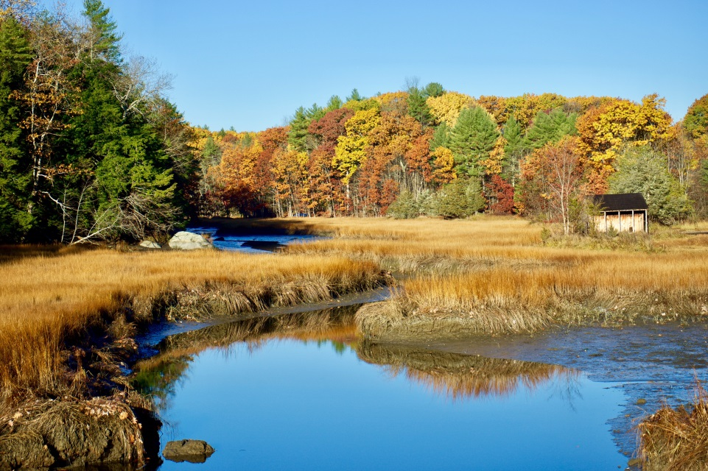

Conserved lands are a source of natural beauty and benefit the community by protecting water quality and improving resiliency to flooding. (Source: Todd Selig)

**Gateway Design Overlay District**: The community places a high value on Durham’s natural beauty, and residents consider the viewscapes along major transportation corridors to be important gateways. Implementing a design overlay along these corridors could balance the rights of property owners to develop their land while ensuring that any development will be of high-quality design. Combining design guidelines into one overlay will simplify the code by providing uniform standards. If the overlay is applied across both commercial and residential zoning districts, it can assure residents of the quality of future development should the underlying zoning district be changed.

**Targeted commercial development**: Because Durham’s remaining land available for commercial development is limited, future commercial development will occur largely as infill or redevelopment. Potential for certain types of businesses is significantly affected by the size and demographics of the local market, so this development will depend in part on Durham’s housing policy. Additional commercial development may be possible in the Main Street West area. The Town should work in partnership with the University to develop a plan for this area that complements investments made on campus and in the downtown.

**Environmental stewardship and resiliency**: While the Town will continue to consider opportunities to conserve important parcels, much of Durham’s ongoing conservation activities are likely to emphasize stewardship of existing conserved lands. Planning for the future should include the necessary resources for stewardship of conserved lands. Discussions should also consider the impacts of climate change and expected sea level rise on land use and infrastructure resiliency. Future conservation easements, including those for land set aside in conservation subdivisions, should consider provisions allowing for agriculture on suitable portions of the protected land.

Connection Recommendations

Concept: Woonerf

**

*Attempts to accommodate all modes of transportation generally do so in separate pathways. A woonerf uses design and traffic calming to accommodate pedestrians, bicycles, transit, and automobiles in shared space making for a lively environment. Low vehicle speed limits are typically encouraged through the use of brick or other textured surfaces and with other features that make traveling at higher speeds psychologically uncomfortable for motorists. Vehicles are not entirely excluded from the space. This may be a creative approach to balance the needs of automobiles and pedestrians in downtown spaces, such as Jenkins Court.*

**Partnership with the University of New Hampshire:** The University is an important partner in the Durham community. The Town and University should continue to collaborate to better integrate the campus with the downtown. The University connects Durham to a variety of cultural and educational opportunities and offers the potential for the development and commercialization of numerous technologies on and off campus. The College of Life Sciences and Agriculture has programs related to sustainable agriculture and agricultural technology that can help the community support local food production.

A woonerf in Batavia, IL. (Source: Chicago Tribune)

**Bicycle and pedestrian improvements**: Residents emphasized the need to improve alternative transportation options and connections in Durham. Enhancing connections between recreational trails and access to recreational facilities is stressed in the Recreation chapter, and forum participants indicated that better mapping, wayfinding, and advertising of trails would be beneficial. Implementation efforts should target possible trail connections, linking recreational trails to the urban core, and improvements within the urban core to improve safety and accessibility.

**Structured parking**: With continuing development and increased density in the downtown, structured parking will likely be needed to satisfy demand. The Town should explore options within the urban core, possibly in conjunction with UNH or private partners, to provide structured parking.

**Agricultural zoning audit**: The Agricultural Resources chapter identifies a number of policies and practices to support local agriculture, including advertising and promoting local farms and advocating for a local food hub and programs to market agricultural products. Small-scale community agriculture—such as community gardens and allowing small livestock on residential properties—is encouraged. The chapter recommends adopting the State of New Hampshire’s definition of agriculture under RSA 21:34-a in the zoning ordinance so that farm owners could diversify their revenue sources. This definition recognizes the necessity of preparing produce for market; transporting people, goods, and machinery; conducting on-site sales, marketing, and agritourism activities; and storing and using fertilizers, pesticides, and compost. Collaboration among the Planning Board, Economic Development Committee, and Agricultural Commission in reviewing the Town’s regulations could identify ways to accommodate more agricultural activities, including the following:

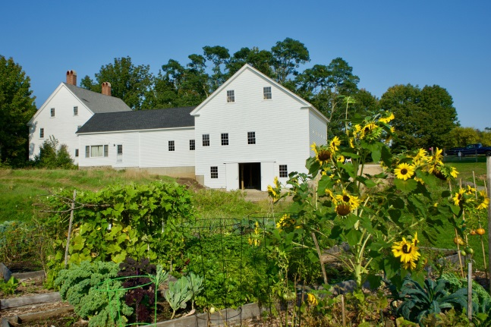

The reconstructed barn and community gardens at Wagon Hill Farm preserve Durham’s agricultural practices. (Source: Todd Selig)

* **Accessory commercial/industrial activities**: The state definition includes *agritourism*, defined in RSA 21:34-a as “attracting visitors to a farm to attend events and activities that are accessory uses to the primary farm operation, including, but not limited to, eating a meal, making overnight stays, enjoyment of the farm environment, education about farm operations, or active involvement in the activity of the farm.” These activities could be allowed subject to appropriate conditions. It is not clear the extent to which commercial and industrial processing activities (e.g., canning, preserving, brewing, and distilling) are covered by this definition. Accessory commercial and industrial activities related to agricultural uses could be allowed outright or as a context-dependent conditional use.
* **Indoor/urban farming**: The state’s definition does include some emerging agricultural techniques, such as vertical farming (producing food in vertically stacked layers), container production, rooftop and vest pocket gardening, and other urban farming operations. Commercial agriculture is not allowed in the downtown and commercial core. The Town should explore expanding the areas where commercial agriculture is acceptable and developing new policies to accommodate and promote urban agriculture, as appropriate.

Quality of Place Recommendations

**The University Town**: Durham’s identity is closely linked with the University. The Downtown & Commercial Core chapter recommends that Durham foster an identity and sense of place, especially in its downtown, to distinguish itself from other cities and towns in the region. The University is an extraordinary resource, and the Town should explore additional opportunities to develop and implement a shared vision for both entities while maintaining and supporting the unique identity of each.

**Historic preservation framework**: A renewed appreciation of Durham’s historic resources could help identify the most significant buildings and structures and differentiate those most worthy of preservation from the merely old. The Town has developed criteria for evaluating conservation lands and may benefit from a similar approach for historic resources preservation.

**Main Street West Area planning**: Durham and the University should initiate discussions to plan for the future of Main Street West. This chapter recognizes the potential for development along the Main Street corridor, including the University’s “West Edge” site and properties around Technology Drive, but careful planning is necessary to define specific areas most conducive to development and to craft the standards that would guide that development. Planning efforts should consider how best to encourage an effective mix of housing, commercial, and research and development facilities that will complement, not compete with, downtown businesses. Pedestrian, bicycle, and transit connections will be important to facilitate movement of students, employees, and community members linking this area, the campus core, and the downtown. Other important planning factors include the presence of agricultural soils, conservation lands, and historic resources in the area such as the Town cemetery.

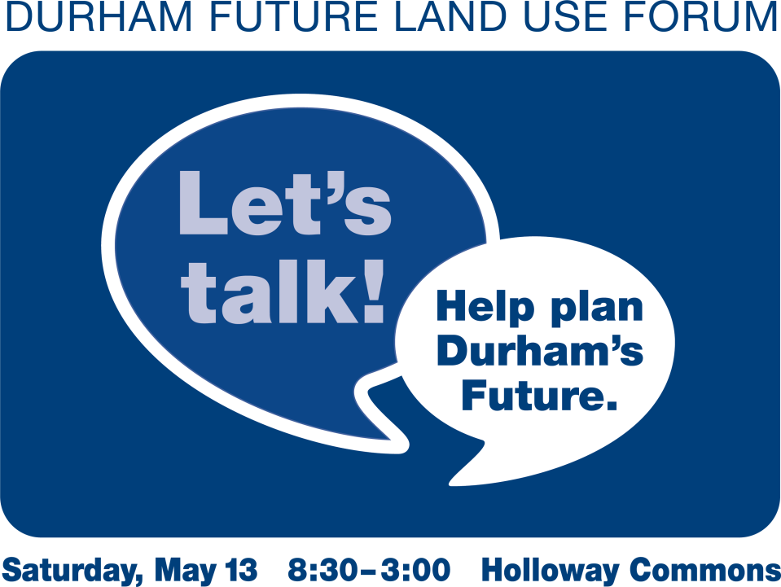Outreach and Planning Process

Work began on the current iteration of Durham’s master plan in 2010 when the Master Plan Steering Committee organized a visioning forum and subsequent survey to gather stakeholder feedback on a variety of issues. The comments formed the basis of the vision statement in the Vision & Community Character chapter and informed the development of chapters devoted to Agricultural Resources, Demographics & Housing, Downtown & Commercial Core, Economic Development, Energy, Existing Land Use, Historic Resources, Natural Resources, and Recreation. Each chapter includes recommendations for both policies and actions to guide the Town of Durham in the implementation of its vision. Recommendations from those chapters that are oriented toward future land uses are listed in the Land Use Recommendation Table. Ten chapters of the Master Plan, including the Vision & Community Character chapter, were adopted by the Planning Board in 2015.

A promotion for the Future Land Use Forum (Source: Barbara Dill)

The Planning Board formed the Land Use Committee in November 2016 and hired the Strafford Regional Planning Commission (SRPC) to assist with developing this Future Land Use chapter. Aided by SRPC and facilitator Peggy Kieschnick, the Committee planned a Future Land Use Forum that was held on May13, 2017. More than 100 members of the Durham community gathered to share what they appreciate about Durham, which aspects of the town they would like to see improved, and what their hope is, in general, for the future of the community. Participants engaged in a variety of small-group activities throughout the day to provide feedback on topics related to commercial development, residential development, land conservation, agriculture, and recreation. Group discussions were led by designated facilitators, most of whom volunteered their time. The forum meeting summary, attached as an appendix, contains much excellent information and readers are encouraged to review it.

Members of the Land Use Committee observed that some groups, including young adults, parents of school-aged children, the elderly, and business owners, were underrepresented at the Future Land Use Forum. In order to hear from as many Durham stakeholders as possible, the Committee conducted additional outreach during the summer of 2017.

The Land Use Committee placed comment boards in several local businesses and gathering places, and committee members collected comments at community events. The Town’s “Friday Updates” emails informed residents of opportunities to participate and encouraged them to submit comments via email. The Committee accepted an offer from Mark McPeak, a Durham resident with experience conducting outreach to underserved populations, to interview some of Durham’s elderly residents. The Committee facilitated a focus group composed of local business owners.

What You Said: *Source: 2011 Master Plan Survey*

*82% of respondents to the 2011 Master Plan Survey said that the quality of Oyster River Cooperative School District was important in making Durham a place they wanted to live.*

|  |  |
| --- | --- |
| **Planning Board Members** | |
| Paul Rasmussen, Chair | William McGowan |
| Barbara Dill, Vice Chair | Nathaniel Morneault, Alternate |
| Bob Brown, Secretary | Lorne Parnell |
| Andrew Corrow | Carden Welsh, Alternate Town Council Representative |
| James Lawson, Town Council Representative |  |

Strafford Regional Planning Commission conducted qualitative analyses of the existing chapters of the master plan and of all comments that were received. SRPC then led the Land Use Committee in a discussion of emerging themes and their implications for future land use in Durham. The Committee completed work on the draft chapter in October 2017 and presented its findings for consideration by the Planning Board at its November 8 workshop. After further discussion and public hearings on November 29 and December 13, 2017, and January 10, 2018, the Board voted to adopt the Future Land Use chapter on January 24, 2018.

|  |  |
| --- | --- |
| **Land Use Committee Members** | |
| Bob Brown, Chair | Barbara Dill |
| Molly Donovan, Vice Chair | Joe Moore |
| Doug Bencks | Paul Rasmussen |
| Andrew Corrow | Peter Wolfe |
| **Staff and Consultant Support** | |
| Michael Behrendt, Town Planner | Cynthia Copeland, AICP, SRPC |
| Todd Selig, Town Administrator | Liz Durfee, AICP, SRPC |
| James Burdin, AICP, SRPC | Rachael Mack, SRPC |