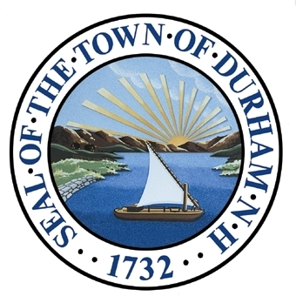

Existing Land Use
The Existing Land Use Chapter of the Master Plan presents the progression of land use patterns in Durham, developed over time as the result of numerous public and private decisions within the Town, as well as the product of local economic conditions and community choice. This chapter includes a community snapshot of existing developments areas, land use development patterns, and generalized land use characteristics.

Adopted by the Durham Planning Board on November 18th, 2015.

Introduction
Land use is closely tied to a town’s physical environment and its community character. Durham’s existing land use patterns are a physical expression of the town’s values, goals, and vision as they will in turn affect the location, type, and extent of future land uses and the growth of the community. The homes, businesses, and recreational opportunities are dependent upon the use of the land, making land use decisions arguably the most important aspects of Durham’s future.
This chapter provides an overview of current land use patterns in the town and will help guide the development of recommendations in the Future Land Use chapter. It contains existing land use information, derived from updated geographic information system (GIS) data, including recent land use patterns and trends. The chapter also includes information generated through a build-out analysis of the town.
Photo 1: Wagon Hill sunset (Source: Paul Norris)
Durham’s Physical Character and Topography
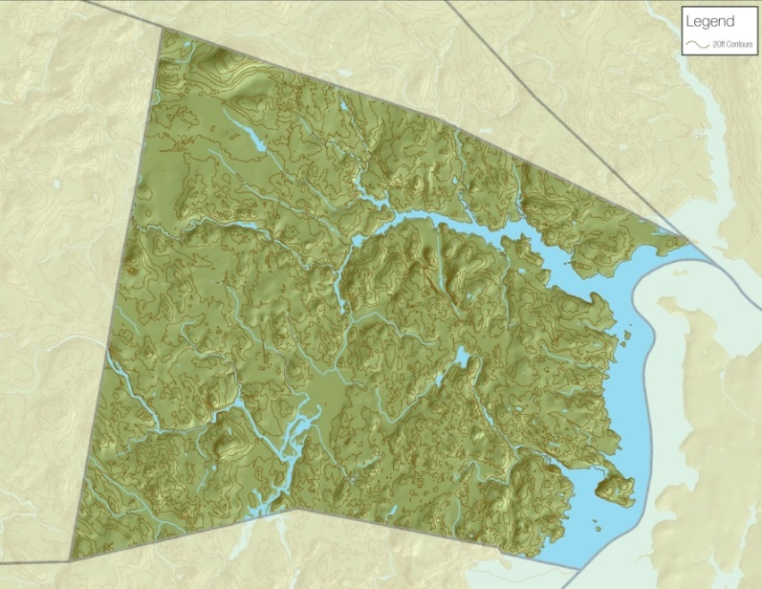
Durham is located in southeastern New Hampshire within Strafford County. The town contains 22.4 square miles of land area and 2.4 miles of inland water area. The towns bordering Durham are: Madbury to the north, Lee to the west, and Newmarket to the south. The Town also has water borders with Newington to the east and Dover to the northeast. The topography of Durham is gently rolling with elevations ranging from sea level along tidal areas to greater than 290 feet on Beech Hill, which is located on the Town’s northern border. Great Bay, Little Bay, Oyster River and the Lamprey River are the Town’s significant bodies of water.
Durham is located in the southern portion of the coastal watershed, and within the reaches of the Oyster River, Crommet Creek/Great Bay, and Lamprey River watersheds. It has an inland coastal geography and contains both freshwater and tidal rivers and estuarine ecosystems. Tidal influence on the Oyster River extends to the Mill Pond Dam near the NH Route 108 crossing.
Map 1: Durham Topography (Source: SRPC)
Existing Development Areas
Durham’s existing development areas were determined by identifying the land uses associated with the town’s major development types, based upon GIS data. The town’s three largest development areas are: existing residential, UNH property, and commercial/industrial activities.

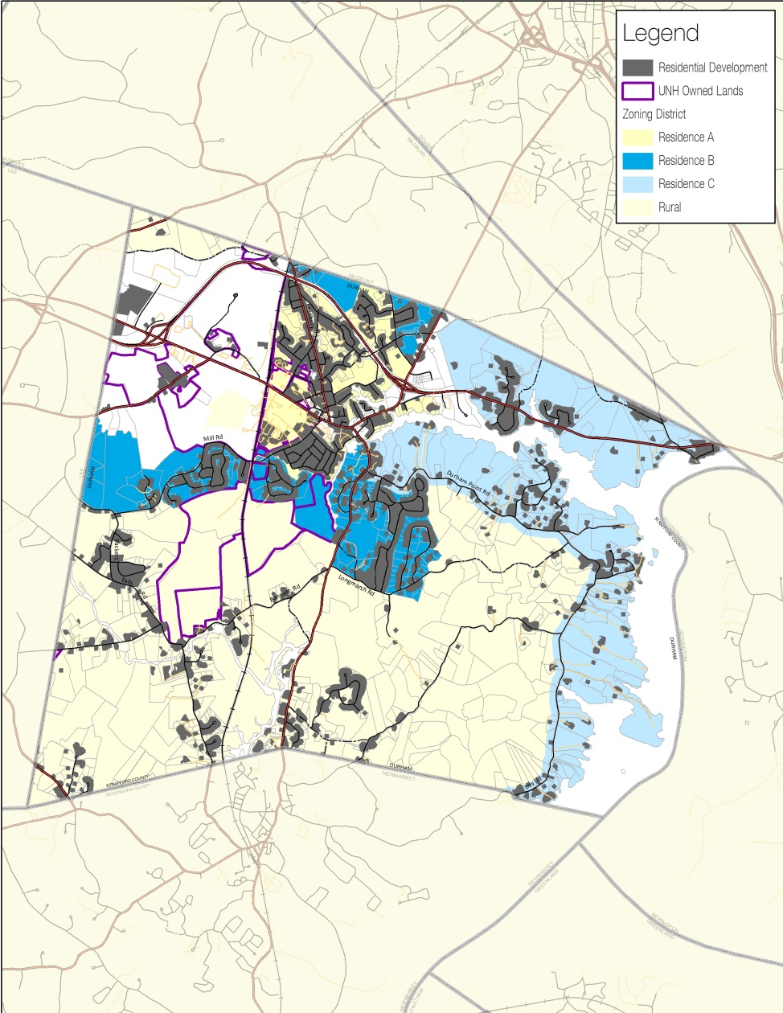
Existing Residential
Map 2: Existing Residential Development in Durham (Source: SRPC)

Residential development accounts for approximately 2,166 acres or about 14% of Durham’s total area, making it the predominate category of developed land. Approximately 93% of all residential development is single family/duplex and the remaining residential land uses are multi-family developments and group and transient quarters.
Table 1: Summary Residential Development
Land Use Classification | Acres | Percent
Single family/duplex | 1,946.8 | 12.28%
*Multi-family | 142.8 | 0.90%
**Group and transient quarters | 76.0 | 0.48%
TOTAL | 2,165.6 | 13.66%
*Multi-family – medium to high rise apartments and condominiums, low rise apartments and townhouses.
**Group and transient quarters – rooming and boarding houses, resident halls and dormitories (UNH), retirement homes, fraternities/sororities, etc.
Source: NH GRANIT
There are four residential zoning districts in Durham: Residence A, Residence B, Residence C, and Rural. The Residence A district is the smallest (895 acres) and the Rural district is the largest (6,845 acres). The Residence B and Residence C districts contain 1,372 and 2,672 acres respectively. These four residential zoning districts make up nearly 87% of the total acreage in Durham that is zoned. Residence B is the district with the least amount of developed land (487 acres) while the Rural district has the most developed acreage (700 acres).
As Table 2 indicates, there is a correlation between the size of a residential district in Durham and the amount of constrained land it contains, which has a direct impact on the estimated amount of developable land remaining in each of these zones.

Quick Fact: Residential zones makes up roughly 87% of the Town’s zoning districts

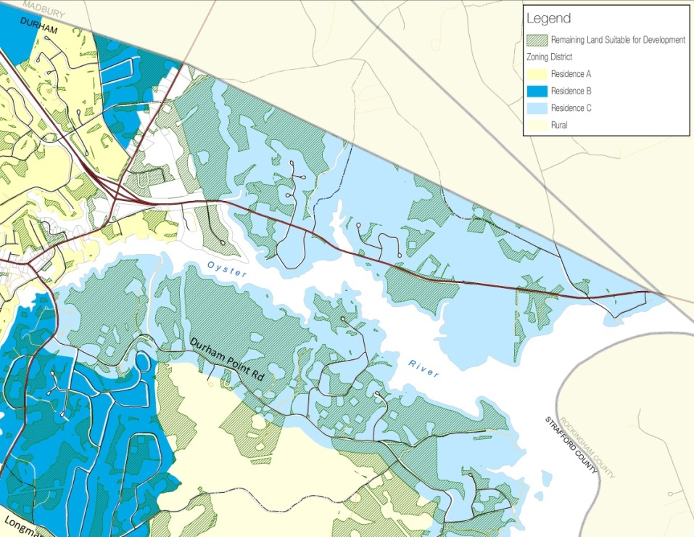
Of the 11,785 acres of residentially zoned land in Durham, roughly 20% is currently built out. There are a number of reasons for this, and the GIS summarized data in Table 2 shows that one is the amount of land in Durham that is physically constrained because it contains infrastructure; is conservation land, Town-owned property or UNH land; or because it contains wetlands, very poorly drained soils, and steep slopes (>25%). There are regulatory constraints on much of the land in these districts, including setbacks, buffers, and other zoning restrictions. Approximately 27% of the land currently zoned as residential is developable, as shown in Table 2.
Map 3: Estimated Acreage of Future Developable Land along Oyster River (Source: SRPC)
Table 2: Estimated Acreage of Future Developable Land Within Residential Zoning Districts
Residential Zone | Total (Acres) | Current Land Built Out  (Acres) |  | *Other Land Constraints  (Acres) | Land Remaining  (Acres) | Percent Remaining
Residence A | 894.67 | 594.36 |  | 184.61 | 115.7 | 12.93
Residence B | 1,372.01 | 487.38 |  | 560.42 | 324.21 | 23.63
Residence C | 2,672.45 | 615.84 |  | 1,049.37 | 1,007.24 | 37.69
Rural | 6,845.23 | 700.79 |  | 4,443.16 | 1,701.28 | 24.85
TOTAL | 11,784.36 | 2,398.37 |  | 6,237.56 | 3,148.43 | 26.72
*Note: Other land constraints consist of conservation land and Town-owned properties, UNH land, and non-developable land (wetlands, very poorly drained soils, steep slopes >25%, and selected local regulations, buffers, and setbacks)
 |  |  | Source: NH GRANIT

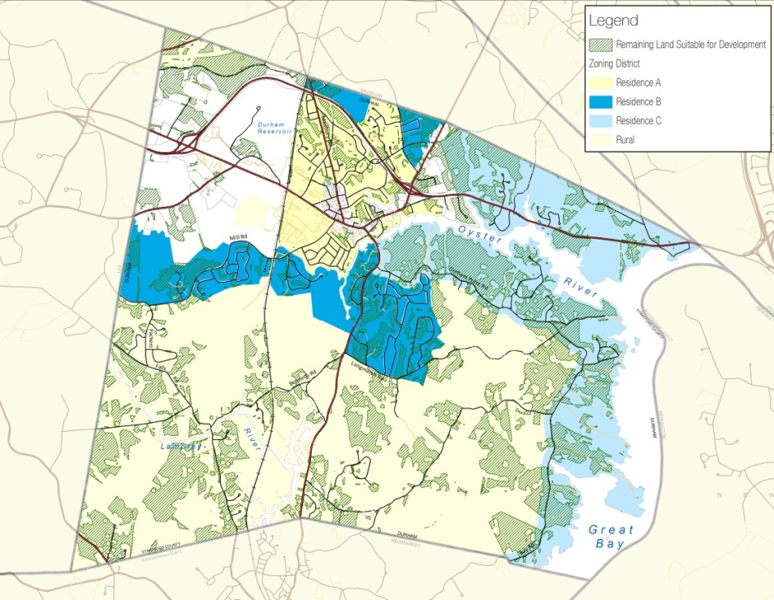
Map 4: Estimated Acreage of Future Developable Land within Residential Zoning Districts (Source: SRPC)
The maps on the right correspond to Table 2 and visually depict the remaining land suitable for development within the town’s existing residential zoning. The land shown as suitable for development was determined by a zoning-based buildout analysis completed by the Strafford Regional Planning Commission. There is more information on the buildout at the end of this chapter.
University of New Hampshire

The University of New Hampshire Campus Master Plan (2012) describes UNH as:
“…a quintessential New England campus – set in a small college town amidst a forested and agrarian landscape. It is an attractive walking campus environment that feels like a small liberal arts college yet accommodates the diverse range of daily needs of 15,000 – 18,000 people at a public research university. This widely admired campus is the result of decades of thoughtful planning focused on balancing tradition with innovation, resourcefulness with investment, and open lands with development.”
The University of New Hampshire occupies approximately 1,928 acres or roughly 12% of Durham’s total area. As Table 3 indicates, 231 buildings are owned and operated by the University and 199 of them are located in Durham. The other 32 buildings are scattered in communities throughout New Hampshire and in Kittery, Maine.
Table 3: UNH Existing Infrastructure
Building Classification | Number of Buildings
Academic | 29
Administration/Support | 21
Research | 61
Dining | 4
Recreation | 11
Residential | 52
Service | 3
Facilities | 41
Emergency | 2
Unknown | 7
TOTAL | 231
Note: 199 buildings are located in Durham; the other 32 are located in surrounding communities throughout the region
Source: UNH Campus Master Plan
The University can be viewed as having two separate and distinct areas:
- Core Campus – Much of this area is located near the downtown and is densely developed with academic and residential buildings. The campus core is generally considered to be UNH property that is within a 10-minute walk from Thompson Hall.
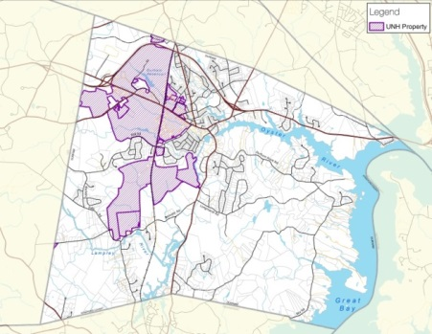
- The Woodlands & Natural Areas – Primarily made up of East Foss Farm, West Foss Farm, Thompson Farm, MacDonald Lot, College Woods, and the UNH Horticultural Farm, the majority of this land is either forested or agriculture land and remains largely undeveloped. These areas are managed by the UNH Woodlands and Natural Areas Committee and provide educational and research opportunities, as well as other benefits for students, Durham residents, and others.
Map 5: University of New Hampshire Owned Land (Source: SRPC)

Quick Fact: Thompson Hall was first built in 1893 and is known as the near-geographic center of campus

The University owns property in six of Durham’s zoning districts: the Central Business, Multi-Unit Dwelling/Office Research (MUDOR), Office Research Light Industrial (ORLI), Residence A, Residence B, and Rural districts. A more detailed description of UNH land in each district is provided below:
- Residence A (193 acres) and Central Business (3 acres) districts – contain the core campus and the most significant amount of campus development in Durham. There is limited suitable land left for UNH to develop in these districts and many of the proposed improvement projects the University has identified will be to renovate existing infrastructure.
- MUDOR (729 acres) and ORLI (171 acres) districts – are home to both College Woods and the UNH Horticulture Farm. Both areas remain largely forested or agriculture lands.
- Residence B district (100 acres) – is largely comprised of the MacDonald Lot and two other small UNH owned parcels. There is little to no development in these areas. The MacDonald lot is a valuable resource and UNH uses it extensively for research and education purposes.
- Rural district (654 acres) – is made up of four UNH owned properties including: East Foss Farm, West Foss Farm, Thompson Farm, and a University designated Natural Area within College Woods. There is no development in any of these areas. UNH uses East Foss Farm to provide instruction on timber harvest activities and prescribed burning, and the area is also used by residents for recreational purposes, including walking, running, hunting, and mountain biking. West Foss Farm is open to the public for recreation and is used for mountain biking, walking, running, Boy Scout activities, cross-country skiing, and live role-playing combat activities. Thompson Farm is primarily used for mountain biking, cross-country skiing, hunting, and running. Sugar maple tapping and timber harvesting are among other activities carried out in this area. The 60+ acres of land in College Woods that is located in the Rural district has been designated by the University as a Natural Area, which means these lands have a preservation status. Since this designation in 1961, nothing has been done to disturb the natural environment in this area.

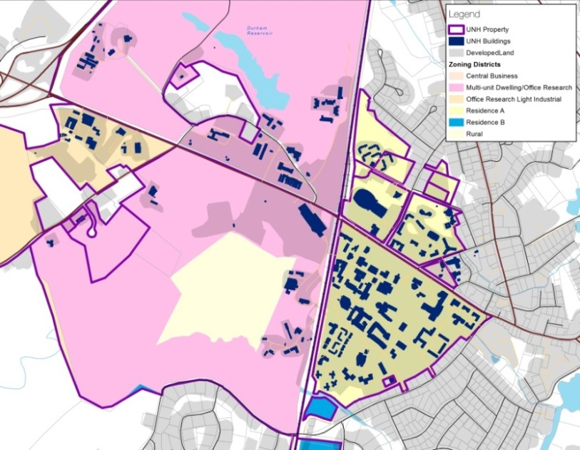
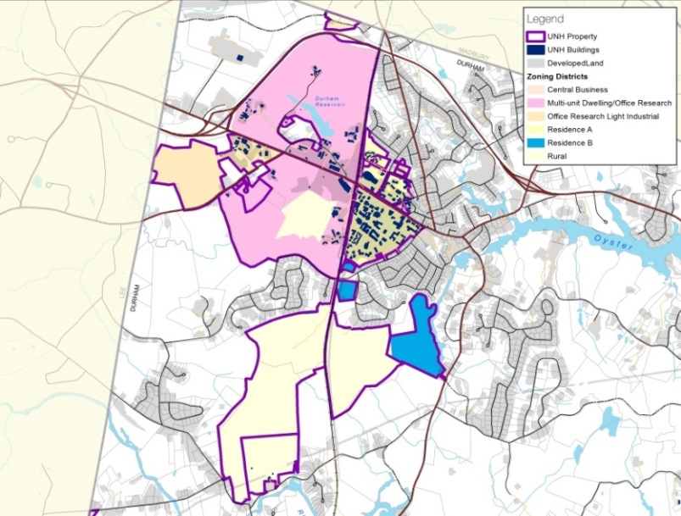
Map 6: Core Campus and Building Footprint (Source: SRPC)

Map 5: University of New Hampshire within Durham Zoning (Source: SRPC)

Quick Fact: UNH occupies approximately 1,928 acres or roughly 12% of Durham’s total area

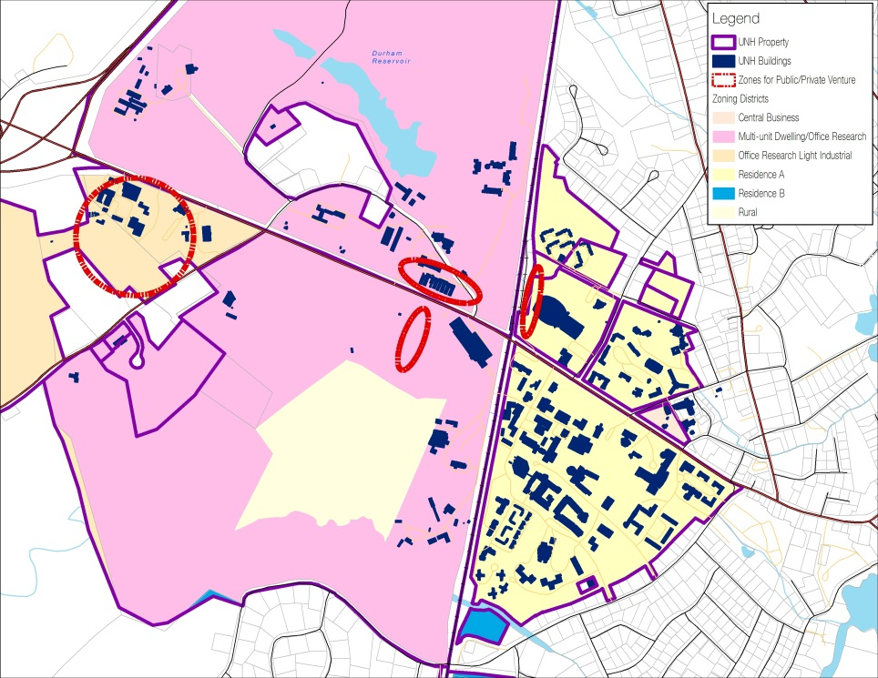
The University is a governmental entity and is subject to all State laws and regulations, but like towns, counties, school districts, and state agencies, UNH land is not subject to local land use regulations, unless a proposed development is not statutorily or traditionally governmental in nature, per RSA 674:54. When the University proposes a development on its land in Durham, it presents its proposed project to the Planning Board, which then holds a public hearing and may issue nonbinding comments on the project.
Map 7: Areas for Public-Private Ventures in MUDOR and ORLI (Source: SRPC)
The University of New Hampshire Campus Master Plan (2012) identified specific areas for public-private ventures as shown on the map to the right. These projects might result in private development that would need to conform to Durham Zoning Ordinance and other regulations.
Table 4: Public-Private Ventures in MUDOR and ORLI
Zone | Total Land  (acres) | UNH Owned Land (acres) | Total Undeveloped Land Suitable for Development
MUDOR | 761 | 729 | > 30 acres
ORLI | 741 | 171
Total | 1,502 | 900
*Note: While there is approximately 585 acres of undeveloped land in the MUDOR and ORLI zones, much of this land is not developable due to College Woods and the Horticulture Farm
Source: NH GRANIT
It is a possible that there could be significant development in these areas. The University has expressed some initial interest and would plan to align public/private ventures with the town’s regulations. Currently the University expects to include student housing, but various forms of commercial and light industrial development could be possible. Because the University has a limited amount (less than 30 acres) of suitable undeveloped land in the MUDOR and ORLI districts as shown in Table 4, the areas it has identified for potential development are almost all areas that would be redeveloped.
Quick Fact: According to current planning assessments completed by the University, of the 900 acres of UNH owned lands in MUDOR and ORLI, less than 30 acres of undeveloped land is suitable for development

Commercial & Industrial

Due to their locations, there are two primary areas in Durham where commercial and industrial development have taken place: the downtown core and the nearby Route 108 area, and areas in the ORLI and MUDOR zoning districts. There are also some outlying areas with commercial and industrial developments, but they are not considered the core areas for this kind of development.
Durham has guided commercial and industrial development with their zoning, which can be broken down into two distinct zoning districts.
- Retail and Commercial Zoning Districts
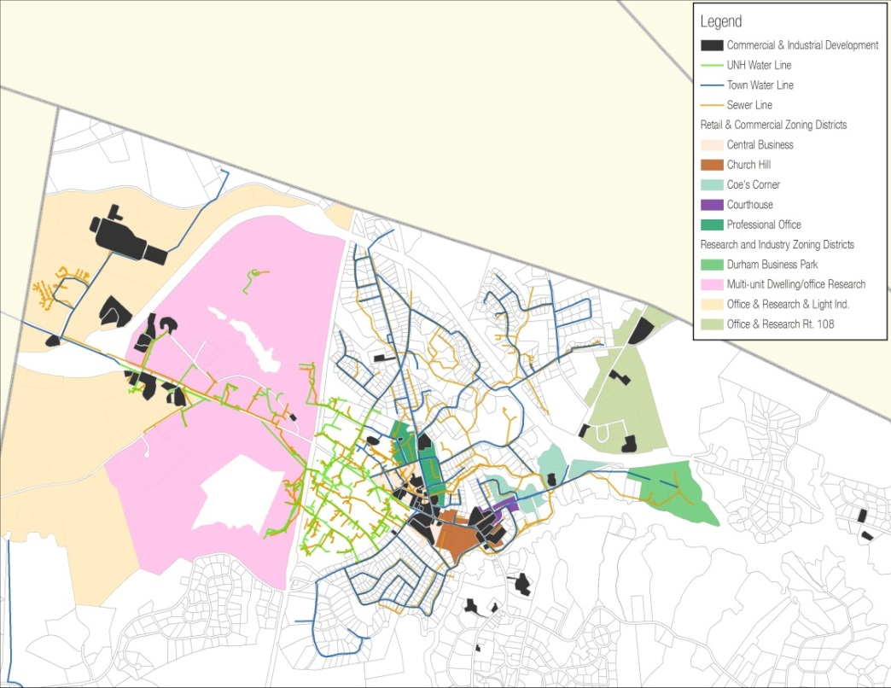
  - Central Business
Map 8: Commercial and Industrial Buildings in Durham (Source: SRPC)
  - Church Hill
  - Coe’s Corner
  - Courthouse
  - Professional Office

- Research and Industry Zoning Districts
  - Durham Business Park
  - Multi-Unit Dwelling/Office Research (MUDOR)
  - Office & Research & Light Industry (ORLI)
  - Office & Research Route 108
Quick Fact: Durham has guided commercial and industrial development through their zoning

The way in which the 2010 GIS land use layer was derived (using 2010 aerial photography), makes it difficult to capture mixed-use building types and other commercial development that is not large in scale. To fill this gap, local assessing data provided by the town was used to geocode addresses of buildings that were a commercial building type. This information was matched with corresponding tax parcels and then digitized using aerial imagery. The new digitized areas were then combined with the existing land use data to create a more accurate commercial and industrial land use layer.

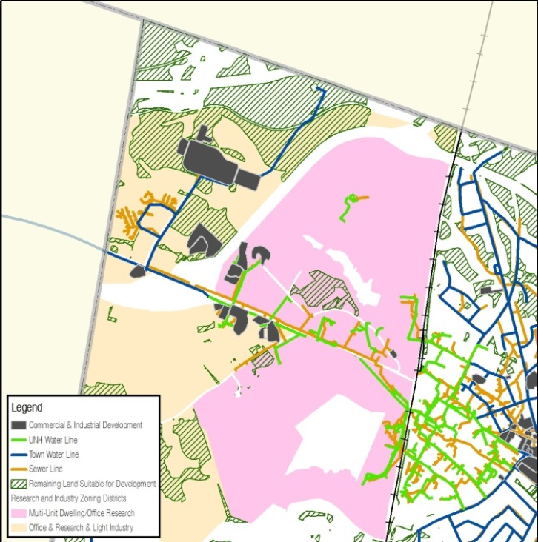
ORLI and MUDOR
Map 9: Commercial Development in ORLI and MUDOR (Source: SRPC)

Commercial development along Main Street and on Technology Drive includes, but is not limited to, Goss International, the NH Fish and Game Region 3 regional office, the NHDOT District 6 highway maintenance operations building, the transportation garage, and the USDA Forestry Science Laboratory. The UNH Interoperability Lab, formerly located on Technology Drive, has recently relocated to the Madbury Commons development in downtown Durham.
Water and sewer is available at Goss International with additional water access from the water tank off Beech Hill Road. There is potential for expansion in these areas.
Downtown and Outlying Areas along Route 108
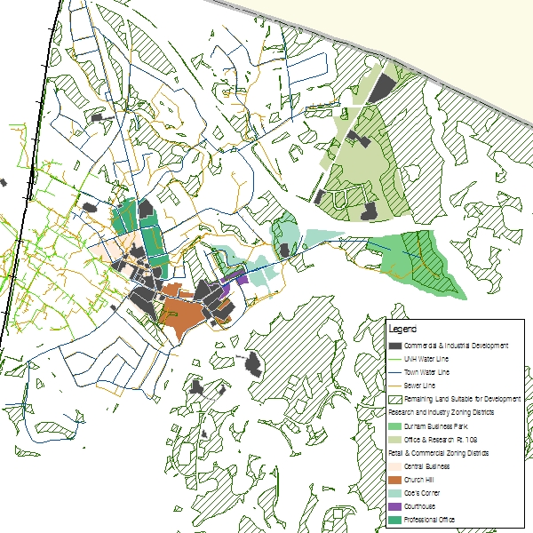
Commercial development in downtown Durham and along Route 108 includes, but is not limited to, restaurants and food service businesses, other retail businesses, auto repair and sales establishments, professional office space, a shopping center, and lodging. All of the student housing developments constructed in the downtown area in recent years have included retail/office commercial space.
Map 10: Commercial Development in the Downtown and Outlying Areas along Route 108 (Source: SRPC)

Much of the downtown area is currently built out, leaving very little land left for future development. If commercial growth is to expand in these areas, infill redevelopment projects could be considered.
There are a few areas that have the potential for water and sewer expansion including the Stone Quarry TIF district, which would encourage more mixed use development and private investment opportunities, as well as the Woodridge Road and Sunnyside Drive neighborhoods. However, both options have unique challenges.

Land Use Patterns
Durham’s emerging land use development patterns were a direct result of changes in demographics, lifestyle choices, and planning mechanisms that were implemented after the 2000 Master Plan. They are important to understand in order to successfully plan for the future. The town’s three most significant land use patterns are: single family/duplex development, land conservation, and off-campus student housing developments.

Single-Family/Duplex Development

The single-family/duplex land use classification dominates all other residential land use types in the Town of Durham. The graph below shows that from 1998-2013, Durham issued approximately 257 new single-family housing permits. These new homes have been spread out over the four residential zoning districts, with some areas seeing more densely clustered development than others. A majority of the residential housing constructed in Durham took place throughout an eight year time period between 1998 and 2005. A total of 213 new homes were built during that time span, which is roughly 84% of all the new single-family developments since 1998.
Figure 1: Building Permits Issued for New Single-Family/Duplex Developments, 1998-2013
From 2006-2013 the number of single-family homes built in Durham decreased dramatically, down to 44 new homes. Durham saw the least amount of residential development between 2006 and 2011, and the fewest new homes were constructed in 2008, after the collapse of the real estate market in 2007. The ensuing recession had an adverse effect on Durham’s housing market and caused the steep decline in new residential construction. Over the past two years, Durham has seen a slight increase in new residential development. In 2013, 12 new homes were built, the most since 2005.
From 1998-2013, a majority of the new single family homes built in Durham were in the RA zone (34%). The RA district has the least amount of total land acreage of the Town’s residential zones, and the lowest dimensional standards. For example, a 20,000 square foot minimum lot size is required for a single-family residence that is not part of a conservation subdivision. The Rural district, where 150,000 square foot lot size is required, experienced the second largest percentage of residential development from 1998-2013 (28). The third largest percentage of residential development took place in the RB district (13%), which requires a 40,000 square foot minimal lot size. The RC district, which also requires a 150,000 square foot minimum lot size, saw the least amount of residential development with only 13% of new homes. Five outlier construction permits were issued in other zoning districts, representing the remaining 2% of new homes built.

Source: Town of Durham Building Department
Residential development patterns during 1998-1999
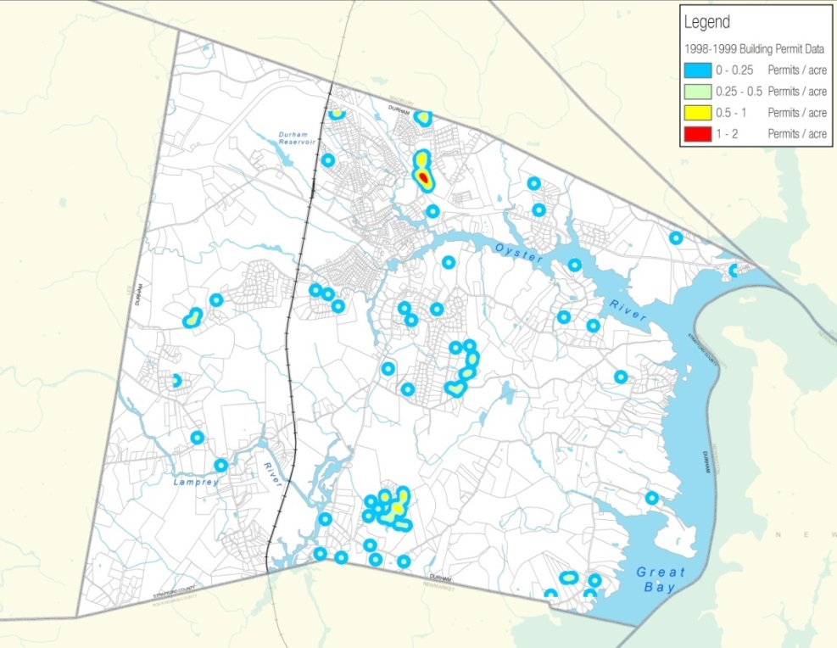
Of special note is that of 257 new building permits issued over the last sixteen years, 86 single-family homes, or roughly 33%, were constructed between 1998 and 1999. A majority of this development took place in the Rural district. In fact, just over 43% of all residential development in the Rural district took place between these two years, and this may have led to some of the recommendations in the 2000 Master Plan to limit this type of development. At the time, single-family development was seen as expensive for the town because it resulted in an increase in the number of school children. There was also a concern that these new developments were occurring further from the center of Town in a low density, sprawling manner, and that this would increase the cost of fire, police, and other Town services.
Map 11: Residential Development Patterns during 1998-1999 (Source: SRPC)
Table 6 indicates that during these two years, 42 homes were built in three areas:
- Nobel K. Peterson Drive and Strout Lane
- Ross Road, Meader Lane, and Ellison Lane
- Sandy Brook Drive
Table 6: Dense Developments, 1998-1999
Location | New Homes
Nobel K. Peterson Dr and Strout Ln | 16
Ross Rd, Meader Ln, and Ellison Ln | 17
Sandy Brook Dr | 9
TOTAL | 42
Source: Town of Durham
This was nearly 50% of all the residential development that took place in Durham between 1998 and 1999. The remaining 43 homes were scattered throughout the Town. The map to the right is a density map showing the locations of all building permits issued during 1998-1999. The color ramp (blue to red) represents the increasing amount of permits per acre.
Quick Fact: Over the past sixteen years, Durham experienced roughly 33% of their residential growth in just two years, 1998-1999

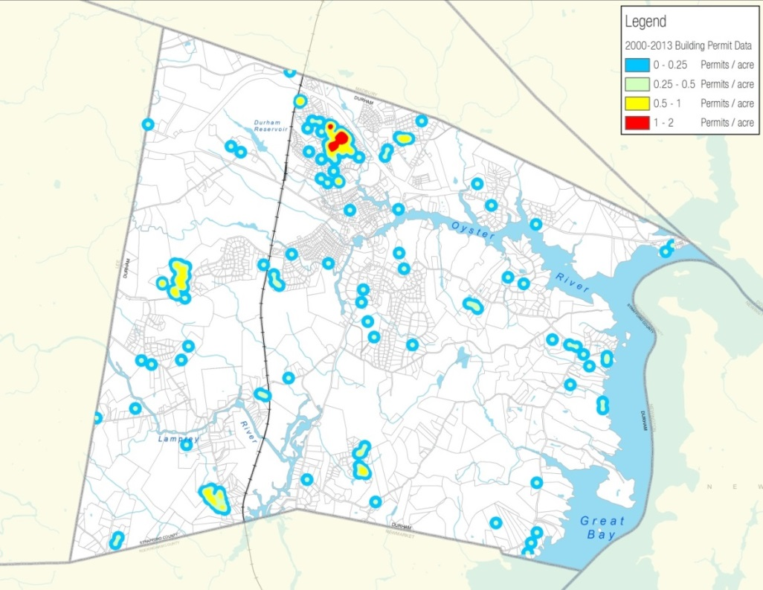
Residential development patterns during 2000-2013
Map 12: Residential Development Patterns during 2000-2013 (Source: SRPC)
There were 171 new building permits issued between 2000 and 2013. Between 2000 and 2005, there were 127 new homes constructed. During this six year span, Durham experienced nearly 50% of its total residential growth throughout the sixteen year period. There was a dramatic decline in single-family development from 2006 through 2011. This sharp drop in residential development can be correlated with both the various growth management techniques to limit single-family development, which included enacting conservation-based developments as well as the housing market crash. In the last two years Durham has seen a slight rebound in new homes.
Table 7 indicates that during 2000-2013, 88 new homes were built in four centralized locations:
- Stone Wall Way
Table 7: Dense Developments, 2000-2013
Location | New Homes
Stone Wall Way | 14
Ross Rd, Meader Ln, and Ellison Ln | 8
Edendale Ln, Roysanne Way, Britton Ln, Sprucewood Ln, and Worthen Dr | 21
Perley Ln, Fellows Ln, Marden Way, Fitts Farm Dr, and Emerson Rd | 45
TOTAL | 88
Source: Town of Durham
- Ross Road, Meader Lane, and Ellison Lane
- Edendale Lane, Roysanne Way, Britton Lane, Sprucewood Lane, and Worthen Drive
- Perley Lane, Fellows Lane, Marden Way, Fitts Farm Drive, and Emerson Road
A total of 88 new homes were built in these four areas, which accounts for 51% of all the residential development that took place between 2000 and 2013. The remaining 83 homes were scattered throughout the Town. The map to the right is a density map showing the locations of all building permits issued during 2000-2013. The color ramp (blue to red) represents the increasing amount of permits per acre.

Land Conservation
Table 8: Summary of Municipal Funding for Conservation in Southeastern NH, 2001-2005
Town | Bond Amount Passed | Appropriation Amount Passed | Total Amount of New Funding
Barrington | 800,000 | 75,000 | 875,000
Dover | 1,000,000 | 700,000 | 1,700,000
Durham | 2,500,000 | - | 2,500,000
Exeter | 3,000,000 | 100,000 | 3,100,000
Fremont | 900,000 | - | 900,000
Greenland | 2,000,000 | 25,000 | 2,025,000
Lee | 634,200 | 1,196,100 | 1,830,300
Madbury | - | 500,000 | 500,000
New Castle | 500,000 | - | 500,000
Newfields | 3,500,000 | 25,000 | 3,525,000
Newington | 500,000 | 100,000 | 600,000
Newmarket | 2,000,000 | 54,000 | 2,054,000
North Hampton | 4,000,000 | - | 4,000,000
Rollinsford | 1,000,000 | - | 1,000,000
Rye | 5,000,000 | 350,000 | 5,350,000
Stratham | 5,000,000 | - | 5,000,000
TOTAL | 32,334,200 | 3,125,100 | 35,459,300
Source: Society for the Protection of New Hampshire Forests

Land conservation refers to land that is protected in perpetuity through deed restriction, conservation easement, or other legal restriction. These restrictions are tied to the title of the land, regardless of its subsequent ownership. Such land may be given to a public body dedicated to the conservation of forests, parkland, and natural resources or to a private conservation trust, with the intent of restricting it from being developed. Conservation land is not required to be open for public access unless it is requested at the wishes of the landowner, or is a requirement of the funding source. One of the typical primary purposes of land conservation is to protect the land’s natural resources and values.
Durham has a long tradition of public support for conserving high priority land possessing significant natural resources, and over the years the town has been a partner in many successful land conservation projects. Many of the more recent conservation projects can be attributed to the many residents who petitioned the Town Council to place a greater emphasis on preserving Durham’s natural resources for future generations. In 2003, following a pattern of land conservation initiatives seen throughout the state, Durham voters approved a warrant article authorizing a Conservation Bond by a two thirds majority, which gave the town permission to borrow up to $2.5 million dollars to fund land conservation projects.
Over the past 10 years, Durham has used funds from the Conservation bond, its Conservation fund, and grant funds in order to preserve its natural resources and rural character, and has added significantly to the hundreds of existing acres of conservation land in the Town. As of 2014, there are ten new conservation easements totaling 735 acres of permanently conserved land. To accomplish this, Durham spent roughly $1.62 million dollars from the Conservation Bond ($889,000 remains) and nearly $1.35 million from the Conservation Fund and a number of grants.

Table 9: Protected Easements Since 2003 Conservation Bond
Year | Property Name | Purpose for Conserving | Acres*
2003 | Beaudette Conservation Easement | Wildlife habitat | 133.83
2004 | Mill Pond Center Easement | Scenic viewsheds | 9.79
2006 | Emery Farm Conservation Easement | Farmland soils | 58.34
2006 | Langley Farm Conservation Easement | Wildlife habitat, soils | 87.95
2007 | Fogg Conservation Easement | Drinking water protection | 91.12
2008 | Gangwer-Roselawn Farm Easement | Farmland soils | 50.96
2008 | Smith Farm Conservation | Drinking water protection | 28.33
2011 | Beaudette (2) Conservation Easement | Wildlife habitat | 64.28
2013 | Amber Acres | Farmland soils, drinking water | 38.53
2013 | Oyster River Forest (formerly known as Sprucewood Forest) | Wildlife habitat, drinking water, recreational access | 172.39
TOTAL |  |  | 735.52
*Acreage was tabulated for areas within the Town of Durham only
Source: NH GRANIT
Table 9 shows the ten new protected easements since the 2003 Conservation Bond, as well as the primary purpose for their protection and total acreage.
When comparing Durham to the surrounding Strafford region, the Town ranks as the top community, in the region, in terms of percentage of land area permanently conserved. It is important to note that the communities shown in Table 10 all have various physical characteristics and conservation policies, none of which are exactly comparable to Durham.
What makes Durham unique is this percentage does not take into consideration any of the blocks of land that are owned by the University or any Town owned and other protected lands which limit or restrict development. This is another major land constraint to be considered.
Table 10: Regional Comparison of Conserved Land
Town | Total Conservation Land (Acres) | % of Land Area
Barrington | 3,457.9 | 11.7%
Dover | 2,161 | 12.6%
Durham | 4,281.3 | 29.9%
Lee | 2,164.3 | 17.1%
Madbury | 854.3 | 11.5%
Newmarket | 1,741.5 | 21.6%
Rollinsford | 702.3 | 15%
*Acreage was tabulated for land area only and did not consider water
Source: NH GRANIT
Quick Fact: Durham’s conservation efforts rank highest in the Strafford region

What You Said: Source: 2011 Visioning Forum
“Land protection of water resource areas”

Table 11: Comparison of Total Conserved Land in Durham from 2003-Present
Pre-Conservation Bond |  | Post-Conservation Bond
Total Conservation Land (Acres) | % of Durham’s Land Area* | Total Conservation Land (Acres) | % of Durham’s Land Area* | Change in Total Acreage | Change in %
3,502.2 | 24.5% | 4,281.3 | 29.9% | 779.1 | 5.4%
Note: The total acreage of conservation land in Durham includes conservation subdivisions
*Calculated percentages were based on Durham’s land area only and did not consider open water
Source: NH GRANIT
Since the authorization of the Conservation Bond in 2003, the acreage of conservation land in town has increased 5.4%. Currently, almost 29.9% of Durham’s land area is permanently protected. Table 11 depicts the change in total conservation land acreage from 2003 through the present. This calculation does not include UNH owned land, Town-owned lands, or land under Current Use.
The land area that is considered UNH property totals 1,928.3 acres and makes up roughly 13.5% of the town. The Town-owned and other protected land totals 192.4 acres and makes up roughly 1.3% of the town. Table 12 indicates that currently, 44.7% of the Durham’s land area is either permanently protected, owned by the University, or has another other kind of development restriction
Table 12: Breakdown of Conservation Land Constraints in Durham
Durham |  | UNH |  | Town Owned & Other Protected Land |  | Total
Total Conservation Land (Acres) | % of Durham’s Land Area* | Total Land  (Acres) | % of Durham’s Land Area* | Total Land (Acres) | % of Durham’s Land Area* | Total Protected Land (Acres) | % of Durham’s Land Area*
4,281.3 | 29.9% | 1,928.3 | 13.5% | 192.4 | 1.3% | 6,402.1 | 44.7%
Note: The total acreage of conservation land in Durham includes conservation subdivisions
*Calculated percentages were based on Durham’s land area only and did not consider open water
Source: NH GRANIT
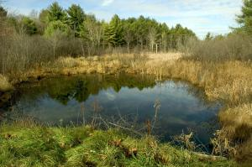
Photo 2: Conserved Wetlands off Bennett Road (Source: Durham Conservation Commission)
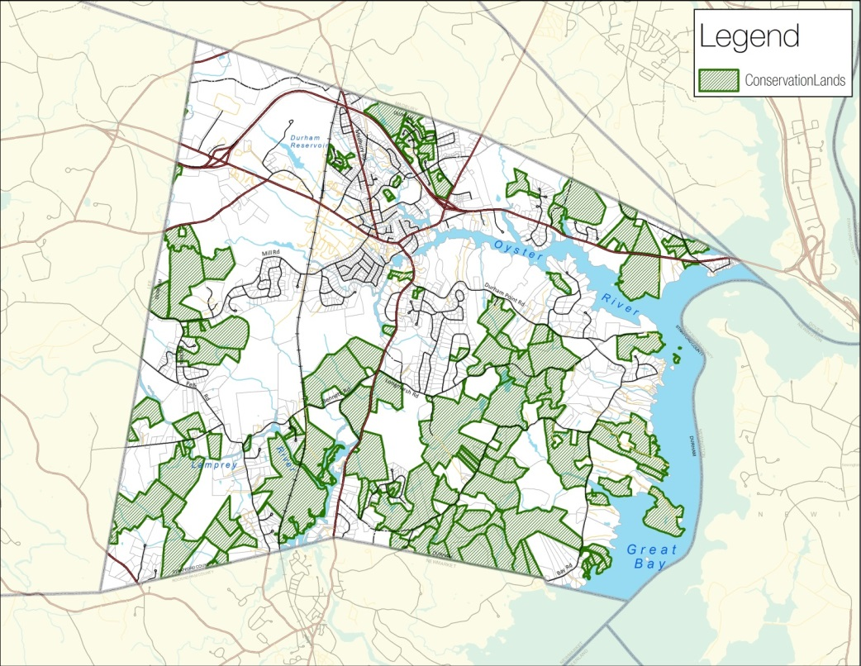
The final component of land conservation to analyze is Durham’s decision to adopt a Conservation Subdivision Ordinance (2004) following recommendations that were made in the 2000 Master Plan, which suggested that these types of subdivisions be the primary type of residential development in the community. Consistent with the principles of smart growth, conservation subdivisions are a zoning option that provides a flexible method of residential development that is not always possible through traditional zoning. The primary objective is to maintain and preserve rural character by allowing an alternative to conventional residential development. This kind of development promotes clustered housing, which preserves large areas of open space and provides visual buffers from existing roads and development. These subdivisions are intended to encourage the connection of open space corridors throughout the town and region for the preservation of wildlife habitat, environmental resources, and public enjoyment. Many communities throughout the region have used this technique as a more viable option for residential development. However, in Durham, since the adoption of the ordinance two conservation subdivision projects have been approved.
Map 13: Conservation Lands in Durham (Source: SRPC)
Table 13: Summary of Conservation Subdivisions since 2004
Name | Developer | Number of Residential lots | Total Acreage | Conservation Acreage | Percentage of Conservation
Sophie Lane Subdivision | Joe Caldarola | 9 | 13.3 | 9.3 | 69.9%
Mill Road Subdivision | Jack Farrell | 9 | 46.8 | 34.3 | 73.3%
TOTAL |  | 18 | 60.1 | 43.6 | 72.5%
Source: Town of Durham

Table 14: Major Private Off-Campus Student Housing Developments Since 2010
Year | Development Name | Address
2010 | Bryant Park West | 262 Mast Road
2010 | University Downtown | 2-10 Jenkins Court
2012 | University Downtown | 9 Madbury Road
2012 | The Cottages of Durham | 100 Clubhouse Street
2013 | Rivers Edge Apartments | 277 Main Street
2014 | The Lodges at West Edge |  | 259 Mast Road
2015 | Madbury Commons |  | 17-21 Madbury Road
2015 | Orion Student Housing |  | 25-25 Main Street
Source: Town of Durham
Table 15: Minor Private Off-Campus Student Housing Developments Since 2008
Year | Development Name | Address
2010 | Rosemary Lane Apts. | 22 Rosemary Lane
2010 | 14 Jenkins Court | 14 Jenkins Court
2011 | Grange Hall Apartments | 37 Main Street
2013 | Kostis Enterprises, LLC | 10 Pettee Brook Lane
2014 | Ballard Building | 1 Madbury Road
2014 | Pauly’s Pockets | 49-51 Main Street
Source: Town of Durham
Off-Campus Student Housing Developments
Over the past several years, a profitable market has developed for building private student housing developments in Durham. As discussed in the Housing and Demographics chapter, upscale student housing has become a vital marketing tool for recruiting young people to attend UNH.
Since 2010, fourteen off-campus student housing developments have been built in Durham, four of which were mixed-use residential/commercial projects. These developments have occurred in two general locations: along Mast Road and west of Route 4 in the Multi-Unit Dwelling/Office Research (MUDOR) and Office Research Light Industrial (ORLI) zoning districts, and within the downtown core in the Central Business (CB) district. Two of the developments, the Cottages of Durham and the Lodges at West Edge, were built on previously undeveloped land in the MUDOR and ORLI districts, while the projects built in the Central Business district are primarily infill/redevelopment projects.
While in recent years the MUDOR/ORLI zones have been successful in attracting new off-campus student housing developments, there has been little economic growth in regard to office research and light industrial activity. This could partially be explained by each zone’s existing constraints and limitations due to the amount of suitable land remaining for development. Both zones are similar in size but offer differing percentages of land remaining for potential future development. In the case of the MUDOR zone, it is mainly constrained by two large UNH owned parcels (College Woods and the Horticulture Farm). Of the total 762 approximated acres that comprise the MUDOR zone, roughly 19.3 acres (< 3%) is land suitable for development. These small pockets of land are located on Mast Road behind the West Edge Apartments and on Mast Road Extension. The ORLI zone is similarly constrained, but certainly not to the extent of the MUDOR zone. Of the total 742 acres that encompass the ORLI zone, roughly 196 acres (26%) is land suitable for future development.
Quick Fact: Of the 1,504 combined acres in the MUDOR/ORLI zones, 14% of the land is suitable for future development.

Table 16: Land Characteristics for MUDOR and ORLI
Zone | Total Land  (acres) | UNH Owned Land (acres) | *Other Land Constraints (acres) | Land Remaining  (acres)
MUDOR | 762.18 | 729 | 13.85 | 19.33
ORLI | 741.55 | 171 | 374.94 | 195.61
Total | 1,503.73 | 900 | 388.79 | 214.94
*Note: Other land constraints consist of conservation land and Town-owned properties, UNH land, and non-developable land (wetlands, very poorly drained soils, steep slopes >25%, and selected local regulations, buffers, and setbacks)
Source: NH GRANIT
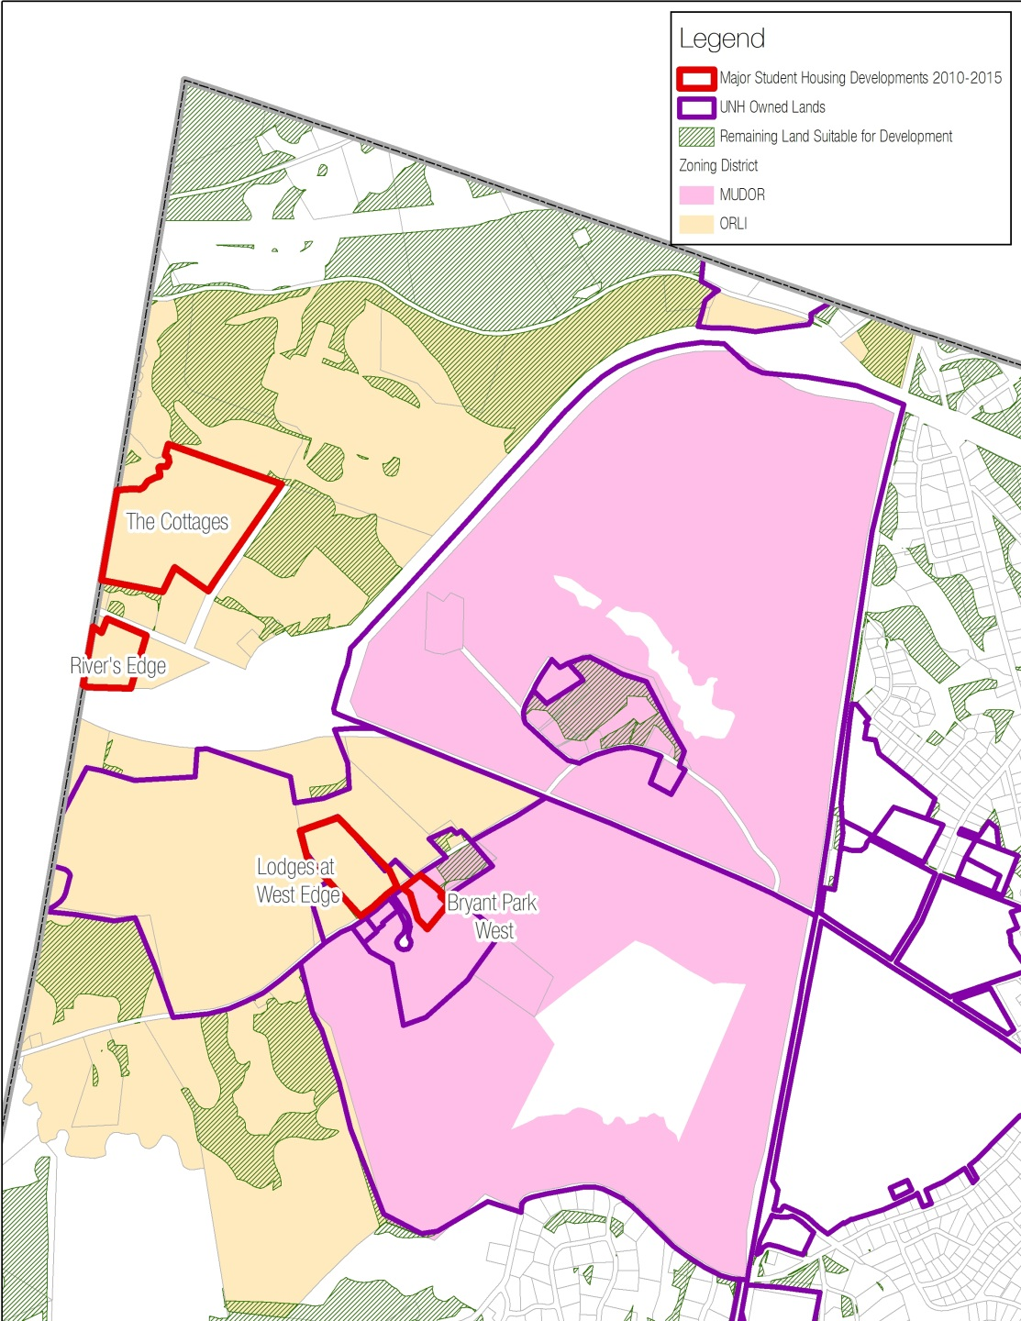
The MUDOR and ORLI zones have attracted private off-campus student housing developments in recent years. Yet, there has been virtually no other economic growth in these zones. While the MUDOR zone is primarily UNH owned lands, ORLI does offer close to 200 acres of land suitable for future development. Water and sewer data in these zones is available in the Commercial & Industrial section of this chapter.
Map 14: Student Housing Developments in the MUDOR and ORLI Zones (Source: SRPC)
Durham’s current ordinance also has a Rural zone in College Woods along the Oyster River. According to the UNH Campus Master Plan (2012) this area has been designated as a Natural Area and places these lands in a preservation status. However, UNH has identified other areas within these two zoning districts for public-private ventures. These areas are located near North Road, Leavitt Lane, and Mast Road. As stated in the University’s Master Plan, it is likely that there will be only limited funding for campus construction projects for some time and public-private ventures may play a role in the future development of the University.
Quick Fact: The ORLI zone offers close to 200 acres of remaining land suitable for future development

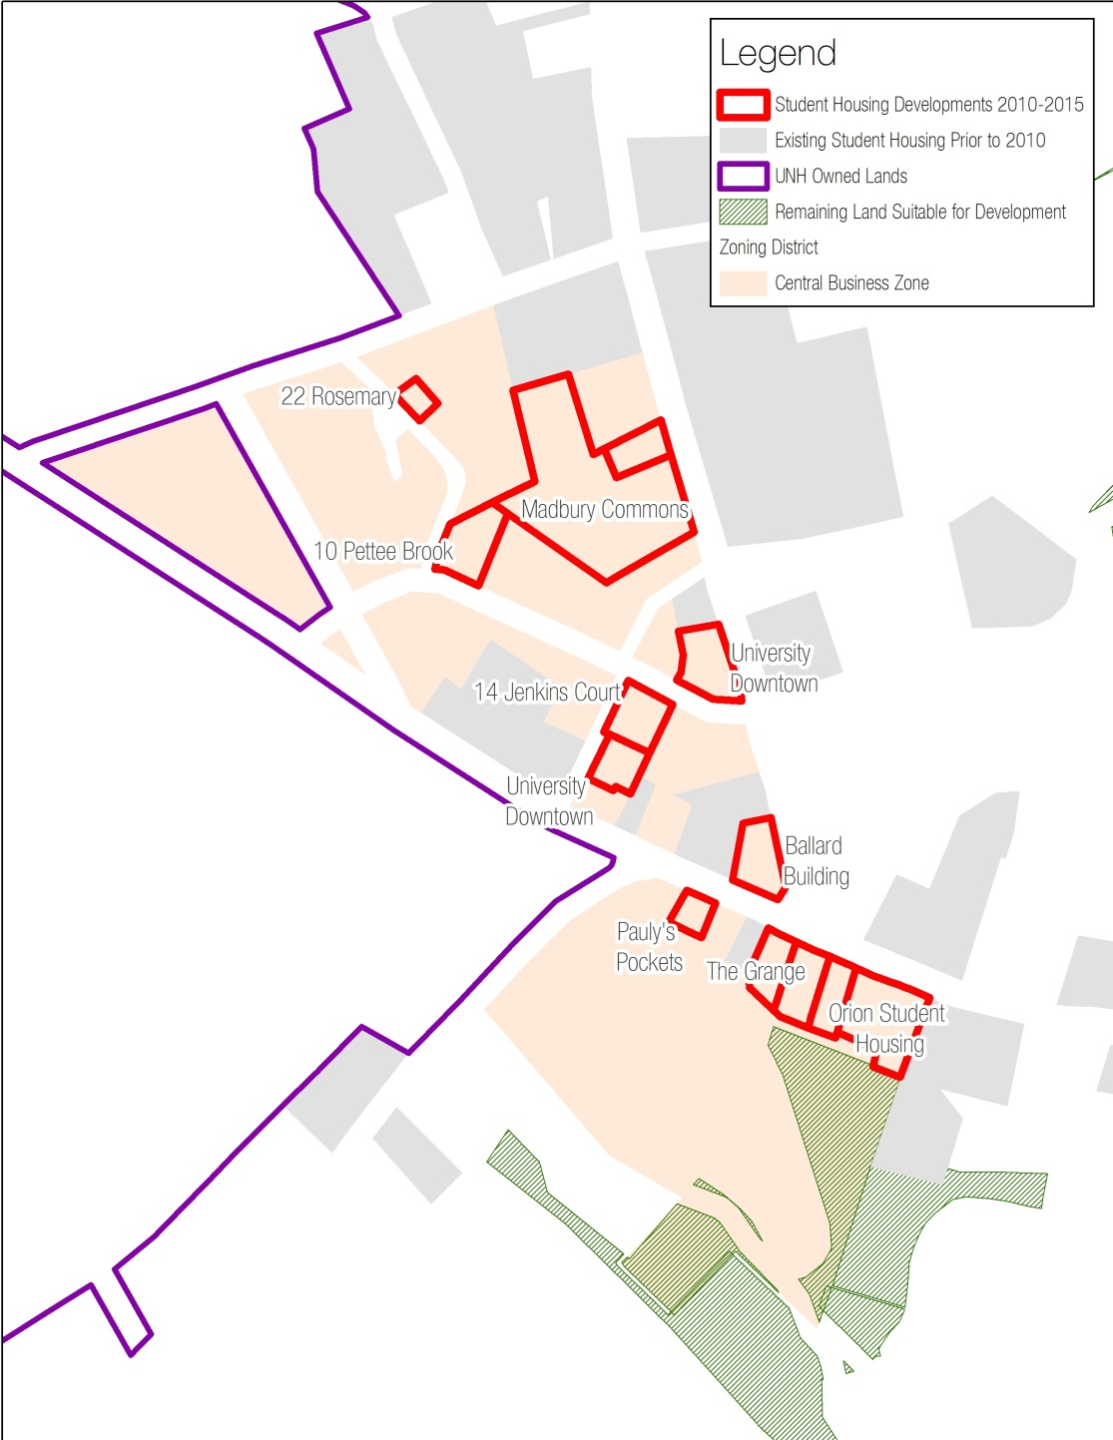
The Central Business zone encompasses much of what residents consider the downtown and commercial core. A number of redevelopment projects include the repurposing of older building stock into new commercial uses and student housing. Of the total 31 acres in the CB zone, roughly 84% is currently constrained. The University owns 9%, leaving an estimated 7% available for future development (area behind the Mill Plaza parking lot).
Map 15: Student Housing Developments in the Central Business Zone (Source: SRPC)
Table 17: Land Characteristics for the Central Business Zone
Zone | Total Land  (acres) | UNH Owned Land (acres) | *Other Land Constraints (acres) | Land Remaining  (acres)
CB | 31.15 | 2.73 | 26.1 | 2.32
*Note: Other land constraints consist of conservation land and Town-owned properties, UNH land, and non-developable land (wetlands, very poorly drained soils, steep slopes >25%, and selected local regulations, buffers, and setbacks)
Source: NH GRANIT
Right now, approximately 15% of the Central Business land acreage is being used for student housing developments. However, this percentage is somewhat misleading as present zoning requires first floor commercial space, which has enabled some of these student housing developments to have small business activity as well. At this point there is uncertainty on the potential impacts of additional students in the downtown. Nevertheless, given the limited area of the downtown the community will need to make a decision as to whether this kind of continued development maintains the mixed-used, pedestrian-orientated character of the downtown area.
Quick Fact: The Central Business zone has roughly 7% of its remaining land acreage available for new development

Land Use Characteristics
According to GIS data generated by Strafford Regional Planning Commission, the following describes Durham’s current generalized land use characteristics.
Durham’s Current Generalized Land Use Characteristics

Table 18: Durham Generalized Land Use Characteristics
Land Use Classification | Acres | Percent
Residential | 2,165.6 | 13.66%
Commercial & Industrial | 256.7 | 1.62%
Transportation, Communications, and Utilities | 470.2 | 2.97%
Outdoor and Other Built-Up Land | 315.5 | 1.99%
Agriculture | 1,335.8 | 8.43%
Transitional | 193.9 | 1.22%
Forest | 8,350.8 | 52.68%
Water | 1,542.0 | 9.73%
Wetlands | 1,102.2 | 6.95%
Other Non-Vegetated | 119.4 | 0.75%
TOTAL | 15,852.1 | 100.00%
Source: 2010 Land Use data – NH GRANIT
Using data derived from the NH Land Use Mapping Standards, Strafford Regional Planning Commission generated GIS information that describes Durham’s generalized land use. Table 18 indicates that roughly 20% of the total land in Durham is classified as developed. The predominant urbanized land use type is residential, occupying approximately 2,165.6 acres, which represents 68% of the total developed portion of town. Other developed lands are commercial and industrial, transportation, communications and utilities, and outdoor/other built-up land. Land that is not categorized as developed includes agriculture, transitional, forest, water, wetlands, and other non-vegetated lands. The largest land use classification is forest land, which makes up roughly 53% of the total land use acreage in Durham. The smallest land use classification is other non-vegetated lands, which is considered barren, disturbed, or idle land, and can also include undeveloped, exposed areas and construction sites for new development.

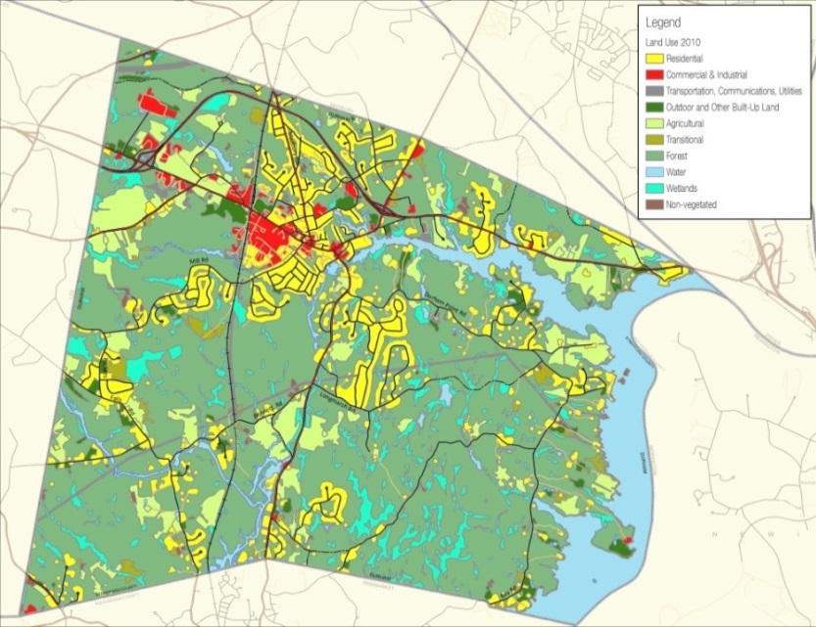
Map 16: 2010 Generalized Land Use Characteristics (Source: SRPC)
What You Said: Source: 2011 Visioning Forum
“Keep sustainability, self-sufficiency in mind while creating ordinances.”

Developed Land
3,208 Acres
20%
Generalized Land Use Estimates and Changes in Durham, 1962-2010

Table 19: Land Use Estimates and Changes in Durham, 1962-2010
Land Use Classification | 1962 acres | % of land use | 1974 acres | % of land use | 1998 acres | % of land use | 2005 acres | % of land use | 2010 acres | % of land use | 1962-2010 acreage difference | 1962-2010 % change
Developed | 1,051.3 | 7% | 1,830.0 | 12% | 2,717.6 | 17% | 3,109.7 | 20% | 3,208 | 20% | 2,156.7 | 205.17%
Agriculture | 2,496.1 | 16% | 1,907.3 | 12% | 1,254.2 | 8% | 1,360.1 | 9% | 1,335.8 | 8% | -1,160.3 | -46.48%
Transitional | N/a | - | N/a | - | N/a | - | 194.2 | 1% | 193.9 | 1% | -0.3 | -0.15%
Forest | 9,889.2 | 62% | 9,512.1 | 60% | 9,334.5 | 59% | 8,428.2 | 53% | 8,350.8 | 53% | -1,538.4 | -15.56%
Water | 1,512.2 | 10% | 1,538.0 | 10% | 1,739.6 | 11% | 1,539.2 | 10% | 1,542.0 | 10% | 29.8 | 1.97%
Wetlands | 255.6 | 2% | 365.2 | 2% | 229.9 | 1% | 1,102.9 | 7% | 1,102.2 | 7% | 846.6 | 331.22%
Other Non-Vegetated | 647.8 | 4% | 699.6 | 4% | 576.4 | 4% | 117.9 | 1% | 119.4 | 1% | -528.4 | -81.57%
TOTAL | 15,852.2 | 100% | 15,852.2 | 100% | 15,852.2 | 100% | 15,852.2 | 100% | 15,852.2 | 100% | N/a | N/a
Note: The wetlands percentage change is misleading as there have been significant technological advancements to delineate wetlands
Source: NH GRANIT
Like many communities in the Strafford region, Durham has experienced an increase in developed land and a decrease in both agriculture and forest land over the last 50 years. According to SRPC’s estimated land use change data from years 1962–2010, nearly 47% of the active agricultural land that existed in Durham in 1962 has either been developed or is no is longer considered an active agricultural area, leaving 1,335.8 acres today. Similarly, 16% of the town’s forest lands have been developed since 1962, leaving approximately 8,851 acres today. There has been an estimated 205% increase in the amount of developed land in Durham since 1962. The total acreage calculations for Durham’s open water have remained largely consistent. Due to scientific and technological advancements, as well as changes in land classification, and land management practices (i.e. beaver control) since 1962, acreage calculations for the town’s total wetland area have adjusted significantly. According to the 1962 data-set, Durham contained just over 255 acres of wetland area; which is now known to be closer to 1,102 acres. Table 19 and the accompanying maps on the next page provide a statistical and visual display of how Durham’s land use characteristics have changed over the past 50 years.

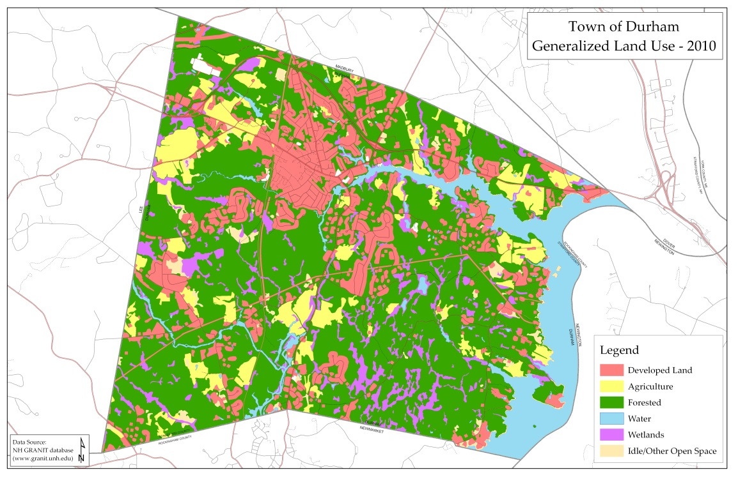
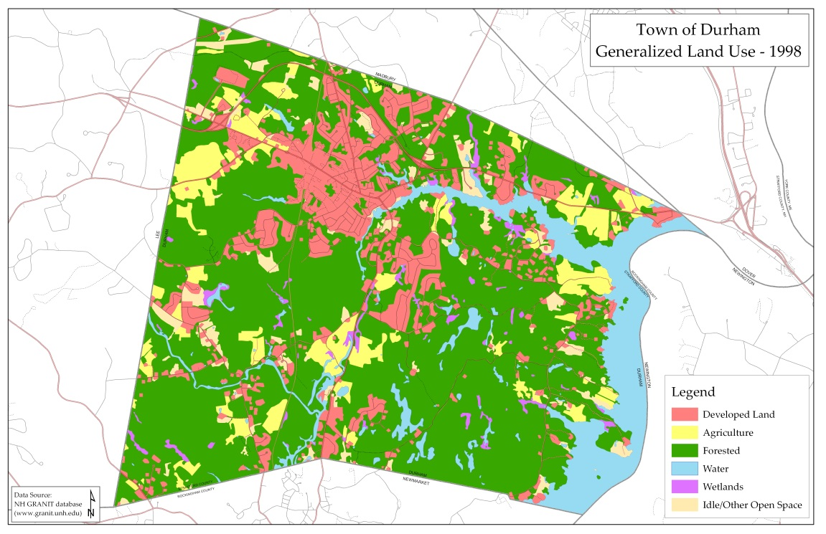
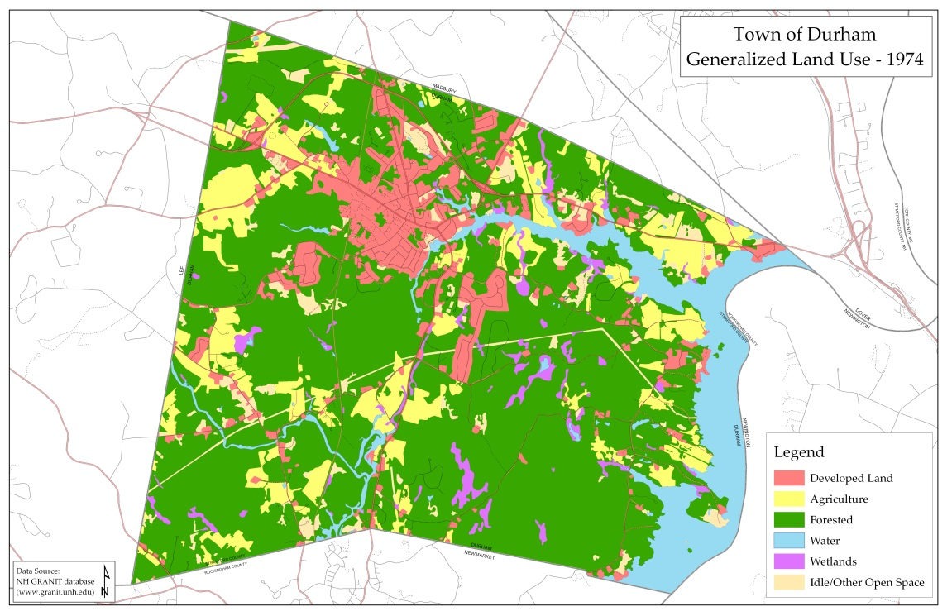
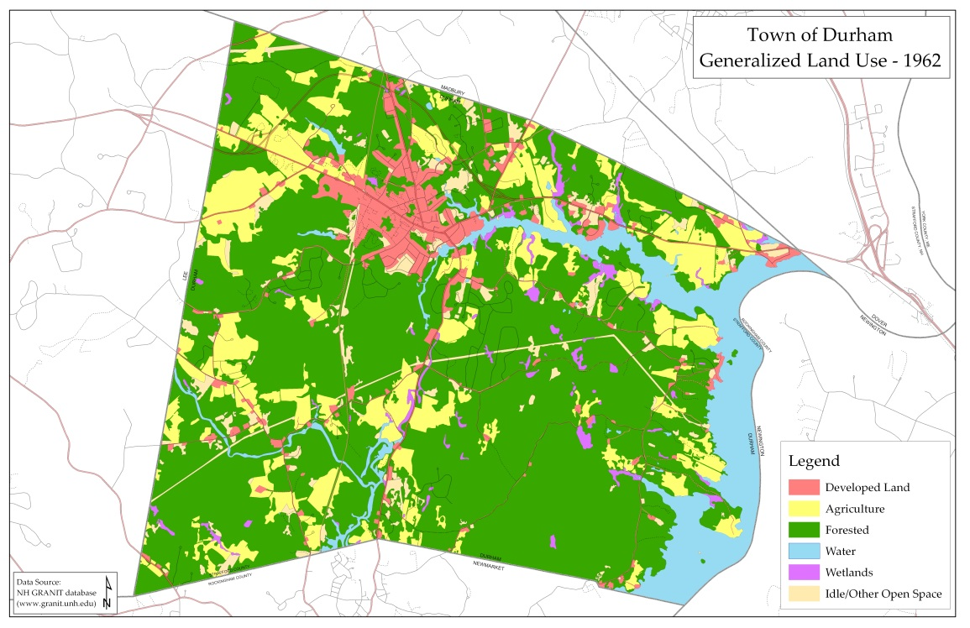
Map 20: Generalized Land Use in Durham - 2010 (Source: SRPC)
Map 19: Generalized Land Use in Durham - 1998 (Source: SRPC)
Map 18: Generalized Land Use in Durham - 1974 (Source: SRPC)
Map 17: Generalized Land Use in Durham - 1962 (Source: SRPC)
Buildout Analysis

A municipal buildout analysis attempts to show what might happen if a community grows to the full extent allowed under its present regulations. It is not meant to paint an exact picture of the future, but instead can serve as a useful tool to anticipate the possible impacts of future development. There are two main types of community buildouts; a tax parcel-based buildout and a zoning-based buildout. A zoning-based buildout analysis was done for the current Master Plan.
The following methodology was completed, using GIS (geographic information system) in order to quantify the remaining amount of undeveloped developable land within the Town.
- Calculate an estimate of the amount of undeveloped land by zoning district within the Town based on the most recent (2010) land use data

- Subtract the amount of non-developable lands by zoning district from step 1
  - Non-developable lands included:
Quick Fact: This buildout analysis is based upon existing zoning, land use regulations, and environmental constraints
    - Permanently conserved lands
    - Town-owned and other protected lands
    - University of New Hampshire owned lands
  - Other environmental land constraints
    - Slopes greater than 25%
    - Very poorly drained soils
    - Wetlands
  - Local regulations, buffers, and setbacks
    - 75 ft. buffer around wetlands
    - 125 ft. buffer along Great and Little Bays, the Oyster River, the Lamprey River, Durham Reservoir, Moat Island Pond, Johnson and Bunker Creeks, and Follett’s Brook including the tidal sections of their tributaries
    - 75 ft. buffer along all other perennial streams except College Brook and Pettee Brook
    - 25 ft. buffer along College Brook and Pettee Brook

Table 20 presents the statistical finds of the buildout analysis. The map on the next page is a visual presentation of the data in Table 20.
Table 20: Buildout Figures
Zoning Districts | Gross Area  (Acres) | *Current Land Already Built Out  (Acres) | Amount of Undeveloped Land  (Acres) | **Land Constraints  (Acres) | Remaining Land Suitable for Development  (Acres) | Percentage Remaining Land Suitable for Development
Residential Districts
Residence A (RA) | 894.67 | 594.36 | 300.31 | 184.61 | 115.7 | 12.93%
Residence B (RB) | 1,372.01 | 487.38 | 884.63 | 560.42 | 324.21 | 23.63%
Residence Coastal (RC) | 2,672.45 | 615.84 | 2,056.61 | 1049.37 | 1,007.24 | 37.69%
Rural (R) | 6,845.23 | 700.79 | 6,144.44 | 4,443.16 | 1,701.28 | 24.85%
Nonresidential/Mixed Use Districts
Central Business (CB) | 31.15 | 28.43 | 2.72 | 0.4 | 2.32 | 7.45%
Professional Office (PO) | 28.33 | 26.43 | 1.9 | 0 | 1.9 | 6.71%
Church Hill (CH) | 24.99 | 22.08 | 2.91 | 0 | 2.91 | 11.64%
Courthouse (C) | 10.53 | 8.68 | 1.85 | 0 | 1.85 | 17.57%
Coe’s Corner (CC) | 33.03 | 17.61 | 15.42 | 8.63 | 6.79 | 20.56%
Office and Research – Route 108 (OR) | 110.68 | 31.47 | 79.21 | 36.16 | 43.05 | 38.90%
Multi-unit Dwelling/Office Research (MUDOR) | 762.18 | 145.12 | 617.06 | 597.73 | 19.33 | 2.54%
Office, Research and Light Industry (ORLI) | 741.55 | 166.94 | 574.61 | 379.00 | 195.61 | 26.38%
Durham Business Park (DBP) | 48.93 | 10.35 | 38.58 | 18.21 | 20.37 | 41.63%
TOTAL | 13,575.73 | 2,855.48 | 10,720.25 | 7,277.69 | 3,442.56 | 25.36%
* Based on 2010 Land Use
**Land constraints consist of conservation land and Town-owned properties, UNH land, non-developable land including wetlands, very poorly drained soils, steep slopes >25%, and selected local regulations, buffers, and setbacks
Note that an additional 442 acres of roadways are classified as “built out” but fall between/outside of Durham’s zoning districts
Source: NH GRANIT
Data Disclaimer: This buildout does not take into consideration the regulatory impacts from the Town’s conservation subdivision ordinance. A more accurate buildout analysis would be needed to truly identify the capability of any area, which can only occur after a review of the physical and regulatory constraints that exist in Durham.
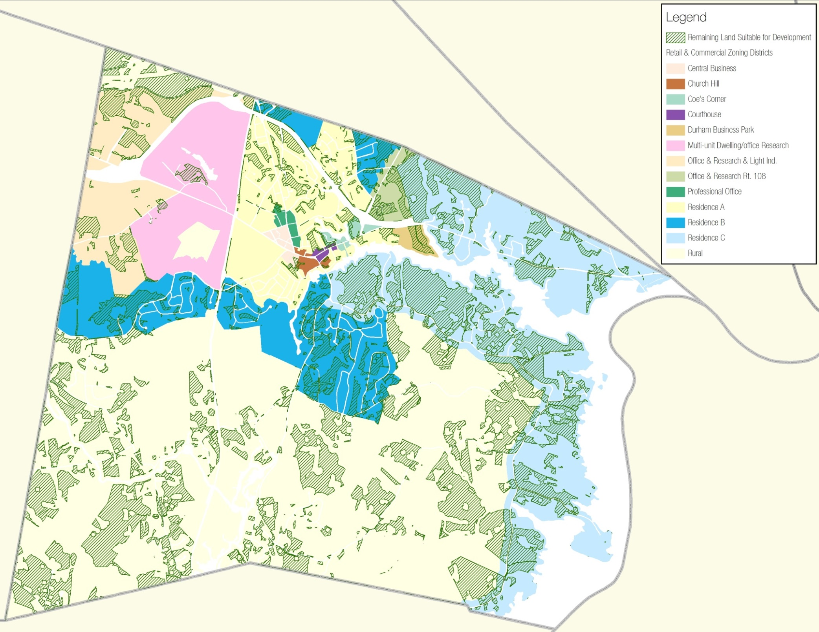
Map 21: Remaining Land Suitable for Development (Source: SRPC)
Connections to Other Chapters
Existing land use issues intersect and align with many aspects of the Town’s plans for the future. As a result, they help inform other chapters of the Master Plan. Considerations raised in this chapter echo throughout this document and are especially linked to the following components of other chapters.

Vision and Community Character
Durham's existing land use patterns are a physical expression of the town's values, goals, and vision. The homes, businesses, and recreational opportunities are dependent upon the use of the land, making land use decisions arguably the most important aspects of Durham's future.

Agriculture
Roughly only 8.5% of the land in Town is classified as agriculture. Durham has experienced a loss of approximately 46% of their agriculture lands since 1962. However, Durham has completed numerous land conservation projects in order to preserve important local farms including Emery Farm, Gangwer-Roselawn Farm, and Amber Acres.
Demographics and Housing
Residential development is the predominant category of developed land. Durham experienced a majority of their residential growth in the late 1990s, which led to significant changes in their zoning regulations. Off-campus student housing developments have been a profitable market in Durham. These student housing developments have occurred in two general locations: along Mast Road and west of Route 4, and within the downtown core.
Downtown and Commercial Core

Off-campus student housing developments that have occurred within the downtown core in the Central Business zoning district have resulted in dramatic changes to the downtown and surrounding areas. There is uncertainty on the potential impacts of additional students in the downtown. The community will need to make a decision as to whether this kind of continued development maintains the mixed-use, pedestrian-orientated character of the downtown.
Economic Development
With their zoning, Durham has guided commercial and industrial development into two areas: the downtown core and the nearby Route 108 area, and areas in the ORLI and MUDOR districts. UNH has identified specific areas for public-private ventures that could result in private development that would need to conform to Durham Zoning Ordinance and other regulations.
Energy

Student housing developers have voluntarily built housing projects that incorporate significant energy efficient measures.
Historic Resources
Thompson Hall, which is listed on the National Historic Register, was first built in 1893 and is known as the near-geographic center of the University’s campus.
Natural Resources

Durham has a long tradition of public support for conserving high priority land possessing significant natural resources, and over the years the Town has been a partner in many successful land conservation projects. Since 2003, the Town has conserved ten new easements and permanently protected roughly 735 acres.
Recreation
Durham's land protection efforts have resulted in the availability of more conservation land, including the Oyster River Forest, to offer additional recreational activities for residents.

Qualifications
Land Use Classification Definitions
Residential – Single family, duplex, multi-family, low, medium, and high rise apartments, townhouses, mobile home parks, condominiums, and group and transient quarters
Commercial & Industrial – Retail, wholesale, services, lodging, government, educational, metal production, mining, and electronics
Transportation, Communications, & Utilities – Air, rail, water, and road transportation, and communication, electric, gas, and water and wastewater utilities
Outdoor and Other Built-Up Land – Urban or built-up land consisting of botanical gardens, zoos, stadiums, racetracks, amusement parks, golf courses, etc.
Agriculture – Cropland or pasture, orchards, bush fruits, vineyards, and ornamental horticulture
Transitional – Brush or transitional between open and forested
Forest – Forest land as defined by the society of American Foresters; broadleaf, coniferous, and mixed
Water – Rivers, canals, lakes, ponds, reservoirs, bays and estuaries, and other waterways
Wetlands – Consists of forest, non-forest, and tidal wetlands
Other Non-Vegetated – Barren, disturbed, or idle land; undeveloped exposed areas or construction sites for new development

The information in this chapter is based largely on data derived by using the NH Land Use Mapping Standard. This standard describes a classification scheme and mapping protocols for generating land use data from high resolution, remotely sensed data sources. The standard was developed by the NH Geographically Referenced Analysis and Information Transfer (NH GRANIT) System staff at Complex Systems Research Center (CSRC), University of New Hampshire, in consultation with the Office of Energy and Planning and the nine Regional Planning Commissions in the state. It was informed by prior land use mapping projects conducted by Planning Commissions and GRANIT staff, as well as a series of discussions hosted by the NH Department of Environmental Services. This broad input yielded a standard which is designed to meet the land use mapping needs of a diverse community of users.
The standard was developed under the auspices of the CTAP/I-93 Corridor Project in southern New Hampshire, and will govern the production of land use data for the 26 towns in that Corridor. While developed for that project, it is recommended for all NH land use data sets derived from high resolution image sources that are to be archived in the GRANIT database. It should be noted that while land use and land cover are at time simultaneous, the standard does not necessarily apply to land cover data sets.
Data Sources
The primary data source for land use data is high-resolution (1 ft.), color, leaf-off, digital orthophotography. Additional data sources include:
- NH Department of Transportation road centerlines
- NH National Hydrography Dataset (NHNHD)
- NHDES water distribution areas, depicting water and sewer service zones
- US Fish and Wildlife Service National Wetlands Inventory (NWI)

The Conservation Fund contains revenue allocated from the Land Use Change Tax. These are tax revenues that are assessed as a result of the development of land in Current Use, and are used by the Conservation Commission for land protection and other conservation-related projects. The Land Use Change Tax is not paid by all taxpayers, only by landowners when they convert their land that was in Current Use from open space into developed land.
Other protected lands include: Oyster River School District, Oyster River Park, NHDOT, Faculty Neighborhood Open Space, NH Fish & Game, and the Towns of Lee and Newmarket
NH Land Use Mapping Standard. CTAP Land Use Mapping Project. GRANIT/Complex Systems Research Center. March, 2007.

