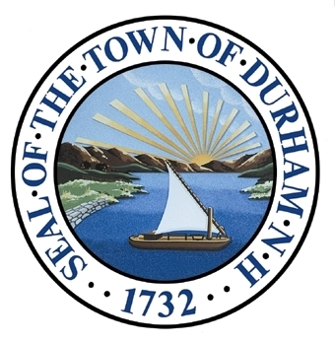

Energy
An Energy Chapter of the Master Plan presents a vision and steps to guide the Town’s efforts for the next ten years and beyond. This chapter includes a brief introduction to energy-related activities implemented since adoption of the 2000 Master Plan and a series of goals and recommendations for achieving the overall vision of a resilient, efficient, and environmentally responsible municipality.

Adopted by the Durham Planning Board on November 18th, 2015.

Durham Energy Committee’s Revision History
Jan 20, 2015: Cumulative changes to a word file marked version 7 were finalized in Word and transferred to Google docs where our committee could view the document in prose format and coordinate revisions to the text more easily. All images and charts were temporarily removed to facilitate a focus on the structure and accuracy of the written content.
Jan 21, 2015: Charlie Forcey simplified the formatting temporarily to facilitate editing, table of contents generation, and support efforts of content experts Mary Downes and Prof. Martin Wosnik’s additions.
Jan 23, 2015: Mary Downes edited substantial sections of the document and added information as needed throughout. Charlie Forcey incorporated those comments, adjusted text for comments, and left comments where no resolution was easily found. Document converted back to Word for final editing.
Feb 11, 2015: Group editing of the NH Energy Sources and Uses Section during a meeting.
February 15, 2015: Mary Downes edited.
February 15, 2015: Charlie Forcey edited to restore the original pillar language (no principles were evident in this draft) and the cohesion of each of the pillar sections.
February 18, 2015: Energy Committee edited NH energy sources with Martin Wosnik and goals and measurements section during a meeting.
February 19, 2015: Charlie Forcey added 2014 pie chart for electricity sources

Our Vision
In 2025 and beyond, the Town of Durham, along with commercial property owners and homeowners, will continue to realize cost savings while reducing carbon emissions, thereby increasing the community’s resiliency and sustainability relative to energy use.
All new construction will be built to high energy efficiency standards that follow current best construction and management practices. A large proportion of existing buildings, including an aging housing stock, will have been retrofitted to minimize heat loss.
In this vision of the future, land use planners will develop recommendations for high density or compactness of new and existing neighborhoods; carefully sited and designed development near the core of the community; and the mixing of uses specifically as a means to reduce energy use for our daily needs. Community and municipal facilities will be centrally located and linked both to each other and to nearby neighborhoods by a comprehensive network of sidewalks and bicycle paths, separated from roadways where possible. Residents will have easy access to safe, fresh, local food that is relatively secure from a disrupted supply of energy or energy-intensive transportation.
Foundation
Through successive Master Plans, Durham’s citizens have consistently voiced support for a walkable, bike-friendly downtown, which was clearly articulated in the 2011 Durham Master Plan Survey. Suggestions at the Energy Committee’s own visioning forums in 2008 and 2009 included “Change the town’s configuration,” and “Study how the layout of Durham affects our energy use.” Some residents see Durham as lacking a secure food supply. Others emphasize that increases in heating fuel prices pose a significant risk to homeowners dependent on this source of energy for warmth in the winter.
What Do We Look Like?
A green town
Durham’s downtown is somewhat walkable – weak links
Lack of accommodations for pedestrians
Need more green space/landscaping along streets and facilities
Durham is not bicycle friendly – system is fragmented
Need integration with roadways
Best transit in NH (Wildcat and COAST)
What Will We Look Like?
More sustainable and alternative energy sources
A community with a fully integrated bicycle system
Green housing
Embracing smart growth principles to afford density
More public transportation
Multi-modal transportation connecting neighborhoods with downtown
TOTAL NUMBER OF PARTICIPANTS 90 citizens
 | How Important are the Following Attributes to You?
 |  |  | Overall Positive Response Rate |  | Strongly Agree | Somewhat Agree
 | Implementation of additional energy conservation measures from municipal facilities |  | 92% |  | 65% | 27%
 | Continuing the re-development of existing structures |  | 89% |  | 51% | 38%
 | Development of alternative energy sources for municipal facilities |  | 85% |  | 59% | 26%
 | Importance of pedestrian and bicycle friendliness |  | 82% |  | 52% | 30%
 | Change in Town codes to promote energy-efficient building construction |  | 82% |  | 56% | 26%
 | Establishment of one or more conveniently placed park-and-rides for carpooling |  | 76% |  | 38% | 38%
 | Improving the bike lane network downtown |  | 74% |  | 41% | 33%
 | Better sidewalks downtown |  | 73% |  | 32% | 41%
 | Better crosswalks downtown |  | 68% |  | 35% | 33%
 | Better biking and walking access to the downtown |  | 59% |  | 33% | 26%
 | Improvements to transportation that connects the downtown with recreation opportunities |  | 39% |  | 12% | 27%
 | Improvements to public transportation to downtown |  | 28% |  | 10% | 18%
 | TOTAL NUMBER OF PARTICIPANTS |  | 467 citizens
The following is a summary of relevant comments and input submitted during the 2011 Visioning Forum and 2011 Master Plan Survey conducted by the Town of Durham. Results of these engagement opportunities form the foundation of this Energy chapter while providing a lens of public perception and interest surrounding these topics.
2011 Master Plan Survey: Energy
2011 Visioning Forum: Energy
Introduction
The Challenges Ahead

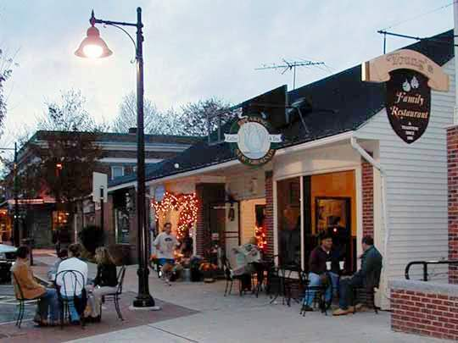
As Durham looks to the challenges facing it and its neighboring communities in the next ten, twenty, and fifty years, its citizens seek to realize a vision of being a sustainable and resilient community. Recent Town Councils have acknowledged this priority in their goals. Progress toward achieving this vision will determine the town’s capacity to thrive in the face of changes in energy supplies, environmental conditions, and the regional, national and international economy.
Photo 1: Young’s Family Restaurant
Durham’s challenges are not unique. As the town moves further into the 21st Century, it faces continued dependence on fossil fuels, which leaves the community vulnerable to energy supply and price volatility. In addition, Durham shares with other small northern New England towns two specific challenges: low population density and a cold climate that have historically resulted in high-energy usage for home heating and limited opportunities to build upon economies of scale.

Boldness, Balance, and Dialogue Characterize Durham’s Energy Past

In 1973, the country was struggling in the midst of a recession and an energy crisis. That autumn, leading New Hampshire politicians, businessmen, and the state’s powerful statewide newspaper supported plans to build the “world’s largest oil refinery” on Durham Point. Shipping magnate Aristotle Onassis’ Olympic Refineries promised to bring jobs and oil independence to the state with no ensuing damage to the environment. Durham residents quickly organized to launch a David-and-Goliath battle against the proposal out of a multitude of concerns, including worries over the environmental health of the Great Bay. At Town Meeting on March 6, 1974, voters blocked the oil refinery proposal in a 1,254 to 144 vote affirming the community’s right to self-determination. Durham’s visionary local action grabbed national attention and made a global impact.
Commitment to a bold vision is often the best route to realizing audacious goals: witness President Kennedy’s challenge to NASA and the country at large “…to landing a man on the moon and returning him safely to earth.” In the realm of combating climate change relative to the built environment, an equivalent goal might be the Living Building Challenge: to make buildings that are “net zero energy” (i.e., consuming no more energy than they generate), water-independent, non-toxic, and culturally rich. When issued in 2006, the Living Building Challenge seemed almost impossible: but today, six buildings have been certified and a dozen others are in the operational phase necessary before certification.
Some concepts that today seem “out there” or cutting edge are likely to become standard precisely because they deliver the best solutions. New technology and an open-minded community can work together for significant change.
Ground and air source heat pumps, solar thermal and photovoltaic, biomass, and district heating (one heating plant that serves many houses or buildings) systems are already making inroads in Durham’s commercial and residential housing developments, both for single-family homes and multi-unit apartments. Electric cars on Durham streets are supported by vehicle charging stations throughout the region, including at the Town’s public library. Bicycle- and car-share programs will augment single-family vehicle ownership. Recently approved group net metering rules, and commercial Property Assisted Clean Energy (PACE) districts provide opportunities for Durham to more rapidly adopt renewable energy and increase the efficiency of its building stock.
A bold vision of sustainable building practices; entrepreneurial, synergistic opportunities between the University of New Hampshire (UNH) campus and Durham business communities; and a significant improvement in the pedestrian and bicycle infrastructure throughout the downtown core is a vision within the Town’s reach.
What You Said:
“More sustainable green office development – green industry”
Source: 2011 Visioning Forum

However, advances toward this vision will not be without costs and points of conflict with other community goals. The efficient flow of commuter traffic and pedestrian and bicycle access downtown is one area in which the Town will need to balance competing needs. Financing efficiency measures with long payback periods may bring higher costs to today’s taxpayers while controlling costs over the long run.
Balance is also needed in the regulatory arena. Strict building and zoning code standards and stringent environmental regulations produce savings over the long term. However, in the short term these regulations can negatively impact builders and property owners.
Such a balancing act requires collaborative discussion leading to broad agreement as the most effective way of achieving the vision of this Chapter.
Durham’s Strengths
Durham has a number of strengths that make its vision of becoming a regional and national leader on municipal energy practices a realistic one. First and foremost, the town has a tradition of forward thinking, organized action, and efficient governance. Durham has a tight-knit and intimate business community that has shown a remarkable ability to respond creatively to new market conditions. It has made significant energy efficiency improvements to many properties, including the town’s single industrial facility (Goss International); Young’s Restaurant, an iconic community gathering spot; and the Mill Plaza. Student housing developers have voluntarily built housing projects that incorporate significant energy efficient measures, generate a significant percentage of their energy needs on-site, and incorporate innovative technologies such as ground source heating.
Durham has significant potential to leverage its intellectual and entrepreneurial capital to promote both energy resilience and economic development, both within the UNH community and in the education and technology hubs of the seacoast and greater Boston metro area. An example of this was the innovative Green Launching Pad based at UNH (2010–2013), which provided support to dozens of local entrepreneurs with energy-related business ideas. Engagement with and support for this kind of collaboration and innovation could help Durham not only to participate in, but to lead the region in attaining greater energy self-reliance while expanding local economic opportunity.
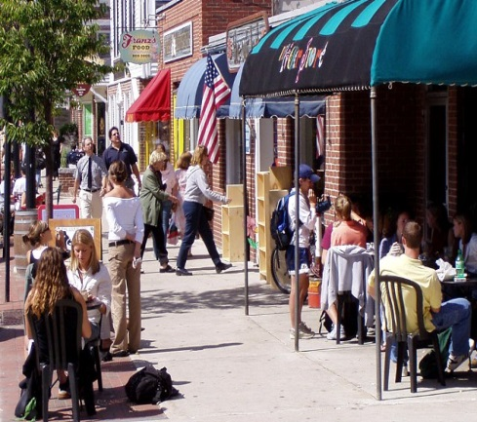
Economic and Security Benefits of Energy-Focused Planning
Photo 2: Downtown Durham
The financial benefits of energy planning derive from greater efficiency (e.g., improved furnace leads to lower heating fuel bills) and from substitution of cleaner, cheaper, more accessible sources of energy. Energy price and/or supply disruptions threaten the economy, as well as the health and well-being of residents, businesses and the municipality as a whole. On the other hand, high-quality, energy-efficient housing and business establishments that are not wholly dependent on distant sources of energy will reduce and stabilize energy costs for all.
Energy efficiency opportunities and lower costs also attract business and industry. A vibrant downtown with businesses connected to higher density residential neighborhoods by a network of sidewalks and bicycle paths will reduce the community’s greenhouse gas emissions associated with transportation, and promote an active community, improved local economy, and greater resilience in meeting shared challenges (e.g., disaster recovery).
State, Regional, and Local Efforts to Date
Readers are urged to turn to this chapter’s Appendix for greater detail about the history of energy initiatives in New Hampshire, New England and Durham. The Appendix also provides a succinct explanation of the science behind global climate change. Table 1, on the next two pages, provides a summarized list of completed energy initiatives in Durham since 2007.
Enabling Legislation for the Energy Chapter of the Master Plan
NH RSA Chapter 674, Local Land Use Planning and Regulatory Powers, Section 674:2 addresses the purpose and description of the Master Plan. Subsection III lists optional sections of the Master Plan that a municipality may adopt, including:
(n) An energy section, which includes an analysis of energy and fuel resources, needs, scarcities, costs, and problems affecting the municipality and a statement of policy on the conservation of energy.
The purpose of this Chapter is to guide planning decisions driven by the Master Plan—focused on transportation, building design, land use, and economic development—so that Durham may better address these challenges. We may not know exactly how these challenges will play out, but we need to take proactive steps to ensure that our town is energy‐resilient.

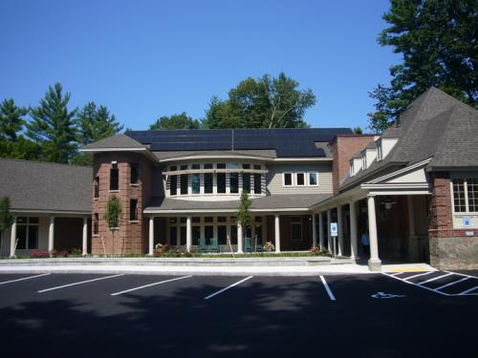
What You Said: Source: 2011 Master Plan Survey
85% of respondents support the development of alternative energy sources for municipal buildings

Photo 3: Durham Public Library (Photo Credit: Revision Energy)
Table 1: Selective Timeline of Energy Initiatives in Durham
2007 | The March 13, 2007 ballot included a New Hampshire Climate Change Resolution. Durham voters adopted the Resolution by a vote of 1,447 to 254. The following month, the Durham Town Council passed a resolution creating an Energy Committee. The Committee’s mandate is to advise the Council on ways to reduce energy use, develop alternative energy sources, and increase the economic security and energy independence of the Town.
2008 | The Durham Planning Board asked the Energy Committee to draft an Energy Chapter for the updated Master Plan to guide Town actions with respect to energy, as supported by RSA 674:2(n). The Committee began work on the chapter by holding two public input sessions. It also conducted a greenhouse gas inventory to estimate the amount of energy Durham uses annually and to identify the attendant emissions from fuel consumption. This inventory became the first step in benchmarking efforts to reduce emissions over a longer period. The results indicated that the majority of greenhouse gas emissions are generated by the use of personal vehicles and for heating homes.
2010 | DEC advised the Town Administrator on the purchase of town electricity from a competitive third party supplier in order to reduce the Town’s energy outlays. As a result, the Town entered into a contract with Constellation NewEnergy, resulting in a projected savings of approximately $40,000 each year.
2010 | Brought to the Town Council a resolution to designate the Town of Durham—in its entirety—an “Energy Efficiency and Clean Energy District,” thereby paving the way for the initiation of a Property Assessed Clean Energy (PACE) program. With approval of the Resolution, Durham became the first such “designated” town in New Hampshire. Based on policies promulgated by federal housing lenders, the State Legislature subsequently removed the financial guarantees that made PACE economically attractive to Durham homeowners while fiscally safe for the town. Durham’s PACE program remains tabled; however, in 2014 the State Legislature approved a commercial PACE program.
2011 | DEC completed a three-year profile of Durham’s municipal energy use and converted that data into a format that allows the NH Office of Energy Planning (OEP) to compare the energy usage of New Hampshire communities. (Refer to section on Municipal Energy Use for more information.)
2011 | DEC initiated an amendment to the Building Construction chapter of the Town Code, approved by the Town Council. Durham thereby became the first jurisdiction in the country to adopt IECC 2012 building energy codes. The DEC also developed an “Energy Considerations Checklist” (“the Checklist”) designed to help developers, contractors, and homeowners deliberately focus on energy efficiency through all stages of their project’s development.
2011 | DEC advocated for bicycle improvements to the downtown traffic pattern change and addition of better and extended bike lane striping on Madbury Road from Main Street to Garrison Avenue (from the Middle School).
2012 | DEC collaborated with the Peregrine Energy Group, which performed an Energy Opportunity Assessment to guide the Town in developing and implementing an energy reduction strategy. The assessment included specific recommendations and next steps to reduce energy use and increase energy efficiency. It also provided summary information on the buildings with recommendations that can provide a starting point for securing bids from installation contractors for suggested projects.
2012 | Together with Town officials and a local solar installer, the DEC worked with the Town Administrator to develop a Power Purchase Agreement (PPA) for municipal solar generation, requiring no capital expenditure and establishing stable electricity rates equal to or less than currently paid.
2012 | DEC completed the installation of photovoltaic systems on three municipal facilities.
2013 | In April 2013 the Council approved amendments to Chapter 97, “Plumbing Code and Regulations,” of the Durham Town Code to codify the town’s support for water conservation and water-efficient plumbing relative to public water and sewer systems. The amended code now requires lower-flow water-using fixtures (e.g., faucets, showerheads, toilets) in new construction and other projects that require building permits. The Energy Committee and Conservation Commission supported these amendments, acknowledging the critical link between the supply of clean water, the treatment of wastewater, and energy consumption.
2013 | DEC presented a draft Energy Chapter of the Master Plan to the Planning Board, which endorsed it in July.
2014 | DEC coordinated with the Town Administrator to issue a Request for Proposal for a bike-pedestrian improvement “master” plan focusing on downtown; the plan was delivered in the fall
2014 | DEC conducted a baseline transportation survey in late spring and presented results to the Town Council in October.
2014 | DEC collaborated with representatives of the four Durham churches to explore financing solar installations to help offset their combined total of 140,000 kWh in electrical usage.
2014 | As of late 2014, Durham is home to two Leadership in Energy and Environmental Design (LEED) buildings (refer to Table 2 for more information on LEED certified buildings in the region). The UNH campus hosts two LEED Gold buildings: James Hall on Colovos Road and the Peter T. Paul College at Main Street and Garrison Avenue.
2015 | Durham's new Town Hall at 8 Newmarket Road received LEED Silver certification.
2015 | DEC advised the Town Council regarding revising the language of the Solar Energy System Tax Exemption to clarify the intent and implementation of the Exemption, recommending a tax neutral policy for new installations, while grandfathering systems installed prior to April 1, 2015.
Source: Durham Energy Committee, 2015
What You Said: Source: 2011 Master Plan Survey
82% of respondents encourage energy-efficient building construction through Town codes

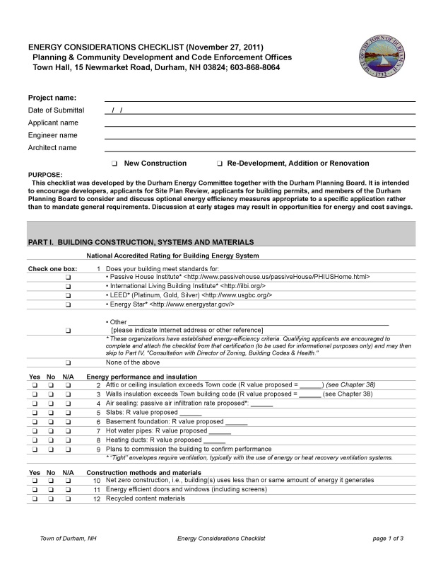
Photo 4: Durham’s Energy Considerations Checklist

New Hampshire’s Energy Uses and Sources

Energy issues extend far beyond the borders of our community. In this section, we will provide a brief overview of energy information at the regional, state, and local level to provide context for our recommendations.
New Hampshire’s Energy Sources and Electricity Generation
The energy we consume is typically categorized into sources of so-called primary energy on one side, and energy usage sectors that consume primary energy on the other side. Sources of primary energy are petroleum, coal, natural gas – all fossil fuels, nuclear energy, and renewable energy. Renewable energy includes hydro, wind, solar, biomass and geothermal energy. On the other side of the equation, the energy usage sectors are transportation, industrial, commercial and residential. Electric energy is generated from a variety of primary energy sources and is consumed by all usage sectors, but due to its importance in our lives it is often treated separately.
New Hampshire’s consumption of total energy in the United States in 2012 was 215 million Btu/person, comparable to other New England states. New Hampshire does not produce most of the primary energy it currently consumes – fossil and nuclear fuels must be brought into the state, leading to a net outflow of energy dollars from the state. New Hampshire energy consumers spend more than $6 billion a year on energy, and of that, 78% leaves the state immediately.
The transportation sector accounted for 35% of New Hampshire's energy consumption in 2011. This is the largest energy usage sector, which at this time is almost exclusively powered by petroleum. Oil (petroleum) prices depend on global supply/demand and geopolitical issues outside of our control and can be quite volatile. In 2013 about 33% of the petroleum consumed in the United States was imported, down from a peak of about 60% imports in 2005.
Residential energy consumption makes up 29% of the state’s usage and is among the highest per capita by percent in the nation, primarily due to the heavy dependence on heating oil during the winter. Commercial activity makes up 23% while industrial energy usage has the smallest share at 12%.
New Hampshire’s electricity generation is dominated by nuclear power. About half of New Hampshire’s net electricity generation (in any given year) comes from the Seabrook nuclear plant, the largest nuclear station in New England. Seabrook produces approximately 10,000 GWh per year (9,240 GWh in 2014). Offsetting the benefits of this local generation, the Seabrook plant’s radioactive fuel is imported to the state.
Figure 1: Net Generation by Fuel Source in New Hampshire, All Sectors, 2014
Source: Advanced Energy Economy, Power Portal < http://powersuite.aee.net/portal/states/NH#energy> based on Energy Information Administration data.
Natural gas is the second-largest generating source of electricity in the state. Usage of natural gas has increased significantly across New England since 2003 with the commissioning of several new large generating stations. In 2014, natural gas provided approximately 3,957 GWh in New Hampshire. Coal provided 1,218 GWh, hydroelectric provided 1,271 GWh, biomass provided 1,368 GWh, and wind currently provided 377 GWh in 2014. As of 2014, more than 16% of New Hampshire's net electricity generation came from renewable energy that includes hydroelectric power, biomass (e.g., wood), solar, and wind. The precise mix of fuels used for generating electricity varies considerably from month to month, year to year.

New Hampshire’s Renewable Energy Sources
The state’s landscape and geography offer opportunities for renewable energy, including solar, wind, hydro, and biomass energy resources. The establishment of the State’s Renewable Portfolio Standard (RPS) through the passage of RSA 362:F in 2007 created a significant source of State funding for renewable energy. The RPS set a target for 24.8% of the State’s electricity to come from renewable sources by 2025, a comparatively modest goal relative to other states with renewable energy targets. The New Hampshire RPS was intended to promote utility-scale investment in renewable energy but has been more effective at promoting small-scale investment in both thermal and electric renewable energy through the Renewable Energy Fund (REF).
Funded by alternative compliance payments from electricity utilities and independent suppliers in the state, the REF has supported the installation of hundreds of solar PV systems throughout the state. These alternative compliance payments are “alternative” to the purchase of renewable energy credits by the utilities and independent suppliers, which would represent more direct investment in larger scale, more cost effective, New Hampshire-sourced renewable energy. Current State policies and associated economic incentives are not on pace to promote renewable energy adoption as fast as will be needed to reach the current RPS goal by 2025.
What You Said:
“92% of respondents support additional energy conservation measures for municipal facilities.”
Source: 2011 Master Plan Survey

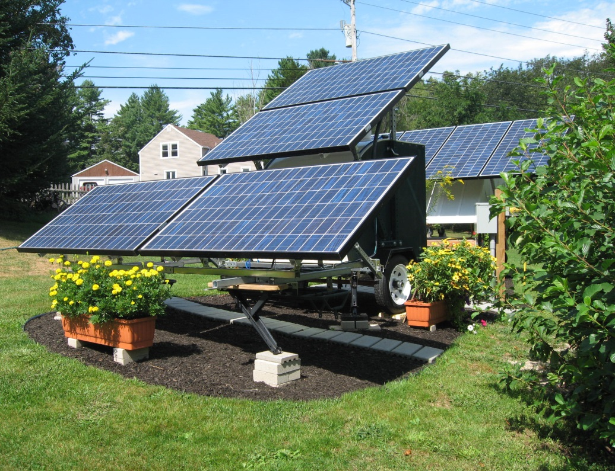
Solar Generation
Photo 5: Locally Installed Solar Panels (Photo Credit: Jack Palmer)
OEP’s September 2014 report New Hampshire 10-Year State Energy Strategy (“NH State Energy Strategy”) identified “solar PV to be the technology with the largest untapped potential in New Hampshire.” However, to date, the development of solar resources in New Hampshire has been chiefly through small installation at homes and businesses. New Hampshire has on average 20% greater solar potential (insolation per unit area) than Germany, the current world leader in solar photovoltaic production where government policy in the form of “Feed-in Tariffs” have resulted in 36 GW of solar capacity installed in 2014.
As of the end of 2013, nearly 1,500 New Hampshire electricity customers are “net metered,” connected to the electricity grid in such a way as to both take electricity off the grid and put it back on through small-scale solar photovoltaic generation. These 1,500 customers have a combined maximum capacity of greater than 10 MW, and represent an investment of nearly $40 million in solar electricity and solar thermal (chiefly for water heating) in the state.
Wind Power
The favorable commercial scale wind resources in New Hampshire are generally limited to select mountain ridges, hilltops, and offshore locations. The installed wind power capacity in 2014 was 171 megawatts (MW), all of it land-based. In 2014, these wind installations contributed 377 GWh, roughly 31% of the electric energy generated by coal plants such as Schiller Station in Portsmouth. Like any commercial scale energy enterprise, the development of wind resources has been marked by contention over issues ranging from environmental protection to viewscapes, to the health, economic well-being, and other property rights of local communities and their residents.
Hydropower
In addition to wind and solar resources, the state also boasts a number of powerful waterways, including the Androscoggin, Saco, Piscataqua, Merrimack, and Connecticut rivers. Both the Merrimack and Connecticut rivers are home to several hydroelectric power plants, some of which are over a century old and still operating. In 2014, hydropower contributed 1,271 GWh of electrical power, roughly equal to that provided by the state’s coal-fired plants.
Smaller scale hydro capacity (“lo-head”) exists in the Seacoast region, on the Cocheco River in Dover, the Salmon Falls in Somersworth, and, potentially, on the Lamprey River in Newmarket (developable). Tidal energy potential exists in Great Bay Estuary, but tidal energy conversion installations will likely not be as cost effective as other renewable energy technologies.
Biomass
New Hampshire leads the nation in forest-covered land (89%), which provides a source of wood fuel for heat and electric generation, contributing substantially to the state’s economy. Nearly 1 in 12 New Hampshire homes depend on wood products as a heat source. On the commercial scale, Portsmouth is home to the Schiller Station power plant, which includes a 50 MW-capacity biomass-fired boiler and is currently operated by Eversource Energy. This plant generates enough electricity to power approximately 50,000 homes. A similar biomass plant in Berlin has a 70 MW capacity. These two plants and several others contributed 1,368 GWh to the state’s energy mix, more than the combined declining contribution of the state’s coal plants.
Energy Efficiency: The Hidden Fuel
It is a proven fact that the cheapest “source” of energy is energy efficiency, but the excellent financial returns of energy efficiency retrofits are commonly overlooked. Nearly every building in the state has energy efficiency opportunities.
Assistance is available through NHSaves, operated by the state’s gas and electric utilities, which offers programs that provide cash incentives and financing to help homeowners, businesses and municipalities adopt more efficient equipment and processes. The utility-run programs also provide technical assistance, such as energy audits, building operator training, building codes training, and the NHSaves website, to assist their customers in reducing their gas and electric energy usage. More than $25 million a year is invested in energy efficiency by the utilities. This investment benefits not only those who participate in the programs, but all ratepayers, who collectively benefit from both lower demand on the regional grid and the delay in development of new power plants.
The Town of Durham has taken advantage of the NHSaves program rebates, as have many of the town’s businesses and residents. The Durham Energy Committee has promoted participation in the program through its Energy Considerations Checklist and “Button Up NH” workshops that promote weatherization.
Trends in Energy Costs
Residents in New Hampshire and throughout the Northeast experienced sharply rising electricity prices in 2014–2015 due to constraints in the winter supply of natural gas, when there is increasing demand both to generate electricity for the grid and to supply homes and businesses with heat. A 2014 state-by-state comparison of the average retail prices of electricity to the residential sector showed that New Hampshire’s prices were the 7th highest in the country. Our high dependence on imported heating fuel and our long, cold winters contribute to the state’s higher annual energy costs than in much of the country.
Heavy reliance on imported fuel sources and vulnerability to their cost volatility highlights the wisdom of municipalities that pursue an energy strategy to increase reliance on sustainable local sources in order to reduce risk, lower costs, and promote a healthy environment.
Durham’s Energy Uses and Sources
Durham gets its electricity from Eversource Energy (formerly called Public Service of New Hampshire (PSNH)), a local generation and distribution company that serves the vast majority of the town. The New Hampshire Electric Cooperative (NHEC) provides electricity to a very small number of residential customers. A number of independent third-party electricity suppliers use Eversource’s distribution lines to supply electricity to Durham’s commercial and residential customers, including the Town of Durham government. Unitil provides natural gas service to Durham’s residents and businesses located along established natural gas lines.
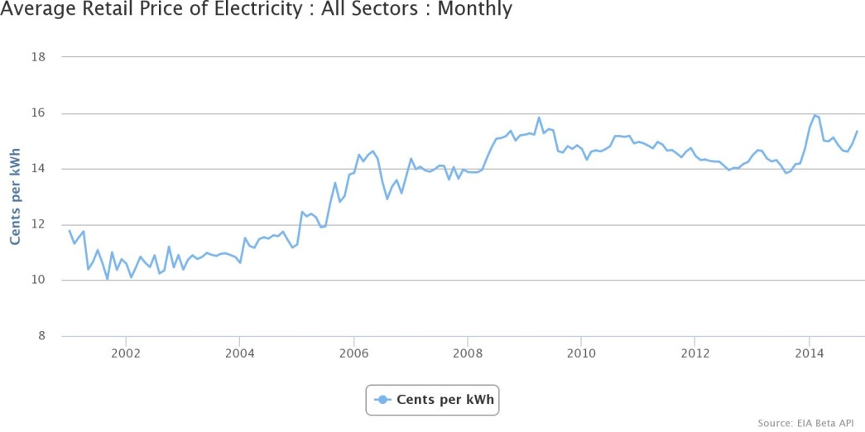
The 2012 U.S. Census American Community Survey estimates that 50.5% of Durham’s households use fuel oil to heat their homes and 15.5% use natural gas. The remainder use electricity, liquid propane, wood, and other fuels. Durham’s fuel mix closely mirrors statewide trends. According to the NH Office of Energy and Planning, fuel oil is the most widespread heating source in the state. Nationwide, only 6.5% of homes use fuel oil as the primary source of heat, mainly due to the relatively widespread availability of natural gas throughout the country compared to the northeast.
Source: Advanced Energy Economy, Power Portal <http://powersuite.aee.net/portal/states/NH#energy> based on Energy Information Administration data.
Figure 2: Average Retail Price of Electricity in New Hampshire, All Sectors: Monthly, 2001 - 2014.
Municipal Energy Use
Beginning in 2011, Durham started taking steps to identify and track the energy use at all of its municipal facilities in order to assess areas where management or efficiency improvements could result in lower energy use and cost savings. The Durham Energy Committee provided assistance in compiling this data with the help of University of New Hampshire graduate students, the Strafford Regional Planning Commission, and the New Hampshire Energy Technical Assistance & Planning Program (ETAP). In addition, an energy audit of Town-owned facilities was performed through the ETAP program.
The two Town of Durham facilities that use the most energy are the wastewater treatment facility and the Churchill Rink. While a significant amount of energy is needed to pump and treat municipal solid waste, Durham’s plant is doing well compared with other wastewater facilities, as evidenced by its relatively low energy expense: the facility uses only 13% of its overall operating budget for wastewater treatment versus an industry average of 30%. The recent replacement of the facility’s blowers with high-efficiency units has helped to reduce electricity usage. The Churchill Rink is also a large electricity consumer, but since late 2013, its electricity needs have been met in part by a solar electric array on its roof. The former Durham Town Hall at 15 Newmarket Road had been the Town of Durham’s largest user of heating oil. The new Durham Town Hall at 8 Newmarket Road, designed to LEED standards, is anticipated to be significantly more energy-efficient to operate.
Energy Generation at the University of New Hampshire
While Durham does not have any large-scale power generators, the University of New Hampshire operates a combined heat and power plant (“CoGen”), which is currently the primary source of electricity and heat for the five-million-square-foot campus. In operation since 2006, the plant captures waste heat normally lost during the production of electricity and uses this energy to heat campus buildings, thus reducing sulfur dioxide and nitrous oxide emissions. Over the first full academic year (AY) of its operation (AY 2006) greenhouse gas emissions for the campus dropped by 21% from the previous year (AY 2005).
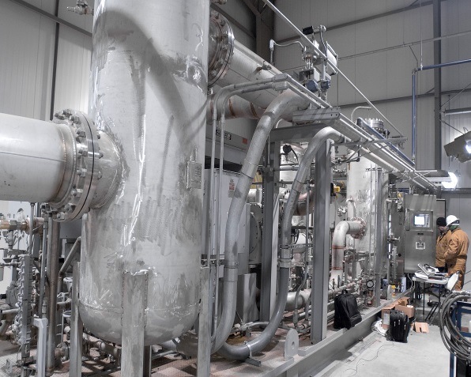
In 2009, UNH completed its EcoLine project, which purifies methane gas from private company Waste Management’s Turnkey Recycling and Environmental Enterprise (TREE) in Rochester, making it the nation’s first major university to use landfill gas as its primary fuel source. Once purified, the landfill’s naturally occurring methane gas is piped nearly 13 miles to the combined heat and power plant, where it can provide up to 85% of the University’s energy needs.
Photo 6: Processing Plant at Waste Management Turnkey Recycling and Environmental Enterprise (TREE)

Renewable Energy Generation in Durham
As of early 2015, 36 Durham property owners have installed a combined 143 kW of solar photovoltaic capacity. The Town worked with ReVision Energy to install, under an umbrella power purchase agreement, 120 kW of solar capacity at the police station, the public library, and Churchill Rink. These late 2013 and December 2014 installations effectively doubled the amount of solar electric energy being generated in Durham. The municipal arrays produce enough energy to power about 14 average NH homes for a year and offset about half of the power usage of these three facilities.

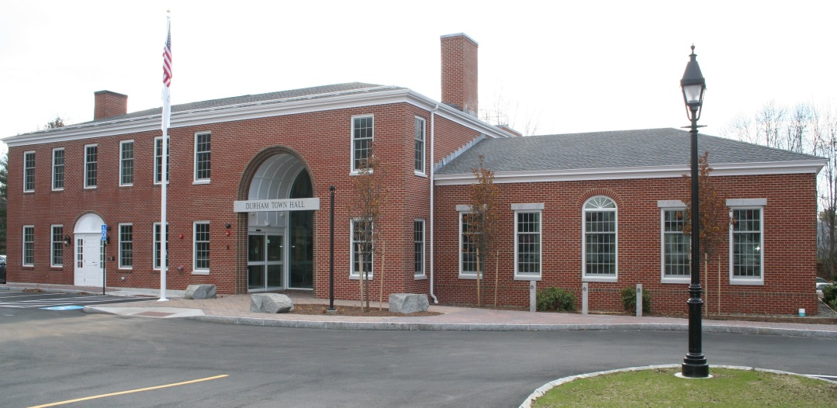
Leadership in Energy and Environmental Design (LEED) Buildings
Photo 7: Durham Town Hall at 8 Newmarket Road (Photo Credit: DCAT Studios)
As of late 2014, only seven buildings in the region had been certified, or were in process of being certified, as Leadership in Energy and Environmental Design (LEED); Durham is home to three of the seven (refer to Table 2 for more information on LEED certified buildings in the region).
The UNH campus houses two LEED Gold buildings: James Hall on Colovos Road and the Peter T. Paul College at Main Street and Garrison Avenue. In 2015, Durham’s new Town Hall at 8 Newmarket Road received LEED Silver certification.
Changes to the Town Code
Table 2: LEED Certified Projects in the Region
Name |  | Municipality | Certification Level | Year
Turbocam |  | Barrington | In progress | N/a
Liberty Mutual |  | Dover | Gold | 2008
Children Museum of NH |  | Dover | Silver | 2009
James Hall |  | UNH | Gold | 2010
Peter T. Paul College |  | UNH | Gold | 2013
Town Hall |  | Town of Durham | Silver | 2015
Cocheco Well Water Treatment Plant |  | Rochester | Certified | 2011
 | Source: US Green Building Council, 2015
In 2011, the Town Council approved a change to Chapter 38 of the Town Code, "Building Construction" that resulted in Durham becoming the first municipality in the country to adopt the 2012 International Energy Conservation Code (IECC). This action beat by three years the deadline for compliance and set the bar for other communities in New Hampshire and throughout the country to adopt these significant changes (it should be noted that Durham committed to basing its energy code construction on “the current printed edition of the International Energy Conservation Code,” not the 2012 version, per se).
Each revision of the International codes sets higher standards for greater energy efficiency performance and recommended renewable energy guidance. The 2012 IECC required more insulation, a tighter envelope, tighter ducts, better windows, and more efficient lighting than the prior 2009 version.
In April 2013 the Council approved amendments to Chapter 97, “Plumbing Code and Regulations,” of the Durham Town Code to codify the Town’s support for water conservation and water-efficient plumbing relative to public water and sewer systems. The amended code now requires lower-flow water-using fixtures (e.g., faucets, shower heads, toilets) in new construction and other projects that require building permits. The Energy Committee and Conservation Commission supported these amendments acknowledging a link between water and energy consumption.
Durham’s Three Pillars of Energy Planning and Action
In 2008 and 2009 the Energy Committee sponsored a series of public conversations to guide development of the Master Plan chapter. Discussions focused on how Durham could improve its economic vitality, ensure its energy stability, and reduce its environmental impact. Three themes arose from these discussions, which the Committee identified as pillars around which the community could organize energy planning and actions.
Pillar I: Building Design and Land Use
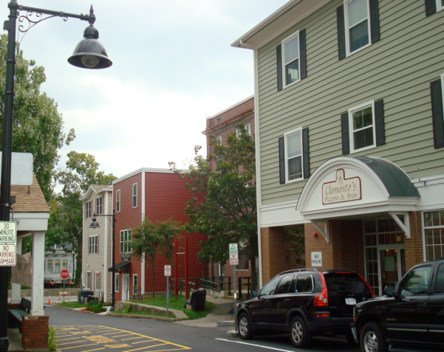
Durham has taken steps to “brand” itself as a leader in municipal best practices for land use, conservation, and energy-efficient zoning and planning, such as concentrating new housing in existing neighborhoods. This “branding” reflects many residents’ values and is a viable strategy for attracting desirable economic activity and new residents to Durham. Much more could be done, however, to “walk the talk” in being a community that actually prioritizes the convenience and safety of pedestrians and bicyclists.
Land Use Regulations and Incentives
As the community courts new businesses, reviews land use and development plans, approves building permits, and revises zoning and building codes, it should seek ways to maximize energy efficiency, reduce environmental pollution, and discourage the use of motorized vehicles for daily activities. The Planning Board should work with local developers to encourage energy efficient development.
Photo 7: Jenkins Court
Building and Construction Code
The Town of Durham building and construction code can be a powerful tool to ensure energy-conscious “best practices” in architecture and construction. In New England, the largest portion of energy consumption, second only to transportation, is for heating homes and businesses. Much of this heat comes from fossil fuels, such as heating oil and propane, which is often burned in outdated and inefficient furnaces and boilers. By setting a high bar for energy performance at the time of construction and renovation, the Code Office can ensure that future building owners and occupants are in a competitive advantage relative to other communities.

Pillar II: Transportation
Transportation accounts for the largest share of energy use across the country—about 35% for the state. For Durham, it accounts for the largest single portion of the town’s annual residential and municipal energy use and cost. In 2008, Durham’s Greenhouse Gas Emission Inventory determined that approximately 43% of the town’s greenhouse gas emissions come from residents driving personal vehicles, reflecting both a high degree of commuting and the hub-and-spoke geography of town development.
Through careful planning, Durham can help residents to significantly reduce transportation costs and carbon emissions, and enhance the quality of residents’ lives in the process. In addition, as the “NH State Energy Strategy” noted, “A strategic plan to reduce transportation energy use is also an important component of the State’s economic development activities as the majority of transportation energy dollars immediately leave the state’s economy to pay for imported fossil fuels.”
Photo 8: Example of a shared lane marking – “Sharrow”
Many of Durham’s transportation patterns are rooted in its suburban, low population density character, the presence of the University, and the regional economy.
What You Said: Source: 2011 Visioning Forum
“Improve walkability”

From an energy perspective, improving Durham’s transportation network, land use patterns, and building construction practices is essential to reducing consumption. These improvements reduce the need for energy outright, offer excellent economic payback, and promote environmental stewardship. As noted above, a key strategy that Durham can pursue to reduce its energy consumption is through thoughtful planning and zoning.
Reducing Short-length Car Trips
Short car trips – less than two miles – are costly in terms of fuel, carbon emissions, and downtown vehicular congestion. Unlike longer car trips, short trips can be accomplished via a wider variety of transportation options in a community like Durham.
While already boasting the most extensive public transit system in the state, Durham has ample opportunity to increase the number of short trips undertaken on foot or on a bicycle. The 2014 Transportation Survey undertaken by the Durham Energy Committee revealed that over half of those Durham residents responding use a bicycle at least occasionally. Add to that the thousands of UNH students who make the town their home during three quarters of the year, and the opportunity for increasing non-vehicular miles traveled is large indeed.
Both the Town of Durham and UNH have taken proactive steps to move toward this vision by adding bicycle lanes and trails, improving walkways and crosswalks, and calming traffic with stop signs and speed tables. However, the town would benefit from examining in closer detail the current traffic and transportation patterns and then setting an aggressive but realizable goal to reduce vehicle miles traveled (VMT) within its borders.
Through the use of policy, promotion, regulation, and enforcement Durham and UNH can improve the health and quality of life for residents, while reducing traffic congestion, promoting downtown business activity, and reducing greenhouse gas emissions.
UNH Traffic Demand Management
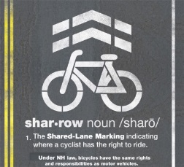
In 2003, the University of New Hampshire adopted a traffic demand management (TDM) approach to addressing the challenge of off-campus student and employee commuting. Since then, parking permit demand has remained flat or in decline, and transit ridership has increased dramatically. The University remains committed to promoting a walking campus, limiting parking capacity expansion, and enhancing transportation options (intercity rail, cycling infrastructure, car-sharing) that reduce the need for private vehicle use and parking. Working collaboratively with UNH, Durham should ensure that its policies reinforce this commitment and do not work at cross-purposes or serve to undermine it.
Transit
The University operates Wildcat Transit, which serves nine regional communities, and the Campus Connector, which serves Durham. Together, these two public systems comprise the largest transit system in the state. In FY2014, the two route systems logged over 1.2 million passenger trips, reducing an estimated four million private vehicle miles from the regional roadway system.
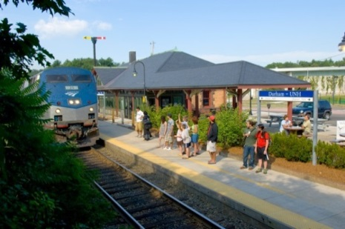
Approximately 45% of the Wildcat Transit fleet runs on compressed natural gas (CNG). The balance of the fleet runs year-round on B20 biodiesel, choices that further reduce the environmental impact of regional transportation.
Photo 9: Rail Station - Downeaster (Photo Credit: UNH Photographic Services)
In addition to the local transit system, Amtrak’s Downeaster train serves Durham and the UNH campus, connecting the town and its residents to Boston and Portland-Freeport-Brunswick. In 2013 over 61,000 passengers rode the Amtrak Downeaster to and from Durham, according to Northern New England Passenger Rail Authority (NNEPRA) ridership reports.
The campus has also recently introduced the ZipCar car sharing, open to community and campus members who join ZipCar.

Automobile Parking
On-campus vehicular parking demand has decreased, with “flat to consistent decline in permit sales at a time of slight campus growth but substantial student residential growth.” In the decade prior to 2012, the number of commuter student parking permits issued declined 34%, and resident student permit sales declined 5%. This exceeds national demographic trends of declining car ownership rates in the 16-25 year old population. However, developments in student housing in and near downtown since 2012 will challenge this trend.
Bicycle Parking
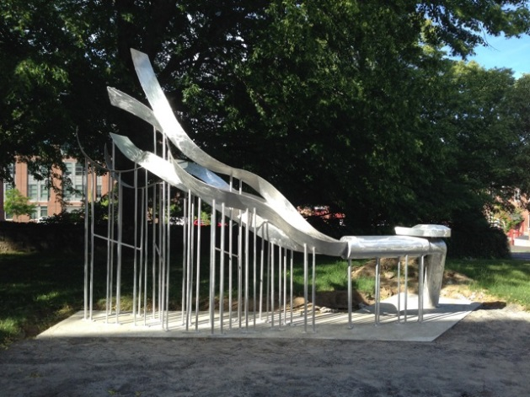
Not surprisingly, the demand for bicycle storage in and around the UNH campus has increased. UNH Housing has an informal benchmark of one outdoor bike rack storage space for every four beds at non-core-campus settings. By late 2014, UNH provided additional non-residential location storage capacity for nearly 3,000 bikes on campus for general use, an increase of approximately 19% since 2011, including outdoor functional “public art” parking through its ArtBike program.
Photo 10: Art Bikes (Photo Credit: UNH Campus Planning)
The Town provides single-loop hitching post bike parking in the core downtown area. Heavily used covered bike parking adjoins the entrance of the public library, while “overflow” bicyclists can use an uncovered rack toward the middle of the parking lot. Bike parking for employees and visitors is provided at the Town Hall, as well as at the police station and public works departments, which are located a distance away from downtown. The middle and high schools also report increasing numbers of students riding their bikes to school, particularly during the warmer months. In the downtown core, however, bicycle accommodations remain at the level they were before the development boom.
The Durham Energy Committee has been an advocate, before the Planning Board and other bodies, for the installation by private developers of secure bicycle facilities, e.g., bike racks and bike storage rooms. To date, this strategy has had mixed results. Private developments approved between 2008 and 2014 are anticipated to house approximately 2,371 occupants. Yet, according to notes on approved site plans for these developments, storage will be provided for only one in 10 of these occupants, leaving the other 90% to find less secure and convenient places to park and store their bikes, or to find means of getting around town other than by bicycle.
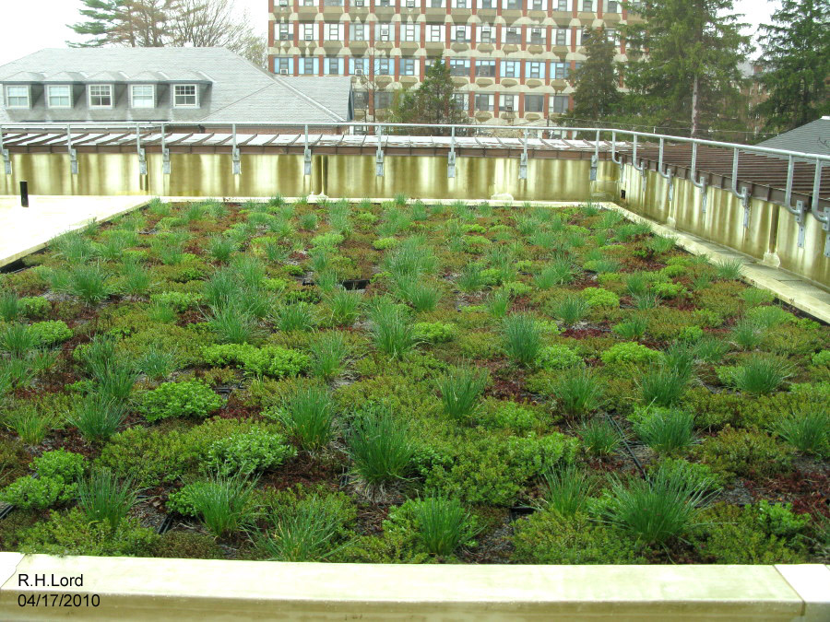
As of 2014, Durham falls short of being the bicycle and pedestrian-friendly community overwhelmingly supported by several previous Master Plans and by the Master Plan Survey conducted in 2011. The anticipated influx of thousands of new downtown residents arriving in the fall of 2015 underscores the need for improved bike-ped facilities.
Photo 11: Green Roof on James Hall (Photo Credit: Richard H. Lord)
Since municipal property taxes fund a good portion of Durham’s roadway maintenance and improvements, and since the community has made clear that the Town should accommodate multiple forms of transportation, it is incumbent upon the town to ensure that the roads accommodate all the different ways that Durham residents choose to travel. Durham should continue to include the improvement of bicycling and walking opportunities in its transportation strategy.
Pillar III: Alternative and Renewable Energy Sources
Demand-side management of Durham’s energy consumption is not sufficient on its own for creating a resilient community. Even if all energy efficiency and conservation measures were deployed, Durham’s residents and businesses would still need to heat and power its buildings and transportation network. Durham must take action on a municipal level to reduce consumption of fossil fuels, increase reliance on alternative and renewable energy sources, stabilize energy expenditures, and hedge against increasing fuel prices.
What You Said: Source: 2011 Visioning Forum
“More sustainable and alternative energy”

Key Conclusions

The following key conclusions have been organized to correspond with Durham’s three guiding pillars.
Key Conclusions about the current state of Pillar I: Building Design and Land Use
- Much of Durham’s building stock and municipal equipment is aging and energy-inefficient.
- Vehicle use is the default in town, given both low-density central neighborhoods and significant distances between outlying neighborhoods and the center of town.
- Over two-thirds of Durham residents depend primarily on fossil fuels to heat their homes, whether directly or via electric heat.
- Durham has been proactive in promoting and enforcing regulations relating to energy efficient building construction.
Key Conclusions about the current state of Pillar II: Transportation
- Approximately 43% of the town’s emissions come from residents driving personal vehicles, a higher percentage than the statewide average.
- Short car trips are costly in terms of fuel, carbon emissions, and vehicular congestion in the downtown area, and are the easiest vehicle miles traveled (VMT) to substitute through alternatives such as walking and bicycling.
- Walking and bicycling are impeded by a lack of safe and attractive network of routes, sidewalks, trails, and paths.
- While Durham is fortunate to have access to UNH’s excellent transit system, it is not available year round, and poses other barriers to residents’ use.
Key Conclusions about the current state of Pillar III: Alternative and Renewable Energy Sources
- Durham’s second-largest use of energy is for heating homes and businesses, much of it from fossil fuels.
- Petroleum fuels are subject to volatile pricing, come from non-local sources, and are unsustainable as well as polluting.
- New Hampshire’s electricity generation is dominated by nuclear power.
- New Hampshire’s electricity rates are significantly higher than the national average due to complex economic factors that are not easily predicted or controlled.
- As of 2014, only a small fraction of New Hampshire’s net electricity came from renewable energy, leaving the state well behind target for achieving the Renewable Portfolio Standard goal of the state’s electricity deriving from renewable sources by 2025.
- The combined heat and power (“CoGen”) plant at the University of New Hampshire currently provides most of the university’s energy needs.
- The two Town facilities that use the most energy are the wastewater treatment facility and Churchill Rink, the primary needs of which have been addressed by the Town through the addition of energy efficiency and renewable energy improvements.

Goals and Recommendations

This section outlines the goals and recommendations associated with the key conclusions of this chapter that are intended to strategically guide Durham’s energy efforts over the coming decade. It’s important to note that the goals and recommendations below are not prioritized. Below each goal you will find related key conclusions from the previous section of this chapter that form the respective goal’s foundation.
Land Use Recommendation

Issue: Durham’s current building stock and municipal equipment is aging and energy inefficient (Pillar I: Building Design and Land Use)
Goal: Take steps to rebuild, renovate, redesign, and/or replace municipal facilities and capital assets to reduce energy use by 30% from 2015-2025
Key Conclusions References: #1, 2, 3, 4
Recommendations
Planning
- Conduct detailed energy audits on all municipal facilities and implement recommendations. Prioritize energy-inefficient facilities, according to the energy audit, and make an action plan to weatherize. Use energy benchmarks to guide informed decisions.
- Use the Capital Improvements Program (CIP) to identify energy efficiency opportunities and to set priorities and timeframes for investments.

Funding
Pursue grant opportunities, rebate programs, and financing mechanisms for replacing and retrofitting inefficient equipment and structures.

Regulation
Identify and implement innovative technologies that lead to energy savings and ancillary benefits. Amend land use regulations and Town codes, if necessary, to allow for their use.

Partnerships, Collaboration, and Resource Sharing
Team up with UNH for collaborative energy challenge programs.

Goal: Encourage residential energy conservation
Key Conclusions References: #1, 2, 3, 4
Recommendations
Survey and Inventory
- Survey Durham home energy usage, heating technology, and resident attitudes toward home weatherization.
- Inventory and showcase model energy-efficient homes in Durham and those that use alternative energy generation to promote energy-efficiency cost savings and to provide a local model for retrofits. Provide homeowners with regionally relevant models for retrofits.

Partnerships, Collaboration, and Resource Sharing
- Work with utilities and fuel companies to help homeowners collect residential usage information and track change over time.
- Work with private and nonprofit organizations to establish an ongoing community-wide home weatherization program.
- Work with state legislators to initiate and promote (a) municipal and private funding mechanisms for energy efficiency programs and (b) state energy efficiency incentive and grants programs.

Goal: Encourage property owners to increase energy efficiency by requiring best management and energy efficient building practices for both new construction and renovation
Key Conclusions: #1, 2, 3, 4
Recommendations
Regulation
- Regularly review changes in national and regional building code standards. Initiate amendments to Town Code if necessary to ensure that Durham remains progressive regarding energy efficiency construction, allowing proven innovative energy efficient technologies, methods, and materials, subject to approval by the Director of Zoning Building Codes and Health.
- Prohibit new homeowner associations from establishing covenants that restrict energy options, including energy efficient measures such as outdoor clotheslines, and energy renewable measures, such as and solar panels.

Education and Outreach
Promote well-sited, energy efficient homes by:
  - Conducting an inventory of high efficiency homes and other buildings through a review of building permits and self-reporting. Track and report trends in those numbers over five years in the Town’s Annual Report.
  - Create an online survey tool to provide information about building practices as part of building permits and Planning Board processes.
  - Place articles about energy efficient buildings in Durham’s “Friday Updates.”
Goal: Develop regulations and incentives to create energy efficient municipal, residential, commercial, and industrial development
Key Conclusions: #1, 2, 3, 4
Recommendations
Planning
- Require the Director of Zoning, Building and Codes, and Health to be certified as a residential energy inspector and to receive annual International Code Council Energy Certification as a residential energy inspector.
- Regularly review the educational “Energy Considerations Checklist” (“the Checklist”) and update as needed.
- If supported by state-enabling legislation, work with Town of Durham officials to introduce an energy tax or surcharge to discourage the construction and use of excessively large or energy wasteful structures.

Regulation
- Work with the Planning and Zoning Department to identify items on the Energy Considerations Checklist that could be required, rather than suggested, and follow up by initiating amendments.
- Provide density bonuses or other available incentives to encourage net-zero or ultra-high efficiency building techniques for structures sited within a specified distance of the community’s core.

Issue: Low density central neighborhoods and significant distances between neighborhoods and the center of town encourage vehicle use (Pillar I: Building Design and Land Use)
Goal: Reduce the distance between new development and the community core and promote higher density in nearby neighborhoods in conjunction with conservation with open space and shared infrastructure (roads, driveways, septic systems, district heating)
Key Conclusions: #1, 2, 3, 4
Recommendations
Planning
- Advocate for the development of Traditional Neighborhood Development (“TND”) near downtown and existing neighborhoods, working with Town of Durham officials to amend land use regulations.
- Plan for an interconnected network of sidewalks and bicycle paths in future downtown redevelopment.

Regulation
- Require dedicated bicycle lanes, pedestrian walkways, and connections to main networks in new subdivisions, when feasible.
- Amend zoning, subdivision, and site plan regulations to reflect the direct impact of developments on road maintenance, infrastructure (including bicyclist and pedestrian facilities) and other municipal expenses.
- Advocate for small lot sizes for properties served by municipal water and wastewater.

Issue: Increased pedestrian activity and bicycle usage in Durham are impeded by lack of designated routes, sidewalks, trails, and paths (Pillar II: Transportation)
Goal: Significantly increase the number of Durham residents and UNH employees and students who walk to destinations in town and between neighborhoods
Key Conclusions: #5, 6, 7, 8
Recommendations
Survey and Inventory
Prepare a sidewalk inventory, conduct a survey to identify opportunities for new sidewalks or walking paths, and develop a maintenance and improvement plan.

Education and Outreach
- Work with the town’s middle and high schools to encourage students to walk to and from school and reduce the use of individual family cars.
- Promote public awareness of pedestrian pathways and trails on the Town’s website and through Friday Updates.

Transportation Alternatives
- Establish an alternative traffic pattern based on context sensitive design and “Complete Streets” policies in downtown both to increase walkability and safety and to alleviate traffic congestion.
- Expand Durham’s network of inter-neighborhood pedestrian pathways (such as the Faculty neighborhood path between the Mill Plaza and Thompson Lane) to reduce pedestrian travel distances.
Funding
Dedicate a meaningful portion of funding for all future roadway projects to pedestrian infrastructure.

Partnerships, Collaboration, and Resource Sharing
Leverage long-term improvement of pedestrian infrastructure through regional partnerships and cooperative initiatives, in particular with UNH.

Goal: Significantly increase the use of bicycles for commuting and personal transportation
Key Conclusions: #5, 6, 7, 8
Recommendations
Survey and Inventory
Survey downtown and nearby residential neighborhoods to identify opportunities for new bicycling paths.

Education and Outreach
- Work with the schools and UNH to encourage bicycling by students and employees.
- Increase signage and education about “sharing the road,” i.e., respecting users of other modes of transport.
- Promote public awareness of bicycle pathways and trails on the Town of Durham website and through Friday Updates.

Best Management Practices
Using best practices and context sensitive design or “Complete Streets” policies, expand dedicated bicycle lanes and road striping throughout Durham and in coordination with UNH.

Regulation
Improve bicycle convenience and security by providing and maintaining bike parking for public use in prominent locations at all major municipal properties, sheltered from the elements when possible, and by requiring a meaningful percent of bicycle parking and storage as part of new private development permits.

Funding
Dedicate a meaningful portion of funding for all future roadway projects to bicycle infrastructure.

Partnerships, Collaboration, and Resource Sharing
Leverage long-term improvement of bicycle infrastructure through regional partnerships and cooperative initiatives.

Planning
Develop a comprehensive network of bicycle paths connecting neighborhoods and nearby towns that are common destinations for Durham residents, including linkages to existing and planned regional bicycling networks and integrating with UNH’s pedestrian, bike, and transit system.

Issue: Limited availability of regional public transit in Durham (Pillar II: Transportation)
Goal: Improve access and convenience of public transit, particularly for commuters
Key Conclusions: #5, 6, 7, 8
Recommendations
Education and Outreach
- Improve awareness of public transportation options and schedules through links on the Town of Durham’s website, notices on our public access television channels (DCAT), and by locating a transportation information kiosk downtown that directs pedestrians to nearby train, bus, short-term rental, and ride share programs.
- Support and promote Amtrak Downeaster train service in Durham in conjunction with efforts of the Economic Development Committee.
- Support and promote public transit for UNH and other commuters within and between Durham and to popular regional destinations such as Dover, Portsmouth, Rochester, Manchester, Boston, and New York City. Bus service to and from Concord and Manchester, an east-west transit corridor, is particularly needed, including to the Manchester airport. Identify towns, such as Rochester, where significant numbers of UNH community members live and work, to expand commuter bus service between the towns. Increase awareness of availability of public transportation.

Partnerships, Collaboration, and Resource Sharing
Working with UNH, improve comfort, safety, and convenience of existing bus stops throughout downtown and surrounding neighborhoods.

Advocacy
Encourage coordination of train/bus service schedules. Stimulate demand by increasing funding, in collaboration with UNH, to improve convenience and infrastructure to enhance comfort (e.g., provide comfortable waiting and seating areas and protection from inclement weather).

Issue: Today’s vehicles are relatively energy inefficient, produce high levels of emissions, and rely almost exclusively on fossil fuels (Pillar II: Transportation)
Goal: Increase use of highly fuel efficient and low-emission vehicles in the community
Key Conclusions: #5, 6, 7, 8
Recommendations
Survey and Inventory
Measure the fuel consumption of municipal vehicles (“fleet”), using the Town’s energy inventory tools, to provide objective data that can be used to aid purchasing decisions.

Planning
- Require Town of Durham departments to develop a plan to reduce fleet energy use by 30% within 10 years.
- Consider purchasing vehicles that use compressed natural gas. Continue to work with UNH to expand access to and use of its compressed natural gas fueling station.
- Create incentives for “high fuel economy” and electric and alternative fuel vehicles (e.g., dedicated parking spaces, property tax discounts, registration fees).
- Establish transportation hubs with Park & Ride and ride share options on the east and west sides of Town in close proximity to major commuter routes.
- Because of the prominent role that electric vehicles are likely to play in our transition from a carbon-intensive transportation sector, Durham should continue to lead the state in its investment in the charging infrastructure required to make electric vehicles practical on a larger scale. Specifically, Durham should continue to monitor and promote the Town’s two existing electric vehicle charging stations at Durham Public Library and Pettee Brook Municipal Lot. The Town should also seek opportunities to add low-emission and high-efficiency vehicles to the municipal fleet, and new municipal stations to support them as needed. Finally, the Town should encourage installation of stations at existing and new parking lots and garages, commercial multi-unit residential sites, and other sites operated by local organizations, including the University of New Hampshire.
- Create additional parking and carpooling solutions, targeted to key commuter and ORCSD routes. Establish a commuter page on the Town of Durham’s website to coordinate free commuter parking, ride sharing, and other carpooling services.
- Institute a town-wide no-idling policy with a special focus on schools, municipal offices, and downtown. Install and publicize no-idling signs and support this recommendation through educational outreach. (See Integrated Education, Outreach, and Workforce Training section below.)

Education and Outreach
Provide data and other educational material to Town staff members who use the municipal fleet.

Advocacy
- Encourage the Town Council to adopt a purchasing policy that requires newly purchased vehicles to be as energy efficient and clean as possible, given budgetary, intended use, and market limitations. When purchasing or replacing municipal vehicles, acquire vehicles that qualify as lower emission vehicles, such as those that meet California Low Emission Vehicle (CALEV) Standards and/or that use cleaner, alternative fuels such as electricity generated in total or in part from renewable energy.
- Encourage short-term car rental, bicycle rental, and ride share services to reduce the overall number of cars operated and maintained by the Town and residents.

Issue: Petroleum prices are volatile and are likely to rise over the long term due to peak oil, but alternative energy has high upfront costs (Pillar III: Alternative and Renewable Energy Sources)
Goal: Reduce Durham’s municipal vulnerability to energy price volatility
Key Conclusions: #9, 10, 11, 12, 13, 14, 15
Recommendations
Survey and Inventory
Evaluate current and prospective Town energy suppliers based in part on their renewable energy portfolios and stability of their price offerings. Lock in rates through longer-term contracts with innovative suppliers of energy.

Planning
Enter into “power purchase agreements” (PPAs) where appropriate, working with a vendor that installs its equipment on municipal sites under lease-purchase arrangements. This will allow the Town to produce some of its own energy through renewable sources at little or no additional cost to taxpayers in the short term and less cost and more security in the long term.

Partnerships, Collaboration, and Resource Sharing
- Seek partnerships with renewable energy suppliers to further reduce the Town’s dependence on fossil fuels.
- Participate in the development of regional energy cooperatives.

Funding
Seek grant and rebate funding for municipal renewable energy projects.

Goal: Encourage the integration of solar access into site plan regulations
Key Conclusions: #9, 10, 11, 12, 13, 14, 15
Recommendations
Planning
- Develop a solar resource that describes site characteristics that maximize solar potential.
- Establish policies to guide decision-making about solar energy system deployment on public and private land. These policies may address solar access protection, street and building orientation, or preferential locations for new solar energy systems.

Regulation
- Support the Planning Board in updating the Town’s site plan regulations and zoning ordinance to address solar access issues.
- Amend zoning, subdivision, and site plan regulations to reflect opportunities for, and impacts on surrounding properties of, solar energy systems installations, including protection of solar access.

Issue: The burning of fossil fuels is detrimental to human health and the environment (Pillar III: Alternative and Renewable Energy Sources)
Goal: The Town, its residents, and business owners will choose energy options with low impact
Key Conclusions: #9, 10, 11, 12, 13, 14, 15
Recommendations
Planning
- Encourage developers to build common utilities such as district heating or common photovoltaic (PV) systems through community solar arrays and group Power Purchase Agreements (PPAs).
- Encourage the use of PV and solar thermal hot water in both new construction and retrofits, as well as the integration of passive heating and cooling techniques and measures.
- Encourage the Town Council to revisit and adopt the updated provisions of RSA 53-F and establish an energy efficiency and clean energy district, which enables private financing from individuals or institutions for qualifying energy conservation and efficiency improvements to commercial properties through the Commercial Property Assessed Clean Energy (C-PACE) program. Provide a survey to business owners to determine interest level on PACE assessments and encourage energy efficiency renovations and renewable energy system installations.

Partnerships, Collaboration, and Resource Sharing
- Work with the Economic Development Committee and Town of Durham officials to attract green fuel and recharging businesses to “Gasoline Alley.”
- Work with heating fuel companies that serve Durham, the state, and nonprofit interests to help shift fuel companies’ focus to provide an array of heating options.
- Maintain communication with Office of Energy and Planning and State of New Hampshire representatives regarding alternative energy-related initiatives.

Education and Outreach
- Create a public outreach program to promote public awareness about renewable energy options. (See Integrated Education, Outreach, and Workforce Training section below.)
- Offer consultations and educational resources on renewable energy through the Energy Committee and other local resources.

Goal: Commit to a comprehensive integrated education, outreach, and workforce training program
Key Conclusions: #9, 10, 11, 12, 13, 14, 15
Recommendations
Education and Outreach
- Develop a comprehensive energy efficiency and renewable energy outreach and education plan.
- Provide information about the purpose and value of a town-wide no-idling policy and encourage compliance.
- Create an energy efficiency and sustainable energy systems website.
- Encourage use of alternative energy production by sponsoring open houses, regularly contributing notices to the Town weekly newsletter, and profiling existing and new renewable energy installations for posting to the Town of Durham’s website.

Partnerships, Collaboration, and Resource Sharing
Partner with Oyster River Cooperative School District (ORCSD) administrators, parent organizations, the Oyster River Sustainability Committee, and student groups to survey bicycle infrastructure at all school locations, review safety of routes to school, and encourage bicycle use and carpooling.

Advocacy
- Support regional and national actions to reduce greenhouse gas emissions.
- Consider establishment of an energy commission with regulatory authority to provide a mechanism for raising and expending funds in support of energy efficiency goals.

Connections to Other Chapters
Energy issues intersect and align with many aspects of the Town’s plans for the future. As a result, they help inform other chapters of the Master Plan. Considerations raised in this chapter echo throughout this document and are especially linked to the following components of other chapters.

Vision and Community Character
Durham has taken steps to brand itself as a leader in municipal best practices for land use, conservation, and energy-efficient zoning and planning. This branding reflects many residents' values and is a viable strategy for attracting desirable economic activity and new residents to Durham. Durham strives to be more sustainable and resilient community, in order to thrive in the face of challenges in energy supplies, environmental conditions, and the regional, national, and international economy.
Agriculture
Durham residents want easy access to safe, fresh, local food that is relatively secure from a disrupted supply of energy of energy-intensive transportation.

Demographics and Housing
Durham was the first jurisdiction in the country to adopt IECC 2012 building energy codes. The Town has approved amendments to their plumbing code and regulations to support water conservation and water-efficient plumbing. As of early 2015, thirty six property owners have installed 143 kW of solar photovoltaic capacity. Durham is home to three LEED certified buildings. Student housing developers have voluntarily built housing projects that incorporate significant energy efficient measures.
Downtown and Commercial Core

Durham has added bicycle lanes and trails, improved walkways and crosswalks, and calming traffic with stop signs and speed tables to encourage non-vehicular miles traveled by residents. The Town provides single-loop hitching post bike parking in the core downtown area.
Economic Development
Durham has a tight-knit and intimate business community that has shown a remarkable ability to respond creatively to new market conditions. It has made significant energy efficiency improvements to many properties, including Goss International, Young's Restaurant, and the Mill Plaza. Durham has potential to leverage its intellectual and entrepreneurial capital to promote both energy resilience and economic development.
Existing Land Use
Durham strives to review land use and development plans, approve building permits, and revise zoning and building codes, in order to seek ways to maximize energy efficiency, reduce environmental pollution and reduce the need for motorized vehicles for daily activities. Durham has taken steps to identify and track the energy use at all of its municipal facilities in order to assess areas where management or efficiency improvements could result in lower energy use and cost savings.
Historic Resources
Many of Durham's existing building stock, which includes historic structures, are aging and energy-inefficient. These structures may benefit from retrofitting projects to minimize heat loss and create energy savings.
Natural Resources

The state's landscape and geography offer opportunities for renewable energy including solar, wind, hydro, and biomass energy resources. Durham has benefited from renewable energy through solar electric energy being generated from a number of solar array installations.
Recreation

Durham should continue to include the improvement of bicycling and walking opportunities in its transportation strategy. UNH provided additional non-residential location storage capacity for bikes on campus for general use, including outdoor functional public art parking through its ArtBike program.

Qualifications
This Energy chapter is intended to provide an analysis of trends related to energy consumption, power generation, energy focused planning initiatives, and basic energy characteristics. Comparative analyses between the Town of Durham, Strafford Regional Planning Commission planning region, and State of New Hampshire are provided as a contextual tool for informing readers. While this chapter provides a snapshot view, it is not a comprehensive study.
Findings are based largely from data extracted from the US Energy Information Administration. However, some data was derived from the Durham’s 2011 Municipal Energy Usage Report, Master Plan Visioning Forum, and Master Plan Survey. Localized energy usage was derived from service providers including: Unitil, Public Service of New Hampshire, and NH Electric Cooperative. Other information was based on 2010 Census 100% Count, with support from American Community Survey 2012 5-Year Estimate (2007-2012). American Community Survey Estimates, as a sample-derived dataset, present margins of error and limited accuracy. However, in many instances these data represent the best available information, and are therefore the basis for many elements of analysis within this chapter.
Additional datasets that were referenced during the development of this chapter include those from: the Database of State Incentives for Renewables & Efficiency; the Energy Bureau at the NH Department of Environmental Services; New Hampshire Local Energy Solutions; and the US Green Building Council. Goals and recommendations were developed by the Durham Energy Committee.
This chapter is intended to provide Durham’s decision makers with the best available information.

.

Twenty years is a common timeframe within which municipal bonds for capital project are paid off.
US Department of Energy, Energy Information Administration (EIA), www.eia.gov. 215 million Btu per person per year would be equivalent to approximately 1,900 gallons of gasoline per person per year.
Independent Study of Energy Policy Issues, VEIC, 9 September 2011.
Source Advanced Energy Economy, Power Portal < http://powersuite.aee.net/portal/states/NH#energy> based on Energy Information Administration data.
New Hampshire 10-Year State Energy Strategy. New Hampshire Office of Energy & Planning, September 2014. <http://www.nh.gov/oep/energy/programs/documents/energy-strategy.pdf> (retrieved 2/17/15)
"Photovoltaics Report", Fraunhofer ISE. 28 July 2014. Archived from the original on 31 August 2014. Retrieved 31 August 2014 < http://www.ise.fraunhofer.de/en/downloads-englisch/pdf-files-englisch/photovoltaics-report-slides.pdf>. The ‘Feed-in Tariff’ law guarantees a rate of return for solar generation by requiring utilities to pay a premium to any home or business that generates clean renewable energy. See more at: http://www.revisionenergy.com/blog/understanding-maines-solar-potential/#sthash.ttPqJmsO.dpuf.
American Wind Energy Association <awea.org>.
Based on an average household annual kWh electricity use in New Hampshire of 7,378 kWh per year. DOE Energy Information Agency. The Solectria website (manufacturer of the systems’ inverters) provides a real-time monitor showing energy production for each of these solar generation systems. <http://www.solrenview.com>
“New Hampshire Leads Nation in Percent Tree Cover, Urban Tree Cover Highest in Connecticut.” USDA Forest Service, Northern Research Station, News Release, August 6, 2012. <http://www.nrs.fs.fed.us/news/release/us-tree-cover>
FIXES blog, “Investing in Energy Efficiency Pays Off” entry by David Bornstein, February 6, 2015. <http://opinionator.blogs.nytimes.com/2015/02/06/investing-in-energy-efficiency-pays-off/>
A report based on the audit, “Energy Efficient Opportunities for Town Buildings in Durham, New Hampshire,” was published in February 2012. <http://www.ci.durham.nh.us/sites/default/files/fileattachments/administration/rfp-energy_conservation_energy_efficiency_opportunities_0.pdf>
Cogeneration is the process whereby a single fuel source, in this case methane gas, is used to produce both electrical and thermal energy
Ecoline Project Press Release, University of New Hampshire <http://unh.edu/news/cj_nr/2009/may/bp19ecoline.cfm>
See the Appendices for the flier that announced the forum.
New Hampshire 10-Year State Energy Strategy. New Hampshire Office of Energy & Planning, September 2014. <http://www.nh.gov/oep/energy/programs/documents/energy-strategy.pdf> (retrieved 2/17/15) [OR, when finalized: ibid.]
Transportation Policy Committee, Transportation System Data Check, revised final, March 2012 http://www.unh.edu/transportation/tpc/docs/datacheck_2012.pdf
Email dated December 12, 2014 from Steve Pesci, Campus Planning, to Robin Mower, Town Councilor.
UNH Campus Journal, “Sustainable, Functional Art,” by Jody Record, December 04, 2013 http://www.unh.edu/campusjournal/2013/12/sustainable-functional-art and “The Fine Art of Bike Racks,” College Letter, 9/14 http://cola.unh.edu/thecollegeletter/2014-09/fine-art-bike-racks
On the west edge of town, Capstone’s “Cottages of Durham,” which opened its doors in 2012 and is home to at least 619 residents, provides no bike storage, which has resulted in. residents leaving bikes on porches and second-floor balconies. On the other hand, Peak Campus Development’s “Lodges at West Edge” represents the scenario of “build it and they will come.” Home to at least 460 residents, the site provides rack storage for 105 bicycles; visitors to the site can see they are well used. Downtown, “Madbury Commons,” slated to open in 2015 and provide beds for 525 residents, will provide “parking/storage for a minimum of 60 bicycles outside and a minimum of 75 bicycles inside the building” (for 25.7% of approved occupancy). In contrast, the Orion student housing project at 25–35 Main Street, future home of up to 197 residents, will accommodate 12 bicycles in outdoor racks and interior storage for up to 15 bicycles (13.7%).
Traditional Neighborhood Development (TND) “is a planning concept that calls for residential neighborhoods to be designed in the format of small, early 20th century villages and neighborhoods. Those traditional formats were characterized by one-family and two-family homes on small lots, narrow front yards with front porches and gardens, detached garages in the backyard, walkable “Main Street” commercial areas with shops lining the sidewalk, and public parks, town greens, or village squares.” (http://www.crcog.org/publications/CommDevDocs/TCSP/Ch06_FactSheet_TND.pdf accessed 7/1/13)
The Minnesota Department of Transportation defines context sensitive design (CSD) as “the art of creating public works projects that meet the needs of the users, the neighboring communities, and the environment.
A Solar Power Purchase Agreement (SPPA) is a financial arrangement in which a third-party developer owns, operates, and maintains the photovoltaic (PV) system, and a host customer agrees to site the system on its roof or elsewhere on its property and purchases the system’s electric output from the solar services provider for a predetermined period. This financial arrangement allows the host customer to receive stable, and sometimes lower cost electricity, while the solar services provider or another party acquires valuable financial benefits such as tax credits and income generated from the sale of electricity to the host customer.” See http://www.epa.gov/greenpower/buygp/solarpower.htm (6/13)
Solar access is the ability of sunlight to strike a solar energy system

