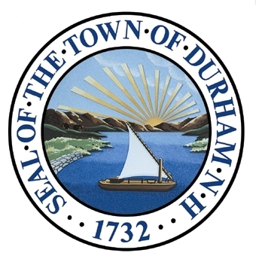Economic Development

*This chapter presents trends key to Durham’s economic development potential, a discussion of the town’s general economic development environment, and recommendations for ensuring the future health and prosperity of the community.*

Adopted by the Durham Planning Board on November 18th, 2015.

Our Vision

*“Durham is becoming a vibrant commercial environment that serves the variety of people in our community: UNH students, year-round residents, children in the Oyster River School District and their families, retired persons, visitors, and increasingly customers and commuters from outside of town. Our highly educated, entrepreneurial community attracts high tech and service businesses providing excellent wages and great employment opportunities. Their employees along with students, residents, and visitors will shop in retail stores and eat in restaurants that source locally-grown produce and locally-made products providing a healthy variety of goods and services. Increased tax revenue from businesses will stabilize or reduce the property tax burden on residents and help to build more efficient municipal public works, fire, and police facilities. Building on this vision, with appreciation and sensitivity to the town’s rural character and natural resources, economic development will improve the overall quality of life in Durham.”*

* *Durham Economic Development Committee (Reflects the January 28, 2011 Master Plan Visioning Forum and May 2011 Master Plan Survey)*

Introduction

This Economic Development chapter of Durham’s Master Plan is intended to provide a roadmap for how the community will be able to pay for residents’ desires for a small New England town appearance, natural resources conservation, agricultural features, and a first-class school district.

This chapter is built upon a foundation created by the results of two public input collection efforts: the 2011 Master Plan Survey and 2011 Visioning Forum. During these events, residents expressed a desire for a balanced approach between economic development and preservation of the town’s historic New England rural character and natural resources. The Town Council has supported this through its council goals. The Economic Development Chapter seeks to offer a balanced approach that builds upon the town’s considerable assets, and helps to steer development in a manner that is most beneficial to the community. The recommendations contained herein are intended to form the basis for future changes in Durham that will positively impact the community.

This Economic Development Chapter of the Master Plan presents a vision for Durham’s economic development activity over the next ten years as well as an assessment of the town’s current economic environment. It provides a brief demographic overview of Durham’s residents and labor force, a discussion of current economic development conditions, and closes with key conclusions, goals, and recommendations that will help drive smart economic growth in future years. The recommendations address the following goals of this chapter:

1. *Proactively recruit new businesses that will lead to a continually improving employment cycle in which each action results in a positive effect.*
2. *Make Durham more business friendly.*
3. *Brand and market Durham's competitive advantages including proximity to the University.*
4. *Focus the Town’s economic development strategies on commercial and industrial sectors, preferably in partnership with the University.*
5. *Support existing businesses by providing resources from a variety of local, regional and state agencies.*

What You Said:

*“…Balanced approach between economic development and the preservation of the town’s historic New England rural character and natural resources.”*

1. *Communicate the role of strategic economic development as a support mechanism within the context of tax base and community development.*
2. *Continue to explore potential commercial and industrial development areas.*
3. *Implement policy mechanisms that support business redevelopment and development.*
4. *Leverage development, redevelopment, or repurposing of student housing to obtain space for other, nonresidential uses.*
5. *Continue participation in Regional Economic Development Initiatives.*

The Economic Development Chapter evolved from various Chapters of the 2000 Durham Master Plan, especially the Tax Stabilization Chapter. The 2000 Tax Stabilization Chapter has been included as part of the supplemental materials for this chapter.

However; much has been accomplished in the past several years, through the facilitation of student housing development and the use of student housing as a lever for further economic development. The faster-than-anticipated development will add over $100 million to Durham’s tax base by 2016, increasing the total by over 10%. Because much of the student housing includes commercial space, it helps generate further commercial development. (This significant change is discussed further under Economic Development Environment.)

Since the last master plan Durham has invested significant amounts of time and money into performing analyses of existing market conditions reaching out to existing businesses, and formulating recommendations in an effort to gain a better understanding of resident and business perspectives. Community input revealed a strong consensus in key areas governing the Town’s future actions.

It should be noted that economic development is no longer primarily a municipal issue, but is strongly impacted by regional, state, federal, and even global developments. Durham realizes that to increase its overall quality of life, it must work in cooperation with adjacent municipalities and leverage each other’s strengths.

Foundation

The following is a summary of relevant comments and input submitted during the 2011 Visioning Forum and 2011 Master Plan Survey, completed by the Town of Durham. Results of these engagement opportunities form the foundation of this Economic Development chapter while providing a lens of public perception and interest surrounding these topics. Public input sessions were conducted prior to a number of major downtown development projects. This should be considered when drawing any definitive conclusions.

2011 Visioning Forum

*A total of 90 citizens participated in the Forum.*

What Do We Look Like?

* Limited, small area and lack of building stock
* Little diversity and lack cross support
* Decline of businesses – retail
* Lack of office/commercial space
* Retail dependent upon students/seasonal
* No incentives
* Limited building heights
* Businesses are sometimes in direct competition with University services
* Little/no collaboration between UNH/town with businesses
* Lack of tax incentives, jobs creation/retention
* Lacking commercial tax base to keep taxes lower
* Student housing dominates businesses
* Downtown has 2 centers, Marketplace and Circle/Main St.
* Walkable downtown
* Hidden agriculture
* Thousands of commuters come in daily

What Will We Look Like?

* Redesigning the plaza – smart growth
* Higher buildings with parking at outside of area
* More businesses along river
* UNH/Durham business growth, job creation
* Local job growth, limited commuters
* More sustainable green office development, green industry
* Active recruitment of businesses from town economic developer
* More retail space available
* More incentives for bringing business to Durham
* Industry clusters with local multiplier effect
* Diverse retail
* Economic development for tax base
* Well-integrated office park done well to assist with tax base
* Be the first choice for businesses coming out of the University
* Vibrant downtown
* Avoid commercial sprawl
* Durham- a model for integrating small-scale agriculture

2011 Master Plan Survey

Durham’s Business Outreach Program

The Economic Development Committee conducted a survey of Durham’s existing business community. Its major findings were:

* Durham must work to change its image (deserved or not) of being inhospitable to business
* Restrictive zoning and stringent code enforcement add time and expense to projects
* More convenient parking is needed
* More visible signage is needed to point visitors to businesses located on side streets or the Plaza
* The character and safety of the downtown and commercial core should be improved
* Durham should strive to become a destination to residents of this and surrounding Towns
* Community and family friendly amenities, including restaurants and retail, should be expanded.
* The University of New Hampshire is an asset to the community; accordingly we should strengthen Town of Durham - UNH relations
* A transparent approval process is needed with regulations that clearly specify what kind of business activity is permitted, and what the design and building standards are

|  |  |  |  |
| --- | --- | --- | --- |
| To what extent do you agree with the following statements about economic development in Durham? | | | |
|  | *Overall Positive Response Rate* | *Strongly Agree* | *Somewhat Agree* |
| Joint UNH projects to promote economic development should be pursued | 91% | 55% | 36% |
| If available, I would spend more money on retail and professional services in Durham rather than out of town | 91% | 69% | 22% |
| Durham should continue to facilitate the re-development of existing structures | 89% | 51% | 38% |
| Durham should continue to facilitate new construction in downtown | 85% | 46% | 39% |
| Economic development (office parks, industry) beyond downtown should be encouraged by the Town | 85% | 51% | 33% |
| Durham should establish architectural and site design standards or guidelines for downtown projects | 81% | 47% | 34% |
| A performing arts center in or around downtown | 72% | 35% | 37% |
| Open to development along the entrance to town along Rte. 155A | 72% | 40% | 32% |
| Open to development along the entrance to town along Rte. 108N | 70% | 42% | 28% |
| Open to development along the entrance to town at Coe’s Corner near Rte. 4 | 64% | 36% | 28% |
| Durham should extend water, sewer, and roads to stimulate economic development | 62% | 24% | 38% |
| Open to development along the entrance to town via Rte. 4 | 62% | 36% | 26% |
| Open to development along the entrance to town along Rte. 108S | 56% | 31% | 25% |
| A tax rate with similar rates as the past is acceptable | 35% | 7% | 28% |
| |  |  | | --- | --- | | *TOTAL NUMBER OF PARTICIPANTS* | *467 citizens* | | | | |

|  |  |  |  |
| --- | --- | --- | --- |
| To what degree would you support the following policies aimed at stabilizing/reducing the property tax rate? | | | |
|  | *Overall Positive Response Rate* | *Strongly Agree* | *Somewhat Agree* |
| Make more land available for commercial development | 71% | 42% | 29% |
| Build a parking structure in the downtown | 71% | 32% | 38% |
| Allow commercial or mixed residential-commercial building heights greater than 4 stories in downtown | 56% | 33% | 23% |
| Encourage shopping plaza developments outside of downtown | 52% | 28% | 24% |
| |  |  | | --- | --- | | *TOTAL NUMBER OF PARTICIPANTS* | *467 citizens* | | | | |

Economic Characteristics

*An analysis of income and employment characteristics provides a medium through which communities can identify strengths, weaknesses, and opportunities for their residents. Income profiles, in particular, have a strong impact on other socio-economic measures within a community. When coupled with employment data, this information provides perspective on how residents experience financial and social change*

*.*

|  |  |  |  |
| --- | --- | --- | --- |
| Table 1: 2013 Income by Household Type | | | |
|  | Total | Family | Non-Family |
| Total | 3,166 | 1,820 | 1,346 |
| Less than $10,000 | 10.4% | 0.7% | 23.6% |
| $10,000 to $14,999 | 4.3% | 1.5% | 8.1% |
| $15,000 to $24,999 | 11.5% | 2.1% | 24.1% |
| $25,000 to $34,999 | 3.7% | 3.4% | 4.1% |
| $35,000 to $49,999 | 7.8% | 5.8% | 10.5% |
| $50,000 to $74,999 | 14.8% | 12.3% | 18.2% |
| $75,000 to $99,999 | 10.6% | 15.0% | 4.6% |
| $100,000 to $149,999 | 16.5% | 27.9% | 1.2% |
| $150,000 to $199,999 | 8.2% | 13.0% | 1.6% |
| $200,000 or more | 12.2% | 18.4% | 3.9% |
|  |  |  |  |
| **Median income (dollars)** | **$71,250** | **$117,121** | **$21,037** |
| **Mean income (dollars)** | **$101,247** | **$143,638** | **$42,032** |
| Source: American Community Survey | | | |

Income

The 2011 Market Study completed by Development Concepts, Inc. estimated that the median household income for the Town of Durham was $64,318. This was roughly equal with the median household income for the state of New Hampshire. However, the Market Study correctly pointed out that these numbers did not reflect the typical household income for permanent residents in the community. Durham is a vibrant combination of two major groups: students with low income and higher-earning permanent residents. Durham is a town of between 5,500 and 6,200 permanent residents and 9,000 students living in on and off campus student housing. This high student-population count results in the skewing of per-capita, mean, and median household incomes towards the lower end of the income spectrum. As a result, typical income analyses misrepresent Durham’s overall economic characteristics.

The Market Study, which attempted to differentiate between these independent segments of population, analyzed income on both a "family" and "non-family" basis. At the time of the study, median family income for 2005-2009 was estimated at $114,757 while non-family income was only $12,316. This differential clearly demonstrates the impact of lower-earning student non-family households on the overall economic characteristics of the town.

According to United States Census Bureau’s 2013 American Community Survey estimates, this income-gap reflects Durham’s permanent and student residents. As illustrated in Table 1 at right, Durham’s 2013 American Community Survey median income was $117,121, nearly $100,000 higher than the non-family household income of $21,037. Similarly, a greater than $100,000 disparity exists between mean incomes for these household types.

Because of its large population of transient students, neither Decennial Census nor American Community Survey data provide sufficient depth of information as they generalize and therefore do not account for Durham’s two-tiered population.

Data sources from American Community Survey and the Durham Tax Database were queried and provided the following information on which recommendations for future Economic Development in Durham are based.

Employment

What You Said:

*“Innovations born at UNH; Implemented in Durham”*

The University of New Hampshire is the region’s largest employer, and the labor force lifeblood for both Durham and neighboring communities. 2012 American Community Survey estimates show that more than 40% of Durham’s workforce is employed within the “educational services, healthcare and social assistance” and another 19% classify themselves as professionals within the “arts, entertainment, recreation, and accommodation and food services” industry. Though not all employees within these two prominent industry categories are employed by the University, a significant number are.

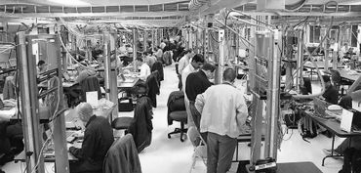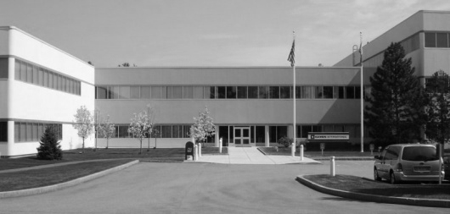

Photo 1: Goss International (Source: UNH IOL)

Photo 2: UNH IOL (Source: Seacoast Online)

|  |  |
| --- | --- |
| Table 2: 2012 Employment by Industry |  |
| Industry | Percentage |
| Civilian employed population 16 years and over | - |
| Agriculture, forestry, fishing and hunting, and mining | 0.6% |
| Construction | 2.6% |
| Manufacturing | 4.2% |
| Wholesale trade | 0.9% |
| Retail trade | 10.9% |
| Transportation and warehousing, and utilities | 2.2% |
| Information | 1.3% |
| Finance and insurance, and real estate and rental and leasing | 5.4% |
| Professional, scientific, and management, and administrative and waste management | 8.0% |
| Educational services, and health care and social assistance | 40.7% |
| Arts, entertainment, and recreation, and accommodation and food services | 19.1% |
| Other services, except public administration | 2.4% |
| Public administration | 1.8% |
| Source: American Community Survey | |

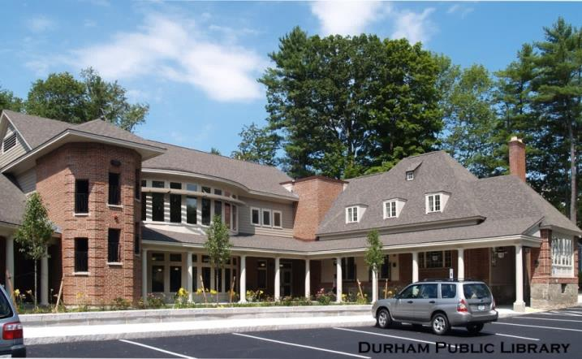Major Employers

|  |  |  |
| --- | --- | --- |
| Table 3: Largest Employers | | |
| Largest Business | Product/Service | Employees |
| University of New Hampshire | Higher Education | 4,077 |
| Goss International Printing Press | Printing Press | 417 |
| Oyster River School District | Education | 259 |
| Town of Durham | Municipal services | 81 |
| Source: Town of Durham, New Hampshire Employment Security | | |

Durham is home to the region’s largest employer, the University of New Hampshire, with more than 4,000 employees. Though education and service industries represent the largest employment sectors within the community, Durham’s second largest employer, Goss International, is an international leader in printing press manufacturing and employs over 400 workers. Despite being home to some of the largest regional employers, few of Durham’s labor-force qualifying population actually work at these locations. See commute pattern data on the following page for more information.

Photo 3: Durham Town Library (Source: Town of Durham)

Unemployment

Durham was fortunate to feel few effects of the recent economic recession and real-estate market crash of the mid-to-late 2000s. Even at peak unemployment in 2009, when national unemployment rates exceeded 10%, Durham was able to maintain high rates of employment. However, Durham’s unemployment rate continued to grow through 2012 to a high of 5.3% while national, statewide, and regional datasets indicated variable yet decreasing unemployment rates.

Definition: Unemployment Rate

*Represents the number of unemployed people as a percentage of the civilian labor force*

Source: Census Bureau

Commute Patterns

Durham is anomalous in that although it contains a major regional employment center, it’s estimated that 94% of residents commute elsewhere for work. Of the 6% of Durham’s population that work within the community, many work at the university in some capacity and a growing number of residents telecommute for their employment. Out-commuting residents tend to fall into one of two categories: those that travel to adjacent communities for lower-wage retail and service industry jobs (typically students) and those commuting to more distant cities such as Concord, Boston, Manchester, or Nashua for higher-paying positions. Interestingly, 91% of individuals employed within Durham actually commute from outside of the community.

|  |  |  |  |  |  |  |  |  |
| --- | --- | --- | --- | --- | --- | --- | --- | --- |
| I work in Durham but I live ______ miles to the ______. | | | | | | | | |
|  | North | Northeast | East | Southeast | South | Southwest | West | Northwest |
| Less than 10 miles | 7% | 12% | 3% | 3% | 5% | 5% | 4% | 5% |
| 10 to 24 miles | 9% | 2% | 1% | 2% | 4% | 3% | 1% | 4% |
| 25 to 50 miles | 1% | 1% | - | 0% | 2% | 5% | 4% | 5% |
| Greater than 50 miles | 2% | 1% | - | - | 2% | 2% | 1% | 2% |

Presented below at right are commute figures, based on 2011 American Community Survey Estimates, which illustrate volume and direction of commuters for both those that live and work in Durham. These tables indicate that the majority of Durham’s residents commute either less than 10 miles to the southeast (likely to Portsmouth) or between 25 and 50 miles to the southwest, in the direction of Boston, Manchester, and Nashua. Some residents travel more than 50 miles to the north and south west, while a negligible number of residents make a commute between 10 and 24 miles in any direction.

|  |  |  |  |  |  |  |  |  |
| --- | --- | --- | --- | --- | --- | --- | --- | --- |
| I live in Durham but I work ______ miles to the ______. | | | | | | | | |
|  | North | Northeast | East | Southeast | South | Southwest | West | Northwest |
| Less than 10 miles | 6% | 4% | 4% | 7% | 3% | 1% | 1% | 2% |
| 10 to 24 miles | 2% | 1% | 1% | 1% | 3% | 1% | 0% | 9% |
| 25 to 50 miles | 1% | 1% | - | - | - | 13% | 7% | 3% |
| Greater than 50 miles | 6% | 2% | - | - | 2% | 7% | 6% | 8% |
| Source: American Community Survey | | | | | | | | |

In contrast, individuals employed within Durham are likely to commute from areas less than 10 miles away to the northeast (Maine and Dover). More than 50% of those employed within Durham commute from less than 10 miles away. A large portion of the labor force lives between 10 and 24 miles to the north, in the City of Rochester or other Strafford region communities. Small percentages commute to Durham from a distance greater than 25 miles.

Oyster River Cooperative School district also plays a role in the analysis of Durham’s dynamic commute patterns. As a regional school district, it brings residents and students from several adjacent municipalities including Barrington, Lee, and Madbury into the community on a daily basis.

Educational Attainment

Not only is Durham home to a large population of undergraduate and graduate university students, but it is also home to a large concentration of highly educated residents. American Community Survey data indicate that 72% of Durham residents above the age of 25 have a bachelor’s degree or greater; of those, 41% have a graduate or professional degree. Within the Strafford planning region and state of New Hampshire, only 33% of residents have a bachelor degree or higher.

Though Durham is more likely to have a highly educated population because of its proximity to the University of New Hampshire, this alone does not account for a 40% greater concentration than in the region and state. Those with a high level of formal education tend to be attracted to the town of Durham and its amenities.

Education attainment can be a driver of economic development within a community. As businesses seek to develop, they often seek areas with a highly educated, trained, and skilled workforce. Economic development professionals often use such datasets to recruit potential commercial tenants and other businesses.

Economic Development Environment

*The content presented within this component is intended provide the audience with economic development conditions and opportunities in Durham.*

Background

Durham is viewed as an upscale community where business activity has in recent decades been focused primarily on retail and services targeted primarily at University of New Hampshire students, and secondarily at local residents (albeit with one large local exception, Goss International, the second largest taxpayer).

New economic development contributes significantly to the vitality of a community by helping to increase non-residential tax revenue to support public needs, provide a variety of retail and services for both full and part-time residents and visitors, create jobs, and generally enhance the quality of life. Local businesses often play an integral role in promoting a community’s cultural environment and in defining its identity.

Public input from both the Visioning forum and Master Plan survey reveal a desire for a balanced approach that both protects the character of the town and encourages economic development. Enlightened economic development accomplishes a balance between these two sometimes competing goals, and it is felt that, with wise governance, the town can make improvements in both arenas.

Increasing the town’s commercial tax base is critical to ensuring the economic health of the community given the current high property tax burden, the future costs to maintain an excellent school system and the investment needed for capital improvements as outlined in the Town of Durham 2015 Capital Improvement Plan (CIP). Durham is unique in that although its permanent population is approximately 5,800 people, it is able to deliver services that are of higher quality than similar size towns without a student population because of its unique partnership with the University of New Hampshire. Examples of these services include a professional full time fire department serving both the town and UNH, a Commission of Accreditation for Law Enforcement Agencies (CALEA) certified police department, modern library with an excellent facility and services, parks and recreation programs and municipal trash collection.

Beginning in 2009, the town has experienced significant commercial development driven by the construction of large, privately-funded student housing projects both in the downtown and in the western areas of town proximate to the UNH campus. Zoning changes designed to facilitate the development of professionally managed student housing, while anchoring commercial growth, have been even more successful than anticipated, and have been leveraged to provide related commercial development.

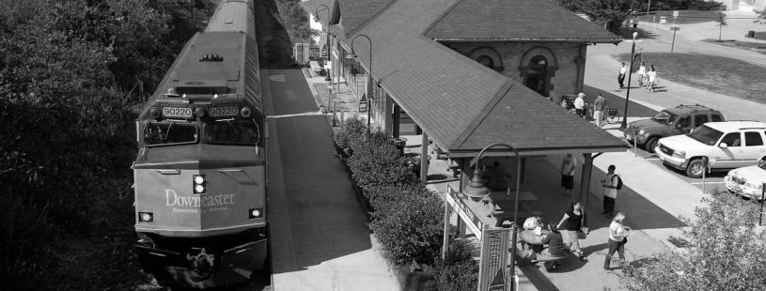

Photo 4: Downeaster and Dairy Bar Department (Source: unh.edu)

Addition of Economic Development Director

With the addition of staff dedicated to economic development, Durham now has a dedicated point of contact for potential business leads that can provide information, resources and assistance as they endeavor to locate in Durham. This position works with other town staff to help businesses and investors through any required permitting processes.

The Economic Development Director provides expert insight and advice on a variety of commercial activities, both to the staff, and to those committees and boards who volunteer service to the town. This point-of-contact person actively works with other commercial agents and brokers to successfully recruit businesses attractive to the town. This office is a clearinghouse for existing businesses that need assistance with retention and growth challenges, and for new businesses looking to locate in prime downtown locations and other commercially designated areas in town. The Economic Development Director also serves as a liaison to important partnerships including the University of NH, and state agencies such as the Department of Resources and Economic Development (DRED). Durham is now positioned to participate more directly in regional and state initiatives.

Access

Durham has convenient access to regional transportation corridors. The town’s principal roadways include Route 108, which travels from Exeter to Rochester; and Route 4, which travels east to Highway 95 and west to Highway 93. This road network access offers opportunities to a variety of businesses to readily capture customers from those driving through town, or to distribute products from town, and makes commuting to town convenient for managerial or office workers. It should be noted, however, that the town has so far been unable to attract suitable clients to the business parks off Route 4 and Route 108.

Durham is also fortunate to be one of the ten stops on the Amtrak Downeaster, which runs five times a day from Boston to Portland or Brunswick Maine, and five times from Portland/Brunswick to Boston. The train is popular among both permanent and temporary residents, and has been exceeding expectations in ridership; with total number of rides in and out Durham increasing from 53,283 to 61,233 between 2011 and 2013(NHDOT). Using rail transit as a mode of travel offers alternative transportation to and from Durham businesses, and makes Durham a more convenient destination for business commuters, families, and students who live off-campus.

The town is also served by the UNH transit system (Wildcat and Campus Connector bus services) and is connected to the inter-community and inter-regional transit systems of C&J Trailways and COAST bus.

Mission Statement- Durham Economic Development Committee:

*Our mission is to assist in the planning and development process of new business ventures and the growth of existing businesses in Durham.*

Source: Town of Durham Economic Development Committee

Student Housing

The Town has recently been very successful is using new privately-owned student housing projects to build its assessed property base and act as an economic engine for the town. This strategy has provided several benefits:

* Increase in the tax base and tax revenue – Completed projects since 2011 have already added $45 million to the tax base, and approximately $60 million in new projects are being developed. In total these projects will add approximately $3 million annually to Durham’s tax revenues. Commercial development, including student housing, will increase from 22% to 30% of the Town’s tax base by 2016.
* Reduction in the number of students living in Durham’s traditional family neighborhoods – The increase in the supply of professionally managed, attractive apartments makes investment in single family neighborhood rentals less attractive, helping to reverse the trend toward students moving into family neighborhoods.
* New inventory of commercial space – the Central Business District zoning requires that student housing be developed in mixed-use projects which create commercial space. This new commercial inventory will help to further invigorate the downtown area, with new retail, businesses and restaurants.
* Enhanced demand for downtown goods and services – the increase in downtown student population creates a possible semi-captive audience for these businesses
* Increase in attractiveness of UNH – new projects provide students with dramatically improved living quarters, compared to most dormitories or in-town quarters.

In 2004 UNH set a target to house approximately 60% of its undergraduate students and since then 53-58% have been housed on the campus in any given year with the remainder living off-campus. Until recently, this supply of student housing in Durham was insufficient to meet the off-campus housing demand, leading to significant problems associated with students moving into traditional family neighborhoods. However, recent and planned housing development has brought the supply into better alignment with demand.

Approximately 4,700 undergraduate students live off campus. Since the fall of 2012, over 1,800 student housing beds have been built, approved or are in the approval process, bringing total off-campus beds to approximately 4,700. Therefore, it is likely the student housing beds in mixed-use and multi-unit buildings will fully meet the off-campus housing requirements by the fall of 2015.

Further, to some residents, the strong surge in student housing threatens to disrupt the desired “balanced approach between economic development and preservation of the town’s historic New England rural character and natural resources.” With so much new development occurring in a relatively short time frame, there are concerns that the downtown area will become even more student-oriented, and that the larger buildings detract from the town’s traditional small-town feel.

Because the town is reaching a saturation point of student housing, further student housing development could cease to be a strong economic engine for the town. For more information, please the Housing and Demographics chapter. Moving forward, Durham needs to carefully monitor housing projects to identify options that ensure the quality and attractiveness to broader markets beyond student housing. Zoning changes should address the potential need to repurpose some buildings for different uses, including but not limited to retail, office space and housing for senior and small households.

Ultimately, the focus for economic development should shift away from the dominance of student housing toward attracting a broader array of new businesses and professionals to the town, thereby diversifying our economic base away from academia, increasing economic vitality and providing wages and employment opportunities that support a resident workforce in Durham. The University represents an economic development opportunity for the town that would contribute to the overall growth of the community’s commercial vibrancy and diversification of the overall tax base. The movement of the UNH Interoperability Lab (IOL), which draws businesses from across the world to Durham, is a strong representation of this opportunity.

Senior Housing

Capital Improvement Projects

Durham has planned and/or completed several significant capital improvements that will be funded through increased property tax revenue and user fees unless the town offsets the costs through new commercial development. Examples of recent and projected capital improvements include:

* *Spruce Hole Well Development*

Well development is necessary to ensure an adequate water resiliency during droughts, will be funded by water users and the University.

* *New Fire Station*

The University master plan calls for a fire station to be relocated, and the existing station provides inadequate space for apparatus, maintenance, personnel and other fire department functions.

* *Police Department Renovation*

The existing police station requires improvements and a modest expansion.

* *Stormwater Treatment*

To help mitigate nitrogen contamination in the Great Bay, Durham will have to address storm water management issues.

* *Wastewater Treatment Upgrades*

The wastewater treatment plant is replacing the sludge dewatering system, making Phase III upgrades to reduce nitrogen, and replacing other major components.

* *Operating Expenses*

The operating budget will increase due to many factors, some of which the Town has little control over such as the downshifting of costs from the State to municipalities, increases in health and retirement benefits, and wage increases.

Source: Town of Durham

As the Housing and Demographics chapter of this Master Plan indicates, Durham, along with New Hampshire and nation, is experiencing a shifting of its age demographics that will soon result in a significantly larger population being over the age of 65. With this demographic transformation will come a need for flexible senior housing that provides an opportunity for population to ‘age-in-place’ or ‘age-in-community’. Anecdotal evidence suggests that Durham will continue to attract seniors because of strong cultural resources both in the community and at the University, various recreational opportunities, beautiful scenic and natural landscapes, and proximity to the region’s strong healthcare network. The Town of Durham has explored opportunities to allow the development of continuing care facilities and/or age-restricted housing in some areas. This housing type provides an opportunity for significant expansion of the commercial tax base while minimizing the impact to the school district and other community services/facilities. However, by creating additional senior housing, Durham would likely increase the proportion of its population above the age of 55, further ‘aging’ its population and potentially increasing the demand on services such as fire, ambulance, police, and public transportation.

Property Taxes

Durham’s per capita municipal property tax burden is among the highest in the state of New Hampshire. Residents have, until recently, seen large annual property tax increases; however, the size of increases has declined during the last two years due to Durham’s significant expanding commercial tax base and the Town Council goal to keep tax rate increases at the rate of inflation or less. Regardless of the recent property tax trend, increases have been difficult to absorb for many, as indicated by the fact that over 60% of residents currently indicate that tax increases similar to those experienced in the past are not acceptable, according to the 2011 Master Plan Survey.

In 2011, the EDC estimated that an increase in the non-residential tax base of $115 million was required to offset the projected $2.3M increase in property taxes over five years if Durham was to stabilize municipal property tax rates. It is estimated that 90% of this increase will be achieved by 2016 with recent and approved commercial development. The Town’s capital improvement plan still includes many large projects financed through municipal bonds, and regardless of recent success expanding Durham commercial tax base, there remains a need to expand the tax base with the challenge of far less reliance on student housing as described later in this chapter.

The town needs to focus on long term sustainability of tax base, quality of life, and affordability. Student housing has gone a long way toward meeting near-term requirements, but is less likely to generate significant further gains. In order to support continued investment in our municipal infrastructure and education system, the Town should broaden its commercial tax base. Of primary concern is incrementally creating taxable property, while at the same time improving opportunities to shop, dine, and find professional services locally, and to generate attractive local employment opportunities. All of this must be done in a manner that helps to preserve the town’s historic New England rural character.

Commercial Tax Base

The Housing and Demographics Chapter indicates that Durham is home to approximately 5,800 permanent residents living in some 1,500 single family homes and some in a small number of rental units. The 2010 Census population of the Town of Durham was approximately 15,000, which includes both permanent residents and a selection of student residents.

Given the recent growth in student housing development, the Town’s tax base is projected to change to 30% commercial, and 70% residential property in 2016. This ratio reflects the fact that Durham, unlike other communities, considers student housing, which will be 20% of the total tax base, to be a commercial use. The total remaining commercial base is only 10% of the total.

Some commercial zoned property owned by UNH has the potential for further commercial development consistent with the UNH Campus Master Plan or other proposals. The University has expressed interest and flexibility in the development in some commercially zoned areas in cooperation and coordination with the Town. The University of New Hampshire, as a governmental education institution is tax exempt, but makes payments in lieu of taxes to support a broad array of municipal services. Nevertheless, 70% of the Town’s tax burden falls predominately on its permanent residents.

Durham’s tax rate is in the upper range of New Hampshire communities, and Durham’s home values are significantly higher than average. Durham’s per capita tax burden on permanent residents is among the ten highest in the state. This makes it challenging for many current residents to continue to afford to live in Durham, and makes Durham less attractive to families moving into the Seacoast region, especially as neighboring school systems improve and become more academically competitive with the Oyster River School District.

Many of Durham’s businesses are dependent on the University of New Hampshire which employs an estimated 4,077 faculty and staff members, according to the 2011 Durham Market Study. Durham business related to UNH consists primarily of off-campus student housing and student-focused retail.

The majority of private research, development and manufacturing in the town is conducted by a single company – Goss International, which manufactures newspaper printing presses and other print-related technology and has its Research and Development Department located in Durham. The company is located outside of downtown, which reduces its impact on downtown retail and service businesses.

Historically, much of Durham’s economic development activity has been focused on lessening the tax burden on Durham residents. The Oyster River Cooperative School District funding formula further complicates the expansion of Durham’s commercial tax base because of its structure: The current formula is based on a 50/50 (per capita/valuation), meaning that any expansion of the commercial tax base within the community has the potential to increase Durham’s cost per pupil to the District and therefore not provide as much benefit as it normally would.

What You Said:

*“A balanced approach that both protects the character of the Town and encourages economic development.”*

Source: 2011 Visioning Forum

Attraction, Retention, Expansion, and Entrepreneurship

Economic Development comprises many strategies to bring investment and employment into a community. Economic activity provides opportunities to create jobs, to lower taxes, to increase services and other desired amenities, and to provide an overall better quality of life for residents. Many think of economic development, through the lenses of attraction (bringing in new businesses from beyond the community), retention (keeping those businesses already here), expansion (growing local businesses), and entrepreneurship (starting new businesses). While attraction gets much of the attention, most new jobs are created through the expansion of existing companies or new companies that spring from within the community.

Durham has the unique advantage of hosting the University of New Hampshire which invests over $100 million dollars annually in research and development. The University also has various commercial activities such as the Interoperability Lab (IOL), located in the downtown area and which draws businesses from around the world to Durham. Several entrepreneurial programs are housed on the University campus including the Alpha Loft and the UNH Innovation and New Ventures program. The community will continue to explore the siting of innovation and entrepreneurial hubs within the downtown and commercial core area.

Durham is currently engaged in bringing all these pieces together to create a vibrant entrepreneurial hub environment in Durham. This will require adequate and affordable “flex space” and the involvement of community business leaders (perhaps retired) to assist with mentoring and nurturing activities for these emerging companies. Support efforts should also be provided to connect growing companies to resources such as affordable space, a talented employee pool such as UNH students, business mentoring, and investment capital.

Durham is also home to a growing number of workers who are telecommuting (using remote access or other means to work from home). Telecommuters are able to minimize commuting time, increase productivity, and inject earnings directly back into their community. The town will work to amend and develop land use regulations that facilitate home-based businesses, occupations, and simple telecommuting activities.

Commercial and Industrial Development Opportunities

Durham has four commercially zoned areas outside of the downtown commercial core: The Office, Research and Light Industry (ORLI) District, the Multi-Unit Dwelling/Office Research (MUDOR) District, Office Research Route 108 (OR) District, and Durham Business Park (DBP). The land characteristics are summarized in the table at below. These commercial zones encompass over 1,500 acres; however, much of the land represents limited feasibility for future economic development due to the following constraints:

* A significant percentage is owned by the Town of Durham or land conservation organizations
* 95.6% of the MUDOR District is owned by UNH.
* The OR District has no existing water or sewer infrastructure.
* Less than 15% of the total land within the MUDOR and ORLI districts is developable according to SRPC buildout analysis.
* The northern portion of the ORLI District has limited development potential due to ~~the~~ terrain characteristics that include east-west average slopes of 4.9%/-5.6% and maximum slopes of exceeding 30%.

Please see the Existing Land Use chapter for more information.

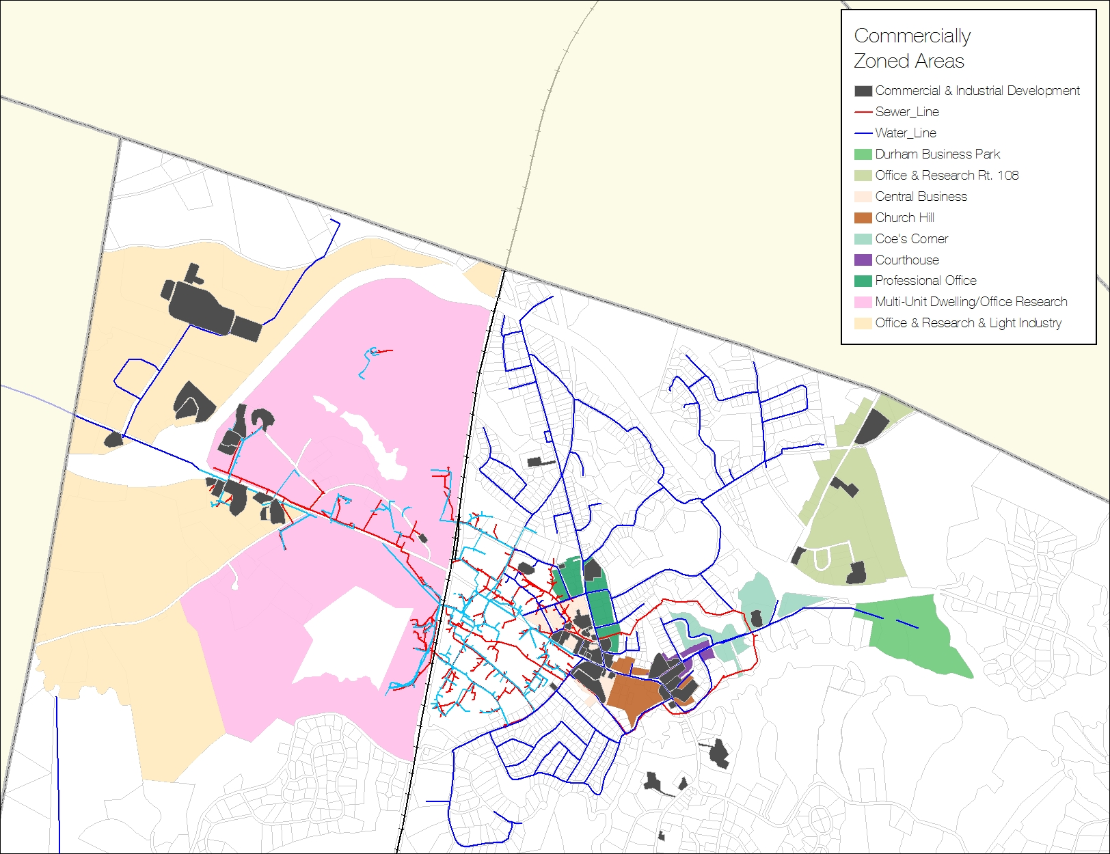

Map 1: Commercially Zoned Areas **(Source:** Town of Durham)

Development Opportunity Areas

The Durham Economic Development Committee and Economic Development Director have identified five “development opportunity areas” for consideration by the Planning Board. The identification process for these areas included an investigation of environmental constraints, zoning restrictions, and other potential conflicts. All potential development areas should be investigated in the context of the most suitable and/or appropriate use within each. It should be noted that several of the identified areas are currently developed property or have limited or no water/sewer infrastructure access.

1. *North Technology Drive (Beech Hill Rd.)*

Despite being characterized by primarily agricultural and forest land, and portions containing steep slopes, this area represents a possible future development opportunity. Its proximity to the infrastructure currently serving Goss International, proximity to Technology Drive, and proximity to both Route 4 and 155 also make it an attractive possible future development area. This area includes multiple environmental development constraints, and the current rural zonings its overall development potential.

1. *South Technology Drive*

Home to current industrial/commercial development, this area includes several acres of developable land with excellent road and utility infrastructure access. The New Hampshire Fish and Game Wildlife Action Plan and the Land Conservation Plan for NH Watersheds both identify this area as an of both regional and statewide importance for conservation. Inclusion within these plans warrants an additional level of sensitivity to all future development efforts.

1. *NH Fish &Game/USDA/West Edge*

This area is owned by UNH but has been identified by the University as a potential zone for public/private development. It currently has a mix of university, state, and federal offices, large parking lots, and some undeveloped land. This area has access to both sewer and water services, as well as a location with excellent access to regional highways.

1. *Durham Business Park*

As of 2015 and after almost a decade of inactivity, the owner is proposing an eldercare facility or senior housing development, a permitted use in this district. According to a private deed, an architectural review committee will be reviewing the plans in addition to the mandatory Planning Board review. As of this writing, this commercially zoned property is likely to be developed in the near future.

1. *Stone Quarry*

Stimulating mixed use development and investment in this area would provide taxable assessed valuation, business revenue, employment opportunities and public amenities within the proposed district that would directly benefit the community as a whole.

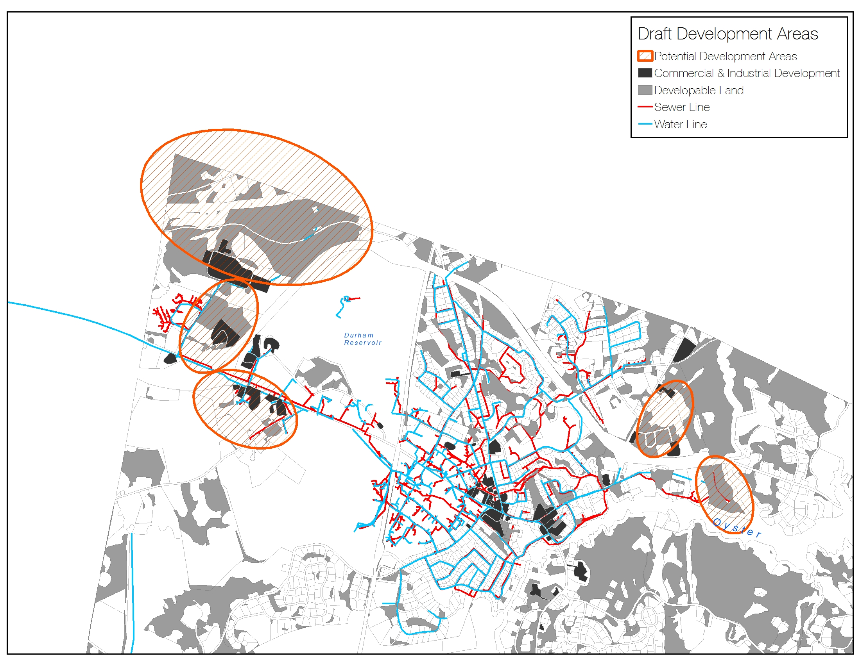

**A**

**B**

**E**

**D**

**C**

Map 2: Potential Future Development Areas **(Source:** Durham EDC and Economic Development Department – digitized by SRPC)

**F**

Employment Opportunities

Currently, the town offers limited employment opportunities that pay wages sufficient to purchase and maintain the median-value home value (approximately $315,000) in Durham. The 2011 Market Study found that Durham residents would need to earn more than double the median income of Strafford County ($20.77/hour) to support a residence in Durham ($44/hour).

As exhibited in the economic characteristics section of this chapter, many of Durham’s residents commute to work in other towns and cities, some more than 10 miles away, requiring a significant investment of time and money. The Market Study notes that residents who work outside Durham are more likely to spend money in the communities where they work, meaning that a significant amount of money earned by Durham residents is spent elsewhere and could be recaptured locally if employment opportunities were available. Commercial Building Stock

The downtown is the heart of Durham; it is pedestrian friendly with a variety of buildings providing both student housing and commercial space. Recent development greatly enhanced its attractiveness and improved its appearance from a time worn, aged and neglected state to a vibrant and inviting environment. However, much of the existing commercial space is in need of major renovation or replacement. Additionally, many of these buildings are of historic significance with additional requirements for redevelopment. Durham currently hosts limited Class A office space, defined by Building Owners and Managers Association International as: “Most prestigious buildings competing for premier office users with rents above average for the area. Buildings have high quality standard finishes, state of the art systems, exceptional accessibility and a definite market presence” [Source: BOMA.org]. This commercial space is particularly important because of its proximity to the University and the amenities and cultural/recreational opportunities it provides.

Many retail businesses in the downtown area focus on the student market, and the business-mix is not as vibrant and diverse as that desired by many residents, workers, or visitors. The downtown businesses, and the general vitality of the downtown environment, would benefit from the stronger demand generated by additional downtown office workers and higher income Durham residents. Downtown economic vitality depends upon a diverse business mix contained within a vibrant and aesthetically pleasing environment.

Photo 5: UNH Outdoor Classroom (unh.edu)

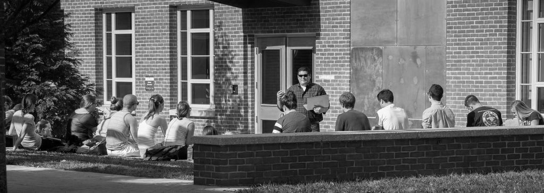

Durham’s downtown has experienced an overall aesthetic improvement with the addition of several mixed-use student housing developments. New housing development has been planned and constructed as resident-first/business-second. The creation of more affordable and flexible commercial space in the downtown area is a primary goal of Durham’s economic development planners.

Development Incentive Programs

TIF Districts

***What is a TIF?***

*A TIF is a special tax district that can be used as an economic development financing tool when market conditions will not allow private investment alone to address physical impediments that limit or prevent otherwise desirable commercial or industrial development.*

***What does a TIF do?***

*A TIF provides financing for public improvements (sewer, water, roads, sidewalks, landscaping etc.) that are required to initiate viable economic development by capturing the new property tax revenue created by the proposed development and using it to offset the cost of the public improvements. A TIF district can include undeveloped land, a Main Street district, the whole downtown, or just a few parcels. The size and configuration of the District is determined by the type and nature of the economic development activity that the Town wants to stimulate.*

***How does a TIF work?***

*After defining the TIF district, the current assessed values and property tax revenues are “frozen” and continue to flow to the Town’s general fund. However, any future “incremental” increases in property tax revenues within the district (through new construction, expansion, or renovations) can be “captured” and all or a portion of this new revenue can be used to pay for the infrastructure improvements (sewer, water, roads, etc.) that enabled the development within the district. Once the improvements are paid for 100% of the property taxes generated in the District go to the Town’s general fund.*

Source: Town of Durham

Since the 2000 Master Plan, the Town has added three programs enabled by state law that can provide tax relief and finance the public infrastructure required for economic development. These programs must be used judiciously, since they reduce tax revenue that could otherwise fund capital improvement projects and stabilize property taxes.

Tax Increment Financing (TIF) Districts

Tax Increment Finance (TIF) districts are an attractive public financing method used for infrastructure improvements within the district. Durham currently has two TIF Districts.

* The Stone Quarry TIF district encompasses Stone Quarry Drive. Its goal is to extend water and sewer lines into the area.
* The Downtown TIF district encompasses the downtown. Its goal is to update the infrastructure in the downtown and improve its attractiveness.

RSA 79-E, Community Revitalization Tax Relief Incentive

Downtown developments and redevelopments that will deliver well-defined public benefits as well as additional local objectives, in accordance with state RSA 79-E, can seek relief from the post-development increase in property taxes for up to seven years.

Economic Revitalization Zones (ERZ’s)

This incentive program offers State Business Enterprise Tax and Business Profits Tax Credits for investment that leads to job creation.

Economic Revitalization Zones were established to stimulate economic redevelopment, expand the commercial and industrial base, create new jobs, reduce sprawl, and increase tax revenues within the state by encouraging economic revitalization in designated areas.

Regional and Local Development Initiatives

New Hampshire’s Seacoast: The “Composites Region”

* *Aligned with the New Hampshire Aerospace and Defense Export Consortium*
* *Includes companies supportive of creating more sustainable manufacturing in the state by buying local and supporting offshoots*

Facts:

* *Manufacturing accounts for 75.4% of New Hampshire's exports*
* *As of 2012, manufacturing accounted for 11.8% of New Hampshire’s gross state product*
* *Over 10% of the workforce in New Hampshire is employed in manufacturing according to 2013 figures*

Source: SRPC, Fosters, NHES

With an increasingly globalized culture, Durham is no longer a local-only economy; it is now part of the Greater Seacoast Region, the New Hampshire, the Greater Boston Area, the United States, and world economic spheres. Durham, as part of the Greater Seacoast area, works collaboratively with its neighbors and UNH to attract high quality businesses that strengthen the local economy and improve the quality of life.

Regional Comprehensive Economic Development Strategy (CEDS)

Strafford Regional Planning Commission (SRPC) works with municipalities, educational institutions, and business leaders to help them find synergies that promote regional goals. The SRPC Comprehensive Economic Development Strategy (CEDS) provides a vision for regional improvement of the quality of life and offers every community the opportunity to apply for EDA grants to fund projects with real regional impact. Durham will continue to actively participate in the CEDS process including annual updates and 5-year overall updates. Durham will be able to leverage the funding made available by SRPC’s recent Economic Development District (EDD) designation.

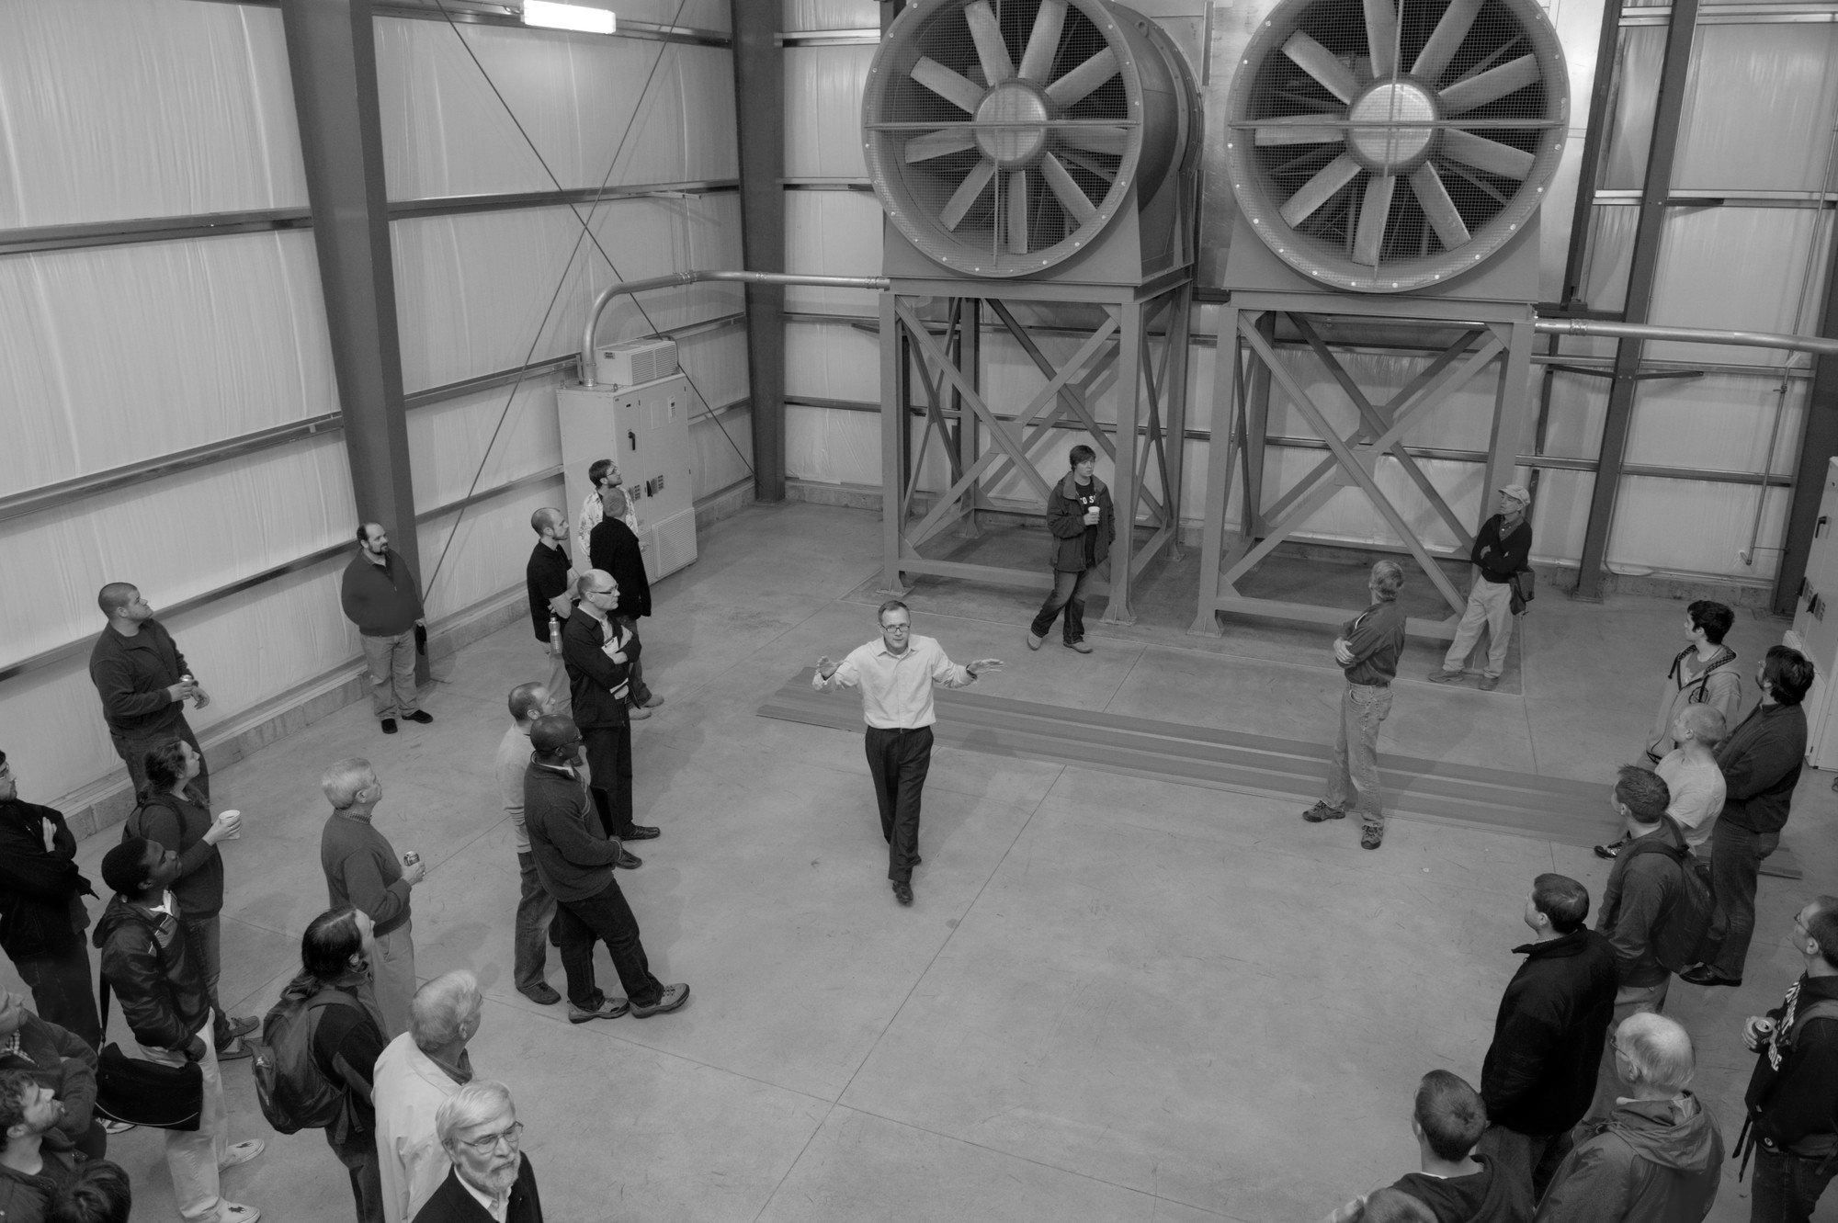

Photo 6: UNH Wind Tunnel (unh.edu)

HUBZone Certification Program

The Town of Durham is also home to one of New Hampshire’s eight HubZones. The HUBZone program is administered by the U.S. Small Business Administration (SBA) and is designed to assist small companies in selected communities gain access to federal contract opportunities, increase employment opportunities, stimulate capital investment, and empower communities through economic leveraging. HUBZone areas are typically areas of low median household incomes or high unemployment, or both.

Key Conclusions

1. Public input from both the Visioning Forum and Master Plan Survey reveal a desire for a balanced approach that both protects the character of the town and encourages economic development.
2. Durham is an economic engine for both the town and the region as the home to the region’s largest employer: the University of New Hampshire. Outside of the University, Durham is home to few employment opportunities for those in manufacturing, business, and/or information industries.
3. Durham is anomalous in that although it contains a major regional employment engine, it’s estimated that some 94% of working residents commute elsewhere for work.
4. Of the 6% of working residents that work within Durham, many work at the University in some capacity. Out-commuting residents fall into one of two categories: those travel to adjacent communities for lower-wage retail and service industry jobs (typically students) and those commuting to distant cities for higher-paying positions.
5. 91% of individuals employed within Durham commute from outside of the community.
6. Durham is a unique, vibrant town populated by two fairly distinct groups. Approximately 5,800 are home-owning permanent residents, while 9,200 are University students.
7. Durham attracts highly educated individuals. Nearly 3 in 4 residents above the age of 25 hold a bachelor degree or higher.
8. Durham’s business activity is focused primarily on retail and services targeted at the University of New Hampshire (UNH), local residents, and the local student population. However, Durham also attracts and provides services/goods to three additional consumer groups: UNH faculty/workers, residents of adjacent municipalities, and other visitors to the University including parents, entrepreneurs, and vendors.
9. The town is currently experiencing significant commercial development driven by the expansion in large, privately-funded student housing development both downtown and in western areas of town in proximity to the UNH campus.
10. Durham has convenient access to regional transportation corridors. This offers opportunities to a variety of businesses that attract customers from those driving through town, or to distribute products from town, and makes commuting to town convenient for managerial or office workers.
11. Durham is one of ten stops on the Amtrak Downeaster, which runs five times a day from Boston to Portland or Brunswick Maine, and five times from Portland/Brunswick to Boston.
12. The Town has recently been very successful is using new privately-owned student housing projects to build its assessed property base and act as an economic engine for the town. However, saturation of supply will soon be reached.
13. Senior housing represents an opportunity for significant expansion of the commercial tax base with minimal potential of impacting the school district and other community services/facilities.
14. Durham has planned and/or completed several significant capital improvements that require funding sources to supplement cost-sharing with UNH
15. The Town’s tax base is composed of approximately 70% residential and 30% commercial property.
16. Durham’s tax rate is in the upper range of New Hampshire communities, and Durham’s home values are significantly higher than average. Thus, Durham’s per capita tax burden on permanent residents is among the ten highest in the state.
17. The majority of private research, development and manufacturing in the town conducted by one company: Goss International.

Key Conclusions (*continued*)

1. Durham is the host community for the University of New Hampshire that invests over $100 million dollars annually in research and development. The University also has various commercial activities such as the Interoperability Lab (IOL) which is relocating to the downtown area. Several entrepreneurial programs are housed in partnership with the University of New Hampshire including the Alpha Loft and the UNH Innovation and New Ventures program. A significant opportunity exists for bringing all these pieces together to create a vibrant entrepreneur HUB environment in Durham.
2. Durham’s four commercial/industrial zoning districts are highly constrained by environmental characteristics, current use, and infrastructure availability.
3. The Durham Economic Development Committee has identified five development opportunity areas within the town, primarily in the northwestern area of the community along the town’s gateways. Several are currently zoned for commercial and industrial activity, making those the most feasible for development.
4. Currently, the town offers limited private employment opportunities that pay wages sufficient to purchase and maintain the median-value home value (approximately $315,000) in Durham.
5. The downtown is the heart of Durham; it is pedestrian and bicycle friendly with a variety of buildings providing both student housing and commercial space.
6. Durham is a member of Strafford Regional Planning Commission and has been involved with the development of the Comprehensive Economic Development Strategy, a regional guiding document.

Goals and Recommendations

This section outlines the goals and recommendations associated with the key conclusions of this chapter that are intended to strategically guide the economic development efforts over the coming decade. It’s important to note that the goals and recommendations below are not prioritized. Below each goal you will find related key conclusions from the previous section of this chapter that form the respective goal’s foundation.



Land Use Recommendation

Issue: Durham must diversify its commercial activity in order to develop a healthier business environment.

*Goal: Proactively recruit new businesses that will lead to a continually improving employment cycle.*

Key Conclusions References: #1, 2, 6, 8, 15, 17, 21, 22

Recommendations:

Development

1. Focus economic development activities towards the chapter’s goals.
2. Continue to foster professional working relationships with business owners and managers, real estate developers, commercial real estate agents, UNH and other local and regional entities.
3. Promote the development of a continually improving employment cycle that results in: more professionals and customers patronizing downtown retail, enhanced retail and service offerings, increased desirability of Durham as a place to live and work, and more businesses choosing to locate in Durham.

Recruitment

1. Identify and regularly communicate with existing businesses within the town.  Look for ways to help them remain, assist them with expansion needs, and apprise them of various opportunities and services of value to their specific activities.
2. Identify specific types of businesses that will fit with Durham’s vision for economic expansion.
3. Identify and recruit business that are compatible with Durham’s community character, enhance economic vitality, and would provide positive contributions to the community.
4. Identify specific areas in the downtown core, commercial and industrial zones, and other development areas where growth and expansion are desired.
5. Foster partnerships and relationships with various startup and emerging company programs such as the Alpha Loft and UNH with an eye towards attracting those companies to stay in Durham.
6. Approach identified industries through website promotion, social media, personal contact, and attendance at a variety of outreach venues to recruit desired businesses.

Regulatory

1. Inventory downtown office and retail space, and make this inventory easily accessible to agents and businesses looking to locate in that area of town.  Use the EDC website for this purpose and keep it up to date.
2. Use zoning regulations to increase the availability office and flex space in areas where that is appropriate.
3. Where possible, attract and encourage alternative employment opportunities such as remote work, home office, technology linked offices, and telecommuting.
4. Be receptive and encourage opportunities to redevelop key properties like the Mill Plaza.  Privately owned properties such as the Mill Plaza play a central role in the community and its potential revitalization, and therefore the town should remain open to opportunities to work with the owner to achieve mutually beneficial goals.

Issue: Durham is not perceived by the business community as an attractive environment for development.

*Goal: Make Durham more business friendly.*

Key Conclusions References: #2, 3, 5, 15

Recommendations:

Development

* 1. Work with committees and commissions to align efforts and to collaborate and communicate about policies and objectives for economic development goals.
  2. Provide clear direction to developers in relation to the planning process and regulations.
  3. Continue providing initial guidance to developers through an engaged and robust Technical Review Group that offers early feedback to developers from a variety of stakeholders and Town staff.
  4. Encourage all town boards, committees and commissions to align their efforts with the Council goals and to collaborate and communicate more frequently with each other and with the community at large.

Regulatory

Communicate with the Planning Board and Town Council on an enhanced table of uses and approval procedures to improve the overall application review process.

*Goal: Brand and market Durham's competitive advantages*

Key Conclusions References: #2, 7, 8, 10, 11, 15, 18, 22

Recommendations:

Marketing, Branding, and Outreach

* 1. Further refine a user-friendly web presence for Durham’s Economic Development Department to promote the town’s competitive advantages and business-friendly environment.
  2. Ensure the Town of Durham and Durham Economic Development Committee websites are being used as a marketing tool for the town through regular updates and branding.
  3. Use social media for recruitment and development.

Partnerships

1. Work in cooperation with the University of New Hampshire on projects beneficial to both entities.
2. Explore and develop potential for mutual research and development, and emerging business opportunities.
3. Identify and develop opportunities for private commercial development on UNH land.
4. Work with other local and regional entities such as Strafford Economic Development Corporation (SEDC) and Strafford Economic Development District.

Issue: The town does not adequately leverage its partnership with the University of New Hampshire.

*Goal: Focus Durham’s economic development strategies on commercial and industrial sectors, preferably in partnership with the University.*

Key Conclusions References: # 2, 4, 6, 7, 8, 18

Recommendations:

Development

* 1. Focus on advanced manufacturing, computer technology, software, telecommunications, energy, research and development, and professional services that offer high wage employment opportunities for a skilled workforce and recent UNH graduates.
  2. Ensure that high-quality and flexible commercial space needed by these businesses is available.

Partnerships

1. Strengthen formal lines of communication between economic development staff/volunteers and UNH’s administration and commercialization departments.
2. Foster an ecosystem of Durham-based vendors and partners in sectors where UNH is active, to keep entrepreneurs spun off from UNH in the local area, and to collaborate around other long-term commercialization and development efforts.
3. Explore opportunities for commercial redevelopment in the West Edge area on University property where the development is consistent with the University’s mission, commercialization programs or objectives while consistent with Durham’s zoning and adding to the tax base.

Issue: Durham should develop stronger business, retention, and attraction programs to strengthen commercial activity.

*Goal: Continue to support Durham’s existing business infrastructure and network through retention strategies.*

Key Conclusions References:# 2, 3, 4, 8, 21

Recommendations:

Business Community Outreach Program

* 1. Continue regular outreach and periodic formal visitations to local businesses by the Economic Development Director.
  2. Develop a business retention program for those business already located within Durham.

Marketing, Branding, and Outreach

* 1. Offer local business owners the opportunity to showcase their business at the monthly EDC meetings.
  2. Create a business directory on the Town of Durham or Durham Economic Development Committee website.
  3. Continue to offer promotional opportunities for local businesses via Town of Durham communication tools such as the Friday Updates.

*Goal: Implement policy mechanisms that support business redevelopment and development.*

Key Conclusions References:# 2, 3, 8, 9, 20, 22

Recommendations:

Regulatory

1. Capitalize on recent and anticipated downtown development through a tax increment financing (TIF) district, which will fund infrastructure within the TIF district.
2. Provide other infrastructure that supports business development and redevelopment by using regulatory and financial incentives such as the RSA 79-E, establishing economic revitalization zones (ERZ); seeking federal and state subsidies and grants; and strategically investing local funds to leverage infrastructure and development projects.
3. Update the Town’s Market Analysis as new trend, demographic and other data becomes available.

Issue: Community perceptions of economic development are largely negative.

*Goal: Communicate the role of strategic economic development as a community support mechanism.*

Key Conclusions References: #1, 9, 16

Recommendations:

Marketing, Branding, and Outreach

* 1. Through strategic communications and board/committee involvement, ensure that residents are aware of the community’s revenue needs and the relationship between increased commercial activity and our ability to achieve our priorities.
  2. Ensure the alignment of the Town of Durham municipal budget increases with increases in the town’s assessed tax base.
  3. Continue to explore the equity of the ORCSD funding formula.
  4. Through strategic communications and board/committee involvement, promote understanding within the community that the quality of the Oyster River Cooperative School District is a major factor in residential and business decisions about locating in Durham – and that, conversely, strategic economic development is critical to maintaining ORCSD funding to support high-quality education.

Issue: Land suitable for future development efforts is limited.

*Goal: Continue to explore new and existing potential commercial and industrial development areas.*

Key Conclusions References: #19, 20

Recommendations:

Partnerships

Work with the University to identify University land in existing or redefined commercial districts that is suitable for commercial development when the development is both consistent with the University’s mission and will increase the town’s tax base.

Development

* 1. Identify land that is suitable for commercial development and redevelopment in the downtown and other areas based on its size, terrain, and infrastructure access and impact on the community.
  2. Actively seek and support development in the OR District, and use the Stone Quarry TIF to expand water and sewer along Dover Road (Route 108) above Coe’s Corner.

*Goal: Leverage development, redevelopment, or repurposing of student housing to obtain space for other residential and non-residential uses.*

Key Conclusions References: #8, 9, 12, 13, 18

Recommendations:

Regulatory

* 1. Use zoning as a tool to strategically leverage mixed use development in downtown to enable repurposing of student housing to more flexible uses as market conditions change.
  2. Use zoning to create housing units that are attractive to residents of all socio-economic backgrounds.

Monitoring

* 1. Monitor the effectiveness of zoning as a tool to achieve mixed uses in downtown.
  2. Closely monitor changes in the student rental market and act to prevent the over-development of student housing.

Issue: Durham has traditionally not been active in regional and state level economic development initiatives.

*Goal: Continue participation in Regional Economic Development Initiatives.*

Key Conclusions References: #23

Recommendations:

Partnerships

* 1. Continue to actively participate in Comprehensive Economic Development Strategy (CEDS) updates and initiatives through the Strafford Regional Planning Commission.
  2. Leverage the funding made available by the Strafford Economic Development District (EDD) designation that would provide funds to strategic economic development projects.
  3. Where feasible and beneficial, Durham should partner and collaborate and coordinate regional economic development efforts for such things as recruiting and attracting advanced manufacturing.
  4. Durham, in coordination with UNH, should provide regional leadership with startup and emerging companies, with the ultimate goal to become a mini-hub providing the economic business structure that supports new and growing companies, especially those that associate with UNH through their various programs and opportunities.
  5. Where appropriate, partner with other seacoast communities to develop regional clusters such as the aerospace industry.
  6. Use valuable regional and state resources, such as the Department of Resources and Economic Development, the SBA, the Small Business Development Center, the UNH Cooperative Extension Economic Development program, and the Strafford Regional Planning Commission, among others, to accomplish local and regional economic development initiatives.

Connections to Other Chapters

Economic development issues intersect and align with many aspects of the town’s plans for the future. As a result, they help inform other chapters of the Master Plan. Considerations raised in this chapter echo throughout this document and are especially linked to the following components of other chapters.

Vision and Community Character

The community fabric of Durham is shaped by the region's largest employer, the University of New Hampshire. However, the town continues to explore ways to bolster business retention and attraction programs that will continue to bring businesses to Durham that are committed to improving quality of life for all Durham residents. The town is also faced with challenges associated with balancing economic development with the preservation of Durham's small town characteristics and environmental protection efforts.

Agriculture

Local agriculture is a small, but emerging industry within the community. The town's working landscape is a critical resource to the community that provides food, fuel, and jobs, among other benefits. A number of establishments in town produce their own food and depend on food produced locally at the greenhouses on UNH farmland, which has led to job creation. Outlets such as the farmers market provide residents with the opportunity to reinvest their dollars in the community. Through developing food hubs, the Town will increase the viability of local and regional farms.

Demographics and Housing

Durham's economic vitality and future economic development efforts are directly connected to the community's ability to provide diverse housing options for employees of businesses within Durham (including the University of New Hampshire). Additionally, economic development and commercial tax base have been heavily impacted by recent student housing development in the downtown area that will shape not only residential, but also commercial uses in that district.

Downtown and Commercial Core

Significant development and redevelopment efforts in the downtown and commercial core area have produced mixed-use structures that offer commercial space for retail and other uses. The town seeks to diversify economic development activity in the downtown area in way that fosters development that caters to both students and permanent residents. The Downtown and Commercial Core chapter addresses barriers to some types of economic development in this area.

Energy

The business community within the town has responded swiftly and creatively to new market conditions surround energy efficiency. Many businesses, including Goss International, Young's Restaurant, and the Mill Plaza have made energy infrastructure improvements in response to changing conditions. Additionally, Durham's energy code creates more stringent energy efficiency protections that can save businesses valuable resources.

Existing Land Use

The existing land chapter details environmental and other constraints on land with the community. An analysis reveals that there is limited land that is feasible for future development efforts. Limited developable land represents one of the biggest challenges for economic development efforts outside of the downtown and commercial core area.

Historic Resources

Historic preservation can represent real economic benefit for both the Town of Durham and its residents. The preservation of structures within the Historic District ensures that the aesthetic elements and culture that have created a vibrant Durham downtown area can be protected. Rehabilitation and beautification efforts of historic assets can catalyze economic development in improved areas.

Natural Resources

Siting of future commercial development must be sensitive to Durham's rich natural resources. Access to high quality natural areas is one of the primary assets of the Town of Durham. Ensuring the viability of these resources and supporting the provisioning of ecosystem services, such as clean drinking water, is essential to supporting the town’s current and future residents and businesses.

Recreation

Durham has significant recreational and cultural resources that attract non-residents to the community. If these continue to be effectively leveraged, Durham could thrive as a destination economy. Economic development activity should make considerations for continuing to grow visitor-based offerings.