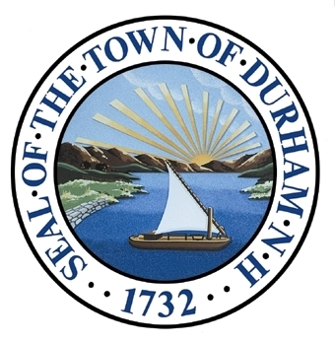
Downtown and Commercial Core
This chapter provides an existing conditions and assessment of development within Durham’s downtown and commercial core.

Adopted by the Durham Planning Board on November 18th, 2015

Our Vision
Over the next 10 to 20 years, the town aspires to have a vibrant downtown with thriving retail and service businesses, high-quality office space, more diverse shopping opportunities, and a range of housing opportunities for students, working singles and couples, and seniors. For some residents, the vision is evocative of Durham in 1965 when it had a diverse mix of businesses. Some would also like to see a community center, and envision a vibrant arts community.
We hope the town will embrace smart growth principles to bring greater density to the core, forming a cohesive, walkable downtown with improved connectivity and traffic flow, including a comprehensive pedestrian and bicyclist network to connect residential neighborhoods and downtown.
The Town seeks to shape development, particularly in the Central Business District, through design standards intended to enhance the quality and appearance of development. The downtown will have a human scale of primarily two and three, and under special circumstances, four-story buildings. The Town and UNH will work with local businesses and private developers to facilitate high-quality development and foster job creation. Jobs will be created in “industry clusters”, resulting in local multiplier effect through the attraction of similar businesses. New office, industry, and other development will embrace energy-efficient development practices beyond state and local regulations. The community will support “buy local” efforts.

Table 1:Downtown and Commercial Core
Zoning District Land Use Statistics
 | Acres | Number of Parcels | Mean Parcel Size
Central Business | 33 | 48 | 0.63
Church Hill | 24 | 22 | 1.14
Coe’s Corner | 34 | 28 | 1.15
Courthouse | 10 | 17 | 0.55
Professional Office | 26 | 38 | 0.65
Total | 127 | 153 | -
Introduction

This chapter represents an update to the downtown and Commercial Core Chapter of the Master Plan 2000. It is intended to build upon significant efforts undertaken over the last fifteen years by providing the following:
- A vision to guide the town’s efforts around the downtown for the next ten year period;
- A brief introduction to activities in, and studies of, the commercial core since the 2000 Master Plan; and
- An update of existing conditions, goals, and recommendations for achieving an overall vision for the downtown and commercial core.
Durham’s downtown and commercial core areas are composed of five zoning districts shown in the map on the following page: Central Business (green), Professional Office (yellow), Church Hill (purple), Courthouse (blue), and Coe’s Corner (red). Durham’s downtown is zoned as the Central Business District. The remaining four districts are the commercial core.
Durham’s downtown is unique in that while it must provide services for permanent residents of Durham, much of the current commercial and retail activity is targeted toward an academic year market of University of New Hampshire students. Additionally, demand for and supply of student housing in the downtown area has increased over the past five years. The result is a sizeable inventory of mixed-use (retail/commercial/residential) space within the Central Business District.
Durham residents have expressed conflicting views about the downtown’s attractiveness and accessibility. Perspectives vary on the area’s walkability, landscaping, civic spaces, business mix, building stock, and even the geographic definition of the downtown and commercial core itself.
This chapter attempts to address these perceptions and concerns, while providing goals and recommendations intended to guide sensible future growth and development.

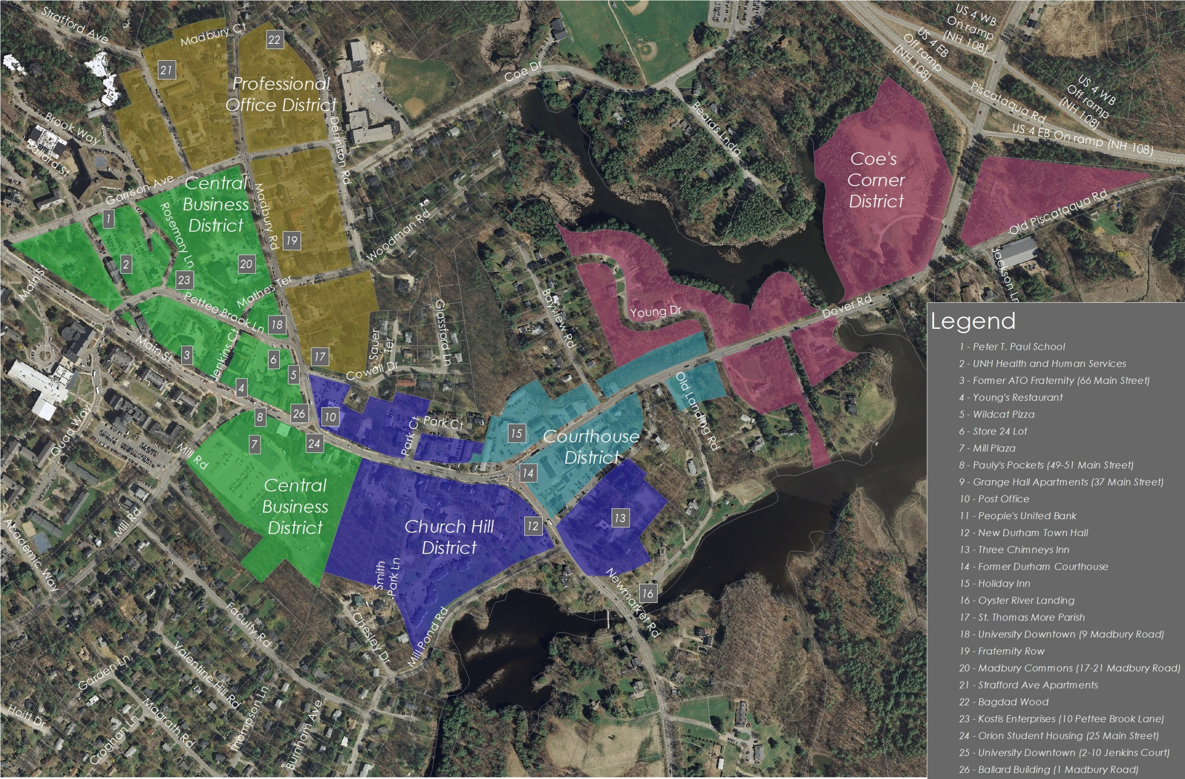
Map 1: Downtown and Commercial Core (Source: SRPC)

Studies and Activities
In the period since the last Master Plan, several significant initiatives (all available on the Town of Durham’s website) have been undertaken by the Town including:
- UNH-Town Traffic Model
(Ongoing – UNH/Town of Durham)
The UNH-Durham computerized traffic model is primarily used to analyze traffic patterns for Pettee Brook Lane and portions of Main Street and Madbury Road. The model is also used to assess the impact of developments and redevelopments in the downtown area on traffic patterns and volume.
- A New Village Center: Durham’s Vision for a Redeveloped Mill Plaza
(2008 – AIANH/Town of Durham)
This report resulted from a year-long effort to study prospects for redeveloping the Mill Plaza property. It includes recommendations and a series of potential site plans that “serve as a reference for the many possibilities that exist for the site.” However, no significant redevelopment has taken place.
- Durham Commercial Core Strategic Plan
(2009 - B. Dennis Town Design)
A road map and resource for directing growth and creating new vitality in the heart of Durham, this Strategic Plan was developed through a five-day charrette led by consultant B. Dennis Town Design. The Charrette brought together private and public stakeholders who identified issues and developed long and short-term physical, programmatic, and policy recommendations. The Planning Board has adopted regulatory amendments to implement some of those policies. (The report can be accessed from the Town website)
- Town of Durham Parking Pricing and Management Report
(2011 – TND Engineering)
This report provides an analysis and recommendations focused on influencing parking behavior, specifically, to increase regular availability, through the use of pricing, technologies, and other methods.
- Durham Business Visitation Program and Economic Development Survey
(2010-2011 – Durham Economic Development Committee)
The major findings of the Economic Development Committee’s outreach to Durham’s business community included a sense that the Town’s zoning is unduly restrictive, and a desire that the Town add more (and more useful) parking and more visible signage, make the downtown safer and more attractive, foster community and family-friendly amenities (including restaurants and retail), and offer education, advice, and support for business owners.
- Town-Wide Market Analysis
(2011- Development Concepts, Inc.)
This study identified significant opportunities to enhance the downtown, notably through the expansion of the retail market targeted to resident and employee populations by focusing on better products and services rather than physical expansion. The study also identified a shortage of Class A office space that could draw desirable business and opportunities for incubator space that may be appropriate for University-led commercialization initiatives.

Foundation
The following is a summary of relevant comments and input submitted during the 2011 Master Plan Survey, completed by the Town of Durham. Results of this engagement opportunity form the foundation of this Downtown and Commercial Core chapter while providing a lens of public perception and interest surrounding these topics. Public input sessions were conducted prior to a number of major downtown development projects. This should be considered when drawing any definitive conclusions.

How important are the following items to improving the downtown?
 | Overall Positive Response Rate | Very Important | Somewhat Important
Bike lane network | 74% | 41% | 33%
Better sidewalks | 73% | 32% | 41%
Better crosswalks | 68% | 35% | 33%
Buildings that combine residential and commercial uses | 62% | 26% | 36%
Improved parking availability | 61% | 35% | 36%
Better biking and walking access to the downtown from where I live | 59% | 33% | 26%
More events/festivals | 51% | 15% | 36%
Better lighting | 48% | 16% | 32%
Two-way traffic patterns | 39% | 17% | 22%
Public transportation that connects the downtown to recreation opportunities | 39% | 12% | 27%
Public transportation to downtown from where you live | 28% | 10% | 18%
TOTAL NUMBER OF PARTICIPANTS | 467 citizens

How important are the following attributes to making Durham a place where you will want to live during the next ten to twenty years?
 | Overall Positive Response Rate | Very Important | Somewhat Important
Sense of community | 91% | 59% | 32%
Vibrant town | 86% | 52% | 34%
Small New England town character | 86% | 43% | 43%
Pedestrian and bicycle friendliness | 82% | 52% | 30%
Access to UNH | 71% | 35% | 36%
Traditional historic architectural character | 71% | 27% | 44%
Local employment opportunities | 61% | 23% | 38%
TOTAL NUMBER OF PARTICIPANTS | 467 citizens

To what extent do you agree with the following statements about economic development in Durham?
 | Overall Positive Response Rate | Strongly Agree | Somewhat Agree
Joint UNH projects to promote economic development should be pursued | 91% | 55% | 36%
If available, I would spend more money on retail and professional services in Durham rather than out of town | 91% | 69% | 22%
Durham should continue to facilitate the redevelopment of existing structures | 89% | 51% | 38%
Durham should continue to facilitate new construction in downtown | 85% | 46% | 39%
Economic development (office parks, industry) beyond downtown should be encouraged by the Town | 85% | 51% | 33%
Durham should establish architectural and site design standards or guidelines for downtown projects | 81% | 47% | 34%
A performing arts center in or around downtown | 72% | 35% | 37%
Open to development along the entrance to town along Rte. 155A | 72% | 40% | 32%
Open to development along the entrance to town along Rte. 108N | 70% | 42% | 28%
Open to development along the entrance to town at Coe’s Corner near Rte. 4 | 64% | 36% | 28%
Durham should extend water, sewer, and roads to stimulate economic development | 62% | 24% | 38%
Open to development along the entrance to town via Rte. 4 | 62% | 36% | 26%
Open to development along the entrance to town along Rte. 108S | 56% | 31% | 25%
A tax rate with similar rates as the past is acceptable | 35% | 7% | 28%
TOTAL NUMBER OF PARTICIPANTS | 467 citizens

To what degree would you support the following policies aimed at stabilizing/reducing the property tax rate?
 |  | Overall Positive Response Rate | Strongly Agree | Somewhat Agree
Make more land available for commercial development |  | 71% | 42% | 29%
Build a parking structure in the downtown |  | 71% | 32% | 38%
Allow commercial or mixed residential-commercial building heights greater than 4 stories in downtown |  | 56% | 33% | 23%
Encourage shopping plaza developments outside of downtown |  | 52% | 28% | 24%
TOTAL NUMBER OF PARTICIPANTS | 467 citizens
2011 Master Plan Survey (continued)

The Downtown
This section provides a basic description of the existing conditions within the Central Business zoning district (known as Durham’s downtown).

Central Business District

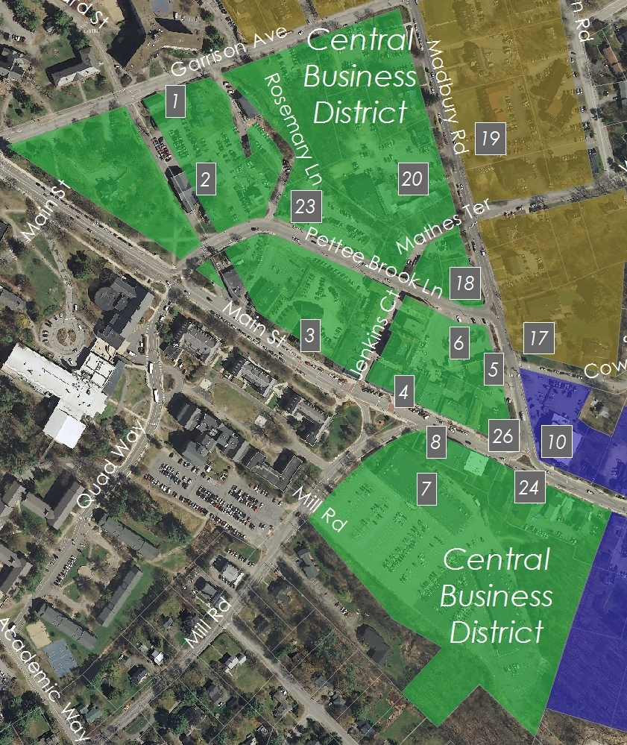
Vision: The Central Business District will be an attractive and vibrant commercial center of the community where desirable retail and commercial growth occurs in a safe and friendly environment.
Map 2: Central Business District (Source: SRPC)

Background
The Central Business District (CBD) is the heart of the downtown and commercial core. Proximity to the University of New Hampshire (UNH), concentrated commercial/retail space, and pedestrian, bicycle, and vehicular access make this area a destination for students, residents, and visitors alike.
For several years, the Central Business District was in decline, losing key small businesses, and seeing limited new investment. Since 2009, however, the CBD has experienced an unprecedented increase in new mixed-use development, with several completed or planned projects reshaping the character of this core area of town.
The Central Business District and commercial core area, which from approximately the 1980s through the early 2000s was aimed primarily at providing services for University students, has more recently been shifting toward providing a greater selection of retail and commercial opportunities for Durham residents, many of whom have no direct connection to the University. Businesses in this area have traditionally struggled to balance products and services for these two very different consumer groups and to accommodate seasonal demand shifts (i.e., UNH off-session and heavy summer-vacation impacts).
Much of the commercial activity is located within the traffic loop defined by Pettee Brook Lane and Main Street., and in the Mill Plaza. Although home to largely commercial and retail spaces, student housing units are now widely interspersed as part of mixed-use multi-story developments.
Pettee Brook Lane to Garrison Avenue contains mostly multi-family residential use (fraternities, sororities, and apartments) and older University owned property. However, the recent addition of UNH’s Peter T. Paul College of Business and Economics (2013) and the Madbury Commons (2015) mixed-use project are potential game-changers.
Recent and Planned Developments
Substantial development and redevelopment of mixed-use student housing in the CBD has paved the way for a complete transformation from the Durham downtown area of only five years ago. Additional development is expected to dramatically alter both streetscapes and scaling in several portions of the Central Business District (see below). For a more in depth discussion of specific developments, please refer to the Housing and Demographics chapter.

Land Use
The downtown geographically identifies the commercial center of town and is critical to the character of the community. It attracts both residents and students and is a primary access point for visitors.
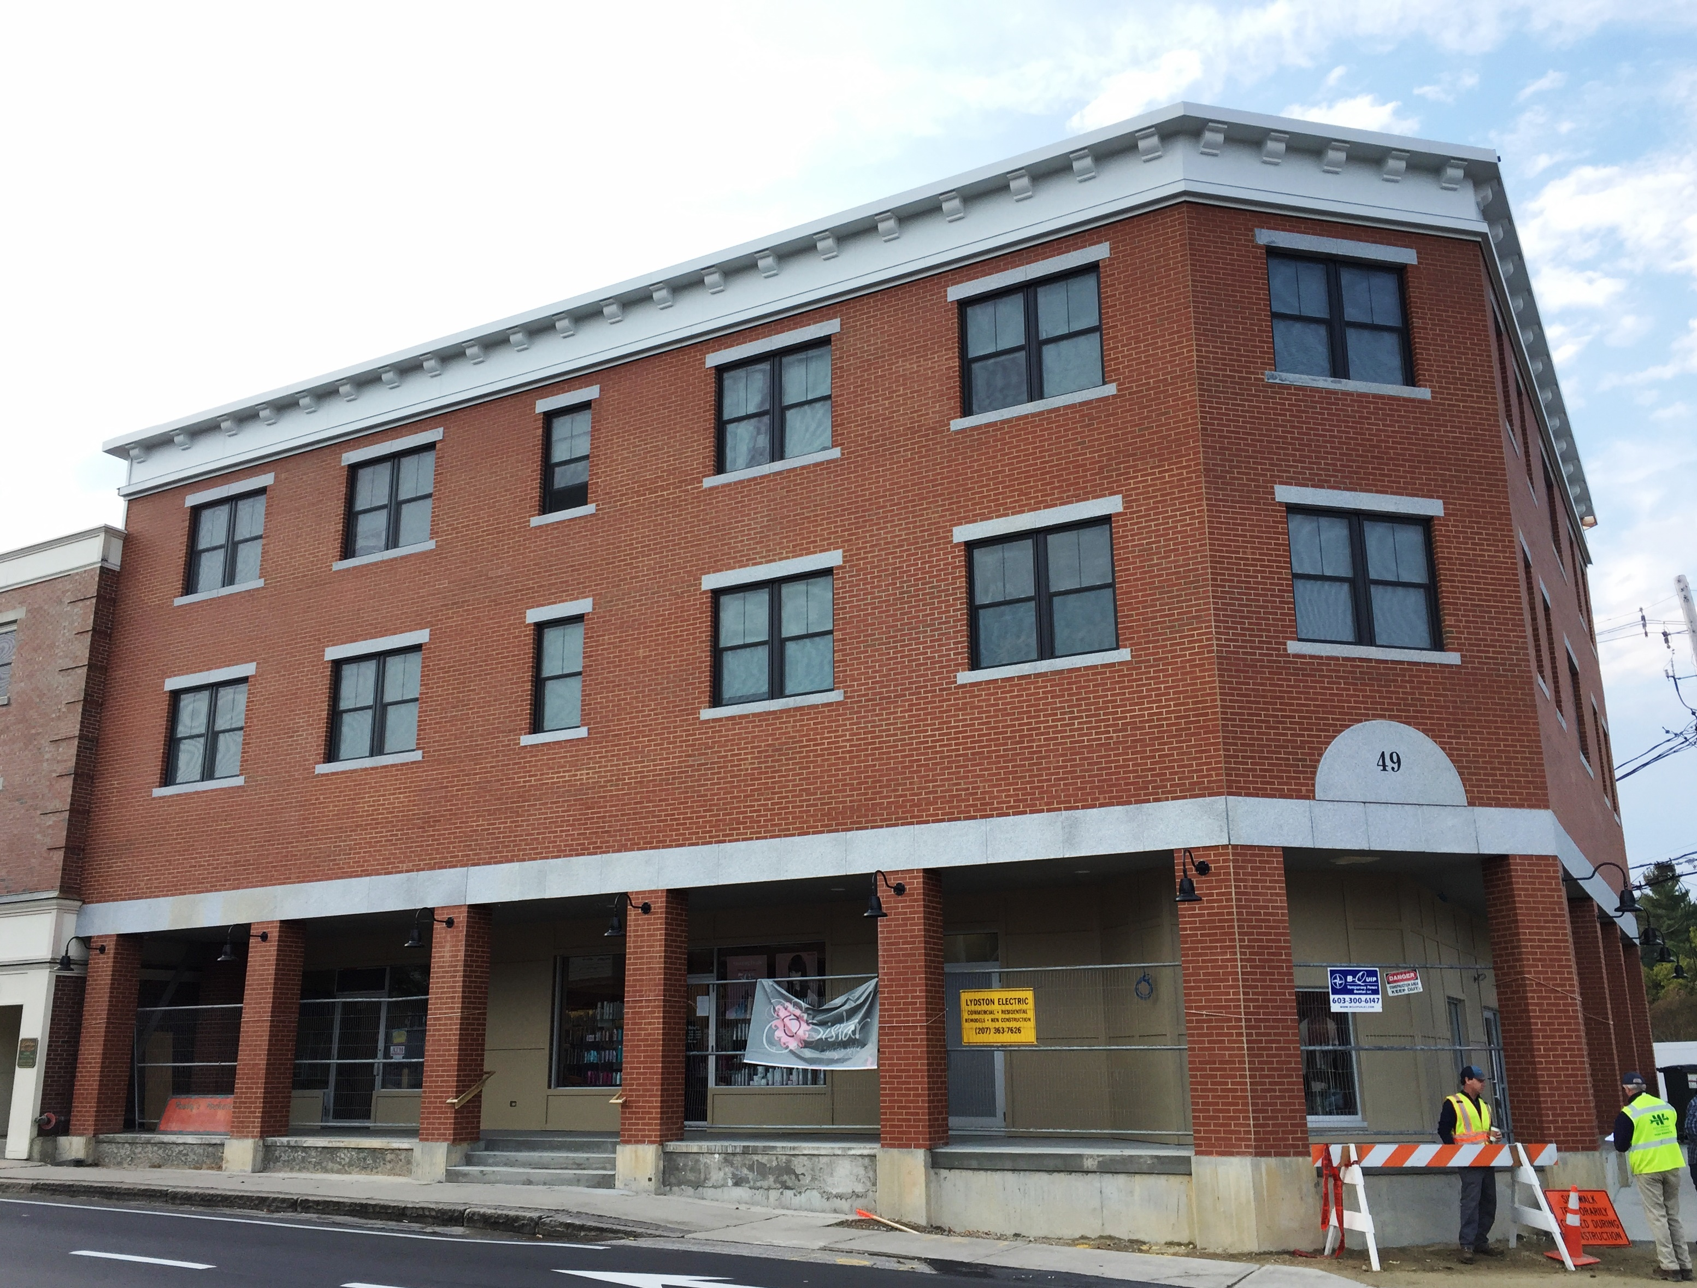
The area’s small geographic size has proven challenging over the years, not least from the perspective of access. The current downtown traffic configuration, looping around Main Street and Pettee Brook Lane was designed from a vehicle-centric perspective. In conjunction with the Route 4 bypass, for purpose of moving thru-traffic, the one-way traffic pattern moves cars relatively swiftly through the center of town, including commuters to and from the University.
Photo 2: Pauly’s Pockets Development (Source: Town of Durham)

This vehicular-focused traffic pattern creates conflicts with pedestrian circulation, as evidenced by the common crossing of pedestrians outside of the crosswalk areas and challenges bicyclists. The 2011 Master Plan Survey respondents noted access to Mill Plaza for all transportation modes as a specific concern.
Given the large number of UNH students who live and/or patronize the restaurants and stores in the commercial core, promoting pedestrian use in the this area should be a high priority. This could reduce vehicle congestion and the demand for limited parking.
The retail businesses located downtown, largely oriented towards students, are a concern for many Durham residents. Promoting businesses that offer a wider variety of goods and services for local residents, visitors, UNH faculty, as well as for students, would bring a greater variety of people downtown and encourage a stronger identity for Durham. The Town and University understand the businesses within the downtown and commercial core cannot rely exclusively on any single one of the aforementioned consumer groups. Instead, the downtown should provide retail and other commercial opportunities that appeal to a diverse and variable consumer base.
Addressing the types of uses permitted in the CBD may also contribute to resolving the third issue of concern, the physical character and appearance of the downtown. The image of downtown, with its combination of public spaces, sidewalks, parking lots, and buildings, is inconsistent in style and massing. By contrast, a traditional commercial center of a small town with its continuous street facade of multi-story buildings found in Portsmouth, Dover, or Hanover, can establish a town’s commercial identity.

Economic Environment
Durham’s Central Business District (CBD) is a small but vital part of the community. The District acts as not only a center of commerce where goods and services are purchased and sold, but also as a vital social center for the community. The Central Business District is presently a mix of apartments primarily occupied by UNH students, retail businesses, and limited commercial office space. In order for downtown to grow and prosper it must achieve economic “critical mass.” Re-evaluation of the Town’s regulations could encourage such growth. Specific improvements to regulations are identified in the goals and recommendations section of this chapter.
A quantitative model that projects the square footage necessary to support a reasonably complete suite of market offerings was not developed for this Master Plan. However, the 2011 Market Analysis suggests that the current retail and commercial space falls short of creating sufficient “critical mass.”
That research indicates that residents’ commercial needs are not fulfilled by the services and retail opportunities currently provided in Durham. Four major factors account for this perspective:
- Downtown does not provide what consumers want: It is a common perception that it is not possible to obtain in Durham all of the goods and services that residents, students, and visitors desire; this leads to shopping trips where offerings are more diverse and complete.
- Downtown is not convenient: It is a common perception that goods and services that are available are less convenient; this leads to shopping as an adjunct to commuting or other activities.
- Downtown goods and services are expensive: It is a common perception that similar goods and services may be priced higher than alternatives outside Durham, leading to price-driven shopping trips.
What is Critical Mass?
Critical mass refers to the size a company needs to reach in order to efficiently and competitively participate in the market. This is also the size a company must attain in order to sustain growth and efficiency.
Source: Investing Answers

- Downtown does not currently achieve necessary “critical mass”: Research suggests that Durham’s current downtown economic activity does not attract the consumer base or resources necessary for many businesses to efficiently and competitively participate in the market. Without the necessary critical mass, businesses cannot operate efficiently and thus sustain growth.
A vibrant and healthy downtown and commercial core can create opportunities for establishing and maintaining a strong and positive sense of community. It could also maximize value of properties within the downtown for assessment purposes. With limited large parcels of undeveloped land in or adjacent to the CBD, Durham can only achieve this “critical mass” by redevelopment and/or “densification” of the existing CBD, with a view to creating more of the business spaces that achieve the town’s goals. This may require that some of the existing uses (fraternity, sorority, and apartment housing) be reduced or restructured to allow for commercial expansion. Incentives and regulations should be developed that encourage the creation of more commercial-oriented activities and that encourage increasing the density of commercial spaces downtown.
Physical Character
The physical character of the Central Business District includes many buildings that abut each other in a traditional downtown manner, but there is not a cohesive appearance due to the varied one story to three story mix of buildings and the wide range of styles. The image and the reality that an active, dense downtown presents are considered desirable, particularly when the downtown has a strong pedestrian presence, as is the case with Durham’s downtown. It is important to promote development that will further improve the character, vitality, and pedestrian use of the downtown. Creating and improving the image of downtown can be achieved through unifying the character of its buildings; maintaining the buildings; focusing on the overall visual effect of the streetscapes, including the sidewalk and pavement materials, style of lighting, signage, and landscaping; removing the overhead power lines, and by making downtown a pedestrian environment with ample social visibility. In 2012, based on the recommendations of the B. Dennis Commercial Core Strategic Plan, the Durham Planning Board adopted architectural standards intended to inspire architects, designers, developers, and builders to produce beautiful structures, respectful of place, context, and tradition. The regulations are not intended to be burdensome nor are they intended to stifle creativity or variety. Through adoption of these standards, the Town has expressed an interest in improving the character of buildings within the commercial core.
Parking
Parking has long been and will continue to be a challenge for Durham. Parking can be a contentious issue, and the consensus among the community is that there is not enough downtown parking. The Town will continue to evaluate and monitor parking supply and demand as the character of the downtown and commercial core changes.
Data indicate that, overall, there is an adequate parking supply in downtown today. The Town seeks to achieve an overall parking ratio consistent with the current and updated studies. The recommendation is 3.2-3.4 spaces/1000 square feet of building in order to become a Park-Once-and-Walk destination (parking in mixed-use settings offers the opportunity to share parking spaces between various users, thereby reducing the total number of spaces required, helping create a “Park-Once-and-Walk environment where people arriving by vehicle park one time and then walk to several destinations). It is anticipated that student housing/commercial development and redevelopment efforts in the downtown area will impact the availability of parking for students and business patrons, placing strain on supply.
The purpose of Park-Once-and-Walk is to balance the number of vehicles at levels the supply of parking can handle. Adoption of parking maximums and shared parking are identified as removing significant barriers to infill development, preventing an oversupply of parking, and reducing areas devoted to pavement. Pursuant to the report, the Town installed new Pay and Display parking kiosks, powered by solar panels, along the south side of Main Street, Main Street across from the Memorial Union Building, Pettee Brook Lane, lower Madbury Road, and Garrison Avenue. The Town, in recent years, has adjusted meter fees in the downtown in an effort to encourage higher turnover of parking spaces and increased business patronage. Rates will continue to be monitored and adjusted with the goal of providing more parking capacity for businesses.
On-street parking should continue to be maximized to the greatest extent possible. On-street parking has the ability to enrich downtown areas by focusing pedestrian activity on the sidewalk and social spaces. On-street parking also serves to calm traffic by creating a narrower travel way and therefore encouraging slower vehicle travel. As redevelopment occurs in the downtown, on-street parking should be incorporated into the streetscape design. Structured parking facilities, such as those discussed for 66 Main St., should be preferred over the creation of additional surface lots. Structured parking associated with another development such as mixed use with offices and residences not only uses land more efficiently in a compact, walkable downtown, it also can help support the development financially. Structured parking can be private, public, or part of a public-private partnership. All structured parking would be subject to the Town’s architectural standards in the downtown and Commercial Core.

Traffic

Downtown Durham enjoys a relatively high volume of pedestrian traffic due to its proximity to the University. Many students live in the downtown area and walk to campus. There is also a draw to the downtown businesses from the campus. This pedestrian use is a valuable asset to the downtown as it provides ample opportunity for social interaction and engagement.
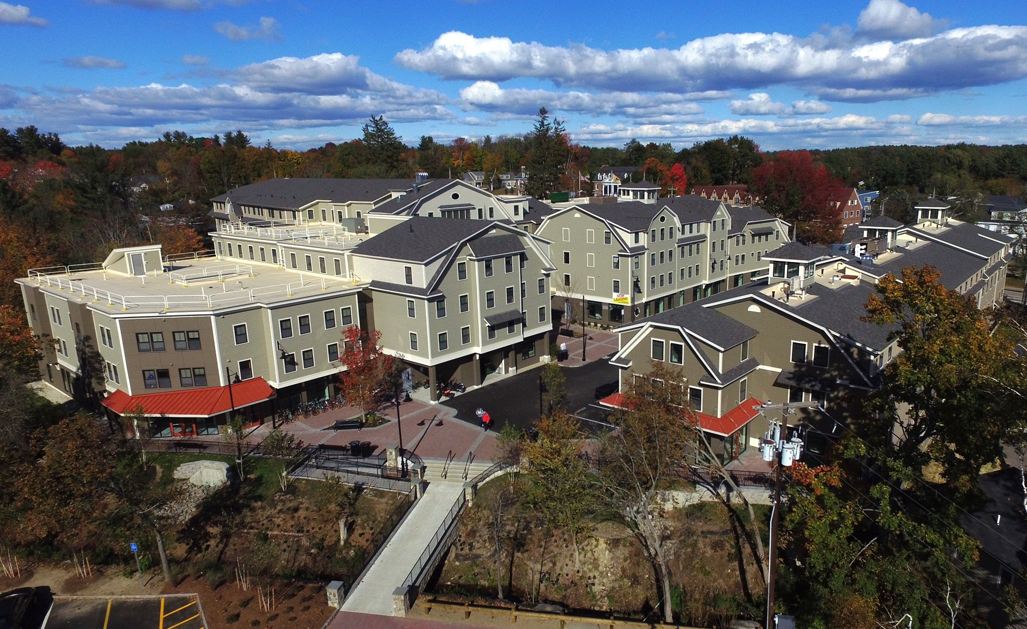
The current auto configuration of the downtown, primarily the one–way loop through the downtown on Pettee Brook Lane, generates a significant amount of both through and circulating traffic. This is evidenced by a traffic count of 9,111 vehicles per day on Main Street (between Pettee Brook Lane and Mill Road) when UNH is in session, and a count of 7,461 vehicles per day on Pettee Brook Lane east of Rosemary Lane. Based on a town-wide traffic study by Strafford Regional Planning Commission, the count is approximately 50% less when UNH is not in session. This downtown vehicular traffic configuration has been analyzed at several points in the early-to mid-1990s. At that time, it was resolved that the one-way would be maintained to ensure high vehicular capacity, greater vehicular safety, and a resulting decrease in air pollution. In the late 1990s, traffic calming measures, one-way angled parking, and improved crosswalks, were implemented in the downtown area. Pedestrian safety however, continues to be a primary goal of both the University and Town.
Photo 4: Madbury Commons (Source: Town of Durham)

Improvements in pedestrian and bicycle safety have been made, but the Town continues to focus on strategies that further enhance the pedestrian access to businesses and the University throughout the downtown, and provision of alternative routes to other parts of Town. One-way traffic loops in downtowns traditionally move traffic more efficiently but the increased speeds give the streets more the character of a highway and can be challenging for pedestrian and other alternative transportation activity. A roundabout at Main St/Pettee Brook/Quad Way has been investigated, but further study is necessary. Therefore, the Town will continue to consider modification of the traffic pattern in this zoning district.
Traffic circulation of vehicles, bicycles, and pedestrians between Mill Plaza and the businesses in the loop area also represents a challenge for the town. Pedestrians and vehicles access the plaza for many different services, which include a grocery store, a pharmacy, restaurants, and other businesses. Although many vehicles access the plaza from the Main Street/Pettee Brook loop (9,234), there is a significant amount of traffic accessing the plaza by using Mill Road from the south (6,957) There is presently only one vehicular access to Mill Plaza, along with bicycle and pedestrian paths from Faculty Road, Chesley Drive, and Main Street. Safety for all traffic circulation for all transportation modes in and around the Mill Plaza will continue to be a primary goal of the Town.

Civic Space
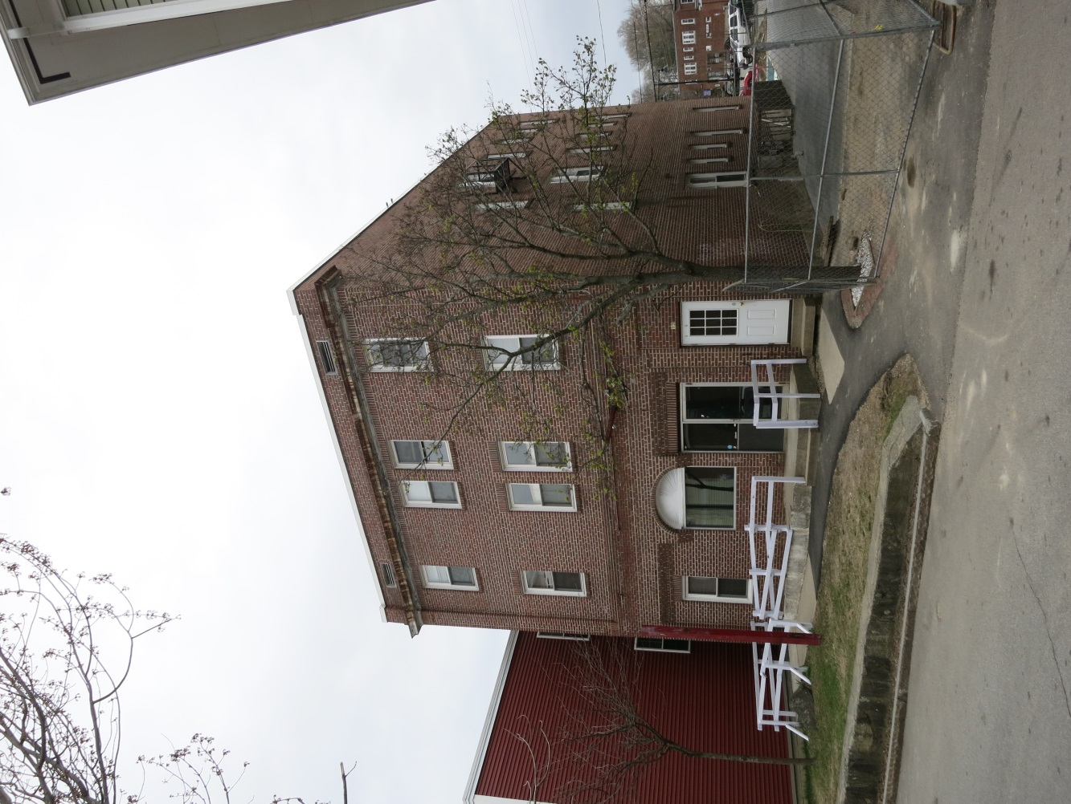
Many residents have identified a lack of civic spaces as a flaw of Durham’s existing downtown area. The Town continues to work to identify strategies and solutions that create additional public spaces in the area of Jenkins Court for the growth of social capital outside of the University of New Hampshire. Jenkins Court has been identified as a potential area of opportunity for the development of a pedestrian mall or other civic gathering area.
Photo 6: Jenkins Court (Source: SRPC)

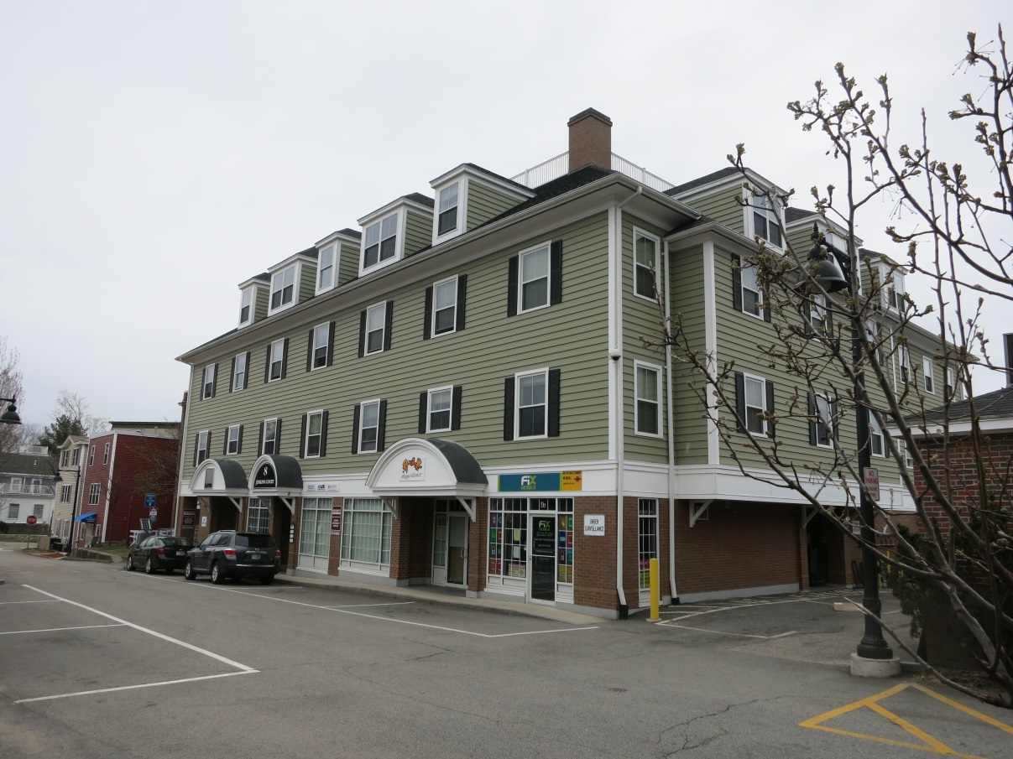
Photo 5: Jenkins Court Development (Source: SRPC)

The Commercial Core
The content presented within this component is intended to provide a basic description of the existing conditions within four zoning districts, which compose Durham’s commercial core area.

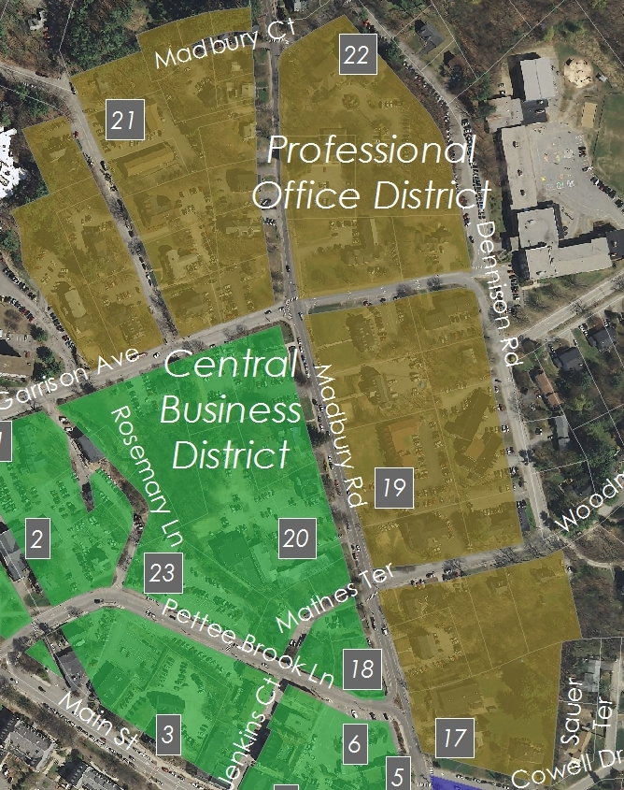
Professional Office District
Map 3: Professional Office District (Source: SRPC)

Vision: The Professional Office District will include professional offices, transitioning from the more intensively developed Central Business District to the adjacent Residential A District. The historic character of Madbury Road will be preserved and potential negative impacts of mixed-use development will not spill over into adjoining residential districts.

Background
Located adjacent to Central Business District (CBD) along Madbury Road is an area with a predominance of fraternities, sororities, and apartments, as well as an elderly housing complex, a medical clinic, and few single-family homes. This area runs along the east side of Madbury Road from Cowell Drive to Garrison Avenue and along both sides of Madbury Road and Strafford Avenue from Garrison Avenue to Bagdad Road. This is known as the Professional Office (PO) District.
The District was created as a response to recommendations from the 2000 Durham Master Plan. At the time of that Master Plan’s drafting, the District was largely composed of multi-family residential buildings, including several structures operated by Greek life organizations associated with the University. Unfortunately fifteen years have passed and the District has not yet been successful in encouraging the creation of new and/or rehabilitated professional offices or the redevelopment of fraternities and sororities.
Expansion of the CBD into this area has been considered, but this change would bring all of the CBD’s permitted uses further from the Town’s existing commercial/retail areas and closer to single-family neighborhoods. This could result in negative impacts to traditional neighborhoods and by shifting retail and commercial focus away from the Main Street development area. The Town should consider creation of a transitional overlay zone between the Commercial Business District and Professional Office District that allows for some permitted uses of the Central Business District.

Land Use
The Town continues to promote professional office uses within the District, while allowing multi-unit housing. However, in order to encourage more professional office uses the Town should consider rezoning in a manner that accommodates the desire for more office space inventory without sacrificing Durham’s residential neighborhoods. One of the characteristics of this section of Madbury Road is the existence of a group of fraternity/sorority buildings set back from the road with large front lawns. The scale of these and other buildings provides a desirable transition between the Central Business District and the residential neighborhoods further down Madbury Road. It is important to preserve both the buildings and their setting in the landscape. This district also underwent a zoning change in 2015 to modify mixed-use residential from a conditional use to a non-permitted use.
Church Hill District
Vision: The Church Hill District will serve as a transition zone from the commercial development of the Courthouse District to densely developed core of the Central Business district. This transition will be maintained through the preservation and maintenance of historic single-family homes and other structures through adaptive reuse.

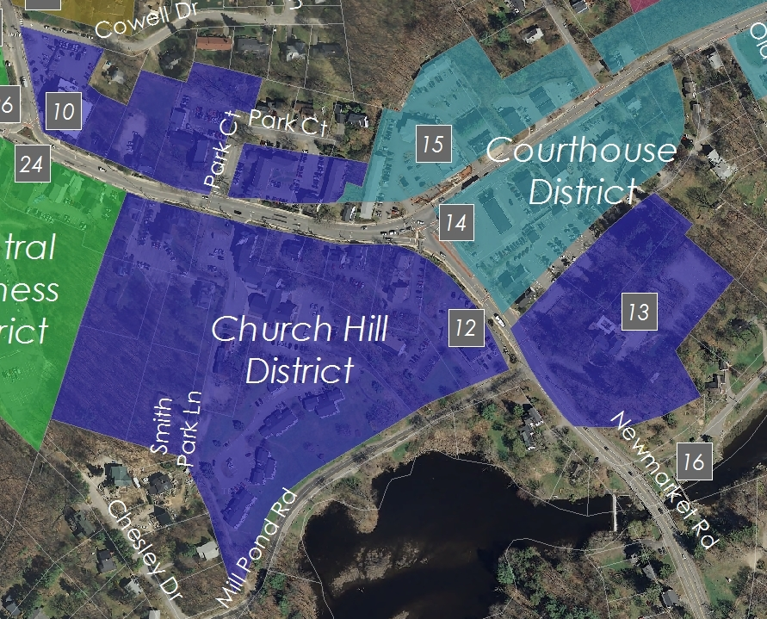
Background
The Church Hill District includes Main Street and Route 108 to the Oyster River Bridge in Durham’s Historic District. The District is well-served by public transportation and pedestrian infrastructure. Nevertheless, bicycle access continues to be a concern, particularly in the area of the district directly adjacent to the Courthouse.
In the decade that followed the 2000 Master Plan, very little development had occurred within the District. However, significant development has occurred in the five most recent years, principally of student housing. Its architectural character is defined by eighteenth- and nineteenth-century houses built by the movers and shakers of Durham's past, when the town played a role in the Revolutionary War and in the formation of the nascent federal and state governments. The top of the Hill is crowned with the white steeple of the Community Church, a familiar visual landmark from several vantage points. On the east side of Church Hill, Main Street passes the Richardson Tavern where meetings of the Selectmen were held before the 1850 acquisition of the Courthouse located at the foot of Church Hill, at the intersection of Main Street with Route 108.
  - Map 3: Church Hill District (Source: SRPC)

From the Old Town Hall to the Oyster River Bridge is the historic mercantile center of Durham connected to the Town Landing at the Oyster River where ships built in Durham took lumber, bricks, granite, and farm crops to seacoast markets and beyond in return for goods from around the world. Church Hill also has a fine collection of old and new buildings of similar design and scale, all adapted to twenty-first century uses, including the new Durham Town Hall, and the recently renovated Three Chimneys Inn. The Oyster River dam, with the landing on one side and the Mill Pond on the other, is a favorite scenic spot for young and old alike in all four seasons of the year.
As older residents moved on, University students increasingly rented the apartments, other owners of single-family homes converted them to more profitable apartments on Church Hill. Students sought apartments first because of insufficient on-campus housing and proximity to downtown. Today, the Church Hill District consists primarily of rental apartments occupied by students with some limited commercial uses on Route 108 and at the edge of the CBD, with few single-family homes on the periphery. Although developments such as the Orion student housing project have improved the aesthetic quality of this district, many rental apartments still exhibit neglect in their appearance. The Town will consider zoning modifications that facilitate development that are compatible with historic structures and the Historic District overlay zone.
Housing
There are three issues that affect the Church Hill area: low property assessment values, the profitability of apartment rentals, and the difficulty of enforcing the zoning requirement prohibiting more than three unrelated occupants in one dwelling (3-unrelated rule). These issues contribute to the degradation of Durham's most historic houses and to the disruption of the downtown and the surrounding neighborhoods.

In partnership with the landlords, an economic analysis should be performed that evaluates the economic benefits of adaptive reuse. In the interim, permitting mixed uses (e.g., office, commercial, apartments) may be the best way to begin to accomplish the goal of adaptive reuse with commercial space on the first floor and apartments above. The appearance, specifically the period facades, of the historic buildings on Church Hill should be preserved while allowing a change in use. A mix of professional offices, restaurants, and retail stores could provide a transitional entrance to the downtown. The buildings in both segments of this area (Route 108 and Church Hill), reinforce the historic character of the area.

Civic Space
Although the Church Hill District does not currently provide land suitable for the creation of public civic spaces, the area to south of the District, adjacent to the waterfront (east of Route 108) has been identified as an area with potential for future improvements for non-commercial development.

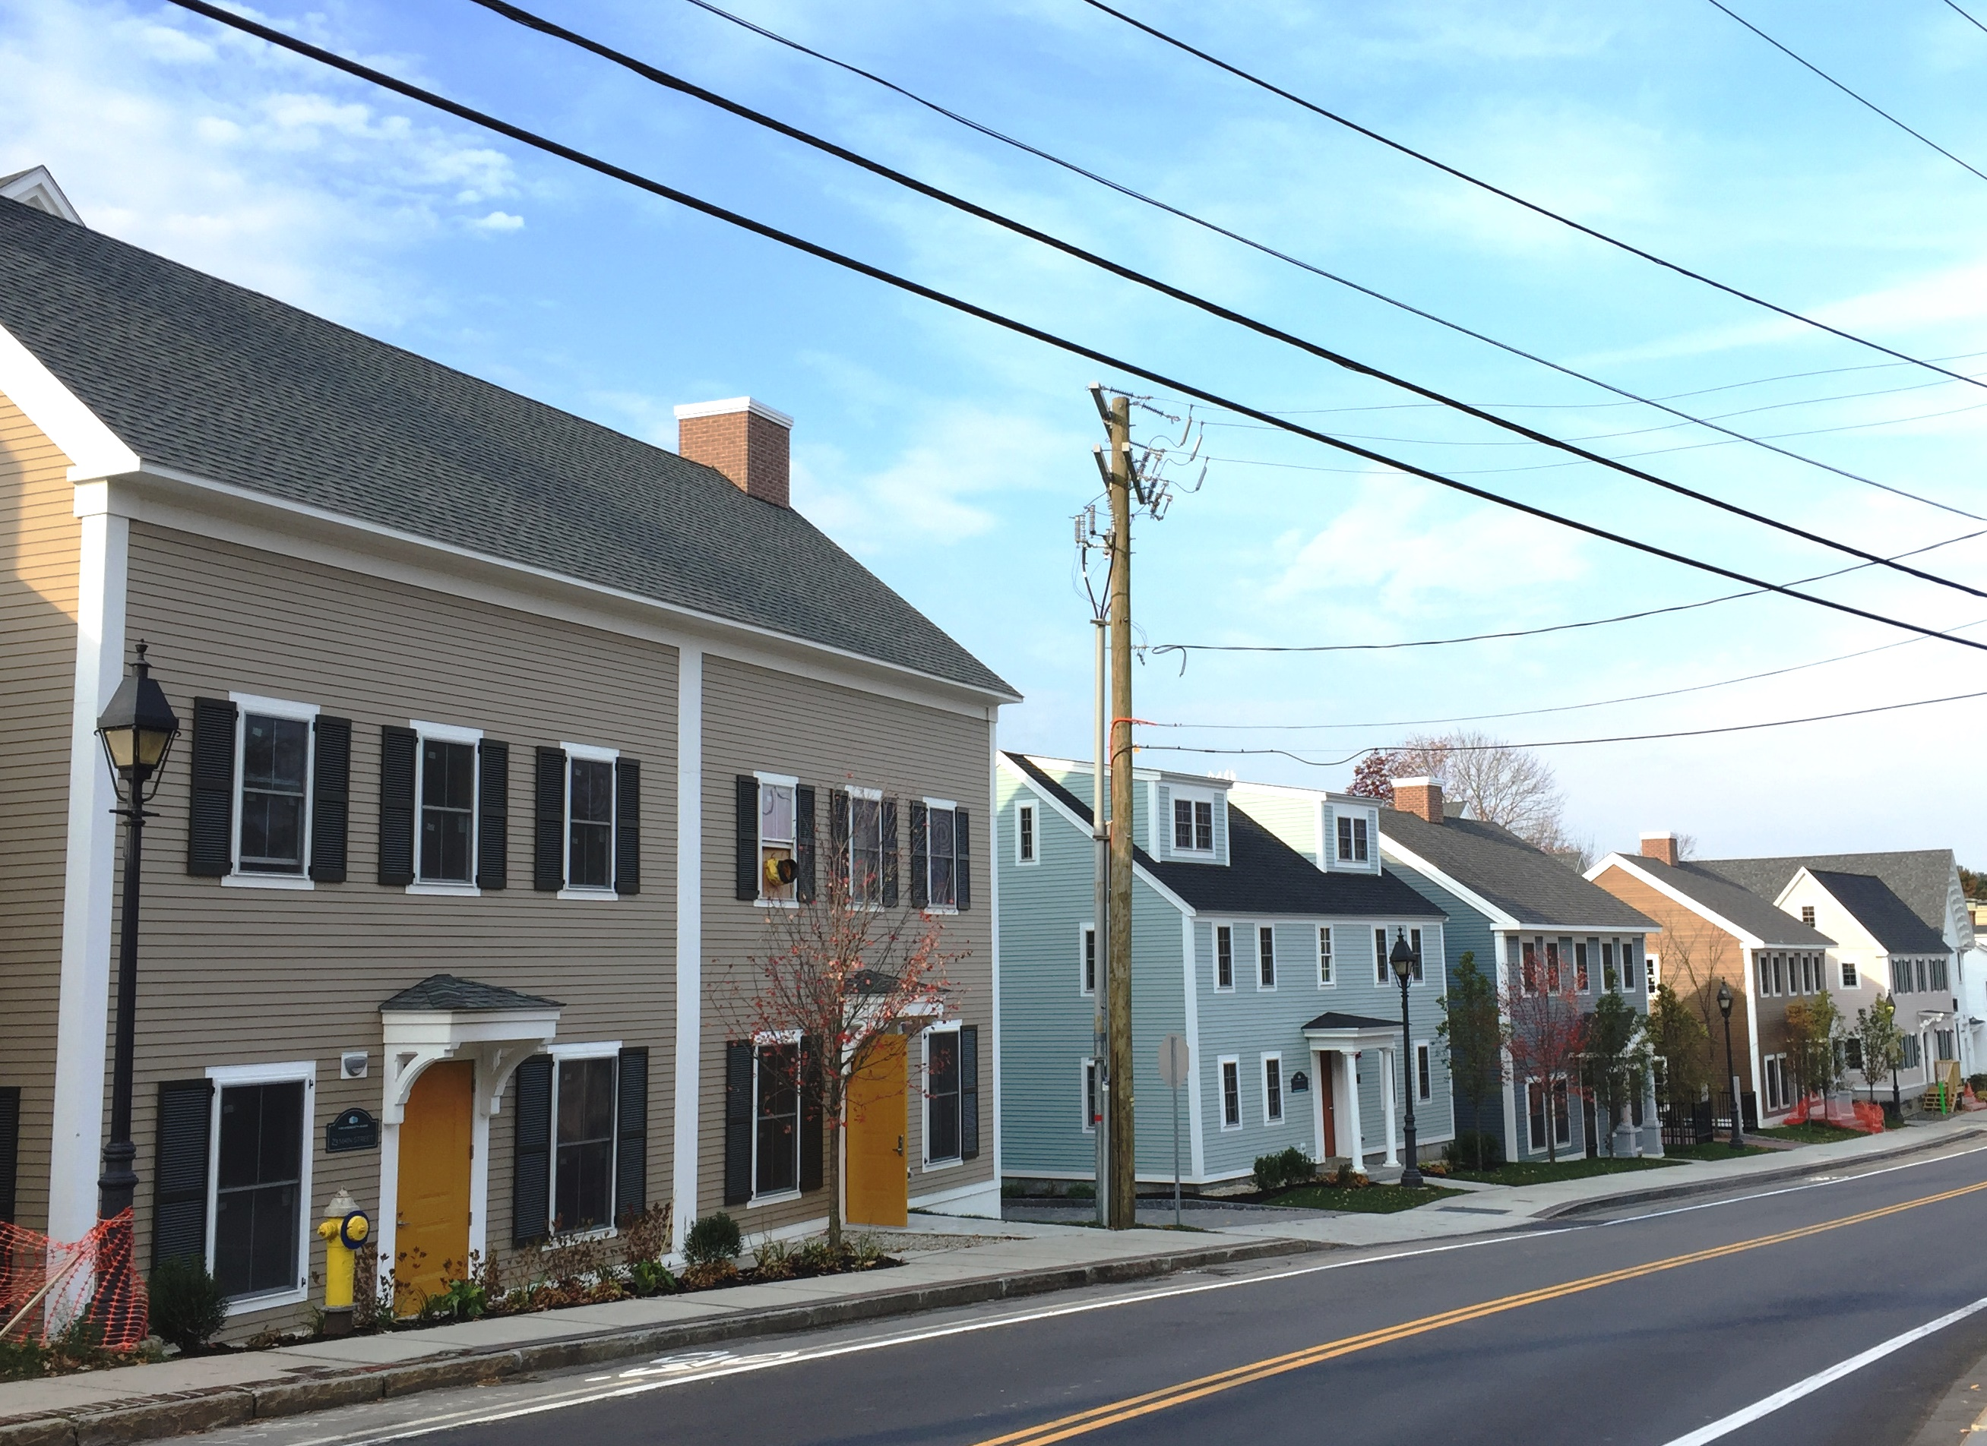
Photo 7: Orion Development (Source: Town of Durham)

Photo 8: Three Chimneys Inn (Source: SRPC)

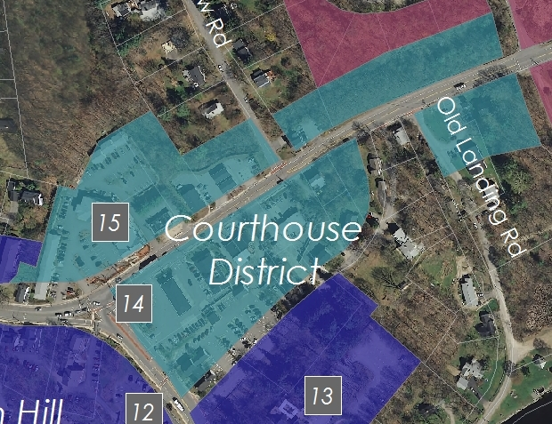
Courthouse District
Map 4: Courthouse District (Source: SRPC)

Vision: The Courthouse District is an attractive area with a small town look including diversified commercial, retail, and governmental services. It provides the sole location for gasoline stations within the town. Revitalize the area to provide a smoother visual transition between Durham’s scenic river front and the Historic District.
Background
At the foot of Church Hill, the commercial core’s character shifts abruptly from the Historic District into "Gasoline Alley," a 0.2-mile stretch of road that represents the heart of the Courthouse District. The District is named for the historic courthouse building located at the corner of Route 108 and Main Street.
Dominated by the automobile related service businesses, this district extends from the Route 108/Main Street intersection along the Dover Road to Schoolhouse Lane. The retail development in Gasoline Alley of both a gas station and hotel, has provided students and permanent residents with essential services in a concentrated area for many years. Durham, unlike other New Hampshire towns, does not have commercial strip development along its major roads. The major commercial activities in the area consist of two gas stations/convenience stores and two auto repair/used car sales establishments. Rental properties and Town administrative facilities complete the balance of the zone. Automobile services are essential to the community and the Town has been successful in concentrating them in this area close to Routes 108 and 4, and the Route 108 intersection with Main Street.
Historically, this area was the commercial and mercantile hub of the tidewater community when waterborne goods arrived at the nearby Town landing to be sold at stores located at the crossroads with the New Hampshire turnpike. Overlooking this important junction still stands the handsome brick Courthouse building, originally built in 1825 as a free-standing commercial block, then later adapted to serve as the seat of Town government from 1840 until recent times. With its historical and architectural significance, it is a part of the Historic American Building Survey and is a contributing structure within the Town’s National Register District. Today, the building is still imposing, yet isolated from other historic buildings, an island unto itself surrounded by asphalt, gasoline stations, and adjacent to a State highway carrying over 17,000 vehicles per day.
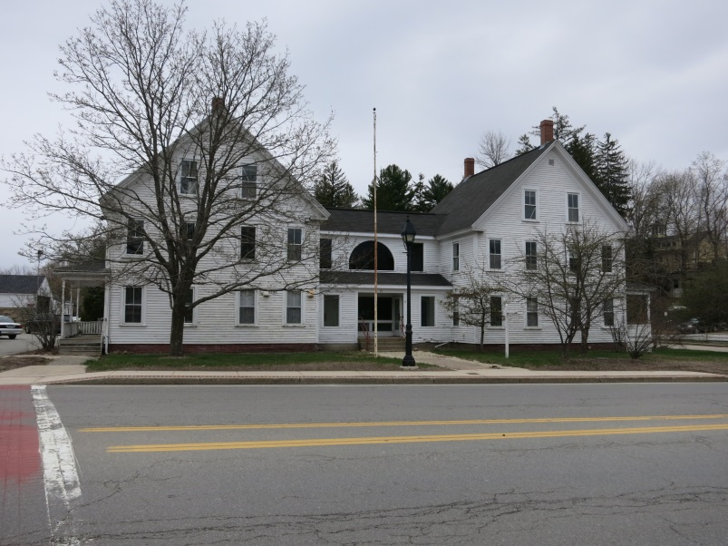
Intersection Improvements
Photo 9 Former Town Hall (Source: SRPC)

Residents and the Town have suggested improvements to the Route 108 intersection with Main Street that will improve safety for vehicular and pedestrian traffic alike. Such improvements will also make the streets more attractive, with trees and landscaping, decorative lighting, and sidewalks.

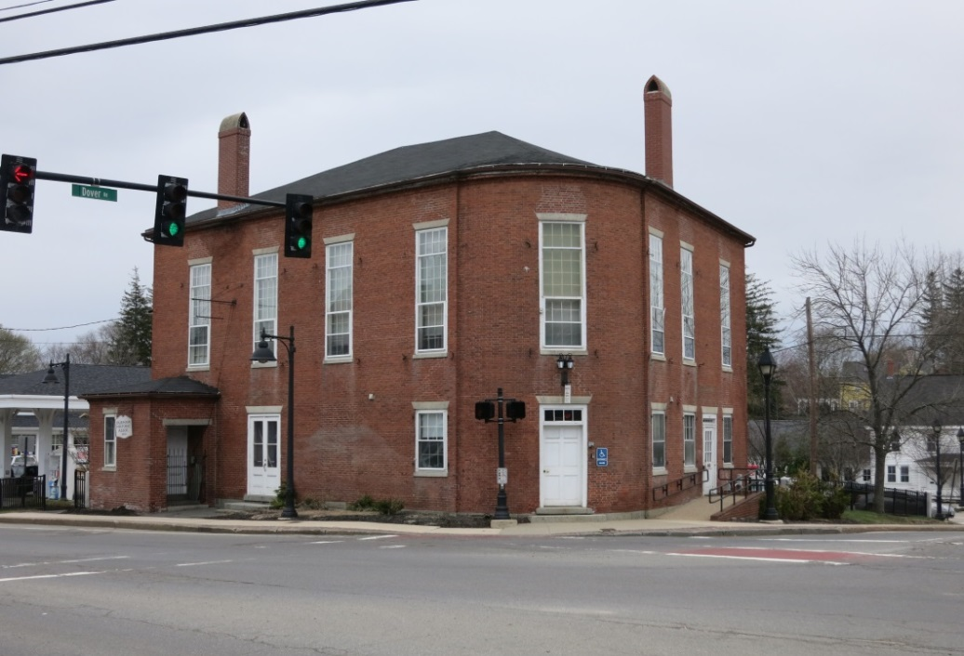
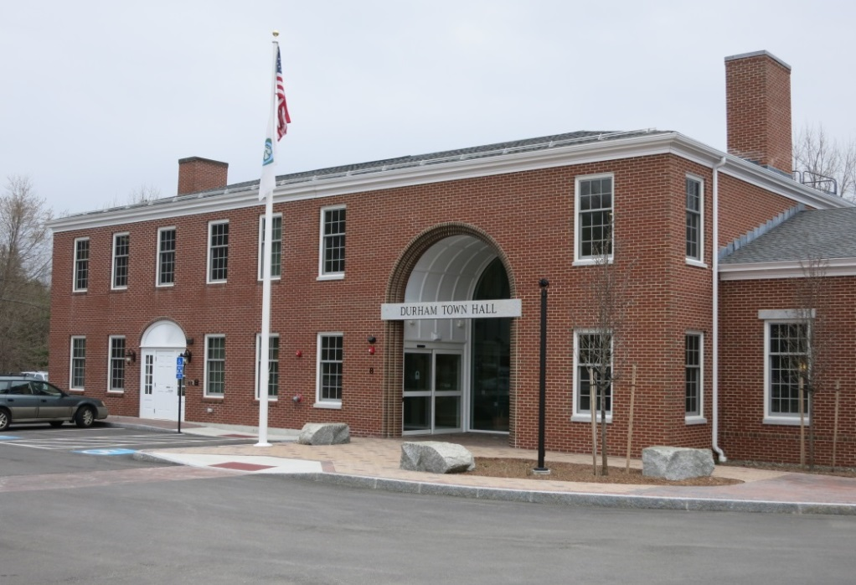
Photo 11: Courthouse Building (Source: SRPC)

Photo 10: New Town Hall (Source: SRPC)

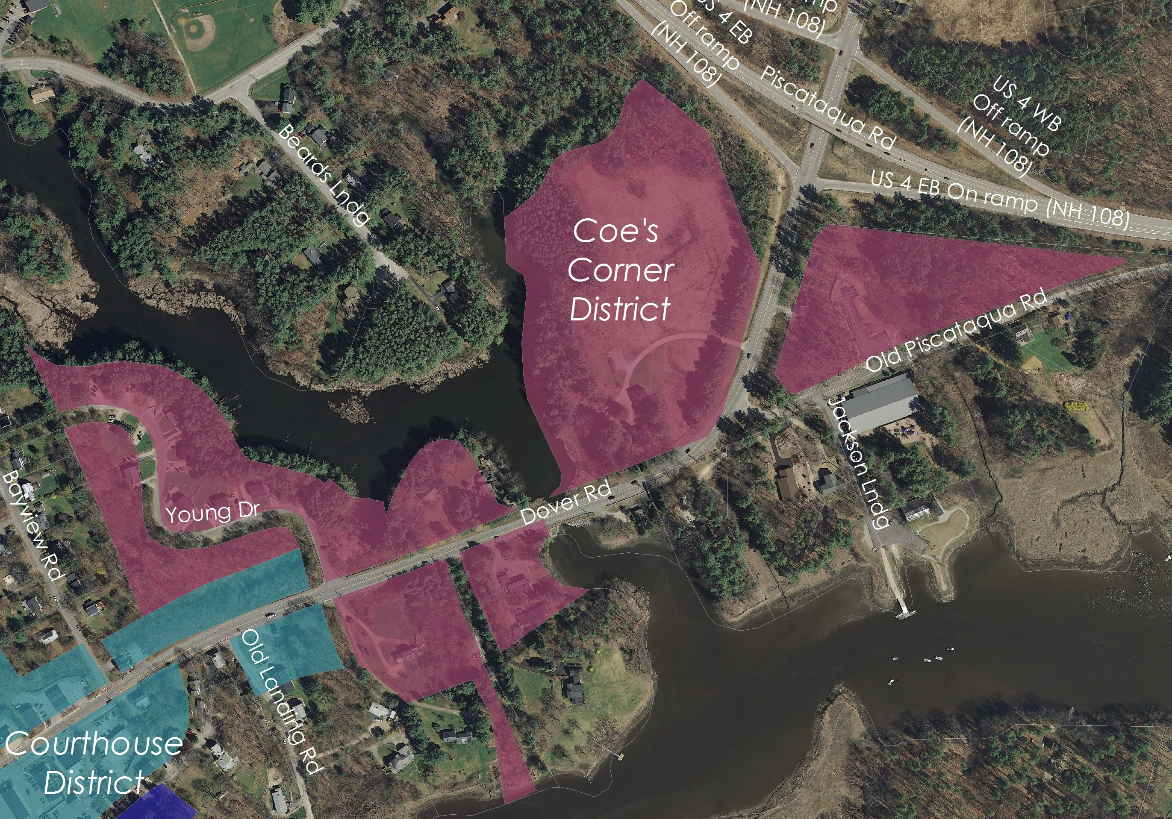
Coe’s Corner District
Map 5: Coe’s Corner (Source: SRPC)
)
Vision: Coe’s Corner serves as a gateway to the more intensively developed Courthouse and downtown districts. It is a transition zone with controlled commercial development, preserving the small scale and scenic quality of the area.
The Coe’s Corner District extends along Route 108 from Schoolhouse Lane to the Route 4 bypass. Similarly to the Church Hill area, little change has occurred in Coe’s Corner in the past fifteen years. Nonetheless, The District continues to serve as a key visual gateway into downtown Durham, making “first impression” of Durham as you enter the town on Route 108. It is also functions as a transition zone between one of Durham’s scenic river views and the commercial center which intensifies within Gasoline Alley. The transition from open space and intermittent low density development at the Madbury end of the corridor to higher density development in Coe’s Corner is subtle; individual lots are smaller and some buildings and houses are closer to the street. This transition is unobtrusive because the land uses are similar and the landscaping is consistent throughout. The next transition, to automotive and retail sales within Gasoline Alley, is more abrupt.
Coe’s Corner represents a mix of small and larger buildings and houses, with some water features visible from the road. The area includes “The Pines Guesthouse,” a historically significant property. This is the former Coe property, for which the area is named. The area also includes several rental housing units, particularly the nine duplexes on Young Drive, which are currently exclusively student-occupied. There are numerous single-family, owner-occupied homes along the Oyster River and Old Landing Road. Abutting Coe’s Corner is the Bayview neighborhood which consists of about sixteen single-family, predominantly owner-occupied homes.
The connection of Coe’s Corner to Gasoline Alley could be improved by the addition of sidewalks with granite curbs, to encourage and facilitate safe pedestrian traffic. The planting of more trees and shrubs and improved landscaping would help to visually connect this area to the rest of the downtown. Any plans for widening Route 108 at the intersection with Main Street would impact this area and should be monitored for consistency with the goals of this area. However, the need for safe bicycle traffic movement may represent a need for such an improvement. Durham residents have expressed the wish that this gateway be protected from uncontrolled commercial strip development in order to project a small-town image.
Due to the District’s current land uses and character, discussions in the period since the 2000 Master Plan have suggested that Coe’s Corner be rezoned for residential use.

Key Conclusions

- Durham’s downtown is unique in that while it must provide services for permanent residents of Durham, much of the current commercial and retail activity is targeted toward an academic year market of University of New Hampshire students.
- Demand for and supply of student housing in the downtown area has increased over the past five years. The result is a sizeable inventory of mixed-use (retail/commercial/residential) space within the CBD.
- In the period since the last Master Plan, several significant initiatives have been undertaken by the Town including the drafting of studies and creation of models that provide insight into activity in the downtown and commercial core.
- The Central Business District and commercial core, once aimed at providing services for University students, is now shifting toward providing a greater selection of retail and commercial opportunities for permanent Durham residents, students, and visitors.
- Downtown Durham enjoys a relatively high volume of bicycle and pedestrian traffic due to its proximity to the University. Many students live in the downtown area and walk to campus. There is also a draw to the downtown businesses from the campus. This pedestrian use is a valuable asset to the downtown as it provides ample opportunity for the growth of social experience and interaction. Conflicting with this pedestrian use is Main Street and the one-way loop through downtown on Pettee Brook Lane, which produces a concentration of both through-traffic and traffic circulating around the loop.
- Many residents have identified a lack of civic spaces as a flaw of Durham’s existing downtown area. The Town continues to work to identify strategies and solutions that create additional public spaces for the growth of social capital outside of the University of New Hampshire.
- The PO District was created as a response to recommendations from the 2000 Durham Master Plan. Fifteen years have passed and the District has not yet been successful in encouraging the creation of new and/or rehabilitated professional offices or the redevelopment of fraternities and sororities.
- The Church Hill District consists primarily of rental apartments occupied by students with some limited commercial uses on Route 108 and at the edge of the CBD
- The Church Hill District is well-served by public transportation and pedestrian infrastructure. Nevertheless, bicycle access continues to be a concern, particularly in the area of the district directly adjacent to the Courthouse.
- The retail development in the Courthouse District of both a gas station and hotel, has provided residents with essential services in a concentrated area for many years. Issues exist with the Main St. 108 intersection and transition to the downtown area.
- Little change has occurred in the Coe’s Corner in the past fifteen years. The District forms an important and very visible gateway into downtown Durham and is the area that forms the “first impression” of Durham as you enter the town on Route 108.
- The transition from open space and intermittent low density development at the Madbury end of the corridor to higher density development in Coe’s Corner is subtle; individual lots are smaller and some buildings and houses are closer to the street. This transition is unobtrusive because the land uses are similar and the landscaping is consistent throughout. The next transition, to automotive and retail sales within Gasoline Alley, is more abrupt.

Goals and Recommendations
This section outlines the goals and recommendations associated with the key conclusions of this chapter. They are intended to strategically guide the efforts in the downtown and commercial core over the coming decade. It’s important to note that the goals and recommendations below are not prioritized. Below each goal you will find related key conclusions from the previous section of this chapter that form the respective goal’s foundation.
Issue: Land uses in the downtown should be more diverse and compatible with community needs.
Goal: Encourage a wide range of retail and other commercial uses in downtown Durham.
Key Conclusions References: #1, 4
Recommendations:
Economic Development
  - Develop an economic development strategy to promote business and target recruitment of desired office development.
  - Promote development of new, flexible office space to support a market for more diverse retail and commercial uses.
  - Continue to carefully monitor commercial space availability, occupancy, and vacancy in the downtown to provide data for regulatory amendments.
  - Encourage business development through the expansion of permitted commercial uses in the Central Business District.
  - Continue to explore collaborative efforts with the University of New Hampshire to attract startup businesses and entrepreneurs.
  - Consider formation of a ‘main street’ or comparable support organization to promote downtown revitalization.
Massing, Scale, and Architecture
- Encourage the replacement of underdeveloped and/or underutilized properties two and three, and under special circumstances, four-story buildings.
- Encourage rehabilitation of landmark and other significant buildings that enhance historic and downtown character.
- Periodically review the Architectural Design Standards against actual evolution of the area.
Housing
- Judiciously promote housing in mixed-use developments in most of the downtown.
- Through land use regulation, encourage housing development targeted at young professionals and seniors who want to take advantage of the vibrant life of a university town.
- Work with landlords and UNH to develop strategies to address conflicts between student housing and other uses.
- Require on-site property management for buildings above a specified number of units or bedrooms.
Streetscapes
- Consider amending regulatory setbacks to allow for wider sidewalks to improve the pedestrian experience and allow for restaurant and café outdoor seating.
Goal: Modify the zoning ordinance to encourage multi-story buildings that make more efficient use of sites with a smaller footprint than the historical sprawling design that covers more surface area and consists of only one or two stories.
Key Conclusions References: #6
Recommendations:
Regulatory
Improve efficiency within the regulatory process to encourage new construction, expansion, and renovation of buildings in the downtown.

Issue: Mill Plaza is a high-priority site for strategic development and/or redevelopment.
Goal: Encourage high quality and attractive redevelopment efforts of Mill Plaza.
Key Conclusions References: #5, 6
Recommendations:
Redevelopment
  - Use the Commercial Core Strategic Plan and Mill Plaza Study to guide redevelopment of the site.
  - Encourage enhancements if/when Mill Plaza is redeveloped or improved through application of the architectural standards, better landscaping in the parking areas and enhancements of the green space and other open space.
Linkage
  - Improve the physical and visual linkage of Mill Plaza with Main Street.
  - Ensure safe, convenient and welcoming crosswalks, sidewalks, alleyways and paths for non-vehicular traffic.

Issue: Select areas of Durham’s downtown are in need of aesthetic improvement or redevelopment.
Goal: Improve the overall appearance of downtown.
Key Conclusions References: #8, 10, 12
Recommendations:
Incentive Programs
  - Create and promote programs to encourage property improvements and enhancements for property owners.
  - Use programs such as RSA 79-E (when appropriate) and seek support from state, federal, private, or non-profit sources to create opportunities for private investment in property improvements.

Issue: Downtown and surrounding ‘core’ areas do not create a sense-of-place that brands Durham as a destination community.
Goal: Create an environment that recognizes downtown Durham as a destination rather than a drive-through; where it is safe and enhances shopping and chance meetings; increase bicycle and pedestrian connectivity.
Key Conclusions References: #1,4, 5, 6
Recommendations:
Alternative Transportation Infrastructure
  - Enhance non-vehicular traffic safety measures along NH 108 north and south to Dover and Newmarket, where UNH commuters live, including sidewalks, crosswalks and bike lanes.
  - Expand and improve the bicycle lanes (e.g., designated paths, lanes or sharrows) to create an integrated network that promotes non-vehicular traffic.
  - Create an inventory of locations, widths, and condition of sidewalks and rights of way.
  - Amend ordinances to reflect a hierarchy of sidewalk widths and to require applicants to construct sidewalks as part of permitting new development.
  - Identify a hierarchy of appropriate sidewalk widths, gaps in the sidewalk system, and anticipated maintenance needs.
  - Encourage land owners to improve alleyways and/or build a network of small streets that make new connections with slower traffic speeds, encourage walking, and create vistas.
  - Explore various funding sources, including the federal Community Development Block Grant, to pay for needed infrastructure improvements.
  - Continue to plan for pedestrian connections (including sidewalks), bicycle paths, and transit linking downtown, UNH, Church Hill, nearby residential neighborhoods, Mill Pond, Town Landing, Courthouse, Jackson’s Landing, and the schools.
  - Continue to support expanded and better coordinated bus and rail service. Link bus and rail to economic and community development.
  - Enhance interconnectivity so that non-vehicular traffic can travel throughout all parts of the downtown (e.g., from Coe’s Corner to the library or Mill Road to the schools).
  - Install bicycle parking downtown; improve roadways for use by cyclists and pedestrians; identify routes for sharrows (shared bicycle and car lanes), and mark streets with signage to identify bike routes and aid in wayfinding to key destinations. Change regulations to require that developers include adequate provisions for short-term parking and storage of bicycles.

Vehicle Infrastructure
- Continue analysis of traffic pattern on Pettee Brook Lane, Main Street, Madbury Road and impacts on nearby streets, such as Edgewood, Mill, and Faculty Roads.
- Analyze the UNH network of streets, including North and South Drive. Continue to work with UNH to determine if this network has a positive or negative impact on downtown businesses and neighborhoods. Explore improvements to the intersection at Pettee Brook Lane and Madbury Road.
- Continue to utilize UNH’s Traffic Model as a tool for assessing the safety and security, as well of the impact of new developments, on vehicle infrastructure in the downtown.
- Study the feasibility of the Northern Connector.
Civic Spaces
  - Explore creation of civic spaces in the downtown.
  - Explore development of pedestrian mall in under or undeveloped downtown spaces.
  - Engage community members to identify and help design civic spaces that will benefit residents and local businesses.

Issue: Existing transportation infrastructure in the downtown and core areas does not facilitate a Park-Once-and-Walk system.
Goal: Provide parking areas in downtown that: accommodate retail and commercial uses, maximize the number of on-street spaces, discourage new surface parking, support a Park-Once-and-Walk environment, are well landscaped, and blend with the character of downtown while allowing for access by alternate forms of transportation.
Key Conclusions References: #4, 5, 6
Recommendations:
Supply
  - Use a combination of more street parking, new structured parking (i.e., a parking garage), and remote lots managed through private/public partnerships to create a hierarchy of prices to better manage parking.
  - Work with landowners to create shared parking and limit the development of new parking that exceeds the Town’s parking standards.
  - Amend land use ordinances to require “public access parking,” which is parking that is available to the general public for a cash fee at the time of parking. This parking would be separate from leased parking that might be available for tenants, businesses, or the general public to buy in advance for fixed periods.
  - Continue to pursue the creation of structured parking in the Central Business District.
Management
- Develop a parking management plan that addresses commercial and retail business needs.
- Assess approaches to parking management and the pricing of parking and fines, including the various methods described in the Parking Pricing & Management Report.
Regulation
- Amend the parking standards in the zoning ordinance to require shared parking for mixed use development based on current and future research.
- Adopt maximum parking standards in the zoning ordinance to encourage infill development, prevent an oversupply of parking, and reduce impervious surfaces.
- Create incentives, such as density bonuses, relaxed parking standards, and encourage the use of RSA 79-E by private land owners to build new structured parking.

Issue: The Town must ensure that proper transitional zoning and neighborhood compatibility are respected in the planning process.
Goal: Preserve the historic character of Madbury Road in the Professional Office District.
Key Conclusions References: #7
Recommendations:
Preservation
  - Work with the Durham Landlords Association, other landlords, and the Rental Housing Commission to encourage the conversion and redevelopment of buildings to other uses.
  - Explore the inclusion of portions of Madbury Road in the Durham Historic District or create a Neighborhood Preservation Overlay District, with lesser standards than the existing historic district.
Partnerships
The Town of Durham should explore opportunities, alongside the University of New Hampshire, to identify strategies that allow for the continued participation and development of fraternities and sororities in the community.

Goal: Preserve the intimate, historic character of Church Hill while accommodating and encouraging sensitive redevelopment.
Key Conclusions References: #8, 9
Recommendations:
Collaboration
Work with the Historic District Commission to develop strategies to encourage appropriate redevelopment, including rehabilitation of historic structures and infill with harmonious new buildings.

Goal: Encourage new development that creates a more attractive transition into the Church Hill District and Historic District.
Key Conclusions References: #8, 9
Recommendations:
Signage
  - Encourage architecture, landscaping, and signage that are compatible with the character of the nearby Church Hill and Historic Districts.
  - Amend the sign ordinance consistent with the Commercial Core Strategic Plan, offering sensible alternatives to large signs typical in commercial corridors. It would be beneficial to develop a set of Sign Guidelines to show developers the types of signage that are desired.
Transportation
Coordinate with NHDOT on plans for widening and improving Route 108 to ensure that plans are compatible with the vision for this corridor, including use by non-vehicular traffic with special consideration for bicyclists.

Issue: Several zoning districts have not been successful in fostering compatible development.
Goal: Explore rezoning of the Professional Office District to encourage expanded commercial uses that are compatible with surrounding residential development.
Key Conclusions References: #7
Recommendations:
Regulatory
The Town should consider creation of a transitional overlay zone between the Commercial Business District and Professional Office District that allows for some permitted uses of the Central Business District.

Goal: Continue to expand the variety of retail, offices, and services in the Courthouse District.
Key Conclusions References: #10
Recommendations:
Access
  - Ensure there are adequate vehicular and bicycle parking spaces in the area of Town Hall and the Courthouse.
  - Establish a stronger non-vehicular connection to the downtown.
Land Use
Encourage a broader range of use than currently exists in this district.

Goal: Allow limited commercial uses in Coe’s Corner that complement the existing scale of buildings and the natural environment.
Key Conclusions References: #11, 12
Recommendations:
Land Use
  - Maintain this zoning district to allow for those commercial uses that complement the scenic and low density character of the corridor; prohibit most, if not all, retail uses.
  - Encourage or require that new businesses reuse existing houses or design compatibly with the district when new construction is proposed. Denser, infill development should be designed to resemble a large house, rather than an apartment block.
  - Consider the removal of Coe’s Corner from the downtown and commercial core as it does not match the character or density of other districts. However, ensure that architectural design regulations continue to be applied should rezoning occur.
Transportation
  - Establish non-vehicular connections from the Courthouse District to the Coe’s Corner District and Jackson’s Landing.
  - Work with NHDOT to ensure that further modifications to Route 108 are consistent with the vision of the Master Plan.
Civic Space
  - Enhance the natural beauty of this gateway into the downtown with trees, shrubs, and other appropriate plantings.
  - Encourage the creation of pocket areas where pedestrians can enjoy views of the Oyster River and Beard’s Creek.
Housing
Promotion of Young Drive homes as viable starter home options for young families and professionals.

Connections to Other Chapters
Downtown and commercial core issues intersect and align with many aspects of the Town’s plans for the future. As a result, they help inform other chapters of the Master Plan. Considerations raised in this chapter echo throughout this document and are especially linked to the following components of other chapters.
Vision and Community Character
Durham residents recognize that a vibrant downtown is important in maintaining a strong sense of community. Accessibility improvements including bike lane networks, better sidewalks, and other transportation alternatives are all part of upgrading the appearance of the downtown. This will provide more opportunities for diverse businesses, mixed retail shops and restaurants, professional office space, and a wider range of housing options. Residents, businesses, and the University anticipate that recent student housing developments will have a significant impact on the greater community character. Potential future projects, including parking improvements, could also alter the character of this critical area within the community.
Agriculture
Agricultural activity and opportunity is limited in the downtown and commercial core. However, future development may be able to incorporate small-scale community, rooftop gardens, or other innovative urban farming/agriculture solutions.
Demographics and Housing
Significant development and redevelopment of student housing in the downtown and commercial core area has occurred within the five years between 2000 and 2015. The implications of this development pattern are unclear at the time of this master plan's development. However, this trend is expected to catalyze other similar development efforts that may focus on housing for other demographic groups such as seniors, young professionals, and young families.
Economic Development
Recent developments in the downtown and commercial core area have produced mixed-use structures that offer commercial space for retail and other uses in this area. The town seeks to diversify economic development activity in the downtown area in a way that creates uses that cater to both students and permanent residents.

Energy
Durham has added bicycle lanes and trails, improved walkways and crosswalks, and calming traffic with stop signs and speed tables to encourage non-vehicular miles traveled by residents. The Town provides single-loop hitching post bike parking in the core downtown area. Recent development and redevelopment projects have integrated energy efficiency measures.
Existing Land Use
Off-campus student housing developments that have occurred within the downtown core in the Central Business zoning district have resulted in dramatic changes to the downtown and surrounding areas. There is uncertainty on the potential impacts of additional students in the downtown. The community will need to make a decision as to whether this kind of continued development maintains the mixed-use, pedestrian-orientated character of the downtown.
Historic Resources
Durham has a recognized historic downtown. Balancing downtown development with historic preservation continues to be a challenge in the town. Preservation activities and achievements include the 1995 Community Development Plan, which aimed to promote a viable downtown while retaining historic structures.
Natural Resources
If not properly managed, large areas of impervious surfaces that contribute to stormwater runoff may threaten water quality and aquatic species in the town's streams, brooks, and in Great Bay. Encouraging development and infill in the downtown helps promote preservation of open space in other areas of town.
Recreation
The downtown and commercial core provide ample bicycle and pedestrian recreational opportunities. However, the community center lacks adequate civic space that can promote social capital and community building. Future commercial development in the downtown and commercial core should be inclusive of the visitor-economy created by Durham’s excellent recreational resources.

