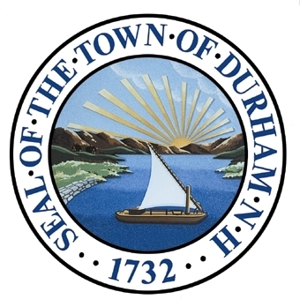
Demographics and Housing
This chapter provides context and discussion on the housing and demographic changes happening in the Town of Durham. It examines both historic trends and future projections of population and housing stock change.

Adopted by the Durham Planning Board on November 18th, 2015.

Our Vision
In 2025 and beyond, Durham is home to an increasingly diverse population, drawn here by the town’s rich cultural and natural resources, the University of New Hampshire, and its outstanding access to the Seacoast region of New Hampshire. Durham provides affordable housing opportunities in safe, healthy, and dynamic neighborhoods for working families, the elderly, professionals of all ages, retirees, and students. The Oyster River Cooperative School District continues to maintain exemplary education standards while sustaining stable enrollment rates, because of a strong base of young families within the community and region. Existing and new housing stock is environmentally conscious and “Durham–compatible,” it provides high-quality, attractive living space for owners and renters while respecting Durham’s rich natural and historic resources. Vibrant public and private spaces that attract new residents will have been created through innovative partnerships between the Town of Durham and the University of New Hampshire.

Qualifications
This chapter is intended provides a “30,000-foot” level analysis of trends related to Durham’s housing demand and supply, population demographics, and basic economic characteristics. It includes comparative analyses of the Town, Strafford Regional Planning Commission planning region, and the State of New Hampshire in regard to these trends. The chapter provides a snapshot view and is not a comprehensive study.
The information in this chapter is based largely on 2010 decennial Census 100% Count datasets, with support from American Community Survey 2012 5-Year Estimates. Locally produced datasets used in developing this chapter include, but are not limited to, the 2014 Student Housing Tally, 2014 Assessing Data, and 2011 Town Wide Market Analysis (Development Concepts, Inc.).
This chapter is intended to provide decision makers with the best possible available information for making choices for Durham. However, the datasets included herein may not be precise enough to arrive at definitive and/or conclusive results. Although data analysis best practices were utilized, the analyst’s interpretation of the data must be considered when reviewing this chapter.
Geographic Definitions
Portsmouth-Rochester, NH HFMR Area
HUD Fair Market Rent Area or HFMR is a data analysis geography for use in regional housing analyses. The Portsmouth-Rochester HFMR is comprised of: Brentwood, East Kingston, Epping, Exeter, Greenland, Hampton, Hampton Falls, Kensington, New Castle, Newfields, Newington, Newmarket, North Hampton, Portsmouth, Rye, Stratham, Barrington, Dover, Durham, Farmington, Lee, Madbury, Middleton, Milton, New Durham, Rochester, Rollinsford, Somersworth, and Strafford.
Strafford County
Strafford County is located in the southeastern portion of the State of New Hampshire, to the west of Maine and north of Massachusetts.
Strafford Region
The Strafford Region is comprised of 18 communities ranging from Wakefield in the north, Northwood to the west, Newmarket to the south, and Rollinsford to the east.
State of New Hampshire
New Hampshire is located within the New England region. Bounded by Maine, Massachusetts, Vermont, and Canada, it is the fifth smallest state by land area and ninth smallest by population.

Foundation
Listed is a summary of input from Durham residents concerning demographics and housing in the Town. This input was provided as part of the 2011 Visioning Forum and the 2011 Master Plan Survey and is the foundation of this chapter. Public input sessions were conducted prior to a number of major downtown development projects. This should be considered when drawing any definitive conclusions.

2011 Visioning Forum
What Does Durham Look Like?
- Too homogenous
- Housing stock for students is high quality
- Durham does care about how students feel welcome here
- Has marked lack of affordable housing for those with “typical” jobs
- Lack of starter homes, losing population in homes
- Taxes are onerous for young families
- Smaller homes often go to landlords rather than families
- Quality of housing is deteriorating
- Need to emphasize elderly housing
- Loss of historic homes to rental uses
- Great to have student housing, but must be more compatible
What Will Durham Look Like?
- Have a presence of a community-based agency to advocate for housing
- Balances new housing with the environment
- Will have housing policies committed to keeping young people here
- Durham and UNH will undertake a joint housing initiative
- Will be a variety of housing options for all types/sizes of households
- Increased presence of workforce housing
Respondent support for housing types:
Single-Family | 84%
Two-Family | 66%
Multi-Family | 38%
Apartment Buildings | 41%
Townhouses | 67%
Condominiums | 67%
Senior Housing | 69%
Conversion of owner-occupied to apartments | 22%
Manufactured Homes | 24%
Manufactured Homes/Mobile home parks | 7%
Conservation Subdivisions | 78%
2011 Master Plan Survey
Support for:
- Promotion of affordable and attractive housing options
- Continuing the redevelopment of existing structures
- Providing local employment opportunities
- Allow more flexibility for in-law apartments
- Expanding family rental housing opportunities
- Providing more affordable housing for:
  - Working individuals and families
  - Young families
  - Seniors
- Having diverse mix of housing options in downtown area
- Creating housing with shared community facilities
- Pursuing multi-unit housing outside of downtown area
- Policies that allow seniors on limited or fixed income to stay in Durham

Population Characteristics
Population demographics shape the nature and rate at which changes occur within a community. By conducting an analysis of historic trends, existing conditions, and future projections, Durham seeks to arrive at well-articulated planning goals for its land, housing, infrastructure, and services.
.
Historic Population Trends
For the purposes of this analysis, Census population figures including both full-time residents and part-time residents, (students) are used.
In the years between 1960 and 2010 Durham’s total population (full-time residents and student population) grew at a relatively consistent, yet high, rate. In this fifty year period Durham grew by 165%, an average of 1,800 residents per decade. Rapid growth occurred not only in Durham, but also in adjacent communities (123%) and the State of New Hampshire (117%). The Durham growth rate placed additional strain on the community to provide services for a rapidly increasing population.
As of the 2010 Census Durham’s total population was just shy of 15,000. The 2011 Town Wide Market Analysis prepared by Development Concepts, Inc. estimated that approximately 58-60% of the total population is University of New Hampshire students. Therefore, SRPC estimates that Durham’s full-time resident population is between 5,500 and 6,200 individuals.
Projected Population Trends
Methodology: Municipal Population Projections
The projections are done in five-year intervals, and are consistent with the county population projections in the report titled: State of New Hampshire, Regional Planning Commissions, Office of Energy and Planning - County Population Projections, 2013 By Age and Sex.
The method used to develop these municipal level projections starts with the above forecast for total population for each county in New Hampshire. Because these numbers are controlled to the county and state projections, these numbers are considered reasonable in the aggregate as well as at the local level.
Next, the town/city share of county population in the 2010 Census (with the Census revisions) was developed and compared to the 2000 Census share of county population for each town/city in that county.
This analysis revealed that the share of each municipality’s population (relative to the county) has been changing over time. To confirm the observed trend, municipal shares of the county population were examined for the Census years 1970, 1980, and 1990. That analysis confirmed the observed trend in changing shares over time.
The methodology used to allocate the county population projections to the municipalities assumes that the 2000 to 2010 shift in share (municipality as a share of the county) will continue into the year 2020. The method attempts to account for a community’s share of the county’s recent population change, rather than assuming an unchanging share of the county’s total population.
Next, that share of the municipality’s population relative to the county’s population is frozen at the 2020 share level (held constant) through the remaining 20 year projection period (2020 to 2040).
Source: NH Office of Energy and Planning

Population projections are essential in order to get a complete picture of future demand on housing, infrastructure, and services within a community. The Office of Energy and Planning, in partnership with New Hampshire’s nine Regional Planning Commissions, completed population projections through year 2040 in the spring of 2014, looking on both the county and municipal level. The methodology used to develop these projections is shown at right.
These projections estimate that Durham will grow by an average of 832 residents per decade through 2040. Between 2010 and 2040, this would result in an overall population growth of 17%, which is nearly twice the projected rate for the State of New Hampshire during the same period. The Strafford region is the fastest growing region in the state, and is expected to grow on pace with Durham, a 13% increase in the 30-year projection period.
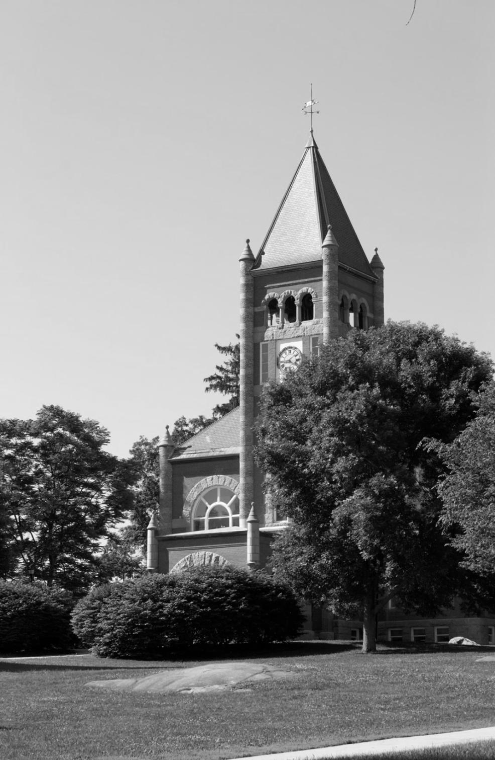
University of New Hampshire Enrollment
Quick Fact: 2013 UNH Enrollment: 14,954

Photo 1: Thompson Hall, University of New Hampshire (Source: Olivier Aumage)
The University of New Hampshire, which accounts for between 55-60% of Durham’s nearly 15,000 residents, has grown in parallel with Durham’s full-time resident population, as shown below. Between 1960 and 2010, UNH experienced a 259% increase in enrollment while Durham grew by 166%. Both total population and enrollment grew by about 10,000 over the period. A sharp increase in enrollment occurred between 1960 and 1970, leveled between 1970 and 2000, and again experienced high growth between 2000 and 2010.
The University typically projects a 0.5% growth in enrollment annually. Emerging alternatives to traditional classroom-based learning may be a catalyst for stabilization, or even a decrease, in enrollment in future years.
Table 1: 2010 Population by Age Cohort
Under 5 | 214 | 1%
5-9 | 353 | 2%
10-14 | 402 | 3%
15-19 | 4222 | 29%
20-24 | 5490 | 38%
25-34 | 451 | 3%
35-44 | 664 | 5%
45-54 | 959 | 7%
55-59 | 466 | 3%
60-64 | 399 | 3%
65-74 | 500 | 3%
75 and Over | 512 | 3%
Total | 14638 | 100%
Source: Census Bureau
Age Characteristics
Durham’s age characteristics are unique because of the Town’s ‘college-town’ profile. According to 2010 Census data, nearly 67% of the total population is between the ages of 15 and 24. However, these figures include student population and therefore are not appropriate for age cohort analysis. As a result, these cohorts were removed from the “Population by Age Cohort” chart below. It should be noted that there is a fairly large cohort of full-time Durham residents within the 15-19 age cohort: high-school students.
The chart below reveals two trends. The first is that between 1990 and 2010, Durham experienced a noticeable drop in population between ages 25-44. The second, an increase in 55+ age population, is a population trend that is occurring across many of New Hampshire’s communities. Referred to as the ‘silver tsunami’ by demographers, this ‘tsunami’ is the result of the shifting of baby-boom generation individuals into older age cohorts. With the noticeable decrease in individuals ages 25-44 (those typically having school-age children), a drop in 0-14 age population occurred, particularly in the decade between 2000 and 2010.
Population, School-Enrollment, and Housing

As noted in the previous section, New Hampshire’s population is rapidly aging while communities are experiencing an observable decline in families and children. As part of its 2012 Housing and School Enrollment in New Hampshire: 2000-2010-A Decade of Change study, New Hampshire Housing and Finance Authority suggests that demographics can have a greater influence on school enrollment figures than housing growth/construction. In the decade between 2000 and 2010, New Hampshire communities gained nearly 45,000 housing units, but lost nearly 21,600 school enrollees. Of the state’s 161 school districts, 130 experienced a decline in enrollment, including Oyster River Cooperative School District (ORCSD).
In 2000, Durham, like many other communities in the State, attempted to address the cost of educating new students resulting from new housing unit construction. This construction was discouraged in the 2000 Master Plan, while providing age-restricted senior housing became a goal for the community. In 2014 the demographic playing field has changed. Family households in Durham are declining and a rapidly growing number of housing units are occupied by only one person or multiple unrelated individuals living together to minimize costs.
Today, construction of new single-family homes and multi-family units in New Hampshire communities typically produce only 0.64 and 0.17 students per unit respectively. Declining or stagnating school enrollment, once considered a goal of some New Hampshire communities, is now costing more as communities work to pay for fixed education costs like maintenance and staffing. Furthermore, state education funding, based on a student-enrollment funding formula, is also decreasing.
With slow growth projected for much of New Hampshire, school enrollment numbers are not expected to return to 1990-2000 levels. Many school districts now have a surplus of capacity that must be addressed. Communities are taking action to improve the overall fiscal health of their education system.

“Towns may not refuse to confront the future by building a moat around themselves and pulling up the drawbridge. They must develop plans to insure that municipal services, which normal growth will require, will be provided for in an orderly and rational manner. Any limitations on the expansion must not unreasonably restrict normal growth.”
Source: Wayne Britton v. Town of Chester
Quick Fact: 130 of 161 NH’s school districts experienced a decline in enrollment between 2000 and 2010
Source: Housing and School Enrollment in New Hampshire: 2000-2010-A Decade of Change

School Age Population
Quick Fact: Total ORCSD Enrollment Decline 2000-2012: -14%
Source: ORCSD

As of 2014 Oyster River Cooperative School District had 2,058 classroom/non-tuition enrollees. According to 2013 projections, enrollment will continue to decline through 2015 to a level below 2,000 students and this trend is expected to continue at an accelerated rate within Durham as the community ages. Between 1990 and 2010, Durham’s school age population, defined as 19 years and below, increased by more than 700. However, school age children actually represent a much smaller percentage of total population when increases in UNH enrollment at ages 17, 18, and 19 are taken into account. The number of children ages 0-9 actually decreased by 16%, likely the result of fewer families, decreased family formation rates, and lower birth rates.
Table 2: School Age Children
 | 1990 | 2000 | 2010 | Total Change 1990-2010 | Percent Change 1990-2010
Under 5 | 312 | 306 | 214 | -98 | -31%
5-9 | 364 | 432 | 353 | -11 | -3%
10-14 | 348 | 490 | 402 | 54 | 16%
15-19 | 3464 | 3161 | 4222 | 758 | 22%
Strafford Regional Planning Commission has developed Durham-only ORCSD school enrollment projections looking out to a horizon year of 2040. These projections account for a decrease in 25-55 population (those cohorts typically having families) and an observed decline in overall enrollment between 2000 and 2010. Those enrollment projections are presented on page 12.
Definition: Oyster River Cooperative School District
“The Oyster River Cooperative School District serves the contiguous Town communities of Durham, Lee, and Madbury…”
Source: orcsd.org

Durham ORCSD Enrollment Projections
Methodology: Durham ORCSD Projections
Enrollment Projection Methodology:
Strafford Regional Planning Commission, in an effort to understand the potential long-term implications of decreasing Oyster River Cooperative School District enrollment from Durham, completed enrollment projections to year 2040 on a 5-year basis. These projections were built using the work of the New Hampshire Office of Energy and Planning, RLS Demographics, and New Hampshire nine Regional Planning Commissions.
The first step in the projection process was to understand the change in family-age population (25-54 year old individuals) from 2000 to 2010. SRPC discovered that Durham had lost 21.6% of its total family-age population in this period. In order to create 5-year a projection, this percentage was then halved, resulting in a -10.8% 5-year growth rate in families. For the purposes of the projections, SRPC assumed that a 10.8% loss in family age population will occur on a 5-year period out to 2040.
As a next step, SRPC determined the2010 ratio of family age population to total Durham population. Approximately 14% of Durham’s total population qualifies within these cohorts. For the purposes of the projections, SRPC assumed a 14% family population make up, out to year 2040.
With the previous elements complete, SRPC calculated future Durham ORCSD enrollment by multiplying the OEP total population projection by the both 14% family-total population ratio and -10.8% growth rate to determine family age population. This family age population was then multiplied by the previous 5-year period’s ration of family-age population to enrollment. For example:
2015 OEP Population Projection: 15,295
15,295 *.14 = 2,167 (family-age population with no loss)
2,167 * .89221 = 1,933 (family-age population with 10.8% loss)
1,933*(929/2074) = 866 (family age population multiplied by ratio of students to family-age population from 2010)
Durham ORCSD 2015 Enrollment = 866 Students
Source: SRPC

The projections below for Durham enrollment in the Oyster River Cooperative School District were developed by SRPC, and are intended to account for the decline in young families as well as the changes in population predicted by the OEP 2010-2040 projections. For a detailed methodology describing the assumptions and equations used here, please see the box at right.
Unlike the Town of Durham OEP population projections that show moderate growth for the community out to 2040, SRPC’s Durham enrollment projections suggest a loss in school enrollment that continues until 2015. After 2015, enrollment numbers are projected to increase at a slow pace until the final study year of 2040. Between 2010 and 2040 Durham’s 17% total population projected growth rate will be contrasted by a growth rate of only 4% overall in enrollment.
Durham’s 2000 Master Plan anticipated a school enrollment growth rate of 38.7% (410 students) by 2010. However, Durham actually experienced a 12% loss in enrollment. Furthermore, the 2000 Master Plan, expected an increase of 80% by year 2020 to 1,910 students. SRPC projections estimate that by 2020 Durham will enroll a total only 907 students.

Table 3: School Enrollment Projection
 | 2010 | 2015 | 2020 | 2025 | 2030 | 2035 | 2040 | Percent Change | Absolute Change
Total Population | 14,638 | 15,295 | 16,014 | 16,386 | 16,720 | 16,983 | 17,133 | 17% | +2,495
Total Family Age Population | 2074 | 1933 | 2024 | 2071 | 2114 | 2147 | 2166 | 4% | +92
Enrollment | 929 | 866 | 907 | 928 | 947 | 962 | 970 | 4% | +41
Source: SRPC

Housing Characteristics
Elements of the housing component are based upon the population characteristics and projections numbers detailed above. An in-depth understanding of the relationship between housing and demographic trends is integral to creating a complete picture of Durham’s past, present, and future. This section provides information related to housing availability, affordability, quality, suitability, and of course, viability. Together these housing elements form a strong foundation upon which goals and recommendations for the future of Durham’s housing stock can be built.

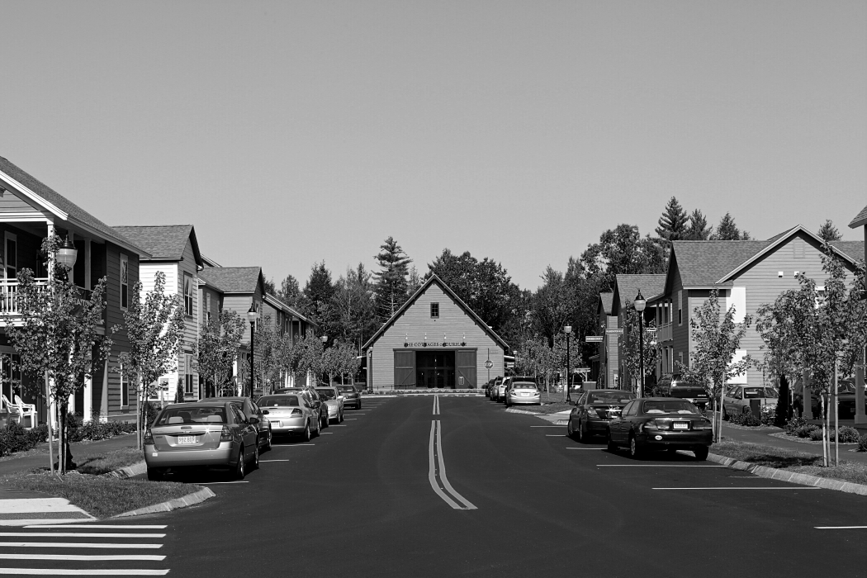
Household Type
Photo 2: Cottages of Durham (Source: Chris Luker)

Durham’s existing housing stock is diverse in composition. According to the Census Bureau, as of 2010, there were 1,713 owner-occupied units and 1,247 renter occupied units as identified by the. This 60:40 (owner-renter) ratio is high both regionally and statewide. The amount of student rental housing in Durham means that this ratio is not truly representative of full-time residents who own or rent housing. In total, 96% of Durham’s housing stock is occupied. Between 1990 and 2010, nearly 600 housing units were added, of which two-thirds were owner-occupied units.

Household Size
Table 4: Housing Unit Type
 | 1990 | 2000 | 2010 | Total Change 1990-2010 | Percent Change 1990-2010 | Composition 2010
Total Housing Units | 2508 | 2923 | 3092 | 584 | 23% | 100.00%
Occupied Units | 2392 | 2882 | 2960 | 568 | 24% | 95.73%
Vacant Units | 116 | 41 | 132 | 16 | 14% | 4.27%
Owner-Occupied Units | 1357 | 1628 | 1713 | 356 | 26% | 55.40%
Renter-Occupied Units | 1035 | 1254 | 1247 | 212 | 20% | 40.33%
Source: Census Bureau
Household size changes from 1990 to 2010 indicate, in concert with population statistics, that Durham has experienced a change in demographics moving towards older, smaller households. While experiencing 70% and 31% growth in 1 and 2 person households respectively between 1990 and 2010, only a 21% and 14% growth in 3-person and 4-person households occurred (those typically indicative of family households).
Table 5: Household Size
 | 1-Person |  | 2-Person |  | 3-Person | 4-Person |  | 5-Person |  | 6-Person |  | 7-Person |  | Total
Owner-Occupied Units
2010 | 268 | 675 |  | 319 |  | 299 | 118 |  | 31 |  | 3 |  | 1713
2000 | 234 | 608 |  | 290 |  | 332 | 124 |  | 35 |  | 5 |  | 1628
1990 | 158 | 517 |  | 264 |  | 262 | 122 |  | 26 |  | 8 |  | 1357
 | 2010 Owner-Occupied Unit Composition
 | 16% | 39% |  | 19% |  | 17% | 7% |  | 2% |  | 0%
Renter Occupied Units
2010 | 477 | 336 |  | 220 |  | 149 | 33 |  | 20 |  | 12 |  | 1247
2000 | 347 | 264 |  | 207 |  | 265 | 72 |  | 92 |  | 7 |  | 1254
1990 | 338 | 289 |  | 145 |  | 170 | 52 |  | 31 |  | 10 |  | 1035
 | 2010 Renter-Occupied Unit Composition
 | 38% | 27% |  | 18% |  | 12% | 3% |  | 2% |  | 1%
Source: Census Bureau
Household Size (continued)
Renter household numbers have remained relatively stable from 1990-2010. Composition figures from 2010 show a heavy concentration in the 1-person and 2-person sizes, likely young couples or graduate students. Interestingly, units greater than 4-Persons in size decreased in count from 1990 to 2010. This trend may be attributed to a decrease in interest from students in large-household living or smaller family formations.

Table 6: Family Households
 | Family Households | Total Households | Percentage Family
1990 | 1447 | 2365 | 61%
2000 | 1581 | 2882 | 55%
2010 | 1544 | 2960 | 52%
Source: Census Bureau
Family Households
There was an observable change in family households in Durham between the 1990 and 2010 decennial Censuses. Of the 2,365 total households reported in the 1990 Census, 61% identified themselves as family households. Twenty years later, 2010 Census figures indicate that only 52% of total households identify as ‘family’. This 10% decrease in reflects the larger trend of population loss in the 25-44 age cohorts.
Quick Fact: Durham has experienced nearly a 10% loss in family households from 1990-2010

Table 7: Housing Unit Vacancy by Type
 |  |  | Vacancy Type
 | Total Housing Units | Vacant Housing Units | For Rent | For Sale | For seasonal, recreational, or occasional use | For migratory workers | Other vacant | Rented, Sold, not occupied
2010 | 3092 | 132 | 31% | 16% | 18% | 0% | 27% | 8%
2000 | 2923 | 41 | 10% | 17% | 42% | 0% | 15% | 24%
1990 | 2508 | 116 | 35% | 21% | 9% | 0% | 16% | 13%
Source: Census Bureau
Housing Unit Vacancy
Durham has exhibited variable housing unit vacancy numbers, dropping from 116 vacant units in 1990, to only 41 units in 2000, a 65% decline.
From 2000 and 2010, a period that included the economic crisis of the late 2000’s, vacant housing units grew by over 200% to nearly 132 vacant units. Despite this variability, vacancy ‘type’ has remained somewhat static over the 20-year study period. Some anomalies include: a large decrease in “for rent” units in 2000, very high number of “seasonal, recreational, or occasional use” vacancies in 2000, and high number of “rented, sold, not occupied” vacancies in 2000.
Building Permits and Development Patterns
Over the past 15 years, Durham has experienced highly variable single-family and multi-family construction. Town of Durham building permit data indicate that more than 20 housing units were constructed in 1998, 1999, and 2001. Single-family home construction reached a near standstill in the years of the economic crisis between 2006 and 2010.
After the adoption of the 2000 Master Plan, the Town adopted zoning changes to manage single and multi-family housing development within the community. This resulted in a sharp decline in multi-family housing development. Following the housing market crash of the 2000’s, there was an increasing interest in the development of student housing in Durham and zoning changes to the Office, Research and Light Industry (ORLI) and Multiunit Dwelling/Office Research (MUDOR) districts created favorable conditions for developers, which then resulted in large-scale, multi-unit residential developments in those areas.
Commercial building permits, for both new construction and renovation projects, remained relatively static during the 15-year study period, with small peaks in 2003 and 2011.
Home Values
Quick Fact: Durham’s Median Home Value is approximately $315,300
Source: Durham Assessing Database

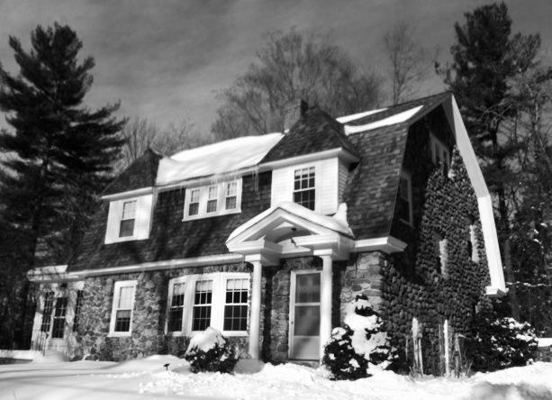
According to the Town’s assessing database, Durham has approximately 1,570 single-family housing units, as of 2013. It is important to note that this count differs from the 2010 Census count of 1,713 owner-occupied units. The average lot size for single family homes is approximately 2.7 acres. Housing stock age varies, though the average year of construction for single-family units is 1963 and the median construction year is 1972. Assessing data indicate that the median total parcel and structure value is approximately $315,300.
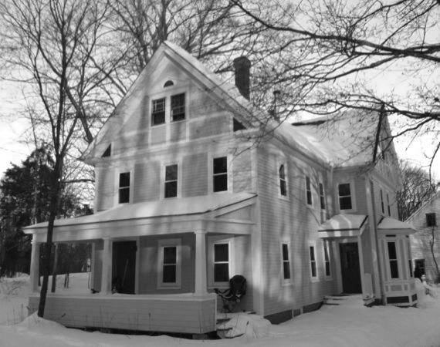
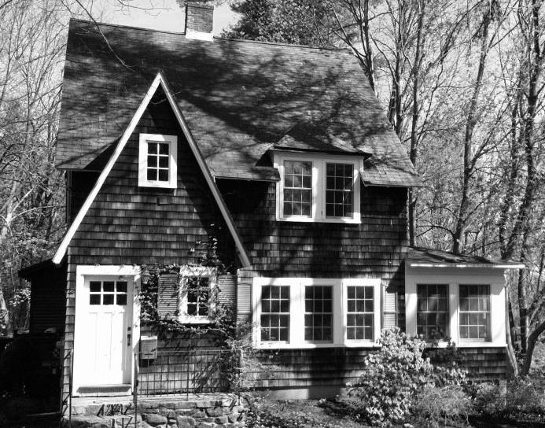
The majority of Durham single-family housing unit values, which includes both parcel and structure, fall between $200,000 and $500,000 in total value. All values range between a low of $117,200 and a high of $1,567,100. Few housing units fall between the values $117,200-$200,000 and $500,000-$1,567,100.
Photos 3,4,and 5: Homes of Durham (Source: Town of Durham Planning Department)

Purchase Prices
Local assessing values cannot be used to compare Durham’s housing stock to the State of New Hampshire and Strafford planning region. However, New Hampshire Housing Finance Authority datasets do allow for this analysis, and are shown in the chart at right. Durham has maintained higher median home purchase prices than all three comparison geographies in the period between 1990 and 2010. The Strafford region, which includes Strafford County, southern Carroll County, and northern Rockingham County communities, has consistently had the lowest purchase prices of these geographies. In 2004, a gap of greater than $100,000 existed between Durham and regional values. The HUD area, including wealthier Rockingham County towns and cities, is closest in values to Durham. Interestingly, the 2013 Durham median purchase price of $320,000 is extremely close to the Town’s assessing database median home value of $315,300.
Purchase Price Frequency
New Hampshire Housing Finance Authority records a majority of the home purchases/sales within each community, including both single-family and condominium units. These data provide an opportunity for a snapshot-in-time analysis of the existing housing market. In 2013, 72 total purchases ranged from a minimum of $90,000 to a maximum of $510,000. In concert with Durham assessing data, the majority of sales occurred between the $180,000 and $460,000 range, with few outliers. The most frequent purchase price for the year 2013 was $370,000.
According to New Hampshire Housing Finance Authority 2013 data, condominium purchase prices ranged from $190,000 to $410,000, with a concentration at the $240,000 price point.
Rental Cost
New Hampshire Housing Finance Authority, in its annual rental cost survey, collects sample data from landlords related to monthly rental prices. Unfortunately, NHHFA’s sampling process excludes seasonal and student housing rentals. NHHFA’s data illustrate a very affordable Durham rental market in comparison to the Strafford region, Portsmouth-Rochester HFMR, and State of New Hampshire. However, SRPC recognizes that because of the largely student-occupied rental market, this estimate does not accurately reflect many more expensive private student housing developments.
As a substitute for the NHHFA sample-derived dataset, SRPC conducted a web-based sampling of rents for new commercial student housing developments in the downtown and peripheral areas of the community. The results indicate that for 2-8 bedroom apartments, values range from $1,598 to $6,040 per month, which is more than $5,000 above the affordability range for rental units in the area. Similarly, per bed values in these units range from $689 -$1,069 per month.

New Hampshire’s Workforce Housing Law
The cost to purchase a home or rent an apartment in Durham has risen substantially over the past decade and continues to remain considerably higher than comparable costs within the region, state, and HUD Fair Market Rent area. A shortage of affordable housing has continued to be an issue of concern in Durham, as well as the region and the southeastern area of New Hampshire for more than twenty years. Housing affordability is a concern from both social and economic perspectives. If households are required to pay a large portion of their incomes for housing, it could result in a shortage of funds for other critical needs, such as food, health care, heating, etc. Furthermore, if inadequate affordable housing is available, it can adversely affect the area’s businesses and public agencies by reducing the supply of workers needed to fill a variety of needed job skills.
In effort to address these issues, the New Hampshire Legislature enacted new legislation in 2008 requiring all communities to support the creation of workforce housing through their land use regulations. New Hampshire Revised Statutes Annotated (RSA) 674:59, Workforce Housing Opportunities, states the following:
“…ordinances and regulations shall provide reasonable and realistic opportunities for the development of workforce housing, including multifamily housing. In order to provide such opportunities, lot size and overall density requirements for workforce housing shall be reasonable. A municipality that adopts land use ordinances and regulations shall allow workforce housing to be located in a majority, but not necessarily all, of the land area that is zoned to permit residential uses within the municipality.”
Defining Affordability
In the State of New Hampshire, affordability is defined as housing expenses when rent and utilities, or mortgage payments (including utilities and insurance), are below 30% of the median household income. Further, in NH RSA’s, workforce housing is defined as housing for sale or rent, where homes for purchase are “affordable to a household with an income of no more than 100 percent of the median income for a 4-person household for the metropolitan area or county in which the housing is located” and rentals are “affordable to a household with an income of no more than 60 percent of the median income for a 3-person household for the metropolitan area or county in which the housing is located”. The median incomes for 3 and 4-person respectively are defined by Fair Market Rent (HFMR) areas, or metropolitan and non-metropolitan counties set by Housing and Urban Development (HUD).

Home Affordability Study

Table 8: Portsmouth-Rochester HFMR Median Income Values
Percent of 4-Person Owner Occupied Median Household Income | Income Value
100% | $84,300
80% | $63,900
60% | $52,860

Source: US HUD
To qualify as workforce housing, owner-occupied units must be “affordable to a household with an income of no more than one hundred (100%) percent of the median income for a four person household” (RSA 674:58.IV). Affordable is further defined as housing units that do not exceed 30 percent of a household’s gross annual income in combined mortgage loan debt services, property taxes and required insurance (RSA 674:58.I).
The US Department of Housing and Urban Development (HUD) specified the income threshold for a four person household in the Portsmouth-Rochester HFMR, which includes Durham and the following communities: Brentwood, East Kingston, Epping, Exeter, Greenland, Hampton, Hampton Falls, Kensington, New Castle, Newfields, Newington, Newmarket, North Hampton, Portsmouth, Rye, Stratham, Barrington, Dover, Farmington, Lee, Madbury, Middleton, Milton, New Durham, Rochester, Rollinsford, Somersworth, and Strafford.

Table 9: Durham Affordable Purchase Price
Percent of 4-Person Owner Occupied Median Household Income | Affordable Purchase Price
100% | $230,311
80% | $189,786
60% | $146,893

Source: NHHFA Affordability Calculator
Thus, to be considered Workforce Housing, the purchase price of a house must be affordable to a household earning no more than $84,300. To better understand the cost of owner-occupied housing in Durham, this report also assesses units affordable to households making 80% and 60% of the above stated HUD median.
To fully understand the affordability of Durham’s housing stock, housing units that are affordable to households making between $52,860 and $84,300 annually are examined. To determine what value would be affordable for households making between $52,860 and $84,300 the NHHFA’s Affordability Calculator was used. The calculator for a home purchase was set to include: a 3.041% tax rate (Durham’s 2013 rate), $10,000 cash on hand, a 5% interest rate on a 30 year loan, and; a 0.5% home insurance rate
The NHHFA Affordability Calculator’s purchase price of $230,311 or less was compared with the Total Value of each owner-occupied unit in the Assessor’s database. Tables 10 and 11 detail the number and percentage of affordable units for both single-family homes, and condominiums, which are the two primary owner-occupied housing unit types in Durham.
Quick Fact: Portsmouth-Rochester HFMR 4-Person Median Income = $84,300
Source: US Department of Housing and Urban Development

What You Said: “Increased presence of workforce housing”
Source: 2011 Visioning Forum

Table 10: Durham Affordable Single-Family Homes
Percent of 4-Person Owner Occupied Median Household Income | Affordable Purchase Price Range | Number of Affordable Single Family Homes | Percentage Affordable Single Family Homes (Units in affordable purchase price range/total Durham housing units)
100% ($84,300) | $0-$230,311 | 143 | 3.5%
80% ($63,900) | $0-$189,786 | 32 | 2.1%
60% ($52,860) | $0-$146,893 | 9 | 0.6%
Total Affordable Single Family Homes | $0-$230,311 | 143 | 9.5%

Source: Durham Assessing Database

Table 11: Durham Affordable Condominiums
Percent of 4-Person Owner Occupied Median Household Income | Affordable Purchase Price Range | Number of Affordable Condominiums | Percentage Affordable Condominiums (Units in affordable purchase price range/total Durham condominium units)
100% ($84,300) | $0-$230,311 | 53 | 82%
80% ($63,900) | $0-$189,786 | 32 | 49%
60% ($52,860) | $0-$146,893 | 23 | 35%
Total Affordable Condominium Units | $0-$230,311 | 53 | 77.9%

Source: Durham Assessing Database
Of the 1,505 single-family homes in Durham, 7.4% or 111 properties would be affordable to a household earning the median household income for a 4-Person owner-occupied unit ($230,311). Within Durham, as well as many other similar communities, the majority of affordable housing units fall between 81% and 100% of median income.

Table 12: Durham Affordable Housing Units
Percent of 4-Person Owner Occupied Median Household Income | Affordable Purchase Price Range | Number of Affordable Housing Units | Percentage Affordable Housing Units (Units in affordable purchase price range/total Durham housing units)
100% ($84,300) | $0-$230,311 | 196 | 12.5%
80% ($63,900) | $0-$189,786 | 64 | 4.1%
60% ($52,860) | $0-$146,893 | 32 | 2.0%
Total Affordable Housing Units | $0-$230,311 | 196 | 12.5%
Source: Durham Assessing Database
Of the 65 existing condominiums in Durham, 78% or 53 units qualify as affordable to households earning 100% of the median household income. However, unlike the single-family home analysis, nearly 34% of all condominium units are affordable to those earning 60% or less of the area median 4-person owner-occupied household income.
Of all 1,570 owner-occupied housing units (single-family and condominium) within the Durham Assessing Database, 12.5% are considered affordable to a four-person household making $84,300 or less annually. However, only 3.5% of all such units are affordable to those earning 60% or less than the median household income.
Quick Fact: 12.5% of Durham’s Owner-Occupied Housing Units qualify as Affordable Housing

Rent Affordability Study

Table 13: Durham Gross Monthly Rental Costs
 | All Units | 1-Bedroom Units | 2-Bedroom Units | 3-Bedroom Units
Durham | $953 | $753 | $1,005 | $1,213
Region | $967 | $745 | $1,012 | $1,395

Source: NHHFA
This section discusses the costs of renting a dwelling unit, with utilities, in the Durham and SRPC region. The Town of Durham has no comprehensive rental price database. However, New Hampshire Housing Finance Authority conducts an annual Residential Rental Cost Survey throughout New Hampshire which provides specific rental data for Durham. The NHHFA Cost Survey does not include seasonal, part-time, or student housing units. The table at right shows median rental costs for the year 2013 for 1, 2, and 3-bedroom units in addition to all size rental units. Although Durham has consistently exhibited higher home values than most regional communities, its monthly rental costs for full-year occupancy remain below regional aggregates for all unit sizes but 1-bedroom units.

Table 14: Durham Gross Annual Rental Costs
 | All Units | 1-Bedroom Units | 2-Bedroom Units | 3-Bedroom Units
Durham | $11,436 | $9,036 | $12,060 | $14,556
Region | $11,604 | $8,940 | $12,144 | $16,740

Source: NHHFA
To qualify as workforce housing under the state statute, rental units must be “affordable to a household with an income of no more than sixty (60%) percent of the median income for a three-person household” (RSA 674:58.IV). New Hampshire RSA’s define affordable rentals as units that do not exceed 30 percent of a household’s gross annual income in combined rental and utility costs (RSA 674:58.I). The HUD specified income threshold for a three person household in the Portsmouth-Rochester HFMR for 2013 was $47,580. Therefore, to consider a rental unit affordable in Durham the median annual costs would have to be less than $14,274.
According to the Residential Rental Cost Survey data, Durham’s median rental prices for 1-bedroom and 2-bedroom are below the $14,274 threshold. However, the 3-bedroom unit median rental cost is not considered affordable by definition, exceeding the threshold by nearly $300.
Student Housing Trends

Housing preferences among University students have evolved significantly in the last ten years. Current students, commonly grouped into what are known as Millennials, are expressing much different expectations for housing from those of their Baby-Boom and Generation X parents. Unlike Baby-Boomers who shared bedrooms, bathrooms, and other amenities, Millennials seek private accommodations that offer shared social spaces, and are willing to pay for it. In fact, one national survey of students indicates that only 3.2% of respondents would prefer ‘traditional’ dormitory-style housing; the most popular housing-type being mixed-use apartments with retail on the first floor and within close proximity to campus.
University Business Magazine identified six key trends in student housing: privatization, privacy, live & learn, safety and security, going green, and perhaps most importantly, luxury. The definition of “amenity” too has changed. In contrast with traditional amenities, new apartment and suite style housing developments are offering private bedrooms, private bathrooms, large kitchens, high-speed internet access, and luxurious common areas with ample recreation opportunities. Housing has become an important marketing tool for higher education institutions when recruiting students. In order to compete with other colleges and universities, schools like UNH must strategically diversify their on-campus housing stock, a task that has proved challenging for many state funded higher education institutions. State institutions, like the University of New Hampshire, are under pressure to maximize the use of limited financial resources as a result of decreased government funding of higher education. The result is a lucrative market opportunity for private housing developers in communities like Durham.
The University of New Hampshire, as of October 2013, has approximately 12,531 undergraduate and 2,411 graduate students enrolled. In order to house these students, the University provides 7,180 beds of undergraduate housing and 333 beds of family/graduate housing. Therefore, 57% of undergraduate and 14% of graduate students can, and do, reside on-campus. This means that 5,351 undergraduate and 2,078 graduate UNH students need some form of off-campus housing. Historically, these students have occupied rental housing units in downtown and adjacent traditional neighborhood single-family homes in Durham, or affordable rental units in Dover and Newmarket serviced by COAST and Wildcat transit agencies.

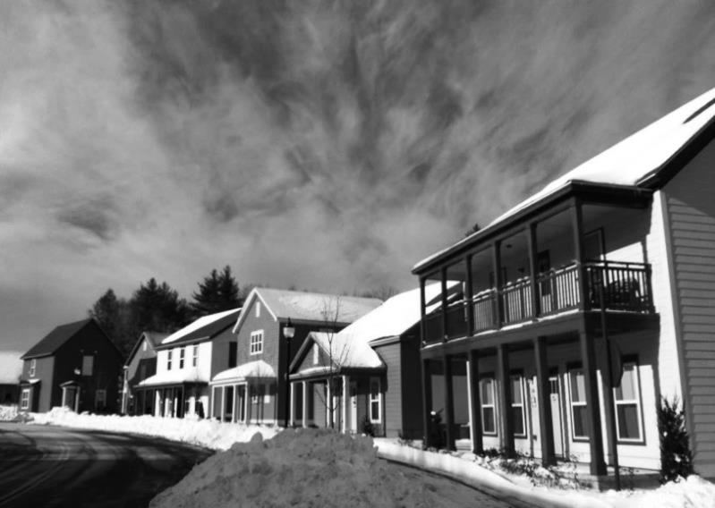
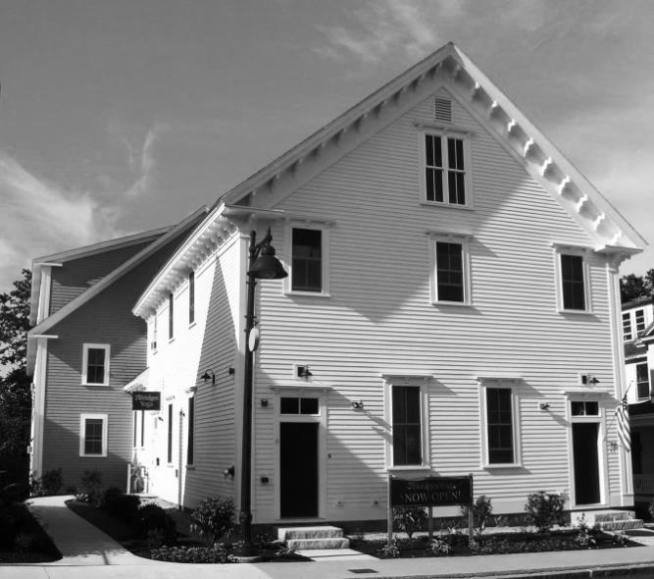
Photos 6 and 7: New Student Housing Development (Source: Town of Durham Planning Department)

Quick Fact: 57% of undergraduate and 14% of all graduate students UNH students can, and do, reside on-campus.
Multi-Family Housing Unit Growth
Large-scale private student housing development in Durham began in 2008, following the initial real-estate market crash and concomitant decrease in housing construction. Multi-family housing unit development building permit data and Durham’s Student Housing Tally indicate that in 2008, approximately 56 multi-family housing units, most of which were designed as student housing. Building permit data also indicate that between 2008 and 2013, 427 multi-family housing units were constructed, the majority of which target students.

Recent Student Housing Development Patterns

A significant portion of recent large-scale student housing development has taken place in the ORLI and MUDOR districts on the western side of the community. Of the large student housing developments (those greater than 100 beds) constructed after 2008, more than half of the beds were built within the ORLI and MUDOR zones. Two of the town’s 400+ unit developments, The Cottages and The Lodges at West Edge, are within these districts.
A primary driver of this development pattern occurring in the periphery of Durham is the “3-Unrelated Rule” and its effect on unrelated tenant rental property housing density. The rule states:
“A Single or Duplex Family Dwelling occupied only by unrelated tenants is limited to no more than 3 maximum unrelated tenants; but no more than 1 tenant for every 300 square feet of habitable floor area… In Multi Unit Dwellings (3 or more units) rental apartment properties, the limit is 1.5 tenants per 300 square feet of habitable floor area in the ORLI and MUDOR Zoning Districts and 1 tenant per 300 square feet of habitable floor area in all other Zoning Districts.”
Enforcement of the 3-Unrelated rule resulted over time in a decrease in the number of students living in single-family home rental apartments in the downtown and traditional family neighborhoods of Durham. The peripheral ORLI and MUDOR districts, then became a viable area of opportunity for commercial student housing developers.
It should be noted that the MUDOR and ORLI developments do not offer the level of access to campus and amenities of older student housing and dormitory living in the Durham downtown and UNH campus areas. An alternative student housing market exists in the Central Business (CB) district based on stricter density requirements of 1 tenant per 600 square feet of habitable floor area. Smaller projects have been proposed and constructed at an equally rapid rate in the CB district since 2008, but have contributed much less bed volume than the larger ORLI and MUDOR student housing projects. Additionally, while MUDOR and ORLI developments have been strictly new construction projects, several Central Business district student housing developments have been or will be redevelopment/repurposing projects.

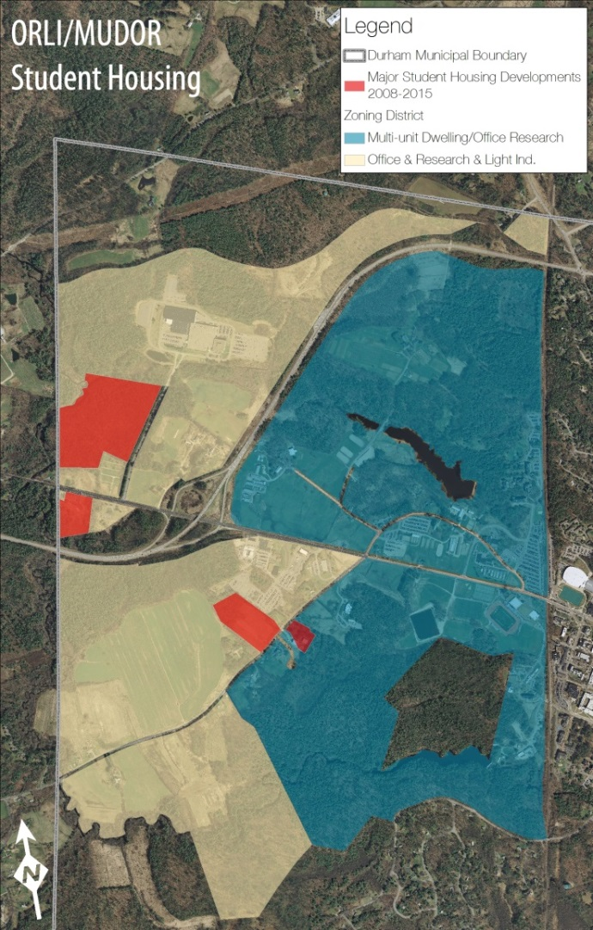
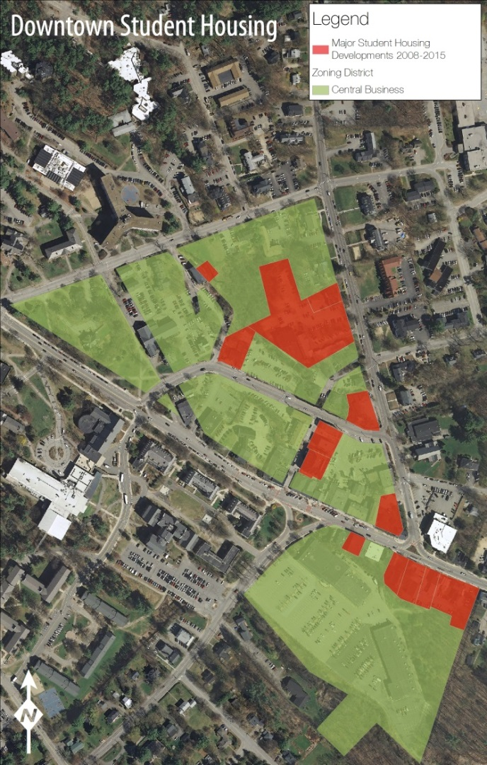
Recent Student Housing Development Patterns (continued)
Map 1: Downtown Student Housing (Source: SRPC)

Map 2: ORLI/MUDOR Student Housing (Source: SRPC)

Student Housing Tally Findings

Table 15: Major Private Off-Campus Student Housing Developments Since 2010
Year | Development Name | Address | Number of Beds | Number of Bedrooms | Zone
2010 | Bryant Park West | 262 Mast Road | 102 | N/A | MUDOR
2010 | University Downtown | 2-10 Jenkins Court | N/A | 60 | CB
2012 | University Downtown | 9 Madbury Road | N/A | 72 | CB
2012 | The Cottages of Durham | 100 Clubhouse Street | 619 | N/A | ORLI
2013 | Rivers Edge Apartments | 277 Main Street | 114 | N/A | ORLI
2014 | The Lodges at West Edge | 259 Mast Road | 486 | N/A | ORLI
2015 | Madbury Commons | 17-21 Madbury Road | 525 | N/A | CB
2015 | Orion Student Housing | 25-27 Main Street | 197 | 179 | CB
TOTAL |  |  | 2,043 | 311

Source: Town of Durham

Table 16: Minor Private Off-Campus Student Housing Developments Since 2009
Year | Development Name | Address | Number of Beds | Number of Bedrooms | Zone
2010 | Rosemary Lane Apts. | 22 Rosemary Lane | 32 | 16 | CB
2010 | 14 Jenkins Court | 14 Jenkins Court | 24 | 24 | CB
2011 | Grange Hall Apartments | 37 Main Street | 38 | 38 | CB
2013 | Kostis Enterprises, LLC | 10 Pettee Brook Lane | 68 | 68 | CB
2014 | Ballard Building | 1 Madbury Road | N/A | 42 | CB
2014 | Pauly’s Pockets | 49-51 Main Street | 34 | N/A | CB
TOTAL |  |  | 196 | 188

Source: Town of Durham
Maintained by Durham’s Planning Department, the Student Housing Tally provides data on both existing and planned student housing developments in Durham. The table at right includes student housing developments in the period from 2009 to 2015.
Existing student housing developments together represent a combined off-campus housing stock capacity of approximately 4,300 occupants. This capacity is intended to serve the 5,351 undergraduate and 2,078 graduate students who require some form of off-campus housing. Under this assumption, 58% of Durham’s off-campus housing demand is currently accommodated. Dover and Newmarket have historically provided ample affordable student housing opportunities for upperclassmen and graduate students who cannot be accommodated in Durham. As the supply of student housing begins to approach the demand, it is anticipated that it could have implications on the housing market in these adjacent communities which depend upon University of New Hampshire student investment. Collaborative partnerships with these communities could be vital in developing a strategy for future housing needs on a regional level.
Senior/Age Restricted Housing
As noted earlier in the chapter, New Hampshire is experiencing a shift in population demographics. This change is driving a shift in housing preference among both older and younger generations, which may result in a misalignment between housing supply and demand in the coming decades. Additionally, the economic crisis of the late 2000s has transformed the ‘traditional’ homeownership path by complicating the process of procuring financing. New Hampshire’s housing market, between 1960 and 2010, was largely controlled by the high rate of in-migration of Baby Boom-age individuals to the state. Now, population projections indicate slowing growth and rapidly aging demographics, a trend that communities must plan and prepare for. This chapter acknowledges that the following trends are emerging:

- Home ownership is declining. Declining in-migration, an unstable housing market, and difficulty in procuring financing have each contributed to a declining attractiveness of owning a home. In particular, seniors are experiencing liquidity challenges as they attempt to downsize and relocate. At the same time, student-debt burden and lower entry-level wages make home ownership by younger people problematic.
- Housing preferences are evolving. Housing preferences of young people have shifted from ownership toward more flexible housing arrangements such as renting. Older populations, with average household sizes of approximately 1.5 persons, are down-sizing from large 3+ bedroom homes to 1 and 2 bedroom units closer to community centers. Together, these shifts are significantly reducing the demand for larger, more rural homes and are creating a supply shortage for smaller, more flexible spaces.
- Existing housing stock is not flexible. It is expected that construction rates will decline with slowing population growth in New Hampshire’s communities. Competition between older and younger generations for single-family homes and rental units in or adjacent to community center areas will create excessive demand on a limited supply of housing in these areas. One solution is the repurposing of existing living space. This means that communities must take proactive steps to ensure that local ordinances and regulations allow for innovative repurposing, rehabilitation, and expansion of spaces.
- Senior housing is a concern. The aging of the Baby Boom generation is expected to result in the doubling of New Hampshire’s senior population by 2030. In parallel, housing unit occupancy by seniors will double, requiring consideration of how to design and retrofit housing for seniors with and without disabilities. Though a high percentage of seniors are interested in ‘aging in place’, this choice could become strained by increasing taxes and real estate costs, increased prevalence of disability combined with a decrease in the ‘caregiver’ population, and a decrease in median household income. Statewide figures estimate that median incomes for seniors are just over half that of all households.
- Seniors choose to ‘age in place’. Despite anecdotal evidence suggesting that seniors migrate to southern, warmer climates, only 3% of New Hampshire’s seniors move annually. A 2010 AARP survey of 45 and older indicated that 86% of respondents would “like to stay in their current residence as long as possible”. However, the ability of seniors to remain in their community is directly related to factors such as income, healthcare, housing stock, and housing cost burden. Nearly 45% of the State’s senior population classify themselves as having one disability. Of those, 18% report that their disability makes independent living challenging. Historically, social agencies have played a key role in ensuring that seniors are able to remain independent, though predicted funding shortages could lead to widespread cuts in these services. As indicated above, although seniors often have more assets, they tend to make one-half the state’s median income, and pay more than 30% of that income towards housing costs. More than 75% of the state’s senior population lives in suburban or rural areas; these areas typically lack access to key services and amenities such as healthcare and food. As a result, down-sizing seniors are searching for housing in downtown areas with close proximity to these vital services. Unfortunately, much of the existing community-center housing stock is older and not ‘senior-friendly’.
- Assisted living demand will rise. NHHFA’s Senior Housing Perspectives report estimates demand for nursing home beds will increase by more than 50% by 2025 (state nursing homes are currently at 100% capacity). In parallel, demand for assisted living units is expected to grow from 4,400 to 7,400 in the next 15 year period, a 68% increase.

Senior/Elderly Housing in Durham
What You Said: “Policies that allow seniors on limited or fixed income to stay in Durham”
Source: 2011 Master Plan Survey

Durham’s zoning ordinance defines elderly housing as:

Table 17: 2006 Age-Restricted Housing Survey Data
Age Restricted Housing Units in 2006 | Age Restricted Units in New Hampshire Housing's Directory of Assisted Housing | Age Restricted Housing Units in 2006 | Housing Units for 55 and Older
239 | 76 | 239 | 239
Age Restricted Housing Units in Assisted Living Facilities | Age Restricted Rental Units | Age Restricted Owner Units | Age Restricted Condominium Owner Units
40 | 107 | 92 | 92

Source: NHHFA

Table 18: Assisted Housing Units
Development Name and Address | Housing Type | Total Units | Assisted Units | Handicap Accessible Units
Bagdad Woods | Elderly | 40 | 40 | 4
Church Hill Apartments | Elderly | 36 | 28 | 2

Source: NHHFA
“Housing principally used, designed or adapted for use by elderly citizens, fifty-five (55) years of age and older who are capable of living independently, and complying with the design requirements of the Architectural Barrier Free Design Code for the State of New Hampshire, as amended. “Elderly housing” may be single family residences, duplex residences, or multiunit residences and can be contained in a single building or groups of buildings and may include dwelling units that do not include services for the residents and/or congregate housing that includes services such as meals, housekeeping, recreational programs and related management support systems.”

Table 19: Other Senior Housing Units
Development Name and Address | Housing Type | Total Units | Assisted Units | Handicap Accessible Units
Spruce Wood | Elderly | ~80 Beds | UNK | UNK
Brookside Common | Elderly | UNK | UNK | UNK

Source: SRPC
According to a survey completed by the Town of Durham Planning Department in 2006, Durham had, at the time, 239 units of age restricted housing within the community. Of these, 76 are included in NHHFA’s Directory of Assisted Housing. The remaining 163 units are split: 107 restricted rental units and 92 restricted owner units (all condominiums). Though nearly 10 years have passed since the completion of this survey, SRPC estimates that few if any age-restricted units have been added. It can be confirmed that as of 2014, Durham maintains 76 assisted housing units according to current NHHFA data. Church Hill Apartments consists of 36 units and Bagdad Woods Apartments consists of 40 units, most of which are HUD subsidized. Both developments are open to persons age 62 and older, and handicapped persons of all ages. Very low income and low income applicants must be considered first. Residents are charged 30% of their income (minus medical expenses if over 3% of income). Securing tenancy in these developments is highly competitive; both complexes currently have waiting lists. The remaining 163 age-restricted owner and renter units are part of two significant senior housing developments: Spruce Wood and Brookside Common.

Housing Unit Projections

As previous sections suggest, Durham is expected to grow at a steady rate for the next 30 years. The question then becomes: how does Durham’s housing stock change to adapt to this increase in population, either through the repurposing of existing buildings or new construction. But, just how many new units will be needed?

As of the 2010 Census, Durham’s average household size for all units was 4.73 persons per household. Assuming that this household size remains constant out to 2040, and the population grows by the projected 2,496 individuals, SRPC estimates that Durham will need approximately 527 new housing units over the next 30 years. SRPC projects that this will be 292 new owner-occupied housing units and 213 new renter-occupied units (assuming a 4% vacancy rate). Care should be taken in the consideration of this estimate as not all population growth is likely to be new residents. Some more natural increases in existing town population may also occur.
Key Conclusions

- Durham has experienced consistently strong population growth over the past five decades, with an overall growth rate of 165%. In absolute terms, Durham total population grew from 5,504 individuals in 1960 to 14,638 in 2010 according to decennial Census figures. Of these, SRPC estimates that approximately 55-60% of the Census population is University of New Hampshire students. Durham’s full-time resident population is estimated to be between 5,500 and 6,200 individuals.
- Population projections for the next three decades indicate moderate growth (in comparison to 1960-2010), with an expected total population growth rate of 17% out to 2040. The Strafford region is projected to be the fastest growing region in the state, with a projected growth rate of 13% to 2040.
- Growth rates are also impacted by slowing University of New Hampshire enrollment growth. Stabilization and even stagnation of enrollment rates due to education alternatives, such as online learning, could result in far lower population growth rates than predicted in projections. Currently, the University of New Hampshire plans for 0.5% enrollment growth annually.
- Durham, in concert with the State of New Hampshire, is experiencing a shift in age characteristics of its population. In the two decades between 1990 and 2010, Durham experienced a large increase in the 55+ age population and a substantial drop in 25-44 age individuals. These changes have resulted in a significant decline (14%) in Oyster River Cooperative School District enrollment from 2000 to 2014. Durham saw a 30% decrease in the 5 and under age population from 1990 to 2010, which has had direct impacts on ORCSD enrollment. SRPC enrollment projections indicate that Durham-only ORCSD school enrollment will continue to decline until 2015 despite steady population growth. Although Durham is expected to grow by 17% between 2010 and 2040, Durham based ORCSD enrollment is projected to increase by only 4% because of declining family-age population and children. These projected demographics could impact youth services and resources while increasing the need for services that target seniors to allow for them to age-in-place.
- Durham maintains a diverse existing housing stock. Approximately 60% of its 3,092 housing units are owner-occupied units and 40% are renter-occupied. Durham’s housing unit growth in the last 20 years has been largely in residential-single family units, adding nearly 600 during that period. Despite the economic crisis of the 2000s, Durham has been fortunate to maintain relatively low vacancy rates, as evidenced by a 4% vacancy rate as of 2010 Census figures.
- ‘Family’ households, in parallel with 25-44 age population and enrollment decreases, have declined by almost 10% in the last 20 years.
- In the past 15 years, Durham has experienced highly variable single- family and multi-family construction growth. Single-family construction projects were concentrated in 1998, 1999, and 2011, while multi-family unit construction erupted in 2008 and peaked in 2013 with the approval and construction of several multi-unit developments (according to available data).
- Durham’s housing stock includes 1,505 total single-family housing units, comprised of single-family homes and condominiums. The average lot size for single family homes is approximately 2.7 acres. Housing stock age varies, though the average year of construction for single-family units is 1963 and median construction year is 1972. Assessing data also indicate a median total parcel and structure value of approximately $315,300.
- Though high median home and parcel values are indicative of a strong demand for residency in Durham in recent decades, these values have the potential to exclude many individuals and families. Durham is aware of the possible short and long-term impacts of an unaffordable and relatively exclusive housing market on local and regional socio-economics. Although the Town allows for the construction of “workforce housing” as mandated in state statutes, additional actions will likely need to be taken to attract affordable housing development and/or repurposing.
- Annual median purchase price data indicate that Durham’s housing stock is consistently more expensive than other housing in the Strafford planning region, HUD housing area, and State of New Hampshire. In 2013, total home and condominium purchases ranged from a minimum of $90,000 to a maximum of $510,000.
- Although rental survey data collected from New Hampshire Housing Finance Authority suggest that Durham’s rental housing market is affordable in the context of the region and state, web-based rent sampling for new commercial student housing units indicates that values range from $1,598 per month – $6,040 per month.
- Of Durham’s 1,570 owner-occupied housing units, 12.5% are affordable to a 4-person household making 100% of the area median family income. O9.5% of single-family homes are affordable while 77.9% of condominiums qualify.
- NHHFA rental survey data indicate that Durham’s rental housing market is quite affordable, with the majority of 2013 sampled units falling 20% below the annual affordability threshold mark of $14,274. However, because of NHHFA’s sampling protocols, more expensive student housing rentals are not included in surveying resulting in inaccurate estimates.
- Comprehensive Housing Affordability Strategy (CHAS) data suggest that nearly 1 in 4 rental and 1 in 10 owner households in Durham are suffering from the effects of one severe housing problem. Severe problems include: incomplete kitchen facilities, incomplete plumbing facilities, more than 1.5 persons per room, and the cost burden greater than 50%. Cost burden data reveal that nearly 1 in 10 owner-occupied units are burdened by expending more than 50% of their median household income toward housing costs annually, primarily students.
- Population projections out to 2040 suggest Durham may require as many as 527 additional housing units. Projecting existing housing stock composition data results in an occupancy-type of 292 new owner-occupied housing units and 213 new renter-occupied units (account for a 4% vacancy rate). Care should be taken in the consideration of this estimate as not all population growth is likely to be new residents ,some more natural increases in existing Town population will occur.
- Though housing unit projections may be fairly accurate, the aging of Durham’s population is one demographic trend that makes projections rather volatile. With a relatively high amount of uncertainty around how those within the baby-boom generation will retire and adapt their housing, it’s difficult to say how the ‘silver tsunami’ will impact the Durham housing market.
- Currently, UNH is capable of housing 57% of its total graduate and under-graduate students. Though the demand of the remaining 43% was historically accommodated by single-family homes in the downtown and surrounding core area, as well as by rental housing units Dover and Newmarket, a strategic change in Durham’s zoning led to a multi-family housing boom in Durham’s rural west-side in the mid-to-late 2000’s. These large-scale developments, combined with smaller developments in the Central Business District, now provide housing for 57% of this remaining demand. Today, development continues; and as supply begins to approach demand, it’s anticipated that Durham’s student housing supply could have implications on the housing market in adjacent communities.

Goals and Recommendations
This section outlines the goals and recommendations associated with the key conclusions of this chapter. They are intended to guide the Town’s housing and community development efforts over the coming decade. These goals and recommendations below are not prioritized. Below each goal are key conclusions from the previous section that form the respective goal’s foundation.

Issue: Durham provides minimal affordable housing options for young families and professionals.
Goal: Provide an adequate supply of affordable housing in Durham.
Key Conclusions References: #13, 14, 15, 16, 17, 18, 19
Recommendations:
Planning Policies
  - Apply smart growth principles when siting future affordable housing developments within the community by increasing density in the downtown area while restricting development in the peripheral areas of the Town.
  - Prioritize projects that incorporate workforce housing units into single and multi-family developments that target median incomes individuals and families.
  - Promote accessory apartments as a viable option for downsizing seniors and for young families and households seeking starter homes.
  - Consider the simplification of the conservation subdivision ordinance to streamline the approval process.
  - Promote the renovation, adaptation, and reuse of student rental properties to be used as starter homes.
  - Promote repurposing and/or redevelopment of vacant and deteriorating housing stock into vibrant multi-family and condominiums.
Zoning Changes
  - Analyze the effectiveness of the conservation subdivision/workforce housing provisions (175-107 II of the Zoning Ordinance).
  - Ensure that zoning measures such as density requirements do not prevent the construction and/or provision of affordable housing.
  - Consider using density bonuses to incentivize the construction of affordable housing by developers.
  - Conduct a comprehensive regulatory audit to ensure balanced community growth.
Partnership and Organization
  - Continue to monitor affordability in the context of the Workforce Housing Law as defined by NH RSA 674: 58-61.
  - Support the formation of a local non-profit housing trust that advocates for and constructs affordable/workforce housing units.
  - Strengthen partnerships with the New Hampshire Housing Finance Authority (NHHFA) and the Workforce Housing Coalition of the Greater Seacoast.

Goal: Increase diversity by attracting young professionals and families to Durham.
Key Conclusions References: #4, 6, 7, 10
Recommendations:
Housing Diversity and Quality
- Support the conversion of older student housing stock in traditional neighborhoods into attractive and affordable single-family and condominium units that provide an opportunity for multi-generational housing uses.
- Support mixed use developments that generate multi-generational interest.
Family/Professional Retention and Attraction
  - Create marketing tools through the Town’s Planning/Community Development/Economic Development department that target individuals between the ages of 20 and 40.
  - Develop a live, work, play, and stay program focused on retaining alumni and younger residents that includes: a periodic assessment of needs, increased housing options, and the establishment of other services and amenities geared towards younger residents.
  - Foster the development of a vibrant downtown that has services and amenities that increase social capital.
Economic Opportunity
  - Provide high-quality local employment opportunities that provide livable wages and economic prosperity for young professionals and working families (see Economic Development Chapter).
  - Ensure that the Zoning Ordinance and other regulations provide opportunities for business development in the downtown and commercial core as well as in peripheral community areas.

Issue: New housing developments must be compatible with Durham’s needs and demands while being environmentally compatible.
Goal: Integrate Smart Growth principles into redevelopment as well as new construction housing projects.
Key Conclusions References: #7, 4, 12, 19
Recommendations:
Future redevelopment and new development siting
- Encourage higher density development in the downtown area.
- Plan for development in a manner that maximize the use of existing infrastructure and reduces the need for new roads, services, and facilities.
- Promote linkages and integration between neighborhoods, community facilities, and places of employment.
- Encourage new housing development and redevelopment in downtown mixed-use areas that promote live, work, and play lifestyles.
- Prioritize areas for development of new housing units based on existing and planned infrastructure access.
- Provide mixed-use developments that create housing for seniors and younger residents in close proximity to shopping and services and encourage multi-generational neighborhoods.
- Encourage infill development within established neighborhoods that is compatible with current land uses, compatible in scale with surrounding areas, and adequately supported by public utilities and the existing transportation system.
Environmental compatibility
- Plan for an anticipated ~175 new housing units per decade in a way that will not adversely impact the environmental and fiscal health of the community.
- Ensure the environmental compatibility of new construction projects during site plan review and planning board approval process.
- Encourage sustainable and energy-efficient design of new housing units.
- Encourage sustainable and energy-efficient retrofitting of existing housing units.

Issue: Durham has seen increased development of student housing stock that could increase supply to the point of meeting demand.
Goal: Continue to provide and maintain high quality on and off campus student housing/Carefully monitor student housing stock.
Key Conclusions References: #3, 11, 18, 21
Recommendations:
Future student housing development, redevelopment, and repurposing
  - Support the conversion of older student housing stock into condominiums or other attractive, multi-generational housing uses that do not increase unit count but increase unit quality.
  - Continue to work with the University to monitor UNH enrollment projections and understand the impact of these projections on student housing stock in Durham and adjacent communities.
  - Work collaboratively with the University to strategically plan new on-campus housing construction and improvements.
  - Convert small and mid-sized homes in traditional residential neighborhoods that are currently occupied by students into attractive space for downsizing seniors and younger families/professionals.
  - Continue to leverage new student housing strategically in the Central Business, Church Hill, and Professional Office districts through the use of mixed-use development.
Existing student housing stock maintenance and monitoring
  - Maintain the quality of downtown single-family home student housing, specifically in historic properties, through inspection programs.
  - Continue the maintenance of the Student Housing Tally by Durham’s Planning Department.
Issue: Investment in and protection of existing housing must be prioritized as development of student housing declines.
Goal: Maintain existing single, multi-family, and condominium housing stock.
Key Conclusions References: #2, 9, 11, 12, 18, 19
Recommendations:
Traditional neighborhood character
- Preserve and enhance the integrity and quality of existing residential neighborhoods in Durham.
- Consider transportation safety measures that reduce speeding, commuter routes or cut-through traffic that may adversely affect street use or the character of existing residential neighborhoods.
- Explore solutions that mitigate the deterioration of historic properties within the Historic District.
- Continue to strictly enforce the three unrelated individuals per dwelling unit rule in order to preserve residential neighborhoods, insure safe and sanitary housing conditions, and help control overcrowding of housing units.
Neighborhood compatibility
    - Stabilize neighborhoods adjacent to commercial and multi-unit uses through the establishment of regulations and ordinances that create transitional yards, vegetative buffers, architectural screens, and control of transportation access.
    - Strictly monitor the effectiveness and enforcement of the Durham Noise Ordinance and the Town’s Disorderly Housing Ordinance in order to minimize noise and light pollution.
    - Conduct annual outreach to and education of residents and students on the Durham Noise Ordinance and Disorderly Housing Ordinance.
    - Encourage developers to work with residents living in neighborhoods adjacent to potential projects to understand the community’s concerns prior to formalizing development plans.
    - Provide adequate buffers between multi-unit housing and other residential areas.
    - Ensure that new construction within or adjacent to existing neighborhoods is compatible with current land uses, compatible in scale with surrounding areas, and is adequately supported by public utilities and the existing transportation system.

Issue: An aging population will create additional demand for housing options for seniors.
Goal: Create and maintain attractive and affordable senior housing.
Key Conclusions: #4, 19, 20, 22
Recommendations:
Senior Population Retention and Attraction
  - Partner with the University to develop senior housing/alumni housing close to the campus and downtown.
  - Explore the services needed to allow residents to remain in their larger single family homes in rural areas.
  - Develop a live, play, and stay program focused on senior resident retention that includes: a periodic assessment of senior needs, more neighborhood-based services geared toward seniors, expanded transportation services, increased housing options, and the establishment of other amenities geared towards senior residents.
Future Senior Housing siting
  - Find ways to site senior housing in the downtown area in a way that avoids noise and light pollution.
  - Provide an opportunity for repurposing underdeveloped sites in the downtown area for senior housing.
  - Support the development of affordable senior housing in the downtown that provides access to vital services and amenities.
  - Actively encourage senior housing development on lands most suitable, such as locations within walking distance to the downtown, and those served by existing infrastructure.
  - Encourage multi-generational neighborhoods and developments.
Zoning Changes
  - Consider allowing senior multi-family housing by right in the Central Business district.
  - Consider an incentive-based zoning ordinance provision that allows increased density for development reserved for seniors.

Issue: Historic and projected enrollment figures, combined with a decline in young families, could impact the future of ORCSD.
Goal: Maintain the competitive edge of the Oyster River Cooperative School District.
Key Conclusions: #2, 4, 10
Recommendations:
Funding
  - Revisit the assessment and student-based funding formula and investigate other formula types utilized across the state of New Hampshire.
  - Consider waiving school impact fees on properties reserved for seniors, age 62 and older.
Cooperation
Work with Oyster River Cooperative School District to develop a long-range capital improvements plan that will accommodate projected school enrollment change in the District.
Student Enrollment Stabilization
  - Address declining enrollment and impact of potential tuition enrollment from adjacent communities.
  - Focus on attracting young families to Durham and other contributing communities.
Connections to Other Chapters
Demographic and housing issues intersect and align with many aspects of the Town’s plans for the future. As a result, they help inform other chapters of the Master Plan. Considerations raised in this chapter echo throughout this document and are especially linked to the following components of other chapters.
Vision and Community Character
Durham's community character has been shaped, particularly in recent years, by student housing development in the downtown and select peripheral areas. The town has traditionally been represented by a diverse demographic, with two very district population groups, students and permanent residents. The inability to create affordable housing options for seniors and younger, non-student population in the future could have large implications on the future of the community.
Agriculture
Many single-family homeowners in Durham maintain private gardens or are members of community gardens. These gardens provide opportunity for the building of social capital and sharing of food resources.
Downtown and Commercial Core
The downtown and commercial core areas of Durham are in the midst of transformation due to recent redevelopment and development efforts focused on student housing development. It is unclear at this time just how these development will impact the vitality of the downtown area. However, it is understood that an assessment of this impact will be necessary in the coming years.
Economic Development
Durham's economic vitality and future economic development efforts are directly connected to the community's ability to provide diverse housing options for employees of businesses within Durham (including the University of New Hampshire). Additionally, economic development and the associated commercial tax base have been heavily impacted by recent student housing development in the downtown area that will affect not only residential, but also commercial uses in that district.
Energy
Single-family home and multi-family developments (including both senior and student housing) are increasingly cognizant of energy efficient housing stock construction practices. (partially due to Durham’s progressive building code requirements). Additionally, many Durham homeowners have explored and/or invested in alternative energy infrastructure improvements in their homes.
Existing Land Use
The development of additional housing stock is heavily constrained by minimal land suitable for future development with the community. Land in the downtown is particularly constrained. Developable land in the peripheral areas of the community is heavily environmentally constrained and must be done in a sensitive manner. See the existing land use chapter for more details of this analysis.
Historic Resources
Durham is home to many historic structures, many of which are historic homes in the downtown and commercial core area. These historic assets must be creatively protected as newer student housing development occurs. Durham's HDC also plays a critical role in the regulator y review process, including residential development, with the town's historic district.
Natural Resources
Future housing development within the community must be done in a way that is environmentally compatible. Durham's culture has been traditionally defined by its rich natural resources. The preservation of these resources is essential when considering any future single-family or multi-family development projects, particularly outside of the downtown and commercial core area.
Recreation
Recreational opportunity is a key strategic marketing asset that the community can use when attracting younger families to community. Currently, young people are prioritizing quality-of-life over employment opportunity when selecting their future homes. If more diverse housing types/prices can be fostered, Durham's recreational assets will attract the next generation of Durham residents.

American Community Survey Estimates, as a sample-derived dataset, present high margins of error and therefore limited accuracy. However, in many instances these data represent the best available information, and are therefore the basis for many elements of analysis within this chapter. Additional challenges with American Community Survey and decennial Census datasets arise in University communities with large transient student populations. The 2011 Town Wide Market Analysis anecdotally notes Boston’s population margin of error as 100,000 people, a product of its many universities. As a result, estimates related to demographics, housing, and economic characteristics should be treated carefully by those reviewing this document.

