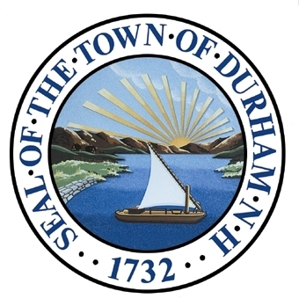
Agricultural Resources
The Agricultural Resources Chapter of the Master Plan presents a vision and steps to guide the Town’s efforts to support and preserve a working landscape of farms, gardens, and forests. This chapter includes a brief introduction to Durham’s agricultural history; description of current farming and forestry activity in town; and a series of goals and recommendations for achieving leadership in local food production in order to pursue long term economic and environmental sustainability and resiliency.

Adopted by the Durham Planning Board on November 18th, 2015.

Our Vision
In 2025 and beyond, Durham’s working landscape of farms, forests, and gardens continue to benefit residents and visitors. Durham demonstrates leadership in local food production to enable year-round access to fresh, local food and to promote long term economic and environmental sustainability and resiliency. Small family farms and the University of New Hampshire’s research farms contribute to the region’s food economy and enable conservation and protection of natural resources in the community. Durham’s land use regulations allow forms of agriculture in all areas of the town. Zoning reflects the value of and fosters the integration of plant and animal agriculture. The town continues to identify opportunities to support food production at all scales. As a result of these factors, the town is recognized as a model for integrating small-scale agriculture throughout the community.

Durham should adopt agricultural policies that:
 | Overall Positive Response Rate |  |  | Strongly Agree | Somewhat Agree
Support homeowner gardens | 91% |  |  | 67% | 24%
Support community gardens | 89% |  |  | 66% | 23%
Support the production and sale of local agricultural products | 88% |  |  | 66% | 22%
Protect agricultural lands for current or future food production | 82% |  |  | 50% | 32%
Allow poultry-raising by homeowners | 60% |  |  | 21% | 39%
Allow livestock raising by homeowners | 60% |  |  | 21% | 37%
Durham residents find the following attributes important or attractive :
(participants were asked to choose their top 3 attributes)
 |  |  | Number of Responses
Rural character |  |  | 119
Natural areas, settings, and resources |  |  | 40
Green, scenic, and/or open spaces |  |  | 16
Wagon Hill |  |  | 16
Land conservation |  |  | 8
TOTAL NUMBER OF PARTICIPANTS: 467 citizens
Foundation
2011 Master Plan Survey: Agricultural Resources

Throughout successive Master Plans, Durham’s citizens have voiced support for protecting the town’s farm and forest lands. Participants in the 2011 Visioning Forum note the role of sustainable agriculture in increasing the town’s self-sufficiency through greater availability of fresh, local food. Knowing where their food comes from is an important issue to residents, and one that guides many household decisions about growing and purchasing food in the community.
What do we look like today? | What will we look like?
Hidden Agriculture | Community Supported Agriculture (CSA)
Community gardens, Wagon Hill | Taxes and zoning to support increased agriculture
De-emphasis of agriculture | Agriculture-friendly town
Lack of sale local food
TOTAL NUMBER OF PARTICIPANTS: 90 citizens
Rural character, Wagon Hill, and natural areas, settings, and resources have been identified by respondents as important or attractive attributes of Durham. Participants in the Visioning Forum indicated that they would like to see more farms. Residents also expressed support for a range of agriculture-related policies, such as supporting the production and sale of local products, protecting agricultural lands for current or future food production, and allowing homeowners to raise poultry and livestock.
The tables to the right summarize relevant comments and input submitted during the 2011 Visioning Forum and 2011 Master Plan Survey, which were completed by the Town of Durham. Results of these engagement opportunities form the foundation of this Agricultural Resources chapter while providing a lens of public perception and interest surrounding these topics.
2011 Visioning Forum: Agricultural Resources

Durham’s Working Landscape

Introduction
Durham’s agricultural heritage dates back to the 1600s and remains visible today in the community’s working landscape and on the University of New Hampshire (UNH) campus. Durham's working landscape is a critical resource to the community that supports a high quality of life and provides food, fuel, jobs, and opportunities for recreation and rejuvenation. As both awareness of the importance of local agriculture and access to locally grown products has increased, residents’ support for maintaining and promoting actively managed farm and forest land, as well as backyard and community gardens, has also grown.
What is a Working Landscape?
A working landscape balances economic, ecological, and social needs in a way that fosters mutually reinforcing uses of the land, such as the production of market goods and preservation of ecosystem services†.
Ecosystem services are the benefits people obtain from ecosystems. These include provisioning services such as food and water; regulating services, such as flood and disease control; cultural services, such as spiritual, recreational, and cultural benefits; and supporting services, such as nutrient cycling, which maintain the conditions for life on Earth. Working landscapes are lands that are maintained to allow the property owner to produce commodities and generate revenue while sustaining these critically important services.
For example, farmland protection not only enables local food production, but provides wildlife habitat, water quality protection, and, in some cases, flood storage. Forests produce the wood needed for housing, furniture, heating, and paper while providing habitat for wildlife, opportunities for recreation, carbon sequestration, and water quality protection. Farmland and forests are cultural and historical places that have great meaning for Durham residents.
The State of New Hampshire recognizes working landscapes in one of its eight smart growth principles: Preserve New Hampshire’s working landscape by sustaining farm and forest land and other rural resource lands to maintain continuous tracts of open land and to minimize land use conflicts.

Over the years, agriculture in Durham and throughout the state has evolved to better meet the needs of current populations in a changing national and global economy. In New Hampshire, these changes include an increase in:
- Niche agriculture of unique, unusual, and uncommon products
- Interest in eating locally, urban agriculture, ethnic markets, and agri-tourism
- Direct sales of locally grown and distributed products.
Emerging outlets for locally grown food include:
- Farm stands and harvest your own farms
- Summer and winter farmers’ markets
- Community supported agriculture (CSA)
- Community gardens
- Garden centers, greenhouses, and plant nurseries
- Local restaurants and institutions.
†Adapted from University of California Berkley College of Natural Resources

Agriculture is important to Durham’s economic vitality and quality of life. With backyard vegetable gardens that supplement household food purchases; small scale, ancillary farms that supplement farmers’ income from other employment; and commercial operations and supporting industries and businesses that directly provide goods, revenue, and jobs, agriculture is an important component of the local and regional economy. Agriculture shapes sense of place in Durham, and thus plays a role in making the town a desirable location to live and work. Local agriculture also provides recreational, social, and educational opportunities. Because the food system is closely linked to health, ecological sustainability, equity, emergency preparedness, and food security, it significantly impacts quality of life in the community.
Durham Town Council’s
2014-2015 Goal Related to Agriculture
Pursue long-term economic and environmental sustainability and resiliency, anticipating the community’s and the region’s future needs through a framework that formally integrates the consideration of multiple elements including society, ecology, economics, transportation, agriculture, recreation, food and drinking water, climate, and energy resources.
A range of issues reinforce the need to maintain, protect, and expand Durham’s local food system. The town and UNH campus have lost some of their most productive agricultural lands to development. Although the demand for local food is high, the town is largely dependent on food grown outside of the region. This demand, coupled with New England’s vulnerability to food shortages, indicates that there is an opportunity and a need to increase capacity to supply locally grown food in Durham. Reducing the town’s dependence on food sourced outside the community and region would serve to decrease the environmental impact of storing and transporting food.
While the focus of this chapter is agricultural resources in Durham, local agriculture extends beyond the town’s immediate boundaries and includes products produced at farms within the region, including Strafford and Rockingham Counties, as well as York County, ME. Access to local food depends on a number of interconnected factors. Thus, strengthening the food system occurs at the back yard, community, and regional level. This includes:
- Facilitating the development and sales of locally grown agricultural products
- Working with UNH to commercialize agricultural initiatives and practices
- Exploring the development of a food hub
- Preparing to adapt to changes in growing conditions.

Durham’s Agricultural Commission
Durham established an Agricultural Commission in July of 2011. The goal of the Agricultural Commission is to “promote the production, availability, and sale of locally grown food, fiber, and forest products” in Durham. The Commission has embraced the charge, prescribed by NH RSA 674:44-f, to encourage farming, forestry, and gardening throughout town, including on private, town, and state property. Refer to the Appendix for a copy of Resolution 2011-14, which established the Commission. As of 2015, there are 25 towns in New Hampshire with an agricultural commisison.
Did You Know?
The Durham Agricultural Commission recognizes residents’ efforts to grow fruits and vegetables in their own yards with “Food Friendly Yards” signs around the community. The signs help raise awareness of home food production.
State Legislation Enables, Preserves, and Protects Agriculture
With the signing into law of Granite State Farm-to-Plate (RSA 425:2-a), it is now the policy of the State of New Hampshire to both encourage and support local food and farming, and the processing of locally grown food, wherever it occurs in the State of New Hampshire, and in whatever form.
The Right to Farm Law (NH RSA 432:33) is intended to protect agriculture from nuisance lawsuits when operations are conducted in compliance with state and local health and safety regulations. (See Appendix for full text of RSAs)
Local Land Use Regulations
Although plant and animal agriculture is necessarily highly integrated in New England, animal husbandry is generally subject to greater regulation and scrutiny than plant-based agriculture or forestry.
What You Said: 60% of Master Plan Survey respondents support agricultural policies that allow livestock-raising by homeowners.

(Source: 2011 Master Plan Survey, photo source: New Hampshire Magazine)
Agricultural activity in Durham is currently permitted by zone. Commercial agriculture, commercial animal husbandry, and plant nurseries are permitted in the Rural (R) and Residence C (RC) residential zones, as well as in all research/industry zones in the town except the Durham Business Park (DBP) zone. Additional agriculture and forestry related uses are permitted in certain residential and research/industry zones by right or conditional use, as outlined in Durham’s Zoning Ordinance. Article XX Performance Standards outlines uses that are accessory to commercial agriculture and livestock and poultry animal husbandry, including retail sales of farm products.
Strategies to enhance the viability of agriculture in the region through developing land use planning policies, economic development programs, land taxation, and development regulations include:
- Conduct assessments of prime agricultural lands that will be affected by current and projected development trends.

- Analyze factors that support or constrain the viability of agriculture in the region such as high property taxes, access to markets, high cost of capital, and land use regulations that restrict farmers' ability to earn additional income through agri-tourism or farm stands. Special attention in this category may be given to "agriculture of the middle," i.e. farms that fall in between local and commodity markets.

- Develop or modify policies, regulations, and other tools such as agricultural land preservation zoning, purchase of development rights, transfer of development rights, and partnerships with land trusts, to protect prime agricultural land.

- Partner with organizations that promote better understanding of farm life for urban dwellers to reduce the urban/rural divide.

(Source: American Planning Association Policy Guide on Community and Regional Food Planning)
In early 2013, Durham amended its Zoning Ordinance to allow and manage the keeping of chickens and turkeys for noncommercial purposes. The ordinance enables the raising of chickens and turkeys in most zoning districts following Best Management Practices issued by the NH Department of Agriculture, Markets, and Food (see http://agriculture.nh.gov/publications-forms/documents/bmp-manual.pdf). The amendment includes the following performance measures:
- Size of property, number of animals, fencing, and percent coverage for enclosed structures and yards
- Setbacks from property lines
- Storage and use of herbicides, pesticides, and similar chemicals
- Storage, sale, and disposal of feed, manure, and deceased animals
- Slaughtering
- Sale of excess agricultural products
- Restrictions of animals that may be noisy or cause other nuisances
- Complaints.

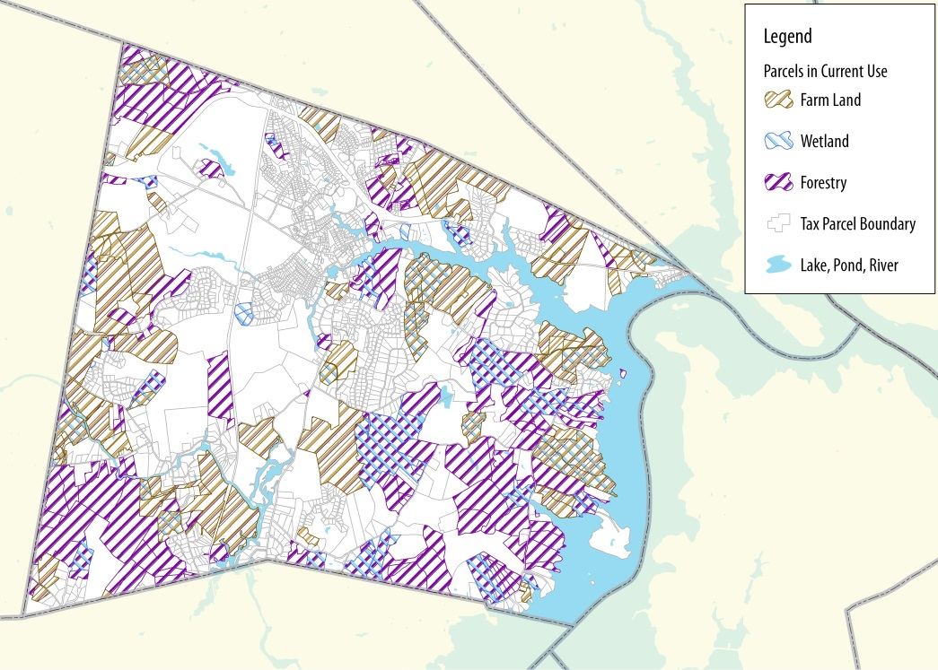
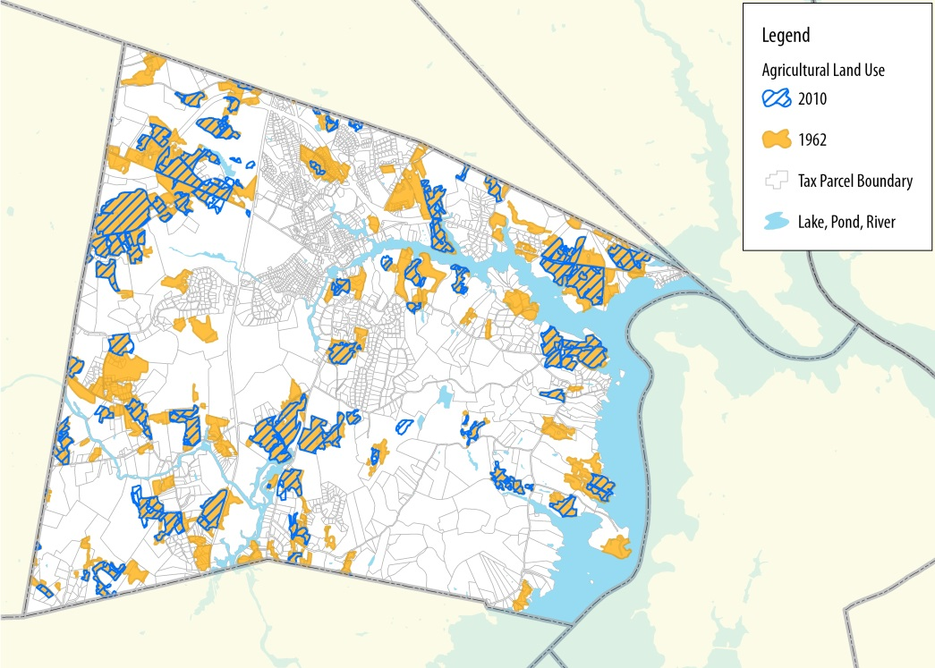
Agricultural Land in Durham
Map 1: Agriculture land use in 1962 and 2010 (Source: SRPC)
Map 2: Parcels in current use (Source: SRPC)
Agricultural activity occurs throughout the town in backyards, on Town-owned land and land that has been farmed by several generations of the same family, and across the UNH campus. Durham’s farms and gardens are diverse in scale, ranging from home gardens to part time, ancillary operations that generate small sales and bartering, to large commercial operations that may include the sale of products to neighbors through farmers’ markets, farm stands and stores, and local institutions.
Durham’s Agricultural Commission identified at least 48 parcels of land with agriculture or gardening activity within the town and UNH campus. Agricultural land, including fields, pastures, row crops, and orchards, comprises more than 1,288 acres in Durham. This land, combined with farm buildings, which account for an additional 47.6 acres, occupies 9.3% of the total acreage of the town. Today, Durham has roughly half as much agricultural land as it did in the 1960s (see Map 1). The average size property on which farming activities are conducted is 13.7 acres, although most are only one or two acres. The largest property is over 108 acres, while the smallest is just 0.2 acres.
Twenty-one farmland only parcels (accounting for 228.7 acres or 2.4% of the town’s total acreage) are in current use (Map 2). Current Use Assessment (RSA-79 A) is a property tax strategy in which land is assessed at its present use rather than its highest potential use. It is intended to preserve open space by helping landowners keep their land undeveloped. Fifty-three parcels (accounting for 2,048.2 acres or 16.4% of the town’s total acreage) are designated as farmland with other current uses.
There are five oyster operations located off Durham’s shores that cover 16.6 acres. The oldest of these operations received its license in 2009.
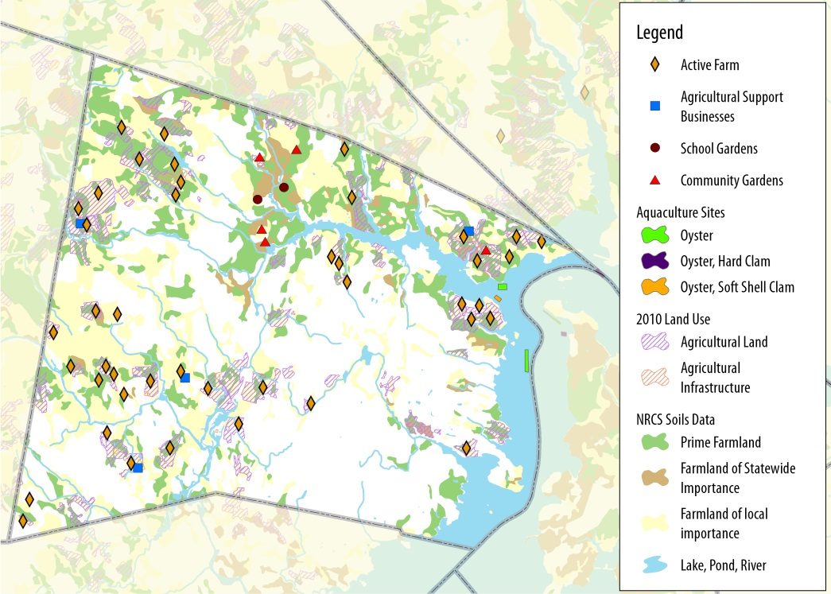
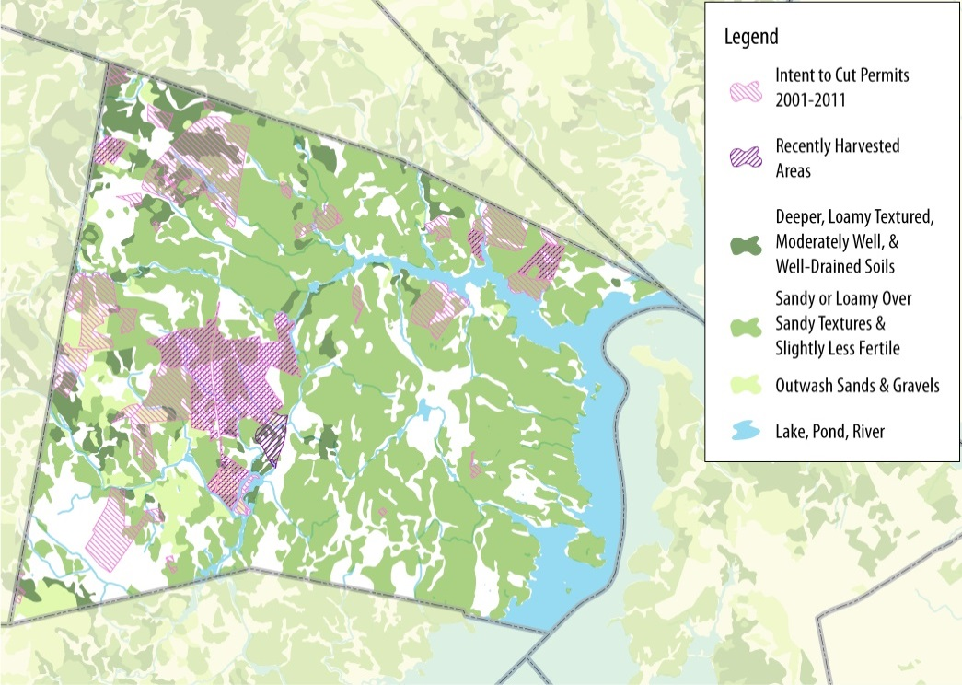
Farmland Soils
Map 3: Agricultural soils and land (Source: SRPC)
Map 4: Forest soils and harvest (Source: SRPC)
Nearly one fifth (18.2%) of Durham’s land has prime farmland soils. Approximately 26% of soils are classified as farmland soils of local importance and less than 3% are classified as farmland soil of statewide importance (Map 3). As of 2010, approximately 29% of the total acres with prime farmland soils in Durham had been developed compared to approximately 18% in 1962.

Forest Resources
Forests account for 8,418 acres (approximately 60%) of the acreage of Durham. Eighty-nine parcels, accounting for 2,791 acres (approximately 20%) of the town’s land area, are designated as forestry with other current uses. Between 2001 and 2011, the Town issued intent to harvest permits for 45 parcels. Of those, all or portions of ten parcels were harvested (Map 4). Loggers, foresters, and landowners who wish to harvest timber must file a Notice of Intent to Cut Timber, which notifies the assessing officials and the New Hampshire Department of Revenue and Division of Forests & Lands.

Community Gardens, Markets & Outlets
What Can You Find in Durham?
Beef Cattle
Chickens
Dairy Cattle
Eggs
Firewood
Fruits
Goats
Grain Crops
Hay
Honey
Horses
Lumber
Maple Syrup
Oysters
Vegetables
Sheep
Wool

Durham boasts a thriving collection of community gardens. The largest community garden is operating at Wagon Hill Farm and involves over 75 families. The Church Hill Apartments (at the Durham Community Church) and Fitts Farm Association each maintain community gardens for their residents. In addition, St. George’s Episcopal Church recently sited a community garden on its property.
Even small gardens can supply a significant amount of food!
Harvest from two 4x10 foot raised beds at Wagon Hill Farm Community Gardens from May 25-July 9, 2012 included:
Local products are also available at grocers, restaurants, and markets. Retail grocers and restaurants in Durham now have contracts to sell and serve food from local area farms. The Seacoast Growers Association (SGA) manages a weekly market from June through October in Durham. The Farmers’ Market provides an outlet for fresh local produce, handcrafted goods, and homemade foods and beverages. Over 15 vendors who sell berries, fruits, vegetables, flowers and plants, dairy, meat, oysters, eggs, fish, honey, syrup, prepared foods, cider, tea, wine, and certified organic products attend the market. As of 2015, the market is held on Monday afternoons in the parking lot at the Jackson’s Landing. Many market visitors are CSA members.
As defined by the US Department of Agriculture, community supported agriculture (CSA) “consists of a community of individuals who pledge support to a farm operation so that the farmland becomes, either legally or spiritually, the community’s farm, with the growers and consumers providing mutual support and sharing the risks and benefits of food production.” See www.nal.usda.gov/afsic/pubs/csa/csadef.shtml for more information (Source: DeMuth, Suzanne, 1993).

Food Outlets
Durham farmers have an expanding list of outlets for their products. In addition to the Farmers’ Market, this includes Emery Farm Stand, Holloway Commons, ORCSD, Tecce Farm Stand, Young’s Restaurant, UNH Dairy Bar, and the UNH Organic Garden’s Farm Stand. The Agricultural Commission sees the opportunity to expand these markets in coming years.
Young's Restaurant, a revered local gathering place and popular family restaurant, is leading the way for commitment and dedication to local food at a restaurant scale in Durham. Not only is this well-known eatery sourcing a significant variety of food from local farmers but, importantly, Young's produces food on its own land in nearby Dover, NH. Young's Restaurant is investing in the latest, new season extension technology (including grow tunnels and hoop houses) to further support this effort.
Likewise, UNH's Dairy Bar Restaurant at the Durham Amtrak Station, an equally popular eatery, is dependent on food grown in its own new greenhouses on UNH farmland, which are within walking distance of the restaurant. This effort has created new jobs in local food production. In addition, the Three Chimneys Inn recently announced that it will start a garden right next to the historic 1649 building to supply its restaurant. A host of restaurants in Portsmouth, as well as in Newmarket, Dover and Kittery, ME, are following suit. This has increased customers’ expectation and appreciation of the great taste of fresh, local products and helped create a sense of connectedness to area farms and farmers.
The 2014 Locavore Index rates New Hampshire among the top five states with regard to commitment to local foods. The index incorporates four measures in all states:
- Number of farmers’ markets
- Number of consumer-supported agriculture operations (CSAs)
- Number of food hubs
- Percentage of each state’s school districts with active Farm-to-School programs.
Food Hubs
The US Department of Agriculture (USDA), other federal and state agencies, and nonprofit groups are working together to help communities build and strengthen local and regional food systems and support small and mid-sized farmers who are struggling to get their products to market quickly and efficiently. One solution to this challenge is the creation of food hubs. USDA defines a food hub as a centrally located facility with a business management structure that facilitates the aggregation, storage, processing, distribution, and/or marketing of locally and regionally produced food products.
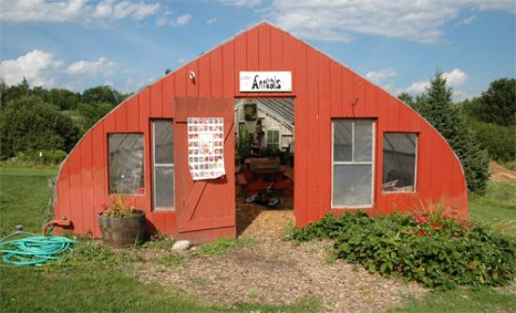
By actively coordinating many aspects of agriculture, food hubs connect growers to local groceries, restaurants, community organizations, and institutions to make local and healthy food more accessible to consumers. As interest, market demand, and production of local and regional agricultural products and food continue to grow, so will the need for these organized infrastructure systems. New food hubs that will draw upon farm products from York County and other area farms that currently supply Durham patrons are being established in Kensington and Portsmouth, NH and in Brunswick and Portland, ME.
Photo 1: Emery Farm (Source: Trip Advisory)
One example of a food hub is a neighborhood garden pod. A neighborhood garden pod includes a community garden, kitchen, and a store that provides information about eating well, farming tips, and community connections, in addition to providing a direct outlet for farm and value added products. Future expansion of Durham’s food system may include community kitchens or food pantries that provide food and opportunities to grow, prepare, and sell value added products.
Did You Know? As of 2010, the local food supply supported approximately 6% of New Hampshire’s population. (Source: Local Food Systems in New Hampshire)

Agriculture Economy
Farm Characteristics
The total sales from farm products in Strafford County ($12.8 million) accounted for approximately 7% of the total sales in New Hampshire as of the 2012 US Census of Agriculture. There were 354 farms in Strafford County in 2012, representing an increase of 26% from 2002. While farm sales and the number of farms in Strafford County and in the state increased by roughly one quarter to one third, the number of acres of farmland, average size of farms, and median size of farms declined between 2002 and 2012. Between 2007 and 2012, acres of land in farms in Strafford County increased by nearly 20% and the number of farms grew by 17% (Table 1).
Today’s farms tend to be smaller and more diverse, and to sell more products directly to consumers. The state and New England rank high nationally in the direct marketing of farm products. Products sold through farmers’ markets, farm stands, and pick your own fruit and vegetable farms accounted for 9.1% of the state’s farm food sales in 2012, compared to the 0.3% sold through direct marketing at the national level.
Table 1: Size and sales of farms in Strafford County and New Hampshire
 |  | Strafford County |  |  | New Hampshire
 | 2012 |  | Change 2007 to 2012 (%) | 2012 |  | Change 2007 to 2012 (%)
Number of Farms | 354 |  | 16.8 | 4,391 |  | 5.4
Total Sales ($1,000) | $12,795 |  | 29.1 | $190,907 |  | -4.1
Direct Sales ($1,000) | $1,169 |  | -1.7 | $20,321 |  | 26.8
Percent of Total Sales | 9.1% |  | -23.8 | 10.6% |  | 32.3
Land in Farms | 30,680 acres |  | 19.2 | 474,065 acres |  | 0.5
Average Size of Farms | 87 acres |  | 2.4 | 108 acres |  | -4.4
Median Size of Farms | 35 acres |  | -18.6 | 38 acres |  | -15.6
Source: US Census of Agriculture (2007, 2012)
The number of farms in Strafford County with direct sales increased from 60 in 2007 to 103 in 2012. Farms in Strafford County with direct sales account for approximately 30% of the total number of farms in the county and 7.6% of the total number of farms with direct sales in the state.⁴
Agriculture has a significant impact on New Hampshire’s economy, employment base, and tax revenue. In fiscal year 2011, the agriculture sector generated an estimated $647 million in sales and other receipts and provided employment for 12,076 people. Agriculture-related tourism accounted for approximately 57% of sales and 47% of employment of this sector.
Food Security
Food has tangible economic value in Durham. Home grown or locally grown food replaces in value food purchased from conventional sources and will likely play a growing role in Durham's economy.
In addition to offsetting home food expenditures, local production increases food security. As defined by the World Food Summit of 1996, food security exists “when all people at all times have access to sufficient, safe, nutritious food to maintain a healthy and active life.” Local food can also play a critical role in ensuring all residents have equitable access to fresh, healthy food.
Reinvesting Dollars into the Community
Local food production and processing diverts the flow of sales, investments, and revenue back into the creation of new wealth and jobs in the community, rather than out of the region.
Agriculture supports – and is supported by – businesses and services in the community and region. Farmers require support from a range of services such as large equipment suppliers, repair services, large animal veterinarians, as well as access to seed and plant stock, fowl, hay, grain, feed supply, compost, and farm supplies.
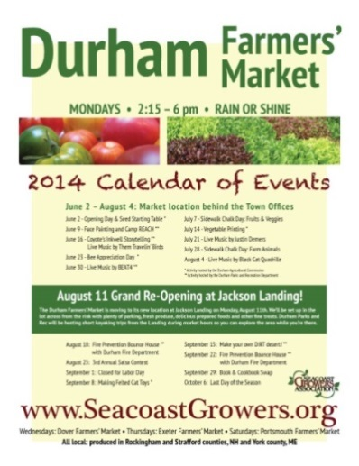
Large Markets
Photo 2: Durham Farmers’ Market flyer
(Source: Seacoast Growers Association)
According to UNH, UNH Dining Services serves approximately 100,000 meals per week during the school year and roughly 30,000 meals per week or more in the summer. Given its commitment to serving as much local food as it can access, UNH creates a very large market demand for food from Durham and surrounding towns. UNH’s College of Life Sciences and Agriculture and Paul College of Business and Economics provide leadership in ensuring the availability of locally sourced food on campus.
Similarly, the Oyster River Cooperative School District (ORCSD) continues to rapidly increase its purchase of local food, meat, dairy, vegetables, fruit, and grains. The Oyster River Cooperative School District (ORCSD) established a Sustainability Committee that includes a food and nutrition subcommittee that oversees the development of both teaching and production gardens at each of the District’s schools. Funds have been allocated from the ORCSD budget to purchase food from local farms to supply the four school cafeterias. In addition, the ORCSD has established a program to compost cafeteria food waste.
Did You Know? New Hampshire households spend approximately $1.8 billion annually on food consumed at home and $1.4 billion annually on food away from home. The total food expenditures in the state are approximately $3.2 billion, with an economic value of approximately 12.5% of total state retail sales. (Source: Local Food Systems in New Hampshire)

Natural Resources & Environmental Sustainability
Local agriculture can improve environmental sustainability by:
- Increasing or preserving greenspace and wildlife habitat
- Decreasing impervious surface cover, allowing for greater infiltration of rain and snowmelt, and carbon sequestration
- Reducing the heat-trapping effect of the built environment through the creation of greenspace
- Reducing both home and transportation energy demand.
Durham’s agricultural future is more likely to reflect small-scale, intensive agriculture rather than large scale, industrial farms. The use of rooftops and green walls as garden space―techniques long used in Europe and other countries―is emerging in the US. In addition to providing space for cultivation, green roofs can improve aesthetics, filter air and water, extend rooftop life, reduce the urban heat island effect, and reduce air conditioning and heating costs.
In northern New England communities, an increasing number of restaurants (including UNH’s Holloway Commons) are growing gardens onsite or on rooftops. Many property owners in high density residential and commercial zones are raising poultry alongside their gardens. It is important to allow businesses and residents who are interested in pursuing appropriate agricultural activities the opportunity to do so.
Although the increase in population density and impervious surface cover associated with development are major drivers of nitrogen loading in Great Bay and the Lamprey and Oyster Rivers, mismanagement of chemical fertilizers and pesticides in residential landscaping and farming activities can adversely affect these water bodies, coastal fisheries, and drinking water supplies too. Sustainable agricultural practices reduce the amount of harmful fertilizers and pesticides that enter the Great Bay watershed.

Adapting to and Mitigating Climate Change
Did You Know?
UNH ranks in the top 20 university farms in the country based on farm size, integration with the main campus, sustainability, teaching of courses at the farm, student use of the farm, and integration with the community. (Source: Best College Reviews)
One major anticipated impact of climate change is disruption of the national and international food supply. Locally grown crops will also likely be affected. Projected impacts of climate change in southeast New Hampshire that will affect agriculture include:
- Lengthening of the growing season
- Increase in summer temperatures
- Potential increase in periods of drought
- Increases in extreme precipitation events.
These changes will likely have a significant impact on certain species, such as sugar maple, and crops that are less heat and drought tolerant. Adapting to changes in climate may require modifying farming practices and identifying new, southern crops that are more suitable to the future plant hardiness zone and precipitation projections for the region.
Because local food has minimal transportation, fuel, refrigeration, packaging, and storage requirements, increasing the consumption of local food is a strategy to decrease the community’s carbon or ecological footprint. Thus, local agriculture is an important component of long term sustainability in Durham.
Agricultural Research in Durham
Durham is the center of agricultural research, innovation, and education in New Hampshire. From the1890’s to the present, Durham has hosted most of the state and federal support system for agriculture in New Hampshire. Much of the state’s agricultural research has been, and continues to be, conducted at UNH farms in Durham. Scientists and farm staff, many of whom live and work in Durham, lead this research.
Table 2: Agencies Located in Durham
USDA Natural Resource Conservation Service
USDA Northern Forest Research Laboratory
UNH Cooperative Extension Service
NH State Veterinary Diagnostic Laboratory
NH Agricultural Experiment Station
UNH College of Life Sciences and Agriculture
Source: Durham Agriculture Commission

With many federal and state agencies located in town, Durham is the headquarters for important soil, forestry, water quality, watershed, farm assistance, veterinary, and conservation programs. These programs provide landowners and farmers with access to a variety of resources. The USDA Farm and Ranch Land Protection Program, which helps farmers keep their productive land in agriculture in perpetuity by providing matching funds to help purchase development rights or easements, is one program available to farmers.
Table Xx: State and federal agencies located in Durham
In addition, many of New Hampshire’s pioneers of agricultural research and teaching, as well as authors of various renowned agricultural texts and bulletins, have lived in Durham. Further, agricultural research, teaching, Cooperative Extension, and farmer training are part of an enormous agricultural support system, which is in itself an agricultural resource for the people of Durham.

Key Conclusions
- As a whole, residents in Durham are mindful of where their food comes from and express a desire for more locally produced food. Agriculture in Durham should be recognized for its cultural importance and contributions to a high quality of life in Durham.
- As the center of agricultural research, innovation, expertise, and resources, Durham is well poised to become a major food hub in New Hampshire. A food hub is an aggregator and an educator of all aspects of food production, processing, preparation, and storage. Being the home of thousands of students (including 14,000 UNH students, as well as high school and middle school students, all within walking distance of the food hub) and with its deep agricultural tradition and activity, Durham offers a unique support system for a food hub in this region. Developing this hub will require expanding Durham’s food system and infrastructure, ensuring that land use regulations support a diverse working landscape, and identifying opportunities to further integrate farming and food production into Durham’s landscape.
- Agricultural activities occur at all scales. Educating and engaging residents about local food can increase sales of local food and therefore plays an important role in increasing the viability of farming in the region. Within the state, direct sales of local food account for approximately 10% of food sales in New Hampshire. Nearly one third of farmers in Strafford County sell directly to consumers. Educating consumers about the opportunities for and benefits of purchasing local food can increase these sales.

- Over the last decade, total agricultural sales and the number of farms in New Hampshire and Strafford County have increased. However the size of farms has decreased. The Town and Agricultural Commission should collaborate with agencies and organizations to identify programs and resources to support farmers and maintain adequately protected farmland.
- Enhancing the Durham’s capacity to be more self-sufficient with regard to food production and consumption is in many ways linked to economic development. Buying local is an opportunity to reinvest dollars in the community. At a smaller scale, produce from backyard gardens can help families save on groceries, allowing them to allocate their dollars elsewhere in the community. The availability of local food in itself, as well as the culture around local food, helps to create a more desirable place to live and is a significant asset for the community. Agricultural research, educational and learning opportunities, and development of new jobs also contribute to the economic vitality of the community. Finally, by encouraging roof top gardens―which help reduce energy needs and expenses ―Durham demonstrates commitment to sustainability, which residents and businesses increasingly value and seek.

- Local food systems help reduce greenhouse gas emissions and the input of energy and materials involved with food production and distribution. Local food has fewer refrigeration needs, requires less fuel to get from farm to consumer, and typically requires minimal packaging and storing. As a result, local food is less resource intensive and contributes less waste and carbon dioxide than food that is imported from outside the region. Strengthening a local food system is a local strategy to mitigate climate change.

- Changes to growing conditions in southern New Hampshire will likely impact the viability of some of the crops that are currently grown in the region, resulting in opportunities for farmers to expand and diversify their crops. Projected changes may require farmers to modify their farming practices and the crops they grow, and may result in greater hardship for farmers. Continuing to develop a strong local food system that is supported by the community will help to ensure the long term economic viability of farming in the region, as well as the availability of fresh local food for residents.

Goals and Recommendations
This section outlines the goals and recommendations associated with the key conclusions of this chapter. The Durham Agricultural Commission developed these goals and recommendations in order to promote the resilience, self-sufficiency, and sustainability of the community. The goals and recommendations below are not prioritized. Below each goal you will find related key conclusions from the previous section of this chapter that form the respective goal’s foundation.
Land Use Recommendation

Issue: Durham is largely dependent on food grown outside of the region, though the demand for locally produced food is high.
Goal: Encourage agricultural activities and development that foster a working landscape characterized by actively managed gardens, farms, and forests throughout the town, including UNH land.
Key Conclusions References: # 2, 3, 4, 5
Recommendations
Regulation
- Work with Town government to adopt the state regulations that enable and protect agriculture, including the state definition of agriculture and statues that support the right to farm. For example:
    - Review and adjust definitions and standards to eliminate unreasonable or unintentional impacts on farming activities. This may include removing limits to the practice of animal husbandry based exclusively on zone rather than parcel size, easing restrictions on places to market products and the regulation of incidental retail sales and signage for incidental sales, and some inspection requirements and taxation issues for local, small-scale food production.
    - Encourage rooftop gardens and green walls as a form of urban gardening that recognizes competing interests in the limited undeveloped land area within the commercial core.
    - Recommend local regulations to allow other forms of livestock and animal husbandry for noncommercial purposes in the community. The regulations should address limits on the number of animals for variously sized properties; storage, management and disposal of feed, manure, and animal remains; slaughtering; need, siting, setback, and size of enclosed structures and containment areas; management of noise and other potential nuisances; and best management practices, among other criteria, standards, and guidelines.

Education and Outreach
1. Provide public education about the value of agriculture to the local economy and quality of life, as well as ways to avoid or mitigate impacts that spill over property boundaries.
  - Recognize Durham and UNH farmers and farms by actively promoting locally produced products, conducting annual Farm Day Tours and educational workshops, hosting a table at the Durham Day Picnic, and sponsoring a float in the Memorial Day Parade.

Partnerships, Collaboration, and Resource Sharing
- Enhance relationships among the Town, farmers, and landowners, including UNH. Serve as a resource for information about grants, programs, and opportunities.
- Continue to build relationships with other agricultural commissions and related organizations in the region.

Production and Markets
1. Help local food producers sell their goods directly to consumers by expanding the Farmers’ Market to operate year-round, encouraging CSAs and other emerging techniques to connect producers and consumers, and finding a permanent location for the market.
- Support and facilitate the establishment of community gardens and home gardens. Encourage setting aside common land in conservation subdivisions for neighborhood garden plots and recreation areas. Work with the Durham Garden Club, Community Gardens for All, and Town committees, such as the Land Stewardship Committee. Highlight the effective cooperation among multiple interests (Agricultural Commission, Recreation Committee, and Conservation Commission) regarding the use of the Wagon Hill Farm property.

Advocacy
Advocate for enabling legislation that is favorable to local food production and processing.

Issue: Durham has lost some of its most productive agricultural lands to development in town and on the UNH Campus.

Goal: Identify and retain, manage, and nurture important productive agricultural and forest lands in Durham, including but not limited to the Woodman Farm, Moore Fields, Emery Farm, Tecce Farm, pasture land on the west end of Town, croplands, and Highland House Farm.
Key Conclusions References: # 1, 2, 3, 4
Recommendations
Conservation
Work with Town government, UNH, landowners and land conservation organizations to protect farmland and forestland through conservation easements, fee simple purchases, and acceptance of donations of land.

Issue: There is no more than a three day supply of fresh food in the New England region at any one time. A food hub would increase the ability of Durham and the region to be more self-sustaining and resilient to shortages in food supply. New England is particularly vulnerable to food shortages because of its position at the end of the supply chain and geographically distant from current food production centers.

Goal: Support development of a food hub for towns in Strafford, Rockingham, and York Counties.
Key Conclusions References: # 1, 2, 3, 4, 5
Recommendations
Partnerships, Collaboration, and Resource Sharing
- Continue to work with surrounding communities to establish a regional food hub of farmers and distributors that will help our community become more self-sustaining in the future.
- Take full advantage of the knowledge, science, and advice of UNH and its College of Agriculture, the Cooperative Extension Service, and US Department of Agriculture, including but not limited to, continuing education, soil testing, and pest management.
- Work with ORCSD, UNH, restaurants, grocers, and other institutions to establish and expand relationships with local farmers and provide local and regionally produced agricultural products as an ongoing part of their menus and food offerings.

Economic Impact
- Recognize local food production and farming as critical elements of a local and regional economy with regard to retaining jobs and monetary wealth in town, as well as generating new wealth from creative and imaginative ways related to processing, value-added products, and numerous small business opportunities.
- Work with UNH to support commercialization and development of agricultural research, and in particular to encourage development of agricultural entrepreneurs and new incubator space that may be appropriate for university-led commercialization initiatives.

Issue: Agriculture will be impacted by climate change and can also help mitigate climate change. Minimizing Durham’s dependence on food from outside sources decreases the community’s carbon or ecological footprint.

Goal: Increase access to local and regional food supplies to reduce reliance on fossil fuels for transportation, refrigeration, freezing, packaging, and storage.
Key Conclusions References: # 6, 7
Recommendations
Regulation
Increase opportunities for local agriculture through zoning adjustments and land conservation by ensuring that local policies do not create unreasonable or unintentional barriers for existing and potential farmers and the freedom to farm.

Best Management Practice
Encourage agricultural methods that reduce or minimize energy impacts when responding to invasive species and pests and diversifying crops.

Economic Impact
Work with the community to expand the availability and use of community kitchens that are licensed and available for use by the public to preserve or create value-added products for their own use or to sell.
Connections to Other Chapters
Agricultural resource issues intersect and align with many aspects of the Town’s plans for the future. As a result, they help inform other chapters of the Master Plan. Considerations raised in this chapter echo throughout this document and are especially linked to the following components of other chapters.
Vision and Community Character
Agriculture has been a defining component of the community's sense of place for centuries. Durham's agricultural research opportunities, rural landscape, and, increasingly, the access to fresh local food from small farms it offers, are among the reasons people choose to move to Durham.
Demographics and Housing
Private and community gardens dot Durham's residential neighborhoods. The benefits of these gardens and small farms include fostering interaction among neighbors, reducing household expenses on produce, and promoting physical activity at all ages. Nearly all homes within Durham have space for a garden, and Durham's Agricultural Commission recognizes residents’ efforts to grow fruits and vegetables in their own yards with “Food Friendly Yards” signs around the community.
Downtown and Commercial Core
Durham’s agricultural future will likely reflect small-scale, intensive agriculture. The use of rooftops and green walls as garden space is emerging in the US and may provide unique opportunities to grow food, as well as provide many other benefits, in the downtown. In addition to providing space for cultivation, green roofs can improve aesthetics, filter air and water, extend rooftop life, reduce the urban heat island effect, and reduce air conditioning and heating costs.
Economic Development
Durham's working landscape is a critical resource to the community that provides food, fuel, and jobs, among other benefits. A number of establishments in town produce their own food and depend on food produced locally at the greenhouses on UNH farmland. This has led to job creation. Outlets such as the farmers market provide residents with the opportunity to reinvest their dollars in the community. By developing food hubs, Durham will increase the viability of local and regional farms.
Energy
Growing and distributing food locally reduces energy demands associated with transportation and refrigeration. Utilizing roof space for food production has been shown to reduce air conditioning and heating costs. In addition to reducing the amount of fossil fuel energy used in conventional cropping systems, organic farming sequesters carbon in the soil more efficiently, thereby helping to reduce carbon dioxide, a major greenhouse gas.
Existing Land Use
Durham’s farms and gardens are diverse in scale, ranging from home gardens to large commercial operations. Durham’s Agricultural Commission identified at least 48 parcels of land with agriculture or gardening activity within the town and UNH campus. Agricultural land, including fields, pastures, row crops, and orchards, comprises more than 1,288 acres in the town. Approximately 20% of the land area of Durham is consists of parcels that have been designated as forestry with other current uses and 16% has been designated as farmland with other current uses. Only 2.4% acres are in current use.
Historic Resources
Agricultural heritage dates back to the 1600s and has shaped development patterns across the town's landscape. Evidence of historic farmsteads is still visible today and farms and gardens are being reintegrated into the community's historic fabric. For example, Three Chimneys Inn recently announced that it will start a garden right next to the historic 1649 building to supply its restaurant.
Natural Resources
Local agriculture can improve environmental sustainability by increasing or preserving greenspace and wildlife habitat and decreasing impervious surface cover. This allows for greater infiltration of rainfall and snowmelt. Agricultural practices that depend on pesticide and fertilizer use contribute to nutrient loading and have a negative impact on water quality in the region.
Recreation
Farms provide opportunities for recreation and seasonal activities in town. Landmarks such as Wagon Hill Farm offer both a place for residents to grow vegetables and a place for enjoying the town's natural resources.
Qualifications
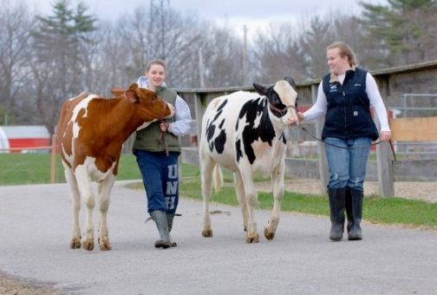
This Agricultural Resources chapter is intended to provide an overview of existing farms, farm characteristics, and agricultural activity in Durham.
Photo 3: UNH’s Fairchild Dairy Research and Training Center (Source: UNH)
Findings are based from data extracted from UNH GRANIT GIS data layers, the US Census of Agriculture, and relevant studies and best management practices developed by state agencies and the University of New Hampshire. Information collected during public outreach efforts supplemented these sources and guided the development of this chapter. Goals and recommendations were developed by the Durham Agricultural Commission. Refer to the Appendix for more detailed information.
This chapter is intended to provide Durham’s decision makers with the best available information.

UNH GRANIT 2010 Land Use
Calculated from GRANIT 1962 and 2010 Land Use data.
Calculated from GRANIT 2010 Land Use and SSURGO
USDA Census of Agriculture. 2012 Census Volume 1. Tables 1 and 2.
Lee, Daniel S. The Impact of Agriculture on New Hampshire’s Economy in Fiscal year 2011. The Institute for New Hampshire Studies. Prepared for the New Hampshire Department of Agriculture. 2012.
Wake, Cameron et al. “Climate Change in Southern New Hampshire Past, Present, and Future.” 2011.
For more information on the vast agricultural research that has been conducted for over a century on Durham land, see “A History of The New Hampshire Agricultural Experiment Station, 1887-1987,” by Walter M. Collins. NH Agricultural Experiment Station Bulletin No. 529, 1990. http://archive.org/stream/stationbulletin529newh#page/2/mode/2up
The Agricultural Commission believes there is a need to regulate incidental retail sales of extra produce, eggs, or other products in a less burdensome manner. Seasonal permits for regular ongoing seasonal sales, such as Christmas trees, farm stands, and other regular, ongoing sale of seasonal products require more scrutiny for traffic safety, among other issues, than the occasional sale of unanticipated, extra, or spill-over yields.
See the NH Department of Agriculture, Markets & Food’s Manual of Best Management Practices for Agriculture in New Hampshire: Best Management Practices for the Handling of Agricultural Compost, Fertilizer, and Manure.

