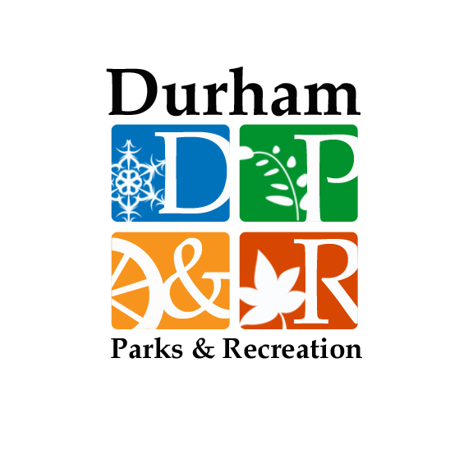
Durham Parks and Recreation Registration Form
Bring in or mail registration form with check, made payable to: Town of Durham (indicate program). Mail to Durham Parks & Recreation Department at: 15 Newmarket Rd. Durham, NH. 03824
Please call Parks and Recreation at: 817-4074 with any questions.
Participant Information (Please complete entire form)
Participant Name: | Program Title & Time: |  |  | Start Date: |  |  | Fee: |  |  | Cash/Ck #:
Age: | DOB:
Participant Contact or Parent/Guardian Information
Address: |  |  | State: |  |  | Zip Code: |  |  | Cell Phone:
Email: |  |  | Home Phone: |  |  | Work Phone:
Emergency Contact Information (other than participant)
Name: |  | Relationship: |  |  | Address: |  |  | Phone Number(s):
Please indicate any medical concerns (medications, physical disabilities, allergies, swimming, accommodations needed, etc.) participants have which we should be aware of:

Durham Recreation Liability Waiver:
All persons participating in Durham Parks and Recreation programs do so at their own risk and without recourse to the Town of Durham, its agents, officers or employees. I, the undersigned participant, parent or guardian, do hereby agree to allow the individual(s) named above to participate in the activity listed, and I further agree to hold the Town of Durham Parks and Recreation Department harmless from and against any and all liability for any injury which may be suffered by the aforementioned individual arising out of his/her participation in this activity.
I, understand that in case of injury or illness, I will be notified. If it is impossible to contact me and if it is an emergency, I hereby give permission to the attending physician to treat, hospitalize, administer anesthesia, or to order injections or surgery for the safety of my child. I, the parent/legal guardian, the undersigned have read this release and understand all its terms. I execute this release voluntarily and with full knowledge of its significance. I have executed this release on this date indicated next to my name. The Durham Parks and Recreation Department may be taking pictures during any programs for use in future publications. Please check the box if you would NOT allow use of these photos. Do not allow the use of pictures.

SIGNATURE:_______________________________________________________________ DATE: ___________________________________
Health Insurance Company: _________________________________________ Policy Holder: __________________________________
Policy #: ___________________ Group #: ______________________ ID #: ________________________ Certificate #: _______________ Make Checks Payable to: TOWN OF DURHAM (No refund given after program begins)

