**Durham Parks & Recreation Department**

COYOTE CLUB

**“Instilling a sense of wonder, responsibility and**

**stewardship for the natural world through ecological studies and primitive skills exploration.”**

 _____________________________________________________________________________________________

**6 Week Program at Wagon Hill Farm**

**Mondays 3:45 to 5:15pm**

**September 16th – October 28th**

**(No class on Oct. 14th due to Columbus Day)**

**Ages: 1st through 5th graders**

**Registration Fee: $75**

|  |
| --- |
| **Coyote Club is a nature based wildlife education program dedicated to bringing the children and adults of southeast New Hampshire the best in naturalist studies, survival skills, environmental education and more.** |

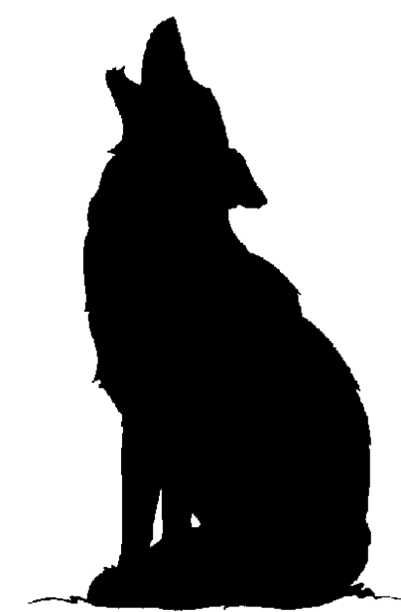  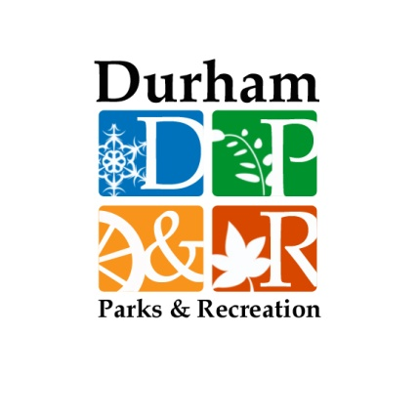

**To register contact P&R Director Stefanie Frazee at: 817-4074**

**or at sfrazee@ci.durham.nh.us. Direct class content questions to John Pazdon at Johnny@nhecology.com**