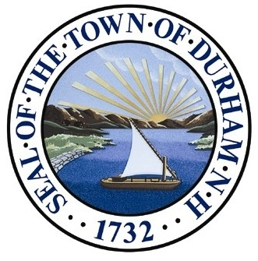
Property Inventory Notebooks

Durham, New Hampshire

Statement of Purpose

The Town of Durham owns more than 60 properties that range in size from less than an acre to nearly 200 acres. The properties were acquired through various means and for various purposes. Some are designated for specific purposes, such as conservation land (e.g., Oyster River Forest), recreation (e.g., Father Lawless), multi-use (Wagon Hill), specific public uses (e.g., Durham Library; Solid Waste Facility), while others are labeled as “vacant lots.”

As properties are acquired over time, and without a system in place to collate pertinent information, it is often difficult to keep track of relevant documents and determine best stewardship practices for a given property. To that end, Town Administrator Todd Selig requested that Public Works Director Mike Lynch inventory all town properties and create Property Inventory Notebooks for each property.

The inventory will identify gaps in information or decision-making (e.g., no property survey, lack of management plan) and help identify any parcels that are not suited to town ownership and therefore best conveyed to another owner. The Property Inventory Notebooks include the following information, when available:

- Property name, size, location
- Property designations, public uses, restrictions
- Property maps
- Management/stewardship plan
- Management/stewardship projects and tracking sheet
- Tax map
- Property deeds
- Property surveys
- Other plans
- Ecological information
- Historical information
- Other

Once a Property Inventory Notebook is completed for a given property, a hard copy in a 3-ring binder will be kept at the Public Works Department office or other town space and a digital copy of each Notebook will be uploaded to the Town of Durham website, providing easy access to the information for decision-makers and the public.

